

23CSE211
Design and Analysis of Algorithms
Lab-6

Submitted to Submitted by
Dr SS Chakravarthi Jagapriyan B - CH.SC.U4CSE24216

Lab-6

- Quick sort

CODE:
#include <stdio.h>
#include <stdlib.h>
#include <time.h>

void swap(int* a, int* b) {
int t = *a;
*a = *b;
*b = t;
}

int partition(int arr[], int low, int high) {
int pivot = arr[high];
int i = (low - 1);

for (int j = low; j <= high - 1; j++) {
if (arr[j] < pivot) {
i++;
swap(&arr[i], &arr[j]);
}
}
swap(&arr[i + 1], &arr[high]);
return (i + 1);
}

void quickSortLast(int arr[], int low, int high) {
if (low < high) {
int pi = partition(arr, low, high);
quickSortLast(arr, low, pi - 1);
quickSortLast(arr, pi + 1, high);
}
}

int partitionRandom(int arr[], int low, int high) {
int random = low + rand() % (high - low + 1);
swap(&arr[random], &arr[high]);
return partition(arr, low, high);
}

void quickSortRandom(int arr[], int low, int high) {
if (low < high) {
int pi = partitionRandom(arr, low, high);
quickSortRandom(arr, low, pi - 1);
quickSortRandom(arr, pi + 1, high);
}
}

int partitionMedian(int arr[], int low, int high) {
int mid = low + (high - low) / 2;

if (arr[low] > arr[mid]) swap(&arr[low], &arr[mid]);
if (arr[low] > arr[high]) swap(&arr[low], &arr[high]);
if (arr[mid] > arr[high]) swap(&arr[mid], &arr[high]);

swap(&arr[mid], &arr[high]);
return partition(arr, low, high);
}

void quickSortMedian(int arr[], int low, int high) {
if (low < high) {
int pi = partitionMedian(arr, low, high);
quickSortMedian(arr, low, pi - 1);
quickSortMedian(arr, pi + 1, high);
}
}

int quickSelect(int arr[], int low, int high, int k) {
if (low == high) {
return arr[low];
}

int pi = partitionRandom(arr, low, high);

if (k == pi) {
return arr[k];
} else if (k < pi) {
return quickSelect(arr, low, pi - 1, k);
} else {
return quickSelect(arr, pi + 1, high, k);
}
}

void printArray(int arr[], int size) {
for (int i = 0; i < size; i++)
printf("%d ", arr[i]);
printf("\n");
}

int main() {
srand(time(NULL));

int arr1[] = {10, 7, 8, 9, 1, 5};
int n1 = sizeof(arr1) / sizeof(arr1[0]);

printf("Original array:\n");
printArray(arr1, n1);

quickSortMedian(arr1, 0, n1 - 1);

printf("\nArray sorted with Median-of-Three pivot:\n");
printArray(arr1, n1);

int arr2[] = {12, 3, 5, 7, 4, 19, 26};
int n2 = sizeof(arr2) / sizeof(arr2[0]);
int k = 3;

int kthSmallest = quickSelect(arr2, 0, n2 - 1, k);
printf("\nThe %d-th smallest element (0-indexed %d) is: %d\n", k+1, k, kthSmallest);

return 0;
}

OUTPUT:
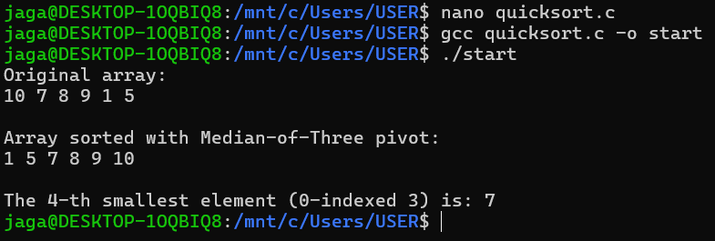

Quick Sort averages O(n \log n) time and O(\log n) space, but its worst-case time is O(n^2),which Random and Median-of-3 pivots make extremely rare
Extra space is only due to recursion stack. Balanced recursion → depth log n. Unbalanced recursion → depth n.

Quick Select averages O(n) time and O(\log n)space, sharing the exact same rare O(n^2) worst-case time scenario.
Partition takes O(n) time. Recursion depth is log n when partitions are balanced → O(n log n). Worst case occurs when pivot is always smallest/largest (highly unbalanced) → O(n²).

