

23CSE211
Design and Analysis of Algorithms
Lab-3

Submitted to Submitted by
Dr SS Chakravarthi Jagapriyan B - CH.SC.U4CSE24216

Lab-3

- Breadth First Search (BFS)

CODE:
#include <stdio.h>

int n;
int adj[20][20];
int visited[20];
int queue[20], front = 0, rear = -1;

void bfs(int start)
{
int i;
queue[++rear] = start;
visited[start] = 1;

while (front <= rear)
{
start = queue[front++];
printf("%d ", start);

for (i = 1; i <= n; i++)
{
if (adj[start][i] == 1 && visited[i] == 0)
{
queue[++rear] = i;
visited[i] = 1;
}
}
}
}

int main()
{
int i, j, start;

printf("Enter number of vertices: ");
scanf("%d", &n);

printf("Enter adjacency matrix:\n");
for (i = 1; i <= n; i++)
for (j = 1; j <= n; j++)
scanf("%d", &adj[i][j]);

printf("Enter starting vertex: ");
scanf("%d", &start);

bfs(start);

return 0;
}

OUTPUT:
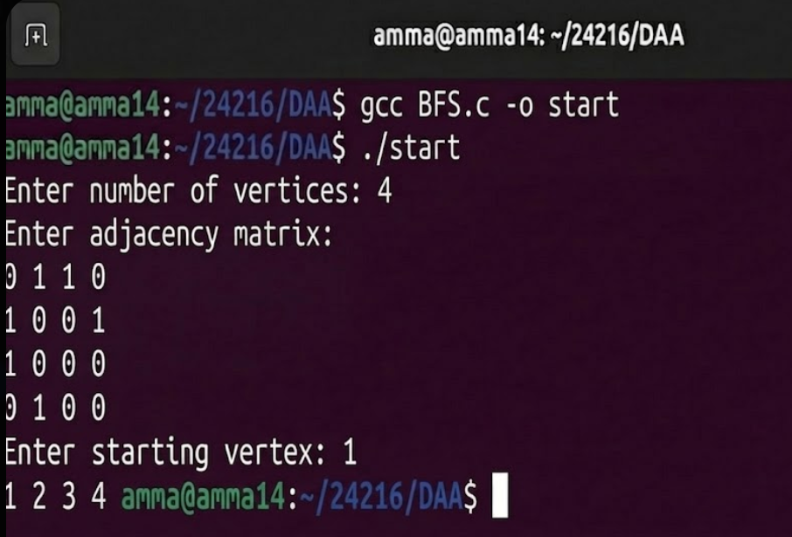

- Depth First Search (DFS)

CODE:
#include <stdio.h>

int n;
int adj[20][20];
int visited[20];

void dfs(int start)
{
int i;
printf("%d ", start);
visited[start] = 1;

for (i = 1; i <= n; i++)
{
if (adj[start][i] == 1 && visited[i] == 0)
dfs(i);
}
}

int main()
{
int i, j, start;

printf("Enter number of vertices: ");
scanf("%d", &n);

printf("Enter adjacency matrix:\n");
for (i = 1; i <= n; i++)
for (j = 1; j <= n; j++)
scanf("%d", &adj[i][j]);

printf("Enter starting vertex: ");
scanf("%d", &start);

dfs(start);

return 0;
}

OUTPUT:

