Contents
Acknowledgement 3
Abstract 4
About Us 5
CHAPTER 1 6
Introduction 6
1.1 Project Overview 6
1.2 Objective of the project’s 7
1.3 Project Scope and Limitations 7
CHAPTER 2 9
Background Study 9
2.1 What is Local Arae Network (LAN)? 9
2.2 System Requirements 11
2.3 Site Map 11
CHAPTER 3 15
System Methodology 15
3.1 ProxMox VM, Flask and Networking Setup 15
3.2 Phyton 16
3.3 JavaScript 16
3.4 HTML/CSS 17
3.5 JSON 17
CHAPTER 4 19
System Architecture 19
4.1 Use Case Diagram 19
4.2 Database Diagram 30
CHAPTER 5 32
Installation Guide 32
5.1 How to install ProxmoxVE server 32
📝 Preparation Before Installation 32
🛠️ Installation Steps 32
🚀 Post-Installation Setup 33
⚙️ Next Steps for Your Chat Application 34
5.2 How to install Linux for Debian 34
📋 Preparation 34
🖥️ Installation Process 35
🔧 Post-Installation Setup 38
🛠️ Setup for Your Chat Application 40
✅ Verification Checklist 41
🚀 Next Steps for Your Project 42

Acknowledgement

We would like to express our deepest gratitude and sincere appreciation to all individuals who contributed directly or indirectly to the successful completion of our final year project, the “Local Area Network (LAN) Based Chat and File Sharing System.”
First and foremost, we would like to extend our sincere thanks to our project supervisors, Sr Maran Gam Awng and Sr Labya Naw Naw, for their invaluable guidance, constant encouragement, and insightful feedback throughout this project. Their expertise and patience were instrumental in helping us navigate challenges and refine our work. Without their unwavering support, this project would not have reached its full potential.
We are also immensely grateful to all the teachers and staff of Mai Ja Yang College for providing us with the necessary resources and a conducive learning environment. The knowledge and skills imparted during our coursework formed the essential foundation upon which this project was built.
Our sincere thanks go to our friends and classmates for their moral support, stimulating discussions, and for willingly testing our application. Their constructive criticism and valuable suggestions were crucial in improving the system’s functionality and user experience.
Lasty, and most importantly, we wish to express our heartfelt gratitude to our families. Their endless love, unwavering belier in our abilities, and immense patience during this demanding period were our greatest source of strength and motivation. This achievement is as much theirs as it is ours.

Thank you all…

Abstract

- This project is designed to provide chat and file sharing within a Local Area Network (LAN).
- It can operate without an internet connection, ensuring independent local communication.
- The system is developed using socket API, supporting both client-server and peer-to-peer communication.
- It enables real-time messaging and fast file transfer with minimal delay.
- A user-friendly interface is implemented to make the system easy to use.

About Us

We are a dedicated team of eight students developing a web application designed to be practical and beneficial for use in schools. Our project is guided by our supervisor, Sr Gam Awng, and co-supervisor, Sr Labya Naw Naw.

Our Team Roles:
· Leadership: Ngadawng Ja Seng Htoi
· Development & Coding: Jangmaw Sunday, Lahtaw Bawkli
· Documentation: Zunwa Zau Ring, Wabaw Zau Ing, Mwihpu Nang Lung
· Support & Assistance: Sham Sut Ring Naw, Labang Myu Ring Awng

We started developing a LAN (Local Area Network)–based chat and file-sharing web application in June 2025. The main purpose of building this web application is to provide a platform where students in our college can communicate with each other easily and efficiently.

CHAPTER 1

Introduction

1.1 Project Overview
Local Area Network (LAN) Based Chat and File Sharing System is designed to enable real-time communication and file sharing among computers connected within a LAN. The system allows data exchange between users without requiring an internet connection, making it efficient and secure for local communication.
The system is to facilitate easy and fast communication and file transfer among team members, departments, office and within a classroom environment. The system enables instant messaging between connected users within the LAN and sending and receiving files (documents, images, etc.) between users or group. Secure login with Username and Password to ensure data privacy. Provides sound or visual alerts for incoming messages and displays online/offline status of user.
This system uses Python language in the backend and HTML/CSS, JavaScript, Json in the frontend. TCP/IP socket programming is built on the Linux Platform.
Develop a chat system that work efficiently over a LAN without the need for internet access and to make file sharing among team members easy and secure. To design a user-friendly interface and reliable communication platform. Lacal Area Network (LAN) Based Chat and File Sharing System provide a standalone LAN-based system capable of real-time messaging and high-speed file transfer among connected computers.

1.2 Objective of the project’s
This project has several main goals. Its first objective is to provide fast and efficient real-time communication for users on the same local network (LAN). It also aims to make sharing files between these users a simple and quick process. Another important function is to allow for the submission of activities, such as school assignments. The system is designed to support direct one-to-one, or peer-to-peer, and group conversations. Finally, all of these features will be accessible through an easy-to-use and user-friendly interface, ensuring a smooth experience for everyone.

1.3 Project Scope and Limitations

1.3.1 Project Scope
"Project Scope" refers to what is included and what the system is capable of doing.
1. User Management
Registration: Users can register an account using a Username and Password.
User List: Ability to view a list of all users currently on the network.
User Status: Ability to see the status of users (e.g., Online, Offline).
2. Real-time Messaging
Private Chat: Users can send private messages to each other.
Group / Broadcast Chat: Users can connect in groups and send messages to all users simultaneously.
Chat History: Users can view their message history.
3. File Sharing
Users can send files, photos, and videos to each other. Supports direct file transfer. File size limits are defined.
4. Administration & Network
Local Network Operation: The system works only within the same local area network (via Wi-Fi or Ethernet).
Centralized Control (Client-Server Model): A central server manages all information and operations.

1.3.2 Project Limitations
"Limitation" refers to the weaknesses of this system or the things it cannot do.
Performance
Limited Users: Depending on the server's performance capacity, the system may become slow if the number of users exceeds 20-30-50. It may not be possible to support over 100 users. Currently, the video call feature is not yet available.
Large File Issues: There may be restrictions in place that prevent sending very large files, such as those several GB in size or videos.
Memory Usage: Storing users' files and chat history requires significant use of the server's memory (RAM).

CHAPTER 2

Background Study

2.1 What is Local Arae Network (LAN)?
A Local Area Network (LAN) is a type of network created to connect computers, printers, phones, and other computer devices located close to each other in a single location (for example, one home, one office, one school) so that they can communicate and be used together.
For example
· If you have Wi-Fi at home, all the phones, computers, and Smart TVs connected to that Wi-Fi are within your home's LAN.
· A computer lab at school with about 50 connected computers, or classrooms with Wi-Fi, are also LANs.

2.1.1 Where are LANs used?
You can find LANs almost everywhere.
1. Homes (Home Networks) - For family members to use the internet, share files, and play games together.
2. Schools - In computer labs, libraries, and teachers' offices.
3. Offices - For employees to communicate with each other, share data, and use a central printer.
4. Hospitals - For patient lookup systems and sharing medical records.
5. Public places like coffee shops - For customers to use the internet.

2.1.2 What is a LAN for? Why is it important?
The main purpose of a LAN is to share resources and make communication faster and easier.
1. Shared Internet Access - One internet line can be used by all computers and phones in an entire house.
2. File and Data Sharing - You can wirelessly send schoolwork from one computer to another. In an office, a document can be set up for all team members to view.
3. Hardware Sharing - You don't need 20 printers for 20 computers. All computers can connect to and use a single printer.
4. Easy Communication - Using chat software (e.g., LAN Messenger) on a LAN allows students or office team members to send messages to each other instantly.
5. Multiplayer Gaming - You can play games together with friends in a computer lab.

2.1.3 How does it benefit students?
For a student, a LAN greatly supports your education and daily life.
1. Research & Learning - Using the school's Wi-Fi, you can easily access the internet to search for information and access online libraries and e-books.
2. Collaboration - Using online platforms like Google Docs or Microsoft Teams via the LAN, you can work on group essays, prepare presentations, and easily send files to other students.
3. Resource Efficiency - To install software in a school computer lab, it doesn't need to be installed on every single computer. It can be distributed to all from one central server.
4. Knowledge Expansion - Understanding LANs provides a good foundation for students interested in technology fields like networking and IT management.
5. Easy Management - Teachers can centrally manage students' computers through the LAN to deliver lessons and assign exercises.

2.2 System Requirements
Hardware
- Proxmox Server: Run multiple VM containers with sufficient CPU, Ram and Storage.
- Local network and router: Support LAN distribution with static IP configuration for each service.
- Ethernet cable: support for network or Wifi, connect to router.
Software
- Proxmox VE: Updated to the latest version.
- Linux VM Templates: Use Debian for each container (Flask, File Browser)

2.3 Site Map
│
├── 📄 Front-end Interface
│ ├── User Login / Authentication
│ ├── Chat Dashboard
│ ├── File Upload / Download Interface
│ ├── User Profile / Settings
│
├── ⚙️ Back-end Services
│ ├── User Authentication Service
│ ├── Real-time Messaging Engine
│ ├── File Handling & Storage Service
│ ├── Database Management
│ └── Session Management
│
├── 🔗 External Integrations
│ ├── Local Network Configuration (LAN)
│ ├── Proxmox VM Setup
│ └── Flask Server Environment
│
├── 🔄 API Requests
│ ├── Send / Receive Messages
│ ├── File Transfer Requests
│ ├── User Status Updates
│ └── System Health Checks
│
── 🗃️ Data Integrations
│ ├── User Data
│ ├── Message Logs
│ ├── File Metadata
│ └── Session Logs
│
└── 👤 User Actions
├── Register / Login
├── Send Message
├── Upload File
├── Save File
├── View Online Users
└── Logout

2.3.1 Front-end Interface Layer
The front-end serves as the primary point of interaction for the end-user. It is a dynamic web application that renders the user interface and communicates with the back-end services via a defined API. Its key modules include:
- User Login / Authentication Interface: A secure portal that collects user credentials and manages the login/logout life cycle.
- Chat Dashboard: The central hub for real-time communication, displaying active conversations, contact lists, and message histories.
- File Upload / Download Interface: Provides a drag-and-drop or browser-based mechanism for users to transfer files to and from the system.
- User Profile / Settings Module: Allows users to view and modify their personal information and application preferences.

2.3.2 Back-end Services Layer
This layer constitutes the core application logic, built upon the Django web framework. It is composed of several discrete services:
- User Authentication Service: Validates user credentials, manages password hashing, and issues session tokens to maintain user state.
- Real-time Messaging Engine: Leverages Web Sockets to facilitate instantaneous, bi-directional communication for message delivery and user status updates.
- File Handling & Storage Service: Manages the secure reception, storage, retrieval, and access control of user-uploaded files on the server's file-system.
- Database Management Service: Handles all Create, Read, Update, and Delete (CRUD) operations for persistent data, abstracting direct database interactions.
- Session Management Service: Tracks active user sessions, manages timeouts, and ensures secure access to protected resources.

2.3.3 External Integrations and Deployment Environment
The system's operational context is defined by its integration with specific external platforms and network configurations:
- Local Network Configuration (LAN): The system is designed to operate within a LAN, leveraging its high-bandwidth, low-latency characteristics for optimal performance and enhanced security through network isolation.
- Proxmox VM Setup: The server component is containerized within a Proxmox Linux (VM), providing a lightweight, isolated, and easily manageable runtime environment.

2.3.4 API Communication Layer
The interaction between the front-end and back-end is standardized through a Restful API and Web Socket connections. The primary API endpoints and actions include:
- Message Endpoints: For sending and receiving text messages in real-time.
- File Transfer Endpoints: For initiating uploads and downloads, handling multipart/form-data requests.
- User Status Endpoints: For updating and fetching the online/offline status of users.
- System Health Check Endpoint: A monitoring endpoint used to verify the operational status of the server and its services.

2.3.5 Data Integrations and Persistence
The system interacts with a relational database to persistently store all operational data. The key data entities are:
- User Data: Stores user profiles, hashed passwords, and preferences.
- Message Logs: Archives all sent and received messages with timestamps and sender/receiver identifiers for history and auditing.
- File Metadata: Contains information about stored files, such as filename, size, uploader, upload timestamp, and physical storage path.
- Session Logs: Records user login and logout times, IP addresses, and session tokens for security and analytics.

2.3.6 User Interaction Flow
The system is designed around a set of core user actions that define the primary use cases. These actions trigger the aforementioned components in a coordinated sequence:
- Register / Login: A user provides credentials, which are verified by the Authentication Service, leading to session creation.
- Send Message: A message composed in the Chat Dashboard is sent via the API to the Real-time Messaging Engine, which broadcasts it to the intended recipient(s).
- Upload File: A file selected through the interface is transmitted to the File Handling Service, which stores it and records its metadata in the database.
- Save File: A user request to download a file is routed through the File Handling Service, which retrieves the file from storage and initiates the download.

CHAPTER 3

System Methodology

3.1 ProxMox VM, Flask and Networking Setup
Proxmox server is an open-source virtualization software based on Linux (Debian) that lets you run and manage virtual machines (VMs), containers, and storage all on one physical server using a simple web interface. It is widely used for creating private cloud infrastructure at home or in enterprise settings. Building a Robust and Isolated Server Environment.

Main Features:

- Proxmox VE enables you to create and manage multiple virtual machines, allowing you to install any operating system you want (Linux, Windows, etc.).
- It supports lightweight LXC containers for efficient resource usage and fast performance.
- The user-friendly web interface helps you manage VMs, networks, storage, and clusters easily.
- Proxmox VE supports features like clustering and high-availability setups, making it useful for both labs and enterprise environments.

Why it's used:
· The Project Scope requires a "Centralized Control (Client-Server Model)," necessitating a dedicated server.
· Using Proxmox Server allows for the creation of a lightweight, cost-effective, and resource-efficient (CPU, RAM) server environment.
· The Networking Setup ensures the server runs stably on the LAN with a static IP, making it reliably accessible to all clients.

Interconnection with other parts:
· System Requirements: This section implements the "Proxmox Server" and "Local network and router" hardware/software requirement.
· External Integrations: This is the practical execution of the "Proxmox Setup" and "Local Network Configuration (LAN)" sections.

3.1.1 Proxmox Virtual Environment (VE) Setup
Proxmox VE was chosen as the primary platform for virtualization. It was installed on a dedicated server to host all the project's virtual machines (VMs) and Linux Containers (LXC). Proxmox provides a powerful web-based dashboard for managing virtualized resources, which simplified tasks such as creating, snapshotting, and managing our containers.
- Initial Configuration: The Proxmox host server was configured with a static IP address on the college LAN to ensure consistent accessibility for all team members. Storage was set up and named appropriately (e.g., local-lvm).
- Cluster (Optional): A single-node cluster was established, as the project did not require high availability.

3.2 Phyton
Python is a programming language that is widely used in web applications, software development, data science, and machine learning (ML). Developers use Python because it is efficient and easy to learn and can run on many different platforms.
Why it's used:
· Python is easy to write and has rich libraries for Socket Programming, Web Frameworks (Django/Flask), and Data Handling, making it ideal for this project's needs.
· All Backend Services like Real-time Messaging, File Sharing, and User Authentication are written in Python.
Interconnection with other parts:
· Back-end Services Layer: It is the lifeblood of all services like the User Authentication Service, Real-time Messaging Engine, and File Handling Service.
· Abstract: The point "The system is developed using socket API" is implemented using Python Socket Programming.

3.3 JavaScript
JavaScript is a scripting language that enables you to create dynamically updating content, control multimedia, animate images, and pretty much everything else. i.e. anything that moves, refreshes, or otherwise changes on your screen without requiring you to manually reload a web page. Features like: animated graphics. photo slideshows.
Why it's used:
· It is essential for achieving the goal of a User-friendly Interface.
· It allows the Chat Dashboard to display new messages instantly without reloading the page (Real-time Update).
· It is used to call Web Sockets or API Calls to easily send user actions (e.g., Send Message, Upload File) to the Backend Server.
Interconnection with other parts:
· Front-end Interface Layer: It is the technology that brings the Chat Dashboard and File Upload/Download Interface to life.
· API Communication Layer: JavaScript initiates API Requests like "Send / Receive Messages" and "File Transfer Requests."

3.4 HTML/CSS
HTML is a markup language used to create static web pages and web applications. CSS is a style sheet language responsible for the presentation of documents written in a markup language. Consists of tags surrounding content. For Example: <p> Welcome to Simplilearn </p >.
Why it's used:
· Creating the basic Structure (HTML) and Visual Design (CSS) of the Website.
· They are the foundational building blocks for creating a web-based User Interface.
· HTML is used to structure components like the User Management Interface, Chat Box, and File Upload Button.
· CSS is used to design the interface to be visually appealing and easy to use (User-friendly).
Interconnection with other parts:
· Front-end Interface Layer: The visual part of all components, including the User Login Interface, Chat Dashboard, and File Upload Interface, is built with HTML/CSS.

3.5 JSON
JavaScript Object Notation (JSON) is a standard text-based format for representing structured data based on JavaScript object syntax. It is commonly used for transmitting data in web applications (e.g., sending some data from the server to the client, so it can be displayed on a web page, or vice versa).
Why it's used:
· Used as a standardized Format for exchanging Data between the Frontend and Backend.
· It is a lightweight, easy-to-read, and fast-to-process format, perfect for data exchange between JavaScript (Frontend) and Python (Backend).
· For example, when a user sends a message, it's sent to the backend in a JSON format like {"sender": "user1", "message": "Hello", "timestamp": "..."}. The backend also returns data, like a message list, in JSON.
Interconnection with other parts:
· API Communication Layer: It implies that all API Endpoints exchange Request and Response data using the JSON format.
· Data Integrations: JSON acts as the data carrier, transporting data from the database to the frontend via the API.

CHAPTER 4

System Architecture

4.1 Use Case Diagram
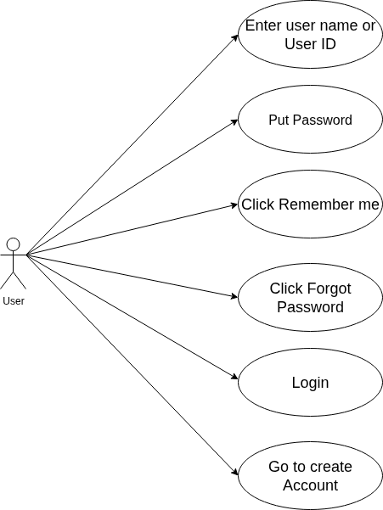

Figure 4.1.1User Login Form diagram

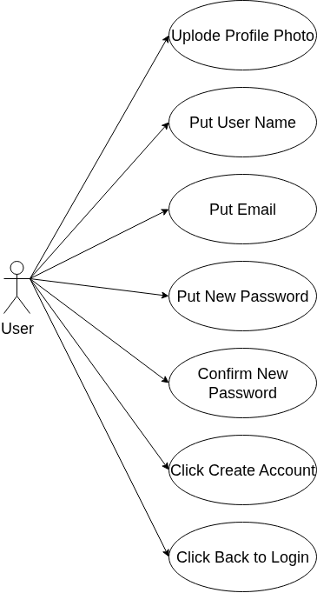
Figure 4.1.2 User Signup Form diagram

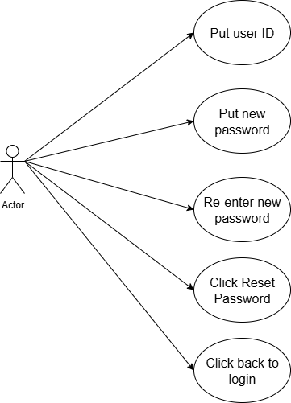
Figure 4.1.3 Forgot Password Form

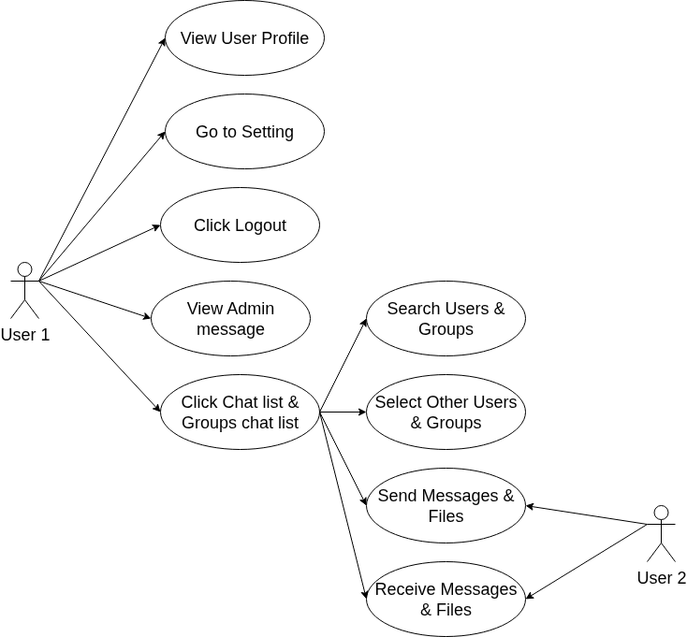
Figure 4.1.4 Home Page Diagram

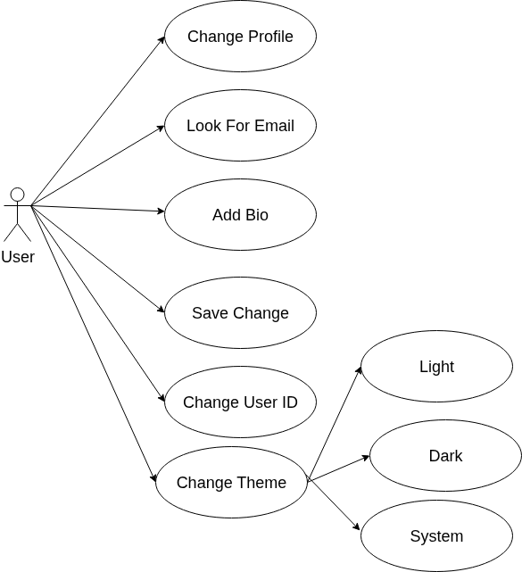
Figure 4.1.5 Setting Diagram1

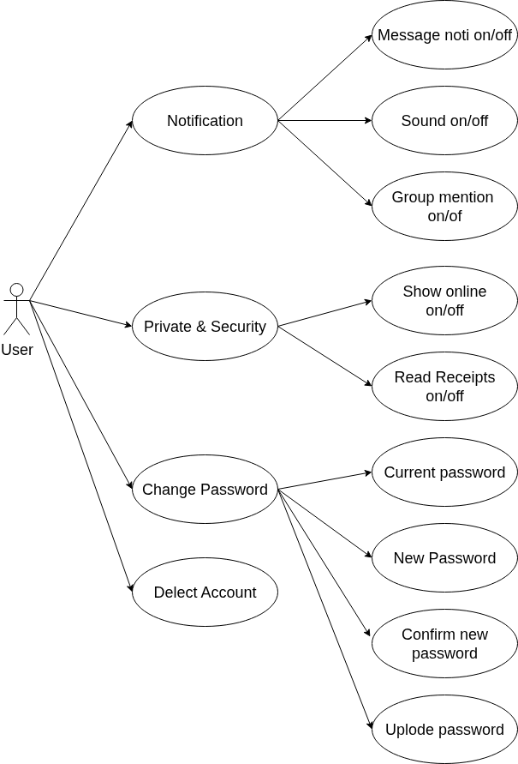
Figure 4.1.6 Setting Diagram2

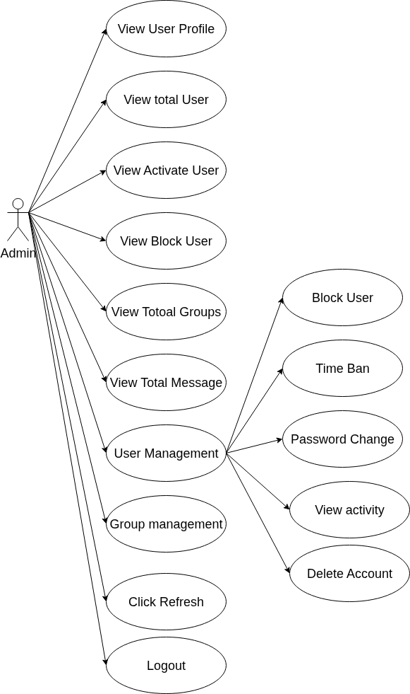
Figure 4.1.7 Admin Form

User Sign up
This diagram visually shows the steps a user needs to follow to create a new account. It is a kind of "use case diagram" for a registration feature.
Step-by-Step Explanation
- Upload Profile Photo: The user uploads a profile picture.
- Put User Name: The user enters their username.
- Put Email: The user provides their email address.
- Put New Password: The user chooses and enters a new password.
- Confirm New Password: The user re-enters the chosen password to confirm.
- Click Create Account: After filling in all required fields, the user clicks to create the account.
- Click Back to Login: The user can also choose to return to the login page instead.

User Login
This diagram shows the login process for a user, similar to the previous example but focused on logging in instead of account creation.
Step-by-Step Explanation
- Enter user name OR Admin username: The user types their unique name or Admin username to identify themselves.
- Put Password: The users and Admin enters their account password.
- Click Remember me: The user can click to have the system remember their login for convenience next time.
- Click Forgot Password: If the user forgot their password, they can start a recovery process by clicking here.
- Login: After filling in the required fields, the user clicks to log into their account.
- Go to create Account: If the user doesn't have an account, they can go to the account creation page.
NOTE: Admin can log in from this login page. Since there is only one admin who controls the entire app, the login feature here is specifically designed for the admin to access and manage everything.

Forgot password for reset password
This diagram shows the actions involved in resetting a password. It is a "use case diagram" for the password reset processes.
Step-by-Step Explanation
- User ID: The user provides their user ID to identify which account needs the password reset.
- New Password: The user chooses and enters a new password for their account.
- Re-enter new Password: To confirm, the user types the same new password again to avoid mistakes.
- Reset Password: After both passwords match, the user clicks to reset the password.
- Click Back to Login: The user can also choose to return to the login screen at any time.

Admin Use Case Diagram
This diagram shows the main features and controls available to the admin in the system.1000000479.jpg​
Step-by-Step Explanation
- View User Profile: Admin can see details of any user.
- View Total User: Admin can view the total number of users registered.
- View Activate User: Admin can check which users are currently activated.
- View Block User: Admin can see users that are blocked.
- View Total Groups: Admin can see all the groups in the system.
- View Total Message: Admin can view the total number of messages.
- User Management: Admin can manage users using:
  - Block User: Admin blocks a user.
  - Time Ban: Admin temporarily bans a user.
  - Password Change: Admin can change a user's password.
  - Delete Account: Admin can delete a user's account.
- Group Management: Admin can manage chat groups.
- Click Refresh: Admin refreshes the admin interface.
- Logout: Admin logs out of the admin panel.

Setting 1
This diagram shows the user profile and theme settings features available to a user in the app. Arrows point from the user to each function that can be performed [1].

Step-by-Step Explanation

- Change Profile: The user updates their profile details such as name or avatar.
- Look for Email: The user can view or check their email address.
- Add Bio: The user adds a bio or personal introduction to their profile.
- Save Change: After making updates, the user saves their changes to apply them.
- Change Theme: The user can customize the app's appearance by changing the theme.
  - Light: User selects a light color scheme.
  - Dark: User selects a dark color scheme.
  - System: User chooses to match the app theme to the system default.

Setting2
This diagram outlines features related to notifications, privacy, and account safety for the user.
Step-by-Step Explanation
- Notification: User can adjust:
  - Message notification on/off: Enable or disable message notifications.
  - Sound on/off: Enable or disable notification sounds.
  - Group mention on/off: Get notified for group mentions.
- Private & Security:
  - Show online on/off: Display/hide online status.
  - Read Receipts on/off: Show/hide message read receipts.
- Change Password:
  - Current password: Enter current password.
  - New Password: Enter a new password.
  - Confirm new password: Confirm new password entry.
  - Uplode password: Update new password.
- Delete Account: User can delete their account.

Home Chat
This diagram shows the actions and workflows a user can perform within a chat application. Each oval is a feature, and arrows represent possible interactions between users and those features [1].

Step-by-Step Explanation

- View User Profile: User 1 can view their own profile for information or edits.
- Go to Setting: User 1 can access settings to customize the app or their account.
- Click Logout: User 1 can log out of the app to end their session.
- Click Chat list & Groups chat list: User 1 can access a list of chats and group conversations.
- Search Users & Groups: User 1 can look for other users or groups to chat with.
- Select Other Users & Groups: After searching, User 1 selects who they want to interact with.
- Send Messages & Files: Both User 1 and User 2 can send messages or files via the chat interface.
- Receive Messages & Files: Both User 1 and User 2 can receive messages or files from others.

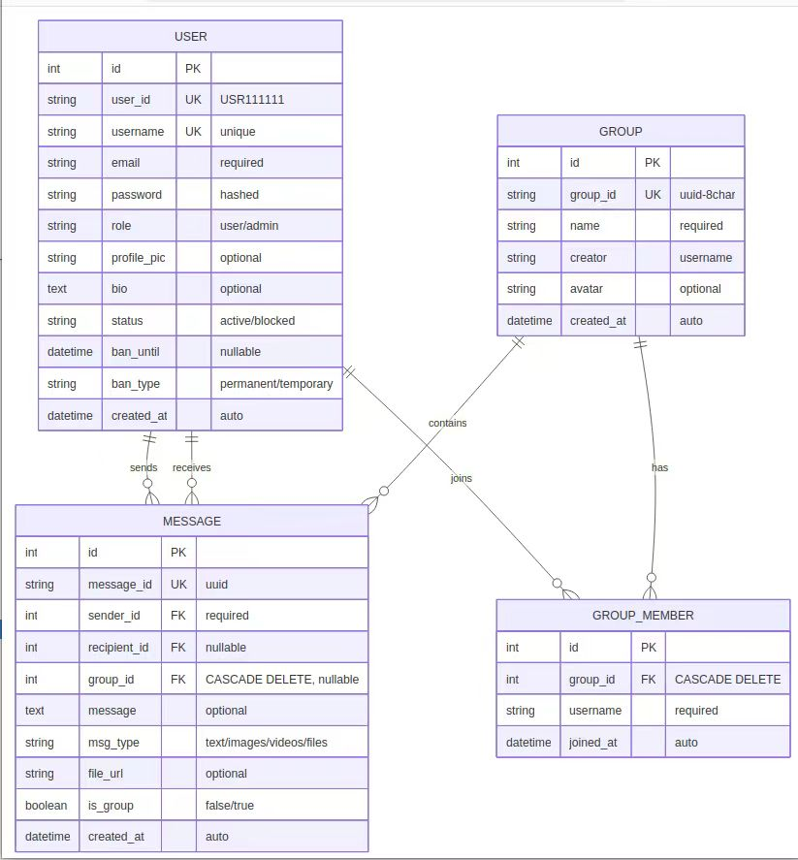
4.2 Database Diagram
Figure 4.6 Database Diagram

Database ERD (Entity Relationship Diagram)
This diagram visualizes how app data is structured using tables and relationships.
Step-by-Step Explanation
- USER Table: Stores all user data such as user ID, username, email, password, role, profile pic, bio, status, ban details, and creation time.
- GROUP Table: Stores group details including group ID, name, creator, avatar, and creation time.
- MESSAGE Table: Each message record includes IDs, sender/recipient, group link, message content, message type, file URL, group status, and timestamps.
- GROUP_MEMBER Table: Connects users to groups with their joined time.
- Relationships are shown via Primary Key (PK) and Foreign Key (FK) links, mapping how records connect across these tables.

CHAPTER 5

Installation Guide

5.1 How to install ProxmoxVE server

Proxmox VE installation is straightforward using the official ISO installer. The process involves creating a bootable USB, running the installer on your server, and completing basic setup through the web interface.
Here is a step-by-step guide to get your Proxmox VE server up and running.

📝 Preparation Before Installation
Before you start, make sure you have the following ready:
· A Dedicated Server: For the best performance and stability, it is recommended to install Proxmox VE on bare-metal hardware rather than as a virtual machine.
· System Requirements: A 64-bit CPU, at least 1 GB of RAM (with additional RAM needed for guest VMs and containers), and a bootable USB stick with at least 1 GB of storage.
· Proxmox VE ISO Image: Download the latest version from the official Proxmox website.
· A Bootable USB Drive: You will need to create one using the downloaded ISO file.

🛠️ Installation Steps
Follow these steps to install Proxmox VE on your server.
Step 1: Create a Bootable USB Installer
  - Use a tool like Rufus (for Windows) or Etcher (for Windows, macOS, Linux) to write the ISO file to your USB drive.
  - On a Linux system, you can use the dd command. First, identify your USB device name (e.g., /dev/sdb) using lsblk, then run:
```bash
dd bs=1M conv=fdatasync if=./proxmox-ve_*.iso of=/dev/your_usb_device
```
Warning: This will erase all data on the target USB drive, so double-check the device name.

Step 2: Boot and Start the Installation
- Insert the USB drive into your server.
- Boot the server and enter the boot menu (typically by pressing Esc, F2, F10, F11, or F12).
- Select your USB drive as the boot device.
- From the Proxmox VE menu, select Install Proxmox VE (Graphical) to start the standard installation.

Step 3: Run the Installation Wizard
- The graphical installer will guide you through several configuration screens:
- EULA: Read and accept the End User License Agreement.
- Target Disk: Select the hard disk where Proxmox VE will be installed. The installer will use the entire disk, and all existing data will be erased. You can click Options to choose a filesystem; ext4 is the default.
- Location and Time Zone: Set your location, time zone, and keyboard layout. The installer usually auto-detects these settings.
- Administrator Password: Create a strong password for the root user and enter a valid email address for system notifications.
- Network Configuration:
- Management Interface: Select the network card for the server management traffic.
- Hostname: Assign a name for your server (e.g., pve or proxmox).
- IP Address, Gateway, and DNS Server: Configure a static IP address for your server to ensure it doesn't change. During installation, you can configure either IPv4 or IPv6; a dual-stack configuration can be set up later.
- Installation Summary: Review all your settings. If everything is correct, click Install. The installer will format the disks and copy the necessary files.
Once the installation is complete, remove the USB drive and let the server reboot.

🚀 Post-Installation Setup
After the server reboots, you will see a welcome message on the console with a URL.
- Access the Web Interface: From any computer on the same local network, open a web browser and go to https://[YOUR_SERVER_IP]:8006 (for example, https://192.168.1.100:8006).
- Log In: Use root as the username and the password you created during installation.
- Subscription Notice: You may see a pop-up message about no valid subscription. You can safely click OK for now, as the product is free to use with access to public repositories.

⚙️ Next Steps for Your Chat Application
With Proxmox VE ready, you can now create virtual environments to host your chat application.
- Create a Virtual Machine: For a Python Flask application, you can efficiently use a full Virtual Machine.
- In the Proxmox web interface, click "Create VM".
- Follow the wizard to allocate resources like CPU cores, memory, and disk space.
- Install Your OS: For the container/VM, choose a lightweight Linux distribution like Ubuntu Server or Debian.
- Deploy Your Application: Inside your new container or VM, you can now install Python, set up your Flask environment, and deploy your LAN chat application files.

5.2 How to install Linux for Debian

📋 Preparation
System Requirements
- Minimum: 1GB RAM, 10GB disk space
- Recommended: 2GB+ RAM, 20GB+ disk space
- Architecture: AMD64 (64-bit)

Download Debian ISO
1. Visit: debian.org/download
2. Choose:
· Netinst (Small ~500MB, downloads packages during install) - Recommended
· Full DVD (~4GB, complete offline installation)

Create Bootable USB
```bash
Using dd on Linux/Mac
sudo dd if=debian-xx.x.x-amd64-netinst.iso of=/dev/sdX bs=4M status=progress
Using Rufus on Windows
1. Download Rufus from rufus.ie
2. Select ISO and USB drive
3. Use DD mode or ISO mode
```

🖥️ Installation Process

Step 1: Boot from USB
1. Insert bootable USB
2. Restart computer
3. Enter BIOS/UEFI (F2, F12, Del, Esc)
4. Set USB as first boot device
5. Save and exit

Step 2: Debian Installer Startup
You'll see the GRUB menu:
1. Install
2. Graphical install ← Recommended
3. Advanced options...
Select "Graphical install" for easier installation.

Step 3: Language and Location
· Language: English (or your preference)
· Location: Your country
· Keymap: Your keyboard layout

Step 4: Network Configuration
```bash
- Installer will automatically detect network
- For manual configuration:
- Hostname: debian-server (or your preferred name)
- Domain name: local (or your domain)
```

Step 5: User Account Setup
```bash
- Root password - create strong password
Root password: ********
Verify: ********
- Create regular user
Full name: Your Name
Username: yourusername
Password: ********
```

Step 6: Disk Partitioning - Important Step
Option A: Guided - Use entire disk (Recommended for beginners)
```
1. Guided - use entire disk
2. All files in one partition
3. Finish partitioning and write changes to disk
```
Option B: Manual Partitioning (Recommended for advanced users)
```
Suggested layout:
- / : 20-30GB (ext4) - Root partition
- /home: Remaining (ext4) - User files
- swap: 2-4GB - Swap space

Steps:
1. Select free space
2. Create root partition (/) - Primary - Beginning - ext4
3. Create swap partition
4. Create home partition (/home)
5. Finish partitioning
```

Step 7: Package Selection
Software Selection:
· Debian desktop environment (for GUI)
· [✓] SSH server - Important for remote access
· Web server
· Print server
· Standard system utilities

For your chat application server, only select "SSH server"

Step 8: GRUB Bootloader
· Install GRUB to /dev/sda (main disk)
· This enables booting into Debian

Step 9: Finish Installation
· Remove installation media when prompted
· System will reboot into Debian

🔧 Post-Installation Setup

First Login
```bash
# Login with your user account
Username: yourusername
Password: ********

# Switch to root for system tasks
su -
# or use sudo if configured
sudo -i
```

System Update
```bash
# Update package lists
sudo apt update

# Upgrade installed packages
sudo apt upgrade -y

# Optional: Full system upgrade
sudo apt full-upgrade -y
```

Configure SSH (for remote access)
```bash
# Check SSH service
sudo systemctl status ssh

# Enable SSH on boot
sudo systemctl enable ssh

# Start SSH if not running
sudo systemctl start ssh
```

Start and Access:
```bash
# SSH directly
ssh root@container-ip
```

Create VM in Proxmox:

1. VM Settings:
OS: Use Debian ISO
System: Default (Q35, OVMF if UEFI)
Disk: 20GB+, SCSI/VirtIO
CPU: 2+ cores, Type: host
Memory: 2048MB+
Network: VirtIO, vmbr0

2. Install Debian following the main installation steps above

🛠️ Setup for Your Chat Application

Create Application Environment
```bash
# Create application directory
sudo mkdir -p /opt/chat-app
sudo chown $USER:$USER /opt/chat-app

# Set up Python virtual environment
cd /opt/chat-app
python3 -m venv venv
source venv/bin/activate

# Install Python dependencies
pip install flask flask-socketio python-socketio eventlet

# Clone your application code
git clone <your-repository>.
```

Test Basic Setup
```bash
# Test Python installation
python3 --version
pip --version

# Test Flask
python3 -c "import flask; print(flask.__version__)"

Package Installation Errors
```bash
# Update package cache
sudo apt update

# Fix broken packages
sudo apt --fix-broken install
sudo apt autoremove
```

✅ Verification Checklist
After installation, verify everything works:

```bash
# System information
uname -a
cat /etc/debian_version

# Disk space
df -h

# Memory
free -h

# Network
ip addr show
ping -c 4 8.8.8.8

# Services
systemctl status ssh

# User access
whoami
sudo whoami
```

🚀 Next Steps for Your Project

Once Debian is installed and configured:

1. Deploy your chat application:
```bash
cd /opt/chat-app
source venv/bin/activate
# Start your Flask application
python app.py
```

2. Set up production service:
```bash
# Create systemd service file
sudo nano /etc/systemd/system/chat-app.service
```

Conclusion

