**Introduction:**

In this inquiry, we employed data derived from an observational study on vegetation, focusing on the percentage of plant cover within designated square meter areas. Alongside the percentage of plant cover, the dataset encompasses insights into various abiotic factors present within the squares, such as annual precipitation, estimated potassium (K) concentrations, and Valley Bottom Flatness index at the quadrat (MrVBF). The objective of this investigation is to leverage the accumulated data to inspect the impact of diverse abiotic factors on the occurrence of exotic and native herbs and grasses. Specifically, we aim to determine whether these two categories of flora display patterns of resource competition or if one demonstrates superior adaptability to certain environmental conditions compared to the other.

**Methods:**

In the preliminary phase of our study, we established distinct categories for the examination of herbaceous vegetation, classifying them into two groups: exotic and native herbs and grasses. The exotic category encompassed both perennial and annual herbs and grasses, whereas the native group exclusively comprised perennial herbs and grasses.

To initiate our investigation, we performed an exploratory analysis of the response variables, namely the percentage cover of exotic and native herbs and grasses. This initial examination aimed to analyze the inherent distribution patterns within the dataset. Consequently, we generated two histograms to visually represent the distribution of exotic and native plants.

Subsequently, we identified nine abiotic factors deemed pertinent to our study and incorporated them into our preliminary model. Employing a general linear model (GLM) with a Poisson distribution served as the initial step in our modeling process. Recognizing the presence of overdispersion in our data, as discerned through the previous Poisson GLM, we opted for a negative binomial distribution to better accommodate this inherent characteristic.

Following this, we systematically constructed simplified models by iteratively excluding various abiotic factors. This iterative approach resulted in the formulation of seven distinct models, each subject to evaluation to ascertain the most fitting one. Model assessments were conducted based on the Akaike Information Criterion (AIC).

In the concluding stage of our analysis, we conducted a comprehensive comparison of the influence of distinct abiotic factors on the cover of exotic and native herbs and grasses, utilizing the models we developed. This comparative evaluation was systematically organized and presented in tabular format. Additionally, to enhance visual interpretation, the outcomes were graphically represented through bar plots. These figures, not only illustrated the effects of the abiotic factors but also provided a clear depiction of their associated standard errors.

**Results:**

Our investigation commenced with an analysis of the distribution of our response variable, encompassing both exotic and native herbs and grasses.

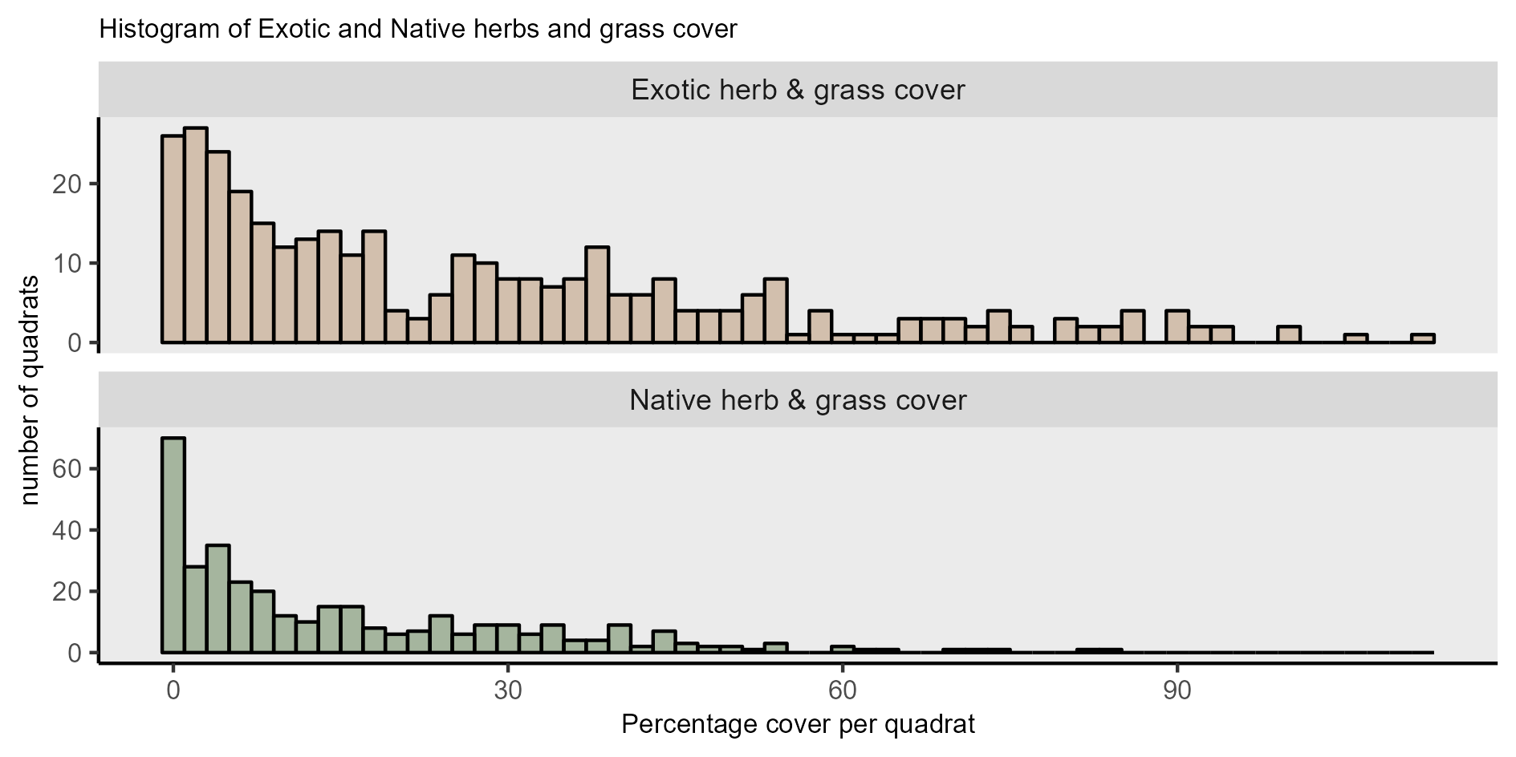

Figure : Histogram of exotic and native herbs and grass cover. Total number of quadrats = 346

The observed histograms (Figure 1) displayed a distribution pattern akin to a Poisson distribution, leading us to employ a Generalized Linear Model (GLM) with a Poisson distribution. However, both the native and exotic models exhibited substantial residual deviances, specifically 5377.7 on 336 degrees of freedom for the native model and 5567.8 on 336 degrees of freedom for the exotic model, indicating notable overdispersion in both instances (Appendix: Table 3). To address this concern, we opted for a negative binomial distribution, similar to the Poisson distribution but with an additional parameter addressing disproportionate variance.

Following this, we systematically constructed simplified models, evaluating each of them using the Akaike Information Criterion (AIC) (Appendix: Tables 4 & 5). We identified two distinct negative binomial models, each encompassing annual precipitation, precipitation during the warmest and coldest quarters, the Valley Bottom Flatness index at the quadrat (MrVBF), and the estimated potassium concentration (K_perc). These models were developed independently for both native and exotic herbs and grasses. A deliberate adjustment was made to the effect of Potassium, increasing a one-unit change to a change of 10% rather than the initial 1%. This modification was implemented to enhance the visual comparison with other values and provide a more nuanced scaling.

Table : Output of the general linear model for native herbs and grasses. The abiotic one-unit units: precipitations in mm, MrVBF scale between 0-10, Potassium concentration in 10% steps.

|  |  |  |  |  |  |
| --- | --- | --- | --- | --- | --- |
| General linear model negative binomial distribution (NativePlant_cover ~ annual_precipitation + precipitation_warmest_quarter + precipitation_coldest_quarter + MrVBF + K_perc) | | | | | |
| Coefficients: | Estimate | Std. Error | Z value | P(<|z|) |
| Intercept | 3.1624 | 1.2950 | 2.442 | 0.0146 |
| annual_precipitation | -0.0258 | 0.0117 | -2.202 | 0.0277 |
| Precipitation_warmest_quarter | 0.0642 | 0.4126 | 1.557 | 0.1195 |
| Precipitation_coldest_quarter | 0.0462 | 0.1902 | 2428 | 0.0152 |
| MrVBF | -0.1701 | 0.0363 | -4.694 | 2.69e-06 |
| K_perc | -0.0271 | 0.1461 | -1.857 | 0.0633 |

The intercept in the model represents the estimated log rate (rate because we have percentual values between 0-100%) when all predictor variables are zero. The negative slopes for annual precipitation, MrVBF, and K_perc indicate a decrease in the log rate of native herbs and grasses with increasing values of these variables, corresponding to 2.5%, 1.7%, and 2.7% negative change, respectively. Conversely, positive slopes for precipitation in the warmest and coldest quarters suggest an increase of 6.4% and 4.6% in the log rate for a one-unit change in precipitation in these quarters (Table 1).

Table : Output of the general linear model for exotic herbs and grasses. The abiotic one-unit units: precipitations in mm, MrVBF scale between 0-10, Potassium concentration in 10% steps.

|  |  |  |  |  |  |
| --- | --- | --- | --- | --- | --- |
| General linear model negative binomial distribution (ExoticPlant_cover ~ annual_precipitation + precipitation_warmest_quarter + precipitation_coldest_quarter + MrVBF + K_perc) | | | | | |
| Coefficients: | Estimate | Std. Error | Z value | P(<|z|) |
| Intercept | 2.2514 | 0.9620 | 2.340 | 0.0193 |
| annual_precipitation | 0.0342 | 0.0087 | 3.936 | 9.28e-05 |
| Precipitation_warmest_quarter | -0.0879 | 0.0306 | -2.873 | 0.0041 |
| Precipitation_coldest_quarter | -0.0576 | 0.0141 | -4.089 | 4.33e-05 |
| MrVBF | -0.0210 | 0.0271 | -0.777 | 0.4372 |
| K_perc | 0.0570 | 0.1092 | 5.225 | 1.74e-07 |

For exotic herbs and grasses, contrasting effects were observed with the five abiotic factors. The intercept indicated a smaller estimated log rate when all predictor variables were zero. Negative slopes for precipitation in the warmest and coldest quarters implied an 8.7% and a 5.7% negative change, respectively, in the log rate for a one-unit change in precipitation in these quarters. MrVBF exhibited a negligible effect, with the slope dropping to zero within the standard error rate. Conversely, annual precipitation and potassium concentration (K_perc) displayed positive effects on the log rate of exotic herbs and grasses' percentual cover. While annual precipitation showed a modest effect of a 3.4% change for a one-unit change, a one-unit change in potassium concentration had an estimated effect of 57% on the log rate (Table 2).

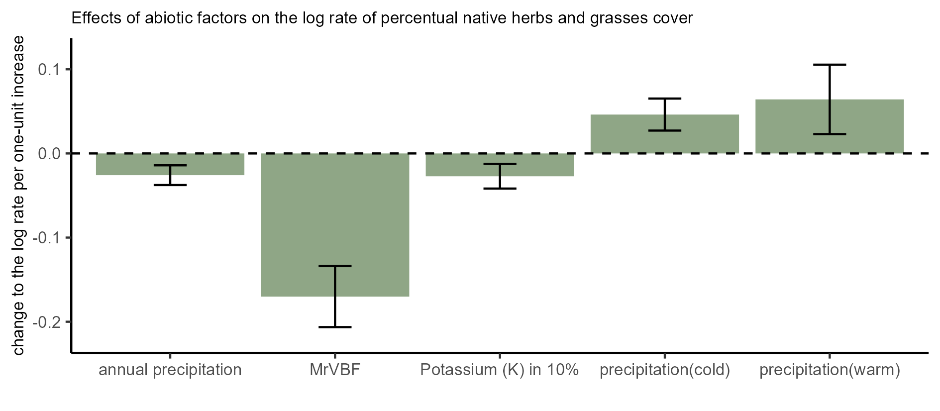

Figure : Effects of abiotic factors on the log rate of percentual native herbs and grasses cover. The abiotic one-unit units: precipitations in mm, MrVBF 1 on a scale between 0-10, Potassium concentration in 10% steps.

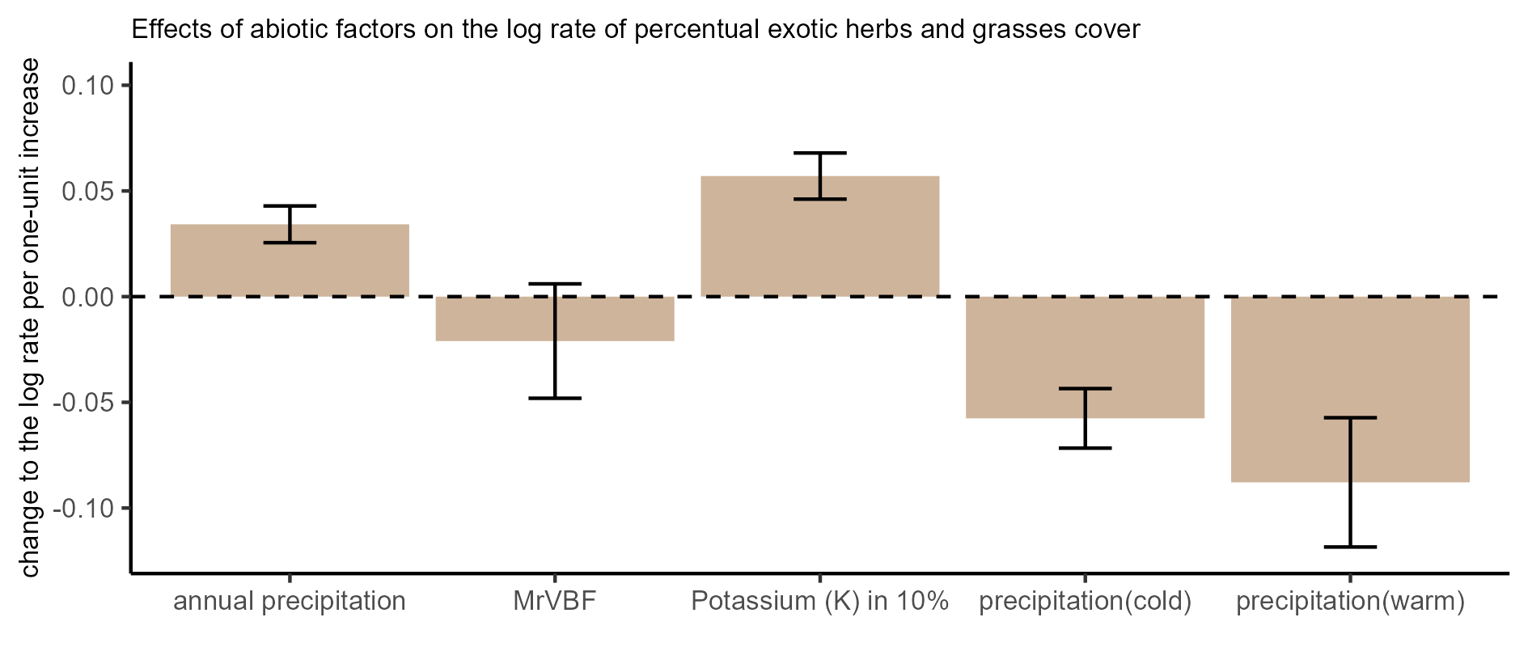

Figure : Effects of abiotic factors on the log rate of percentual exotic herbs and grasses cover. The abiotic one-unit units: precipitations in mm, MrVBF 1 on a scale between 0-10, Potassium concentration in 10% steps.

Upon careful examination of both plots (Figures 2 & 3), the contrasting impacts of various abiotic factors on native and exotic herbs and grasses are vividly depicted. Native herbs and grasses exhibit favorable responses to elevated precipitation levels in the warmest and coldest quarters. However, their abundance is adversely affected by excessive annual precipitation and diminished potassium concentration in the soil. Conversely, exotic plant species demonstrate an inverse pattern, thriving in regions with high annual precipitation and increased potassium concentration while facing challenges in environments with elevated precipitation during the warmest and coldest quarters. This observed dichotomy in responses underscores the nuanced influence of abiotic factors on the abundance of both native and exotic herbs and grasses.

**Conclusion:**

In the broader context, these findings underscore the sensitivity of native and exotic herbaceous species to specific environmental conditions. Native species exhibited resilience and favorable responses to elevated precipitation levels in the warmest and coldest quarters. However, their vulnerability was pronounced in environments characterized by excessive annual precipitation and diminished potassium concentration in the soil. This indicates the importance of maintaining balanced environmental conditions to support the well-being of native herbaceous communities. Conversely, exotic plant species displayed an inverse pattern, thriving in regions marked by high annual precipitation and increased potassium concentration. Nevertheless, these exotic species faced challenges in environments with elevated precipitation during the warmest and coldest quarters, suggesting the presence of specific thresholds beyond which their abundance is adversely affected. The implications of these findings become particularly important in the context of aspects like climate change, which can significantly influence abiotic factors such as annual precipitation. Alterations in precipitation patterns may lead to shifts in the distribution and abundance of both native and exotic herbaceous species, which can have an immense impact on a local ecosystem. Nevertheless, it is imperative to acknowledge that the utilized dataset represents only a fraction of the broader ecological context. The dataset has incorporated numerous additional factors influencing the percentual cover of herbaceous species, including aspects such as interspecies competition with other plants like eucalyptus, as well as variables like foliage projective cover, moss lichen cover, and rock cover. Consequently, further research and exploration are indispensable to advance our comprehension of these intricate ecological dynamics.

**Appendix:**

Table : Deviance comparison of Poisson and negative binomial models for exotic and native herbs and grasses

|  |  |  |  |  |  |
| --- | --- | --- | --- | --- | --- |
| Group | Null deviance on | | degrees of freedom | Residual deviance on | degrees of freedom |
| Native herbs and grasses |  |  | |  |  |
| Poisson model | 6024.4 | 345 | | 5377.7 | 336 |
| Negativ binomial model | 446.74 | 345 | | 412.56 | 336 |
| Exotic herbs and grasses |  |  | |  |  |
| Poisson model | 8204.0 | 345 | | 5567.8 | 336 |
| Negativ binomial model | 525.05 | 345 | | 403.80 | 336 |

Table : Comparison of models with different modifications of abiotic factors for native herbs and grasses

|  |  |  |  |
| --- | --- | --- | --- |
| Model | AIC | logLik | weight |
| glm.nb(data = data, NativePlant_cover~annual_precipitation+  precipitation_warmest_quarter+precipitation_coldest_quarte+ MrVBF+K_perc) | 2547.315 | -1266.658 | 0.54 |
| glm.nb(data = data, NativePlant_cover~annual_precipitation+  precipitation_warmest_quarter+precipitation_coldest_quarte+ MrVBF+K_perc+Th_ppm) | 2549.312 | 1266.656 | 0.20 |
| glm.nb(data = data, NativePlant_cover~annual_precipitation+  MrVBF+K_perc) | 2550.503 | -1270.252 | 0.11 |
| glm.nb(data = data, NativePlant_cover~annual_precipitation+  precipitation_warmest_quarter+precipitation_coldest_quarte+ MrVBF+K_perc+Th_ppm+U_ppm) | 2551.046 | -1266.523 | 0.08 |
| glm.nb(data = data, NativePlant_cover~ MrVBF+K_perc) | 2552.241 | -1272.121 | 0.05 |
| glm.nb(data = data, NativePlant_cover~annual_precipitation+  precipitation_warmest_quarter+precipitation_coldest_quarte+ MrVBF+K_perc+Th_ppm+U_ppm+SRad_Jan+SRad_Jul) | 2553.503 | -1265.751 | 0.02 |
| glm.nb(data = data, NativePlant_cover~ 1) | 2568.071 | -1282.036 | 0.00 |

Table : Comparison of models with different modifications of abiotic factors for exotic herbs and grasses

|  |  |  |  |
| --- | --- | --- | --- |
| Model | AIC | logLik | weight |
| glm.nb(data = data, ExoticPlant_cover~annual_precipitation+  precipitation_warmest_quarter+precipitation_coldest_quarte+ MrVBF+K_perc) | 2912.759 | -1449.380 | 0.64 |
| glm.nb(data = data, ExoticPlant_cover~annual_precipitation+  precipitation_warmest_quarter+precipitation_coldest_quarte+ MrVBF+K_perc+Th_ppm) | 2914.758 | -1449.379 | 0.24 |
| glm.nb(data = data, ExoticPlant_cover~annual_precipitation+  precipitation_warmest_quarter+precipitation_coldest_quarte+ MrVBF+K_perc+Th_ppm+U_ppm) | 2916.602 | -1449.301 | 0.09 |
| glm.nb(data = data, ExoticPlant_cover~annual_precipitation+  precipitation_warmest_quarter+precipitation_coldest_quarte+ MrVBF+K_perc+Th_ppm+U_ppm+SRad_Jan+SRad_Jul) | 2919.191 | -1448.595 | 0.03 |
| glm.nb(data = data, ExoticPlant_cover~annual_precipitation+  MrVBF+K_perc) | 2939.227 | -1460.114 | 0.00 |
| glm.nb(data = data, ExoticPlant_cover~ MrVBF+K_perc) | 2953.902 | -1472.951 | 0.00 |
| glm.nb(data = data, ExoticPlant_cover~ 1) | 3005.154 | -1500.577 | 0.00 |

**Link to the R-Code :**

https://github.com/JaSt17/BIOS4/blob/main/Exam/exam_R_code.R