**Introduction:**

In an experiment, female butterflies reared on two different host plants were allowed to oviposit on the same two host plants (Barbarea & Berteroa). The study aimed to investigate the effects of maternal and larval host plants on the butterflies' adult weight, development time and growth rate. The hypothesis underlying this study posited that butterflies would produce more robust offspring, as indicated by their adult weight, if they oviposited on the same host plant species they were reared.

**Methods:**

To understand the relationships between maternal and larval host plants, butterfly sex, and their collective impact on the adult weight of butterflies, we adopted a structured approach: We initiated our analysis by creating boxplots and density plots. These visual representations allowed us to obtain an initial overview of the dataset. The data were segregated into four groups (BarbareaM & BerteroaM, BarbareaM & BerteroaL, BarbareaL & BerteroaM, BarbareaL & BerteroaM), each corresponding to specific maternal and larval host plant combinations (Figure 1,2).

Subsequently, we performed an analysis of variance (ANOVA) to explore whether statistically significant differences existed in the means of the various groups. This statistical technique allows the examination of the overall influence of maternal and larval host plants, along with their interaction, on adult weight (Table 1).

We conducted post hoc testing using Tukey's Honestly Significant Difference (TukeyHSD) method to gain a more profound understanding of the impact of the different groups. This post hoc analysis enabled us to pinpoint and compare specific differences between individual groups, contributing to a richer comprehension of how different combinations of host plants influenced adult weight (Table 2).

Building upon the insights from the ANOVA and the post hoc test, we conducted independent t-tests for maternal and larval host plants separately. These independent t-tests aimed to ascertain whether each type of host plant, in isolation, had a statistically significant impact on adult weight (Table 3).

Recognizing the potential influence of butterfly sex, we incorporated this variable into our analysis. We introduced another set of boxplots that incorporated the sex of the butterflies as an additional factor (Figure 3).

Subsequently, we conducted another ANOVA to investigate whether the interaction between sex and the type of host plant (maternal or larval) had a statistically significant impact on adult weight (Table 4).

Following these steps, our study aimed to provide a comprehensive analysis of how maternal and larval host plants, coupled with the influence of butterfly sex, collectively shaped the adult weight of butterflies.

**Results:**

In our boxplots, we can readily discern distinctions in adult weights among butterflies originating from different larval host plants. However, distinguishing a clear contrast between the two maternal host plants based solely on the boxplots proves challenging. The Density plot further illustrates a considerable overlap among butterflies originating from the same larval host plant. An additional noteworthy observation from both the Density plot and boxplots is the nearly normal distribution of adult weights within each group. This characteristic facilitates the continuation of our statistical testing, such as employing methods like ANOVA.

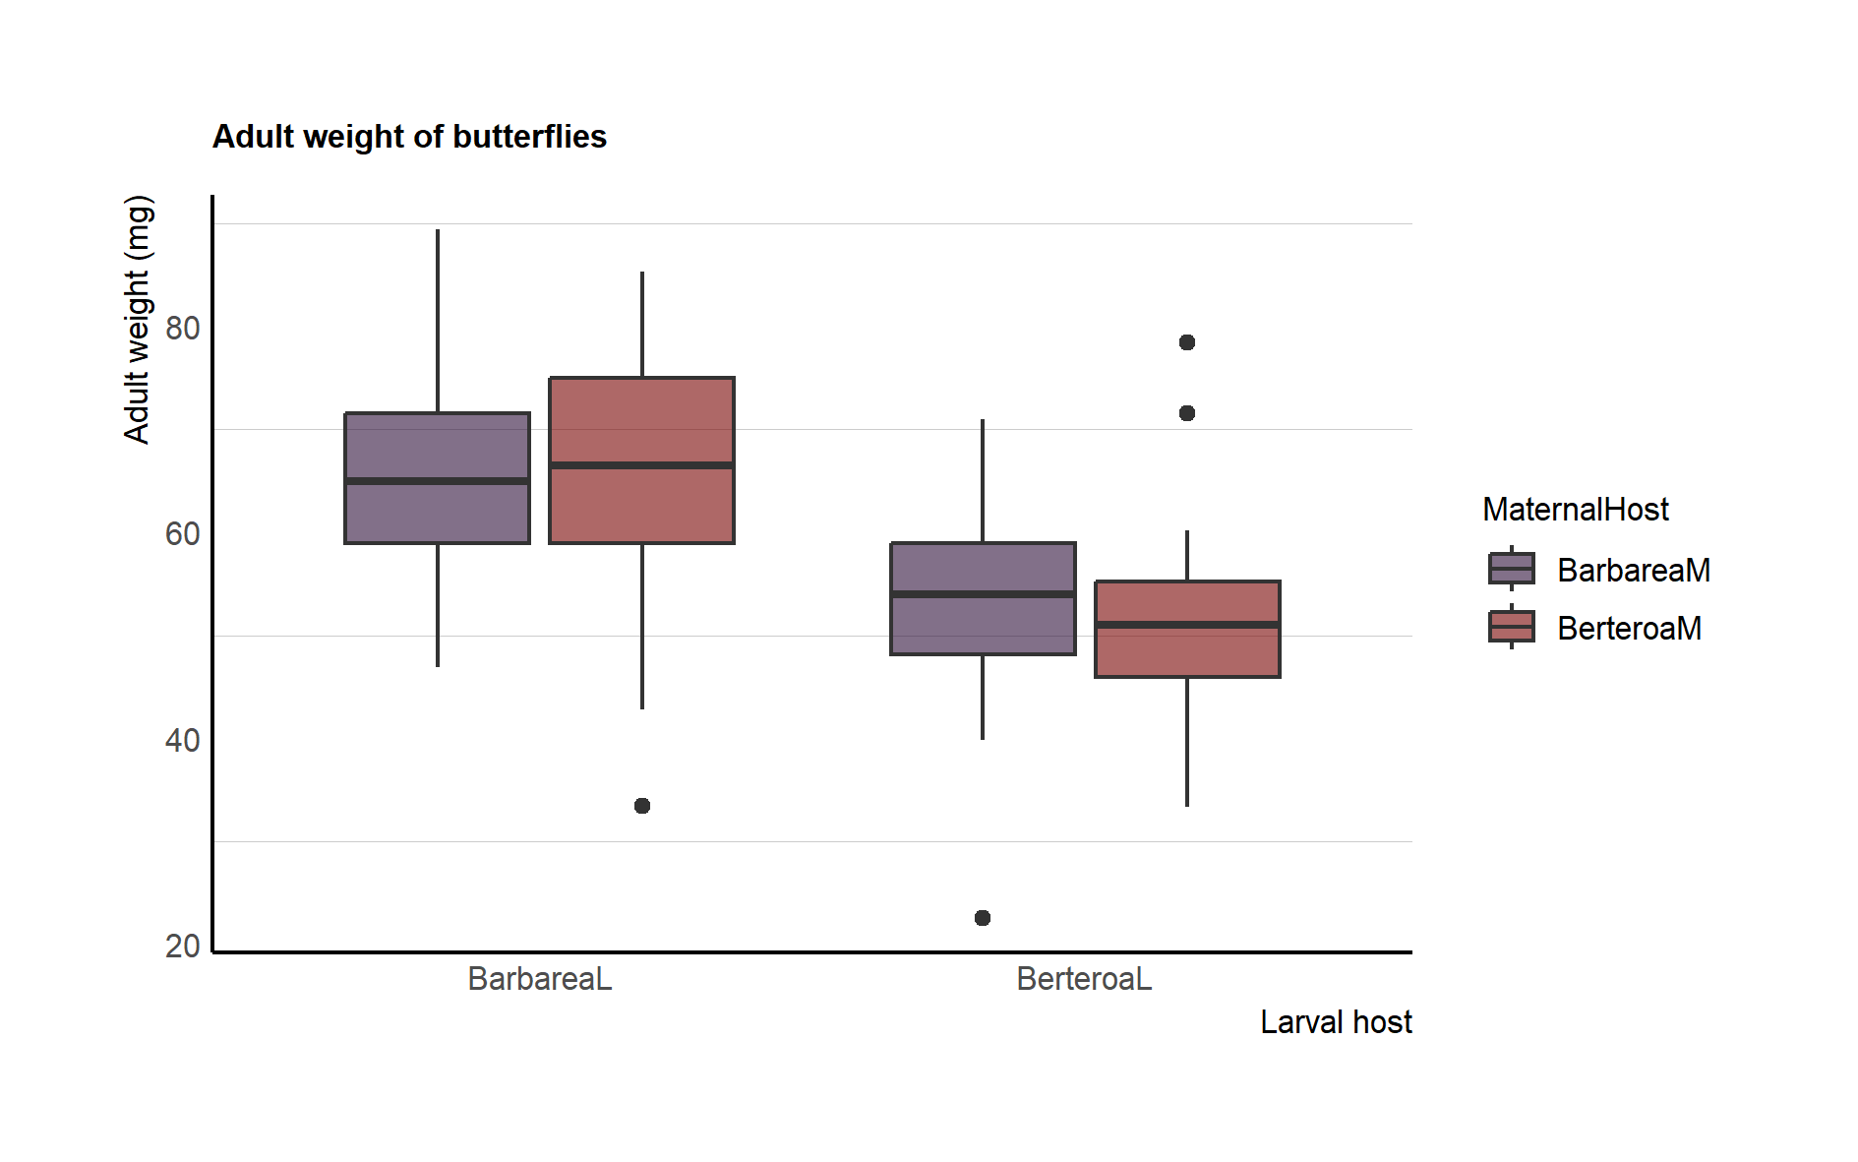

Figure 1: Boxplots of the Adult weight of different groups

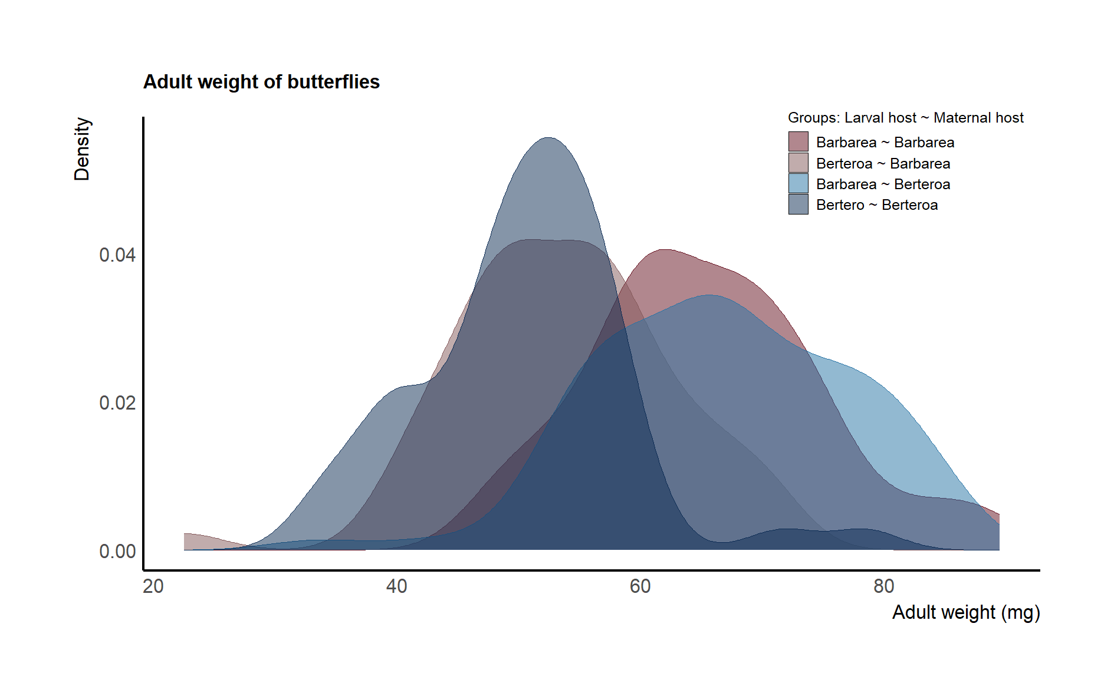

Figure 2: Density of Adult weight of different groups

The Analysis of Variance (ANOVA) results indicate significant effects for both MaternalHost and LarvalHost on adult weight (p < 0.05), suggesting that these factors have a considerable impact. The interaction between MaternalHost and LarvalHost, while showing a trend (p = 0.0539), does not reach conventional significance. The residuals, representing unexplained variance, have a mean square value of 90. This ANOVA indicates that both maternal host and larval host significantly contribute to the observed variation in adult weight, with a potential interaction effect warranting further investigation. To further understand the pairwise differences, a Tukey post hoc test was conducted. For MaternalHost, the comparison between BerteroaM and BarbareaM shows no significant difference (diff = -1.02). In the case of LarvalHost, there is a significant difference between BerteroaL and BarbareaL (diff = -13.91). The interaction between MaternalHost and LarvalHost reveals specific pairwise differences. Within butterflies utilizing Barbarea as their larval host, the mean difference in adult weight between the two distinct maternal host plants amounted to a mere 1.37 milligrams. Similarly, in the case of butterflies with Berteroa as their larval host plant, the two distinct maternal host plants exhibited an average weight difference of 3.13 milligrams. In summary, larval hosts significantly influence adult weight.

Tabelle 1 ANOVA between Maternal and Larval host plants

|  |  |  |  |  |  |
| --- | --- | --- | --- | --- | --- |
| ANOVA between Maternal and Larval host plants | | | | | |
|  | DF | Sum sq | Mean sq | F value | Pr(<F) |
| Maternal host | 2 | 1058992 | 529496 | 5892.37 | <2e-16 |
| Larval host | 1 | 13020 | 13020 | 144.89 | <2e-16 |
| Maternal:Larval | 1 | 337 | 337 | 3.74 | 0.053 |
| Residuals | 283 | 25431 | 90 |  |  |

Tabelle 2: Post hoc test for the ANOVA (TukeyHSD)

|  |  |  |  |  |
| --- | --- | --- | --- | --- |
| Post hoc test for the ANOVA (TukeyHSD) | | | | |
|  | diff | lwr | upr | p.adj |
| Berteroa-Barbarea | -1.02 | -3.23 | 1.19 | 0.36 |
| Berteroa-Barbarea | -13.91 | -16.19 | -11.63 | 0 |
| BertM:BarbL-BarbM:BarbL | 1.37 | -2.31 | 5.05 | 0.77 |
| BarbM:BertL-BarbM:BarbL  BertM:BertL-BarbM:BarbL  BarbM:BertL-BertM:BarbL  BertM:BertL-BertM:BarbL | -11.85  -14.98  -13.22  -16.34 | -15.95  -19.15  -17.53  -20.73 | -7.75  -10.81  -8.91  -11.96 | 0  0  0  0 |
| BertM:BertL- BarbM:BertL | -3.13 | -7.86 | 1.61 | 0.32 |

The application of a t-test to evaluate the maternal host plants reveals an absence of statistical significance between the two distinct groups of maternal host plants. In both groupings, originating from dissimilar maternal host plants, the mean adult weight falls within a range of approximately 60-61 milligrams. Conversely, a marked and statistically significant divergence in the mean adult weight of the butterflies is evident when assessing the larval host plants. Specifically, butterflies that are nurtured on Berteroa as their larval host exhibit an average adult weight of approximately 52 milligrams, while their counterparts reared on Barbarea as the larval host plant present a mean adult weight of 66 milligrams.

Tabelle 3: T-test on Maternal and Larval host plants

|  |  |  |  |  |  |  |
| --- | --- | --- | --- | --- | --- | --- |
| T-test on Maternal and Larval host plants | | | | | | |
|  | DF | t | p-value | | Mean Barbarea | Mean Berteroa |
| Maternal host | 257.21 | 0.73 | | 0.47 | 61.2 | 60.19 |
| Larval host | 242.32 | 12.36 | | 2.2e-16 | 65.95 | 51.98 |

The boxplots within each categorical group defined by maternal and larval host plants fail to reveal a discernible contrast between male and female butterflies. The distribution of male and female specimens within these groups are very similar.

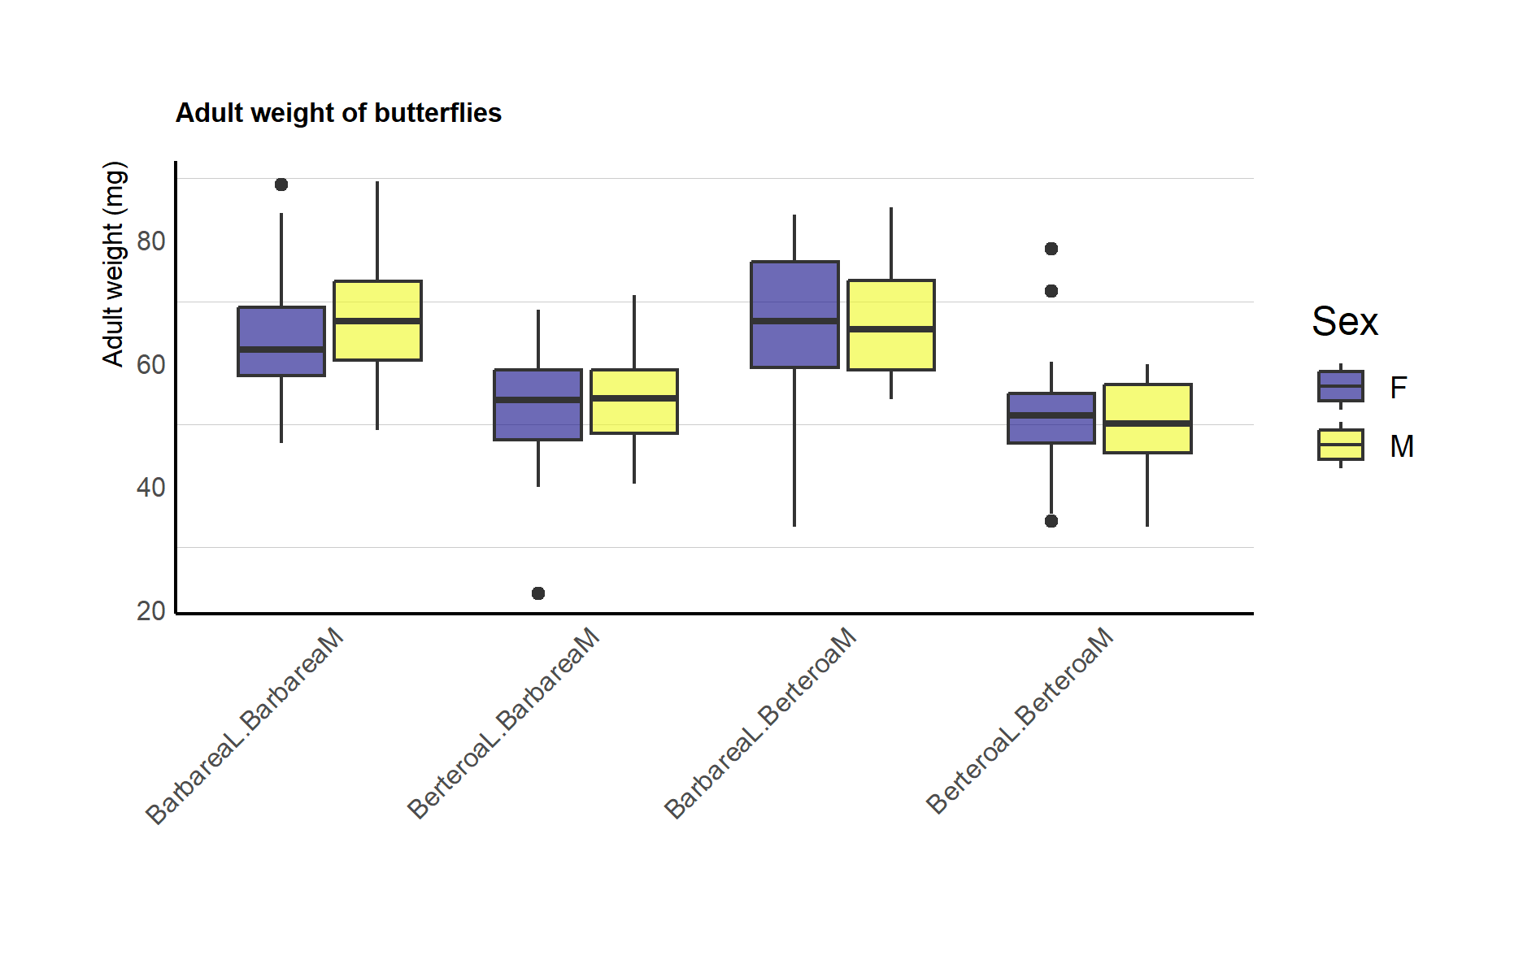

Figure 3: Boxplots for the different groups of maternal and larval host plants divided by different sexes of the butterflies

The results obtained from our analysis of variance (ANOVA) substantiate the preliminary observations made by inspecting the boxplots. The results reveal highly significant independent effects for both Sex and InteractionFactor, with p-values well below 0.05 (<2e-16). This indicates that both Sex and InteractionFactor significantly contribute to the observed variation in adult weight. The F values for Sex (5912.94) and InteractionFactor (49.81) are substantial, reinforcing the strength of these effects. However, the interaction between Sex and InteractionFactor does not reach conventional significance (p = 0.3283), suggesting that the combined influence of Sex and InteractionFactor may not be significantly different from their individual effects. The F value for this interaction (1.15) is relatively low compared to the main effects. The residuals, representing unexplained variance, have a mean square value of 90.

Tabelle 4: ANOVA between Sex and the InteractionFactor (Maternal and Larval host plants)

|  |  |  |  |  |  |
| --- | --- | --- | --- | --- | --- |
| ANOVA between Sex and the InteractionFactor (Maternal and Larval host plants) | | | | | |
|  | DF | Sum sq | Mean sq | F value | Pr(<F) |
| Sex | 2 | 1059101 | 529551 | 5912.94 | <2e-16 |
| InteractionFactor | 3 | 13381 | 4460 | 49.81 | <2e-16 |
| Sex: InteractionFactor | 3 | 310 | 337 | 1.15 | 0.33 |
| Residuals | 279 | 24987 | 90 |  |  |

**Conclusion:**

Upon a comprehensive examination of our dataset and the collective influence of both larval and maternal host plants on the adult weight of butterflies, we have concluded that the sole determinant significantly affecting adult butterfly weight is the larval host plant. Butterflies reared on Berteroa as their larval host exhibit an average adult weight of approximately 52 milligrams, while those raised on Barbarea as their larval host display a mean weight of 66 milligrams. Our initial hypothesis posited that butterflies would yield more robust offspring, as indicated by their adult weight when they laid eggs on the same host plant species they were reared on. However, based on our analysis, we propose a revised hypothesis that butterflies prefer Barbarea as their larval host plant over Berteroa. To further substantiate this hypothesis, a potential avenue for investigation lies in scrutinizing butterflies' development time and whether it aligns with the observed weight trends. Nonetheless, it is imperative to underscore that additional analysis is indispensable to address this question fully.