**Introduction:**

In the present investigation, we conducted an observational study focusing on the abundance of the bee species Eulaema Nigrita within the confines of the Brazilian Atlantic Forest. The study encompasses a comprehensive dataset, incorporating diverse potential predictor variables such as climatic factors (mean annual temperature, precipitation, temperature seasonality, and precipitation seasonality) and aspects related to land use (specifically, the proportion of forest cover).

The primary objective of this short analysis is to examine the influence of mean annual precipitation (MAP), precipitation seasonality (Pseason), and forest cover (.forest) on the abundance of bees. Our overarching hypothesis posits that a higher coverage of trees and an elevated mean annual precipitation (MAP) may inversely correlate with bee sightings, while a heightened level of precipitation seasonality around the average rainfall rate may positively influence bee sightings. This study seeks to uncover how weather and land use affect the number of Eulaema Nigrita bees.

**Methods:**

In the initial phase of our investigation, we conducted an exploratory analysis of our response variable, Eulaema nigrita abundances, to understand our data distribution. To achieve this, we generated a histogram depicting the abundance distribution.

Subsequently, we employed a general linear model (GLM) with a Poisson distribution to initiate our modeling process. Recognizing the presence of overdispersion in our data, as revealed in the initial Poisson GLM, we opted for a negative binomial distribution to better accommodate this characteristic.

Two distinct negative binomial GLMs were then developed. The first model incorporated predictors such as the proportion of forest cover and mean annual precipitation, while the second model considered precipitation seasonality and mean annual precipitation.

Following model development, we used the R predict function to generate predictions based on both models. The outcomes were visually represented through the creation of two plots, illustrating the influence of forest cover, mean annual precipitation, and precipitation seasonality on the abundance of Eulaema Nigrita. These plots were derived from the simulated data generated by the predictive models, providing insights into the relationships between these variables and bee abundance.

**Results:**

We commenced our analysis by examining the distribution of our response variable, Eulaema Nigrita abundances.

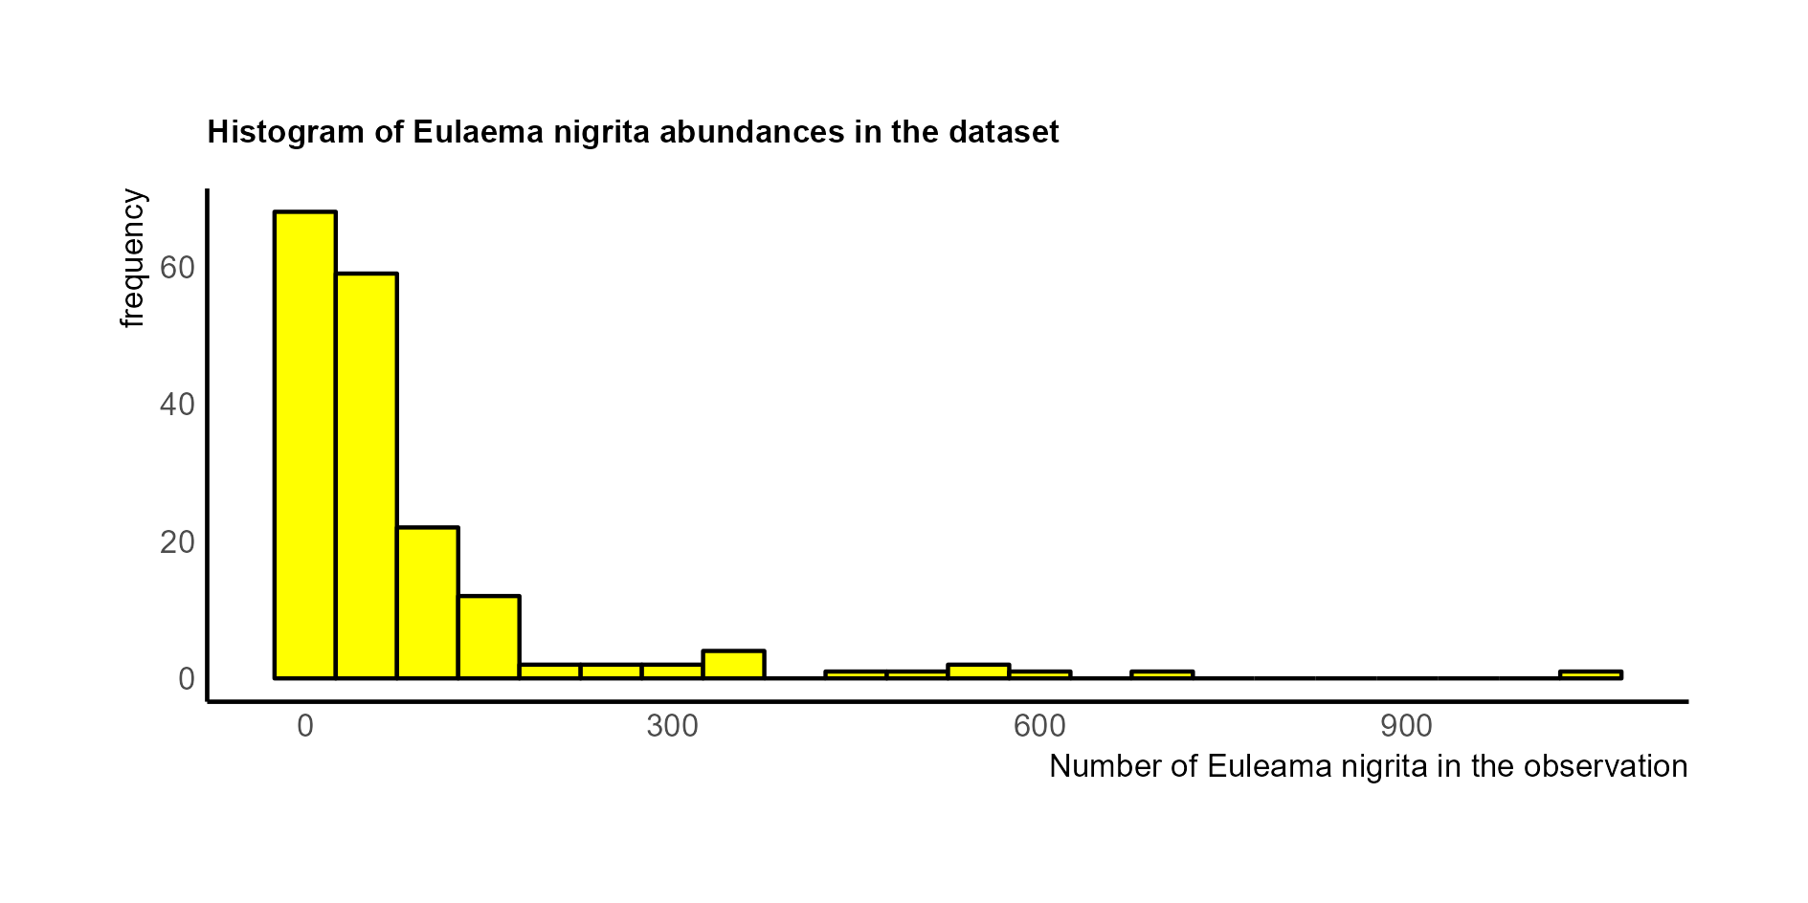

Figure 1: Histogram Eulaema Nigrita abundances

The histogram of abundances closely resembled a Poisson distribution, prompting the application of a Generalized Linear Model (GLM) with a Poisson distribution.

We initiated the modeling process with a regular GLM using the Poisson family. However, this model exhibited substantial residual deviance of 17042 on 174 degrees of freedom, indicating serious overdispersion. Given this concern, we used a negative binomial distribution similar to the Poisson distribution but with an additional parameter addressing disproportionate variance.

Table 1: General linear model negative binomial distribution (Eulaema nigrita ~ MAP + forest + Pseason)

|  |  |  |  |  |  |  |
| --- | --- | --- | --- | --- | --- | --- |
| General linear model negative binomial distribution (Eulaema nigrita ~ MAP + forest + Pseason) | | | | | | |
| Coefficients: | Estimate | | Std. Error | Z value | P(<|z|) |
| Intercept | 5.348 | | 0.422996 | 12.672 | <2e-16 |
| MAP | -0.00128 | | 0.000214 | -5.966 | 2.43e-9 |
| Forest | -1.09097 | | 0.317824 | -3.433 | 5.98e-4 |
| Pseason | | 0.01995 | 0.004186 | 4.766 | 1.88e-6 |

The intercept represents the estimated log count when all predictor variables are zero (5.35). The negative slope for MAP (-0.0013) and forest cover (-1.09) indicates a decrease in the log count with increasing values of these variables. This translates to a 0.13% negative change in bee abundance for a one-unit change in MAP. The value for forest cover shows us that the abundance of bees in a landscape free of forest is about 109 % higher than in a complete forest. In contrast, the positive slope for precipitation seasonality suggests an increase of 2 % with an increasing percentage of precipitation seasonality. The dispersion parameter (0.8368) aligns with the appropriate fit of the negative binomial distribution.

After looking at the combined model incorporating all three predictor variables demonstrating their collective impact on the data, we created two negative binomial GLMs, one incorporating forest cover and mean annual precipitation and the other incorporating precipitation seasonality and mean annual precipitation. These models aimed to provide a nuanced understanding of the individual and combined effects of the predictor variables on Eulaema nigrita abundances.

Table 2: General linear model negative binomial distribution (Eulaema nigrita ~ MAP + forest)

|  |  |  |  |  |  |  |
| --- | --- | --- | --- | --- | --- | --- |
| General linear model negative binomial distribution (Eulaema nigrita ~ MAP + forest) | | | | | | |
| Coefficients: | Estimate | | Std. Error | Z value | P(<|z|) |
| Intercept | 6.67929 | | 0.32959 | 20.265 | <2e-16 |
| MAP | -0.0014 | | 0.00022 | -6.242 | 4.32e-10 |
| Forest | | -1.3318 | 0.31706 | -4.137 | 3.51e-05 |

Table 3: General linear model negative binomial distribution (Eulaema nigrita ~ MAP + Pseason)

|  |  |  |  |  |  |  |
| --- | --- | --- | --- | --- | --- | --- |
| General linear model negative binomial distribution (Eulaema nigrita ~ MAP + Pseason) | | | | | | |
| Coefficients: | Estimate | | Std. Error | Z value | P(<|z|) |
| Intercept | 5.03358 | | 0.412482 | 12.203 | <2e-16 |
| MAP | -0.00145 | | 0.000216 | -6.696 | 2.14e-11 |
| Pseason | | 0.02384 | 0.004079 | 5.844 | 5.1e-09 |

The comparative analysis reveals a similarity in the slope of the mean annual precipitation (MAP) factor across both models. Additionally, it is noteworthy that forest cover continues to negatively influence the logarithmic count, while precipitation seasonality manifests a positive impact. Notably, in the individual effect models, these influences exhibit an increment of approximately 20% when contrasted with the comprehensive model encompassing all three predictor variables. Both models exhibit a dispersion parameter of over 0.75, affirming the congruence of the negative binomial distribution model with the observed data.

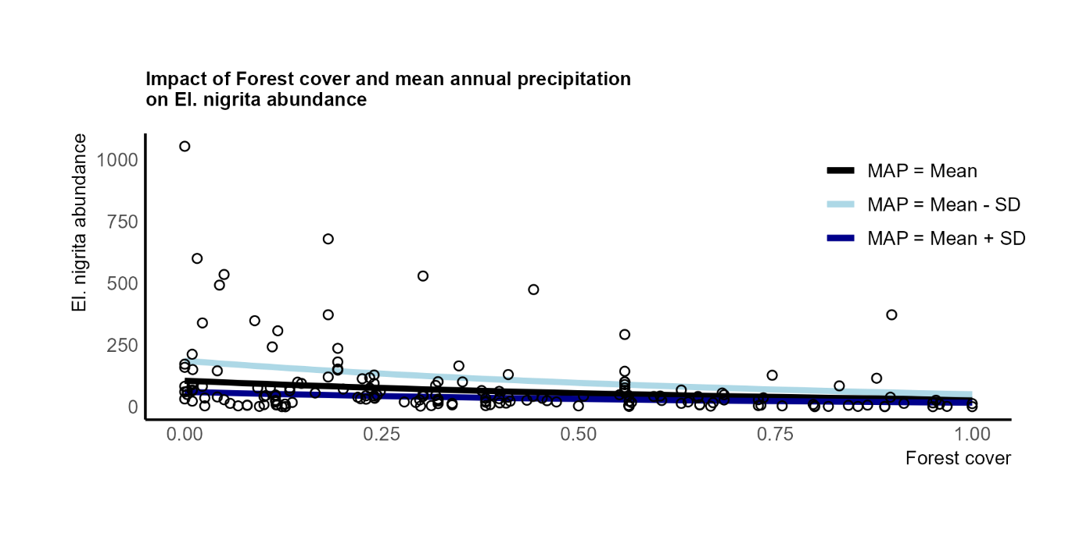

Figure 2: Impact of Forest cover and mean annual precipitation on El. nigrita abundance

The graphical representation depicts a positive correlation between the abundance of bees and a diminishing forest cover. Furthermore, it is observed that a reduced rate of rainfall (MAP=Mean–SD) exerts a favorable influence on the observed abundance of bees.

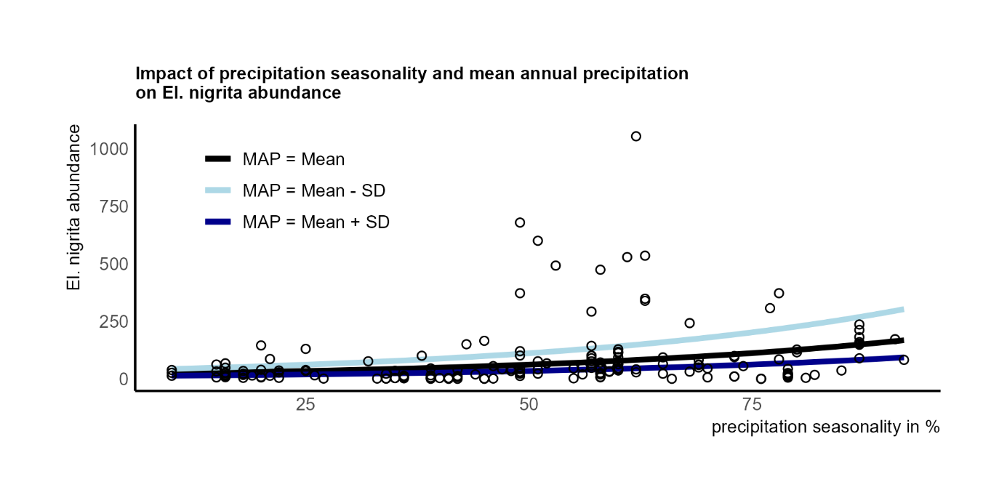

Figure 3: Impact of precipitation seasonality and mean annual precipitation on El. nigrita abundance

The graphical presentation reveals a similar Mean Annual Precipitation (MAP) impact. However, notable distinctions arise as the effect of precipitation seasonality surpasses that of forest cover. Additionally, it is noteworthy that the positive effect indicates that heightened precipitation seasonality corresponds to an increased abundance of bees.

**Conclusion:**

Our investigation shows how precipitation factors and forest cover influence bee abundance. The analysis unveiled a negative impact of forest cover and mean annual precipitation (MAP) on the abundance of bees. Specifically, an elevated proportion of forest cover and increased mean annual precipitation exhibited an inverse correlation with bee sightings. A plausible conclusion suggests that heightened precipitation levels may impede bee flight, as rain conditions challenge their aerial activities. Furthermore, the preference for lower forest cover implies that typical forest tree environments are less conducive for bees.

In contrast, a positive impact was discerned in precipitation seasonality, where a higher seasonality around the average rainfall rate positively influenced bee sightings. We suggest that during months with significantly reduced rainfall, bees tend to engage in more frequent flight activities. The intricate relationships identified in this study contribute to a nuanced understanding of how precipitation factors and land cover jointly shape the abundance patterns of bee populations.