**Question:** Does the brain mass of birds in the Accipiter genus increase linearly to the body mass?

**Methods:**

This report aims to investigate the relationship between brain mass and body mass in birds belonging to the Accipiter genus. To analyze this relationship, use data on over 10,000 birds, each with recorded measurements of their brain mass and body mass. We have chosen to employ a linear regression model with log-transformed values, as the scaling of anatomical parts with body size is anticipated to follow a power-law relationship represented as y = $ax^{b}$. To linearize this power-law relationship, we will use the logarithmic transformation log(y) = log(a) + b × log(x). This transformation allows us to explore the relationship more straightforwardly and interpretably. This approach will enable us to assess whether brain mass increases linearly concerning body mass within the Accipiter genus of birds.

**Results:**

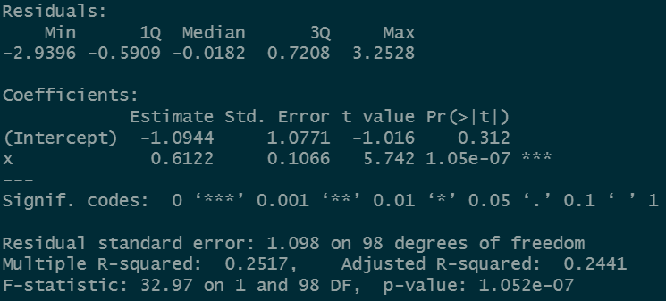

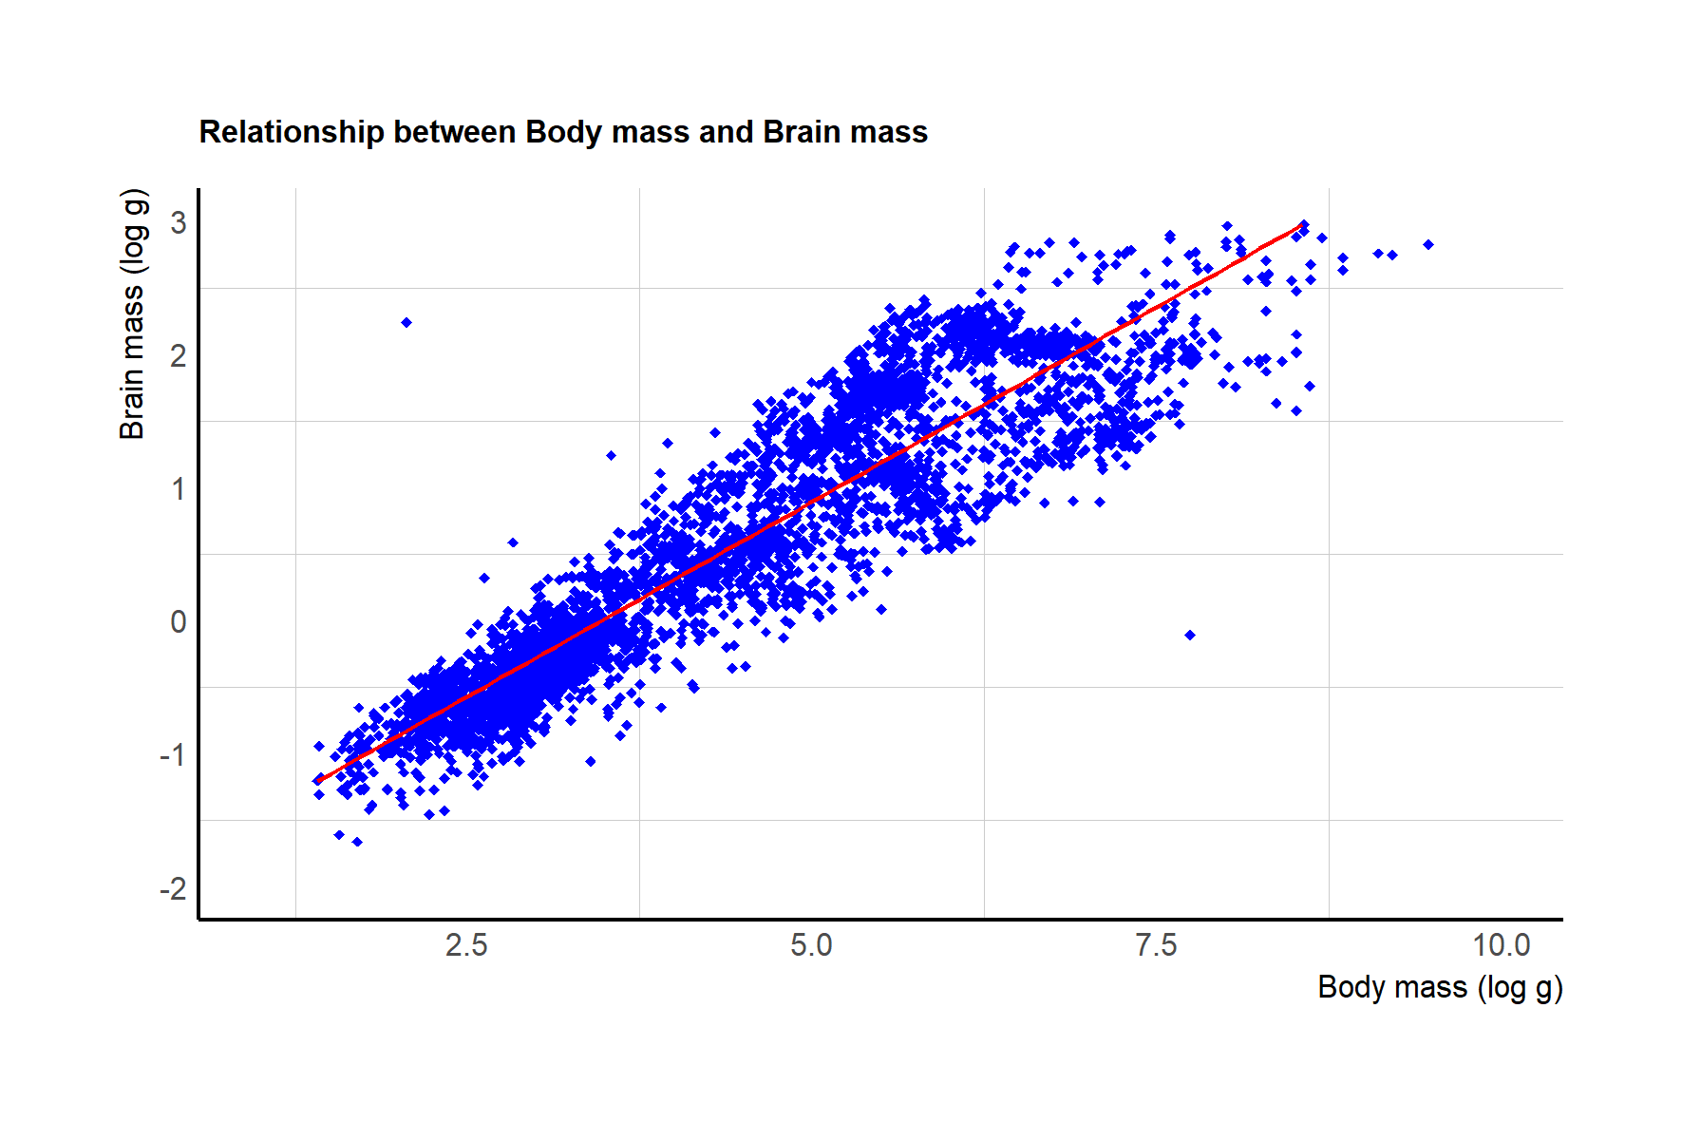

The results of our linear regression analysis conducted in R reveal a significant relationship between the brain mass of birds in the Accipiter genus and their body mass. The p-value associated with this analysis is remarkably low, at 1.05e-07, indicating a high level of statistical significance. This implies that the likelihood of observing such a strong relationship by random chance is extremely remote.

Furthermore, the R-squared value for this analysis is 0.25517, which suggests that approximately 25.5% of the variance in brain mass can be explained by changes in body mass within the Accipiter genus. While this value may not account for most of the variance, it indicates a noteworthy linear association between these two variables.

In conclusion, the low p-value and the moderate R-squared value demonstrate a robust linear relationship between brain mass and body mass in the Accipiter genus. This finding suggests that as body mass increases within this bird genus, there is a corresponding increase in brain mass, supporting the hypothesis that brain mass and body mass are linearly related.