Report: Effects of changes in queuing and service system on customer benefit

This work investigates the effect of modifications to a banking service system involving contact with a teller, having queued and waited for service. The objective of the experiments is to provide proof that changes such as increasing the number of tellers and improving efficiency of service (and thusly minimising service time) provided by tellers will reduce the maximum queue length for an arbitrary period and thusly provide a shorter queue-time by extension a more pleasant experience for customers.

The proposed changes will, respectively, be reducing the mean time taken to service each customer, and increase the number of available tellers to two in total.

The first change will be tested by trialling mean service times from 15 minutes down to 1 minute, in steps of 1 minute. Each of those values will then be tested 15 times each and averaged for a more accurate result.
The second test will be done by reducing the queue length by 2 for each completed service to emulate the effects of servicing two clients at once.

The first test, while averaging for a more accurate result, still does not encompass the maximum/minimum possible times, and could be done with each simulation being represented on a bell-curve for a more accurate representation of best/worst case scenarios. The second test assumes that each teller will service each pair of clients in the same amount of time, which is not accurate on an individual customer basis, but will serve to be accurate enough for a sizeable simulation.

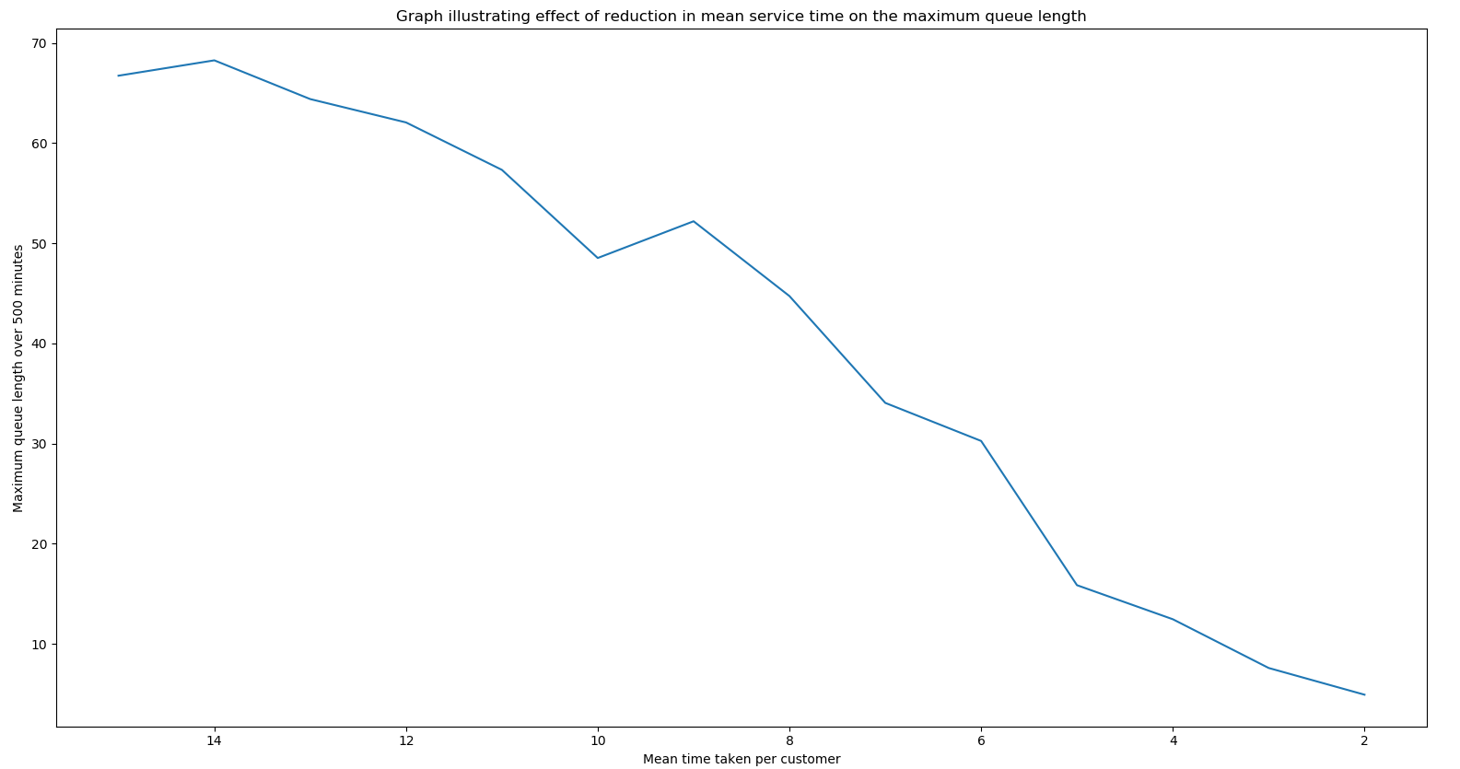
The first experiment (pictured above) shows that with a customer arrival interval of 5 minutes and simulation length of 500 minutes, decreasing the mean service time per customer has a near-linear effect on maximum queue length, bringing the maximum queue to around 5 people at a 2 minute service length.

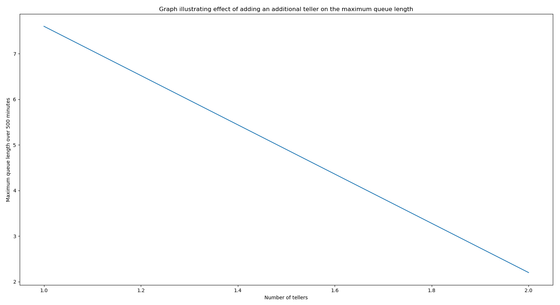
The second experiment (immediately above) indicates that moving from one teller to two, with an arrival interval of 5 minutes, a service time of 3 minutes, and a simulation time of 500 minutes results in a drop in maximum queue size from 8 people to 1 person which, while an extreme example, illustrates the effect of doubling the number of tellers to two. The graph also shows the intermediate values, which are inconsequential to the data given that fractional tellers cannot exist, does still indicate the linear relationship between increasing the number of tellers and a reduction in queue size.

It can be concluded that increasing the number of tellers has a slightly stronger effect on queue length, and is a linear relationship for all quantities, but it cannot be assumed that additional tellers is more cost-efficient than training said tellers, and thusly further investigation should be done into the correct balance of workforce size and worker efficiency. Each increase in efficiency did not necessarily produce results better than the last tested level, due to the innate randomness of the service. The overall trend, however, is that the service as a whole is likely to benefit from any reduction in time taken to serve customers.

