**OOP ASSIGNMENT**

**JaVaiRia LaTeeF**

**SP24-BSE-050**

**SECTION : B**

**JavaFX GUI Application**

**GUI :** A concept for user interaction

**JavaFx :** Framework for building GUI applications

**Operating System - -> Stage - -> Scene - ->Layouts**

**Layout** can be of more than one type like FlowPane, StackPane,GridPane.

These layout will contain Components like fields,buttons,textfields,etc.

In this Application We will use GridPane Layout

Assignment was about to make Application Form by using Gui…

**Output :**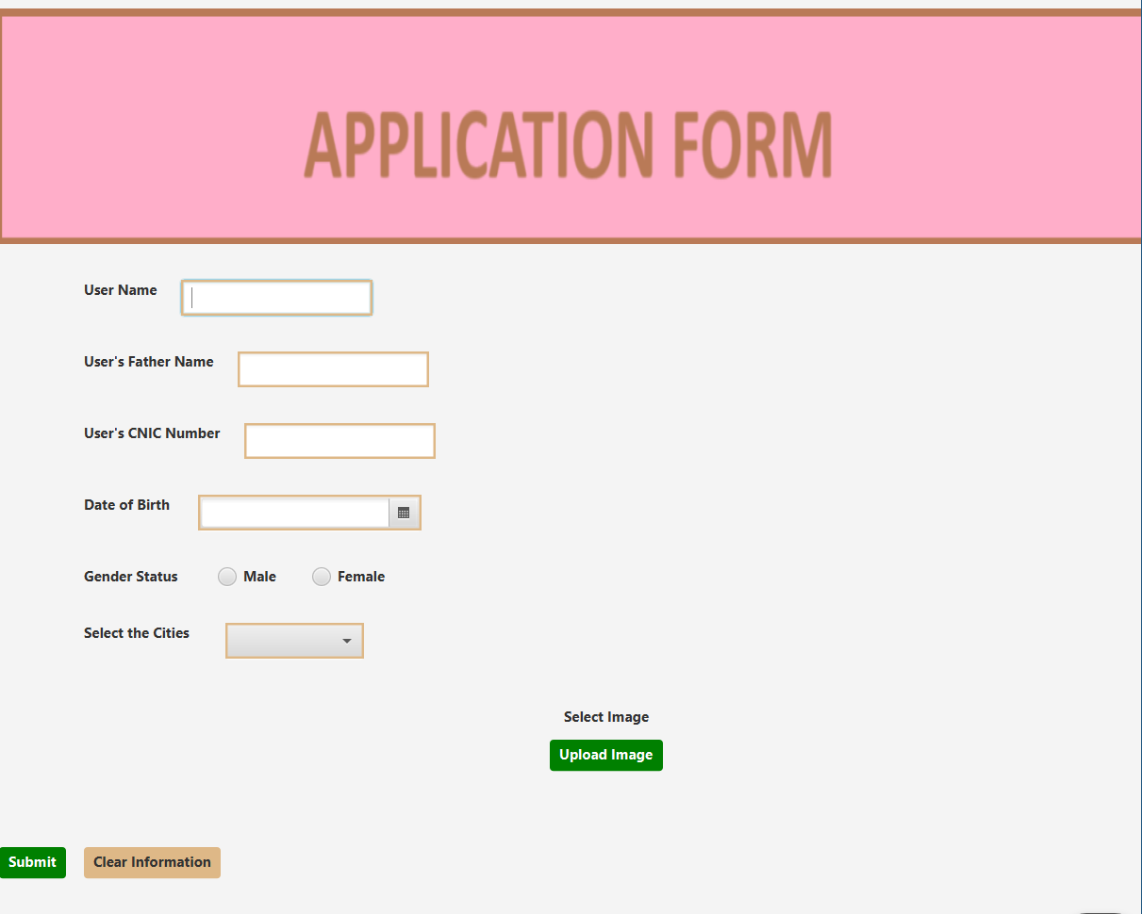

* **Top banner - ->** Application Form ( inserting image by writing some number of lines of code)

**Image topbanner=new Image(this.getClass().getResource("/com/example/form_lab_asg/form2.png").toExternalForm());**

* **Labels and TextFields** are created in which each have specific styling
* **“HBox – layout container**” is also used in different parts of code
* **DatePicker—“user interface control”** for selecting date of birth is used
* **RadioButtons** are used which are shown in output
* **ToggleGroups** are used so that one one option can be selected at a time
* **ComboBox**—"combines the dropdown list and text field” is used for selecting cities.
* **FileChooser** is used to upload the images from the browser

**FileChooser filechooser=new FileChooser();**filechooser.getExtensionFilters().add(new FileChooser.ExtensionFilter("Image Files", "*.png", "*.jpg", "*.jpeg", "*.bmp"));

* **Buttons** are used and actions are set when the user click the button like :

When user click the **“submit button”** actions will be performed like displaying information by using **“Alert”…**and All the information will be save in the Person **arraylist…**

**ClearButton** will clear all the fields …if the person submit the form and then click this button then previous info will be save and and the fields will be clear for new information

**Here is the display :**

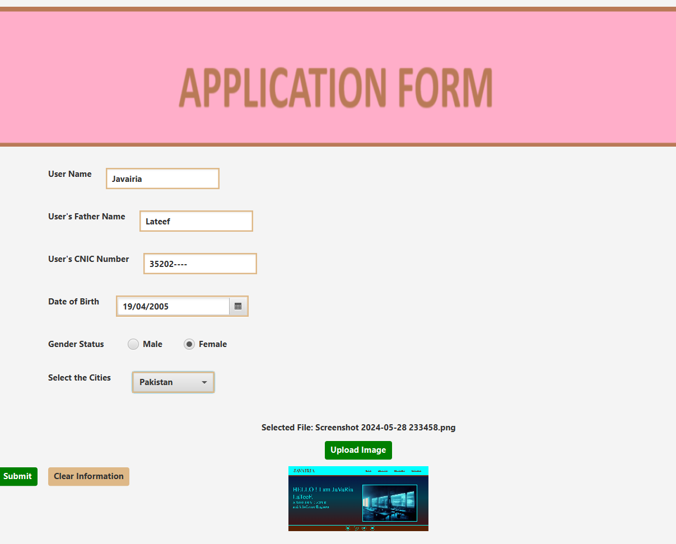

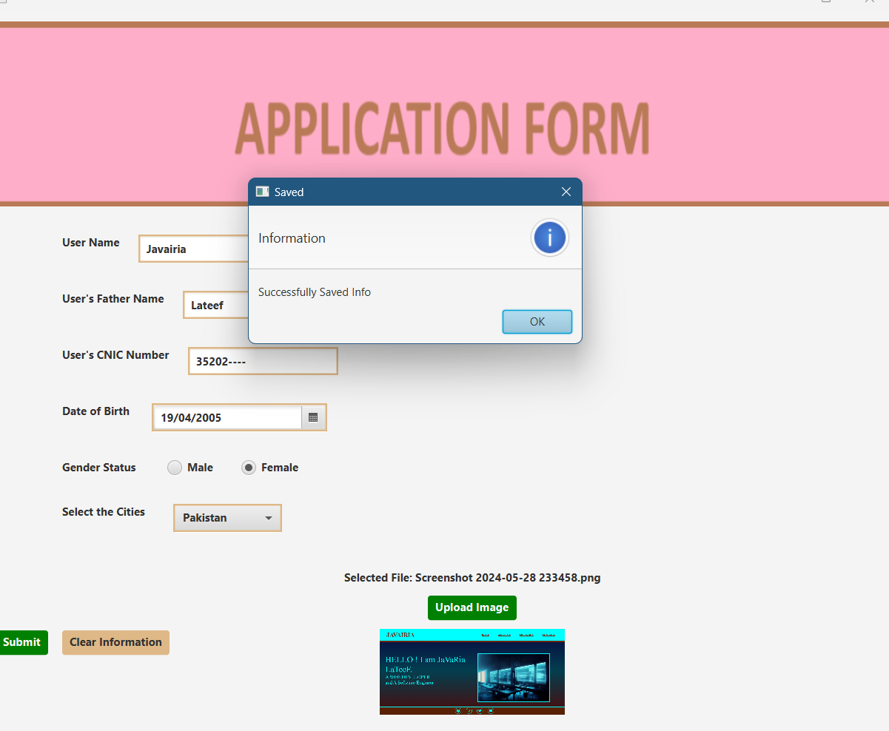

As this info will be saved now after using Clear Information button we write info of other person and also then save the info of that person

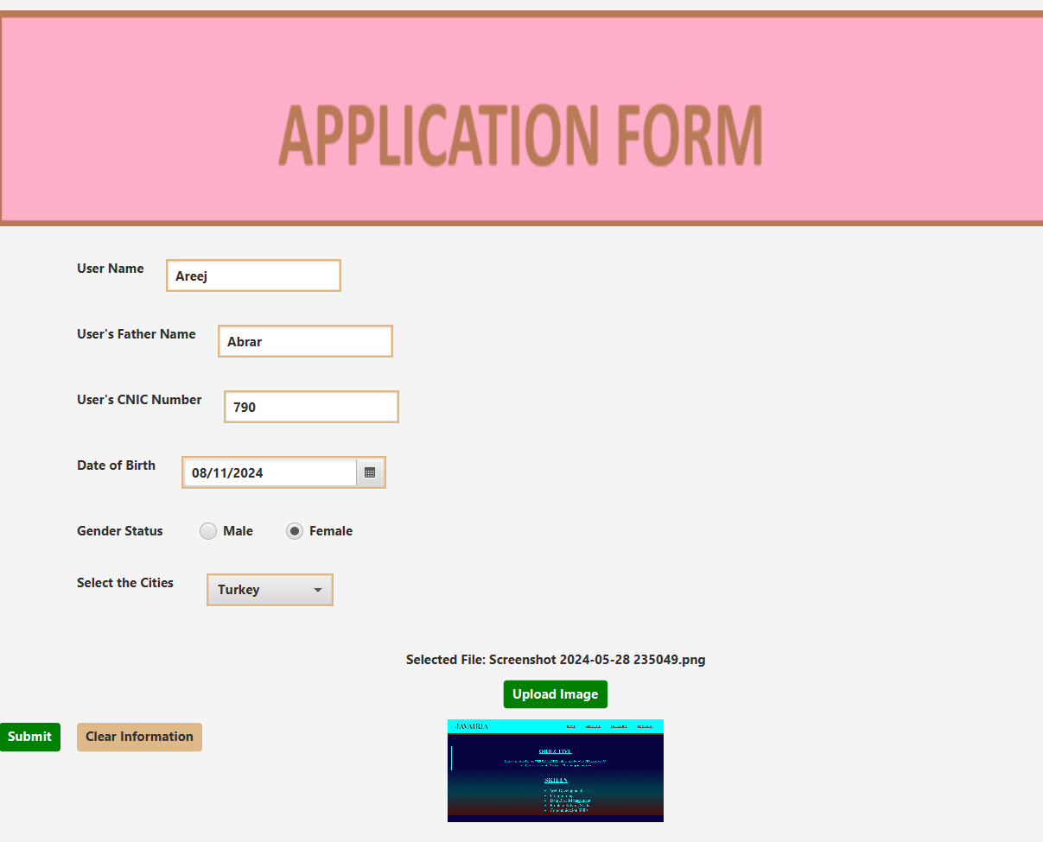

**Displaying Saved Information (which we saved in the ArrayList”)**

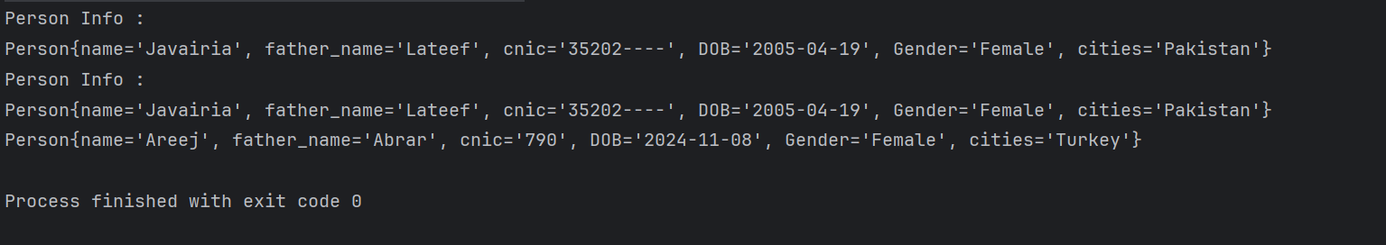

As U can see 1st I save only 1 person info so one person info is displayed

After it I saved another person info named “Areej” then after it 2 person’s info is displayed…..

|  |
| --- |
|  |

|  |
| --- |
|  |