

**ASSIGNMENT # 3**

|  |  |
| --- | --- |
| **Name :** | **Roll No** |
| **JAVAIRIA LATEEF** | **SP24-BSE-050** |
| **MARYAM ABID** | **SP24-BSE-058** |
| **AREEJ ABRAR** | **SP24-BSE-141** |

**UNIVERSITY MANAGEMENT STYSETEM**

**Login**

**by Admin🡪 AdminDashboard 🡪 different features Like :**

**Admin can**

* add User and Remove User
* add Course and Remove Course

In adding and deleting these 🡪data will be saved in the form of tables in database and will be deleted from the database

* User data and User data has been displayed in form of Tables by retrieving data from database

**By Faculty🡪FacultyDashboard 🡪** for now can upload Attendance related to his/her course students **🡪saving info in attendance table in database**

**By Student🡪StudentFeature🡪diff Features**

**Main Login Board** 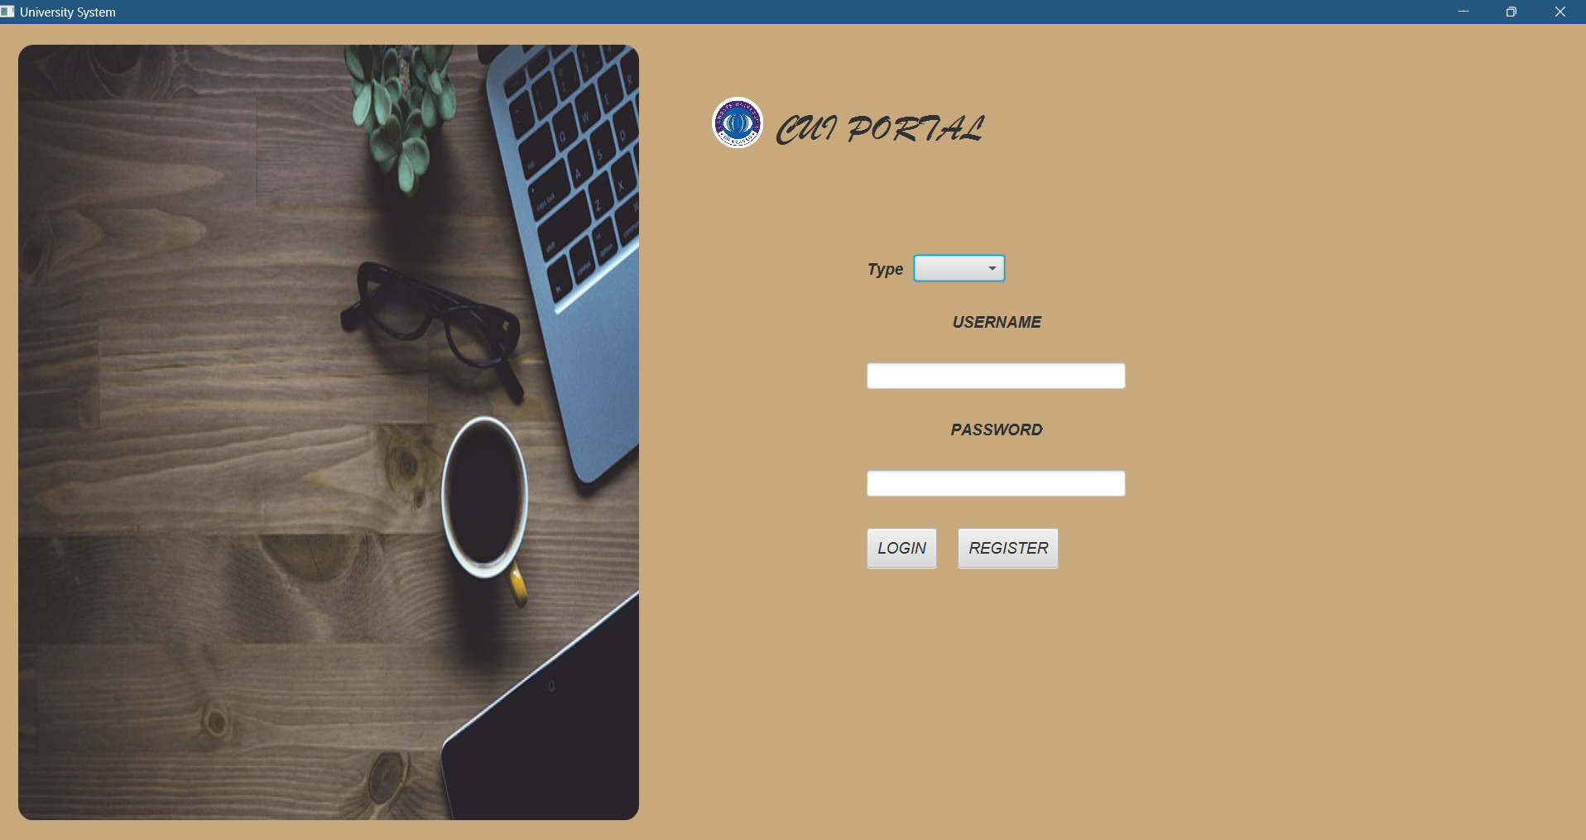

**Admin Dashboard**

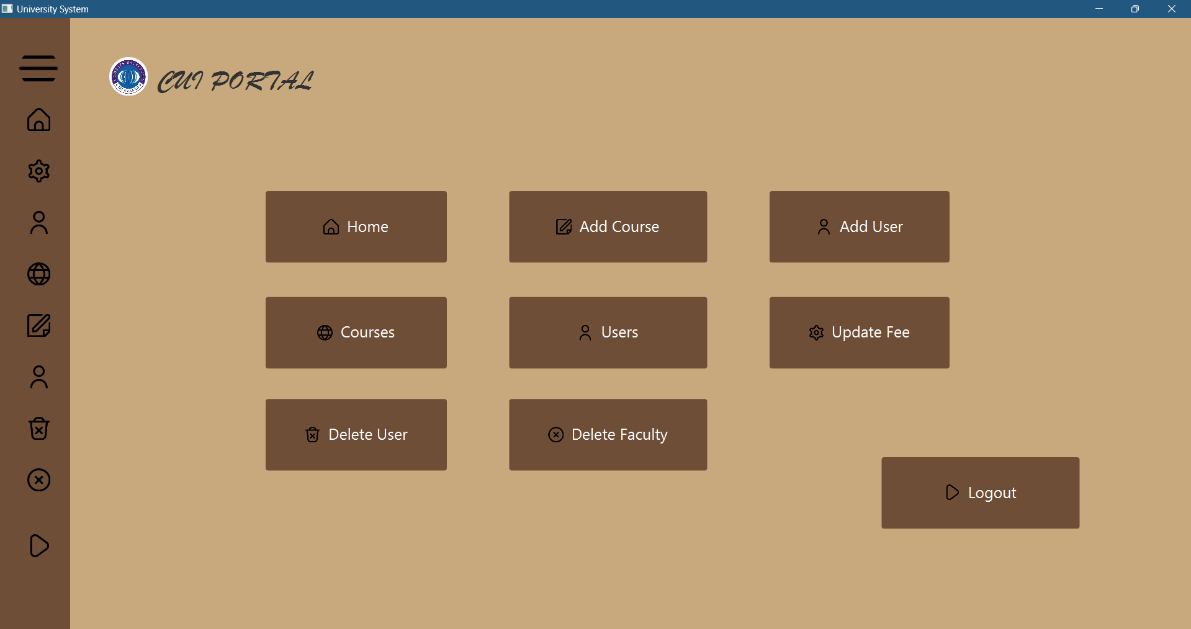

**Add course by Admin (data saved through database)**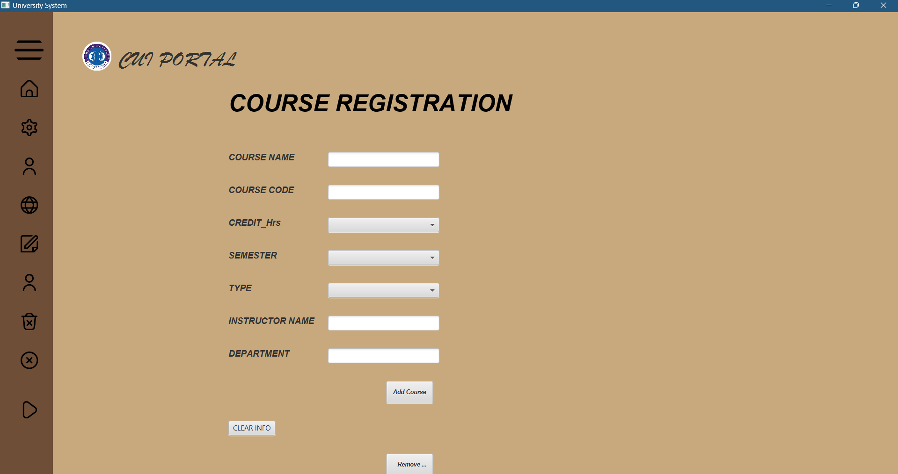

**Add User by Admin (data will be saved by database)**

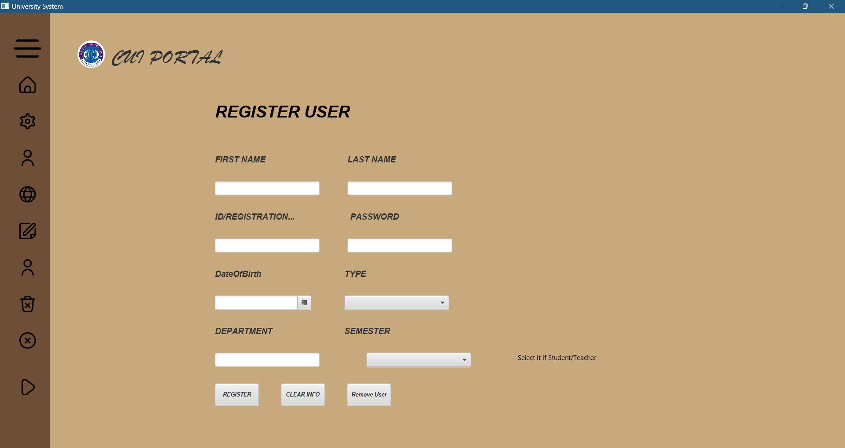

**Course info display (data retrieved from DB table which was saved )**

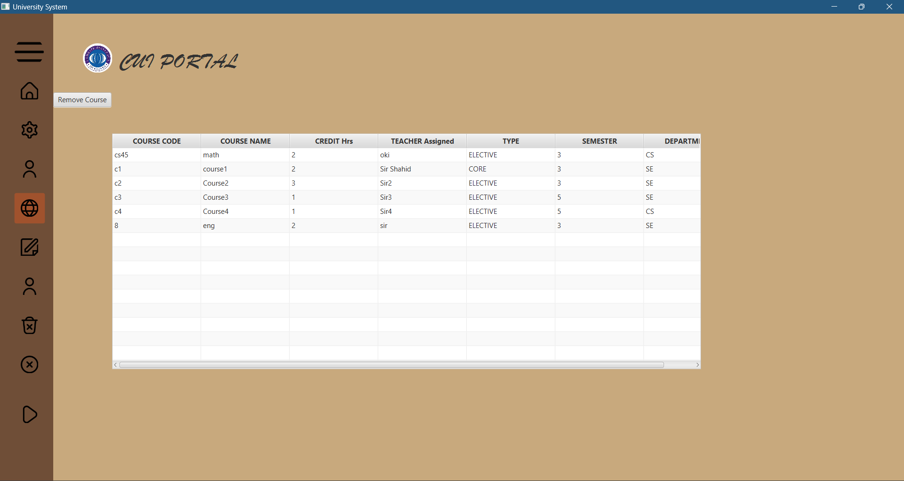

Course Table in Database

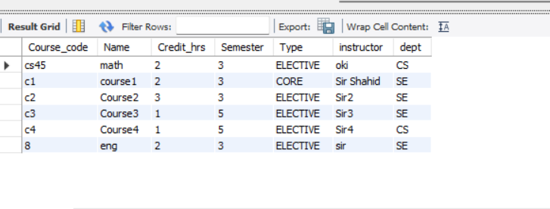

**User info Display (data retrieved from DB table which was saved )**

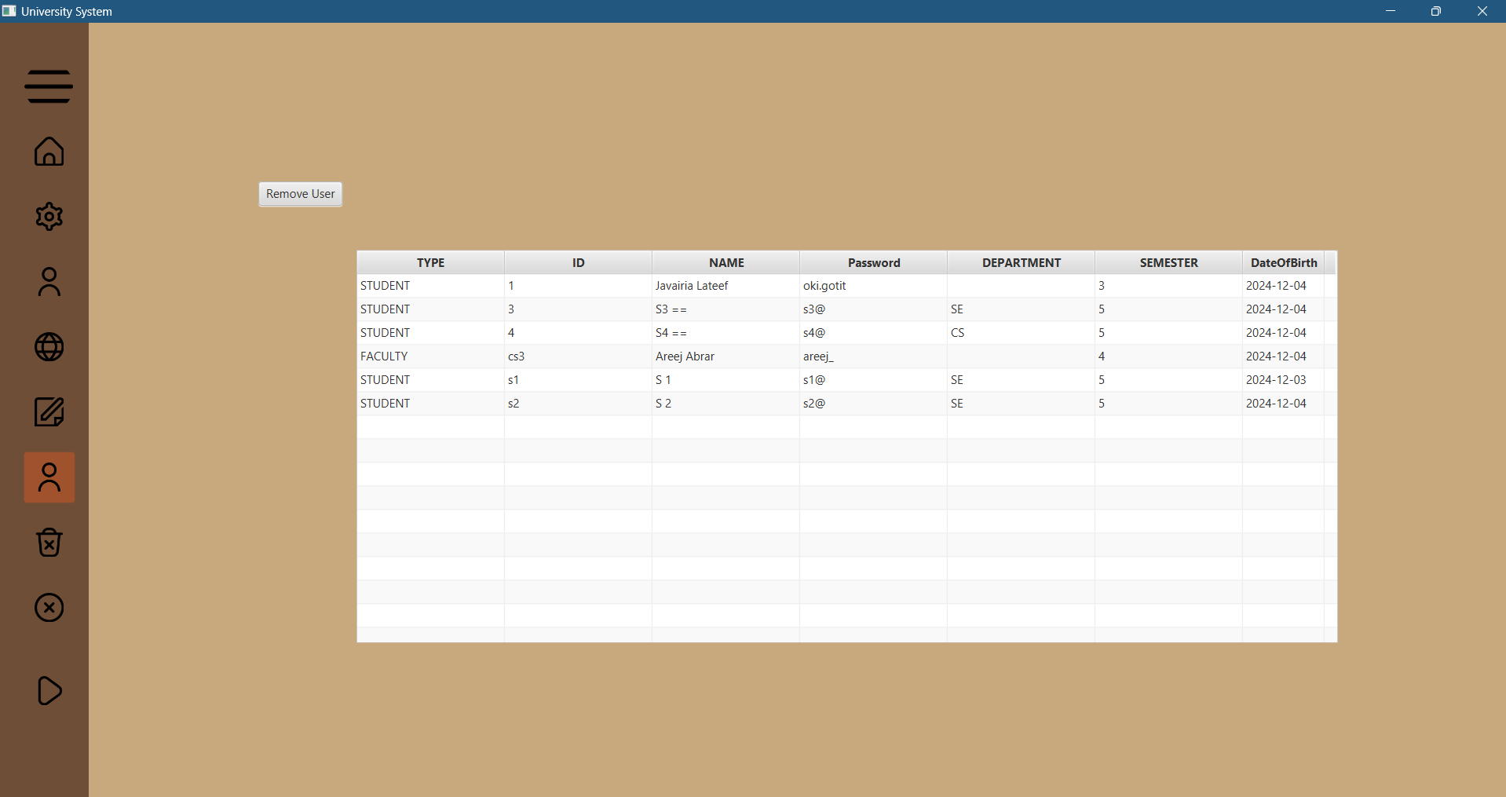

User Table in Database

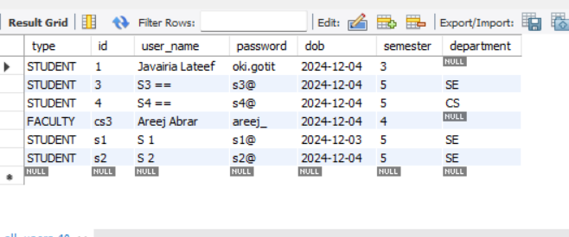

**Faculty Dashboard:**

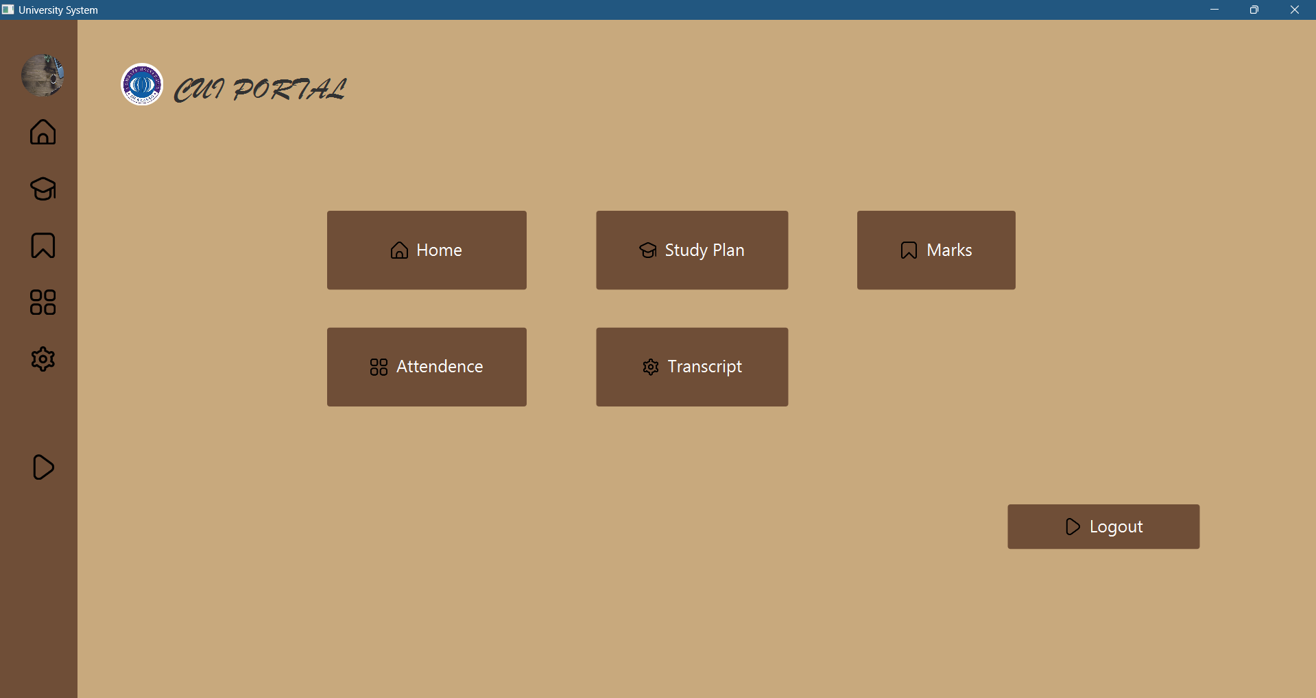

**Attendance by Teacher of His/Her Course**

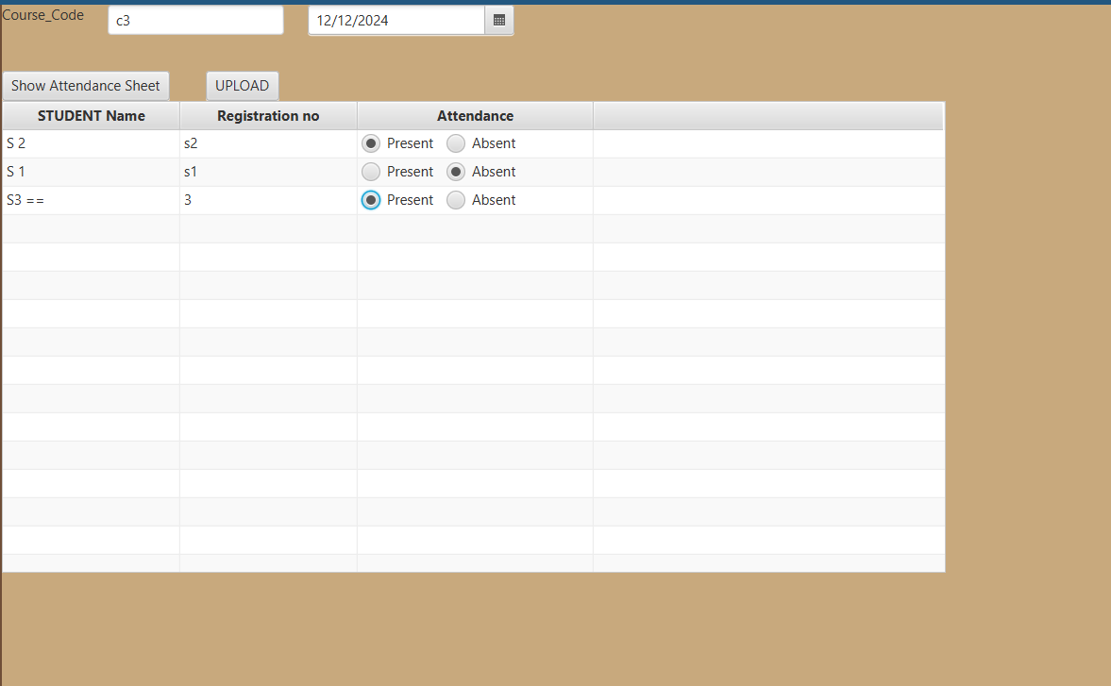

For making logic of Attendance table –had to join tables acc to same semester and department.

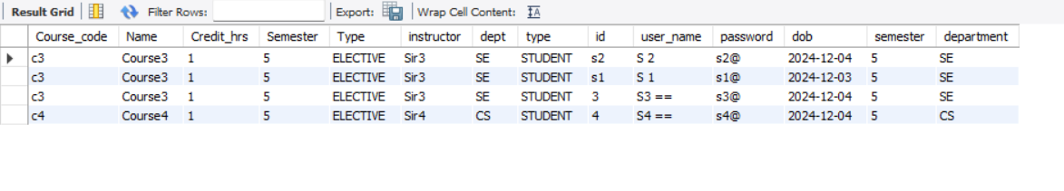

**Student Dashboard :**