*Application Development – Tauresium Development Diary*

*Time Log*

| Date of Session | Time Spent | Notes |
| --- | --- | --- |
| 26/01/2021 | 2 hours | In this session, I completed some basic project planning. This included deciding what I wanted to do, as well as evaluating what was possible. After this session I concluded I wanted to develop a map game for multiple players using a website and webserver. I chose to spend more time developing the concept the next day. |
| 27/01/2021 | 4 hours | This session was spent perfecting the proposed idea. I decided that the game would be an event-driven map game set in the modern day. Players will be able to join the same world together and will compete to hold as much of it as possible.  To control spaces on the ‘board’ players must expend influence, split into three types, ‘Cultural Influence’, ’Economic Influence’ and ‘Military Influence’. These values will all be used for different purposes, with cultural influence expendable on adjacent locations, economic influence used to expand overseas, and military influence used for expanding over owned locations. For the sake of balance, players will have the option to use economic or military influence as culture influence at an increased cost.  I also decided that the game will be built upon a triangulated map of the world, with each ‘province’ represented by a nearby city that most accurately reflects the environment (though, in some cases, not the most realistic geographically) |
| 28/01/2021  (Session 1) | 2 hours | This session consisted of building the groundwork of the website and map **(Figure 1)**. I Decided the best course of action would be to begin the rendering of the map before choosing representative cities, as this allowed me to easily see the boundaries of the regions on the map. The map in this version of the program is rendered using SVG polygon tags within the HTML and were manually mapped using a scaled world map image as a reference for coordinates. Unlike most triangulated maps, this map is intended to not accurately reflect the shape of the area it represents, but more represent the map as a whole – this means that small details will be overlooked, but the map shape will be preserved.  As for the map itself, I used this session to create the Alaska-Canada region.  Also, during this session, I began working on the map selection algorithm, in which clicked on locations are highlighted. This will later be built into a full selection mechanic, where the attributes of selected locations will be displayed. |
| 28/01/2021  (Session 2) | 2 hours | This session came soon after the previous documented session, and was spent improving the map – specifically, North America, central America and half of south America were added to the file. During this session I began to get the hang of the tools I was working with, and managed to produce a lot more provinces in the same amount of time. |
| 29/01/2021  (Session 1) | 1 hour | This session was spent filling in the remaining parts of the Americas not yet implemented – including south America and Cuba. Additionally, during this session Greenland and Iceland were mapped, allowing for expansion of the map into Europe. **(Figure 2)** |
| 29/01/2021  (Session 2) | 2 hours  30 minutes | Added mainland Europe and the British Isles, also changed the JavaScript code to display the ID of a selected province when clicked, and only permit the selecting of one province at a time. Additionally, I worked to improve the aesthetic quality of the website. |
| 29/01/2021  (Session 3) | 2 hours | During this session I worked to add the Scandinavian peninsula and eastern European nations into the map, as well as the Greek/Turkish region. |
| 2/02/2021  (Session 1) | 2 hours | This session consisted of the inclusion of Russia and the coastal regions of China into the map, filling out around half of the map overall **(Figure 3)**. |
| 2/02/2021  (Session 2) | 3 hours 30 minutes | Added the majority of the Middle East, mainland China and Asia, while also modifying some existing locations (notably the Canadian provinces of Alberta and Saskatchewan, which originally composed of three locations but were shortened to two locations to preserve correct triangulation of the map) |
| 2/02/2021  (Session 3) | 1 hour | Added Korea, Japan, Australia, and New Zealand, as well as refined some existing coordinates for south east Asian locations |
| 2/02/2021  (Session 4) | 4 hours | Added Africa and Madagascar, finishing the map **(Figure 4)** and allowing for development to proceed. |
| 3/02/2021 | 6 hours | Added an index page with information about the game, as well as a link towards the map page. Also spent a large amount of time refining the design of the website. |
| 4/02/2021  (Session 1) | 4 hours | Began designing the dataset for the program – first importing the existing province names and SVG vertexes into an empty excel spreadsheet. This excel spreadsheet serves as the ‘database’ before the proper SQL database is implemented, keeping record of data and allowing me to collect information to be used on the website without having to keep updating an SQL database. |
| 4/02/2021  (Session 2) | 1 hour 30 minutes | After importing all of the necessary data and designing the table, I used this time to begin collecting information, specifically names of major cities in the defined regions. In this time, I managed to find 150 different cities to represent 150 provinces in the 435 province dataset, as well as fix an unspotted error in the website proper in which two provinces incorrectly shared the exact same vertexes. |
| 5/02/2021  (Session 1) | 6 hours | Added cities for every existing province and found population metrics (using 2 significant figures, and various rough sources) for each of these cities. Additionally, I used a map of world climates as a rough reference to interpret the climate of each region on the map. |
| 5/02/2021  (Session 2) | 1 hour 30 minutes | Updated the dataset to include the HDI of each region, which is the HDI of the country that owns the city in real life. This was sourced from the 2019 United Nations report on HDI in 189 countries – which does not include every nation, so in the cases of nations like Somalia who refused to participate in the HDI census, their most recent HDI score was used. |
| 5/02/2021  (Session 3) | 30 minutes | Began to add records for national GDP for each city, which much like the HDI data, uses GDP records from the country that owns the cities in use. In particular I used the nominal GDP per capita, and used the 2020 estimates of the international monetary fund as a source for this information. |
|  |  |  |

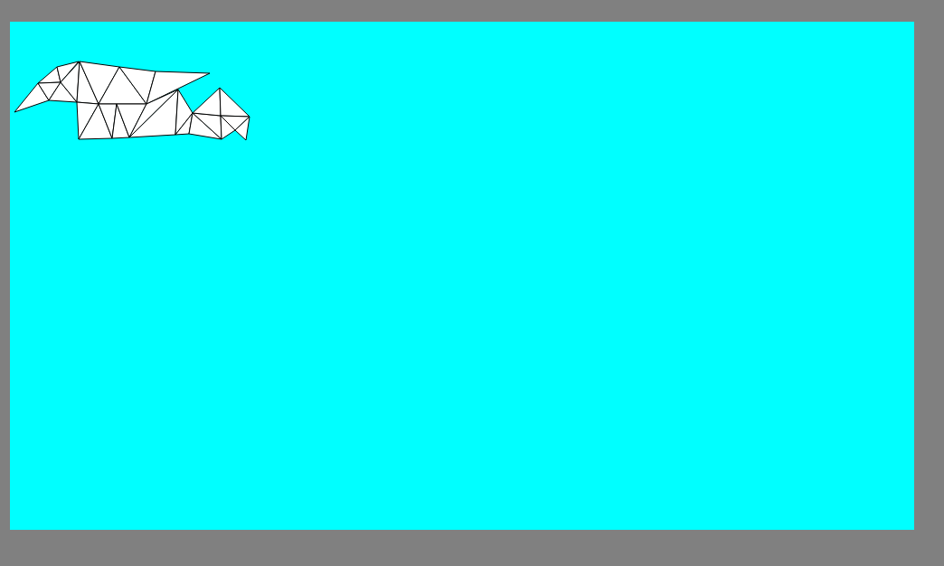

Figure

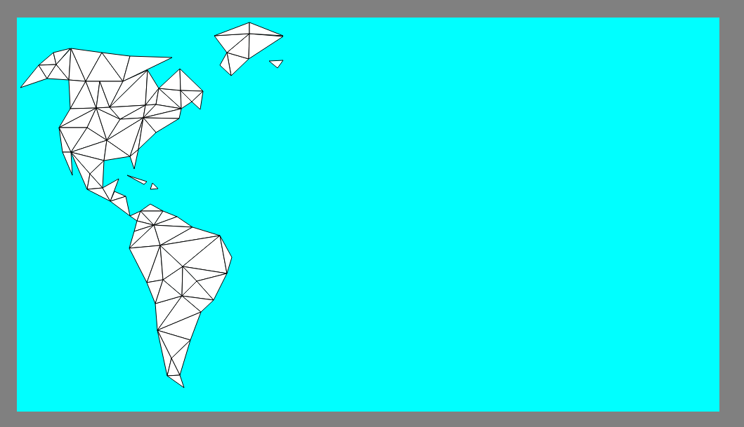

Figure

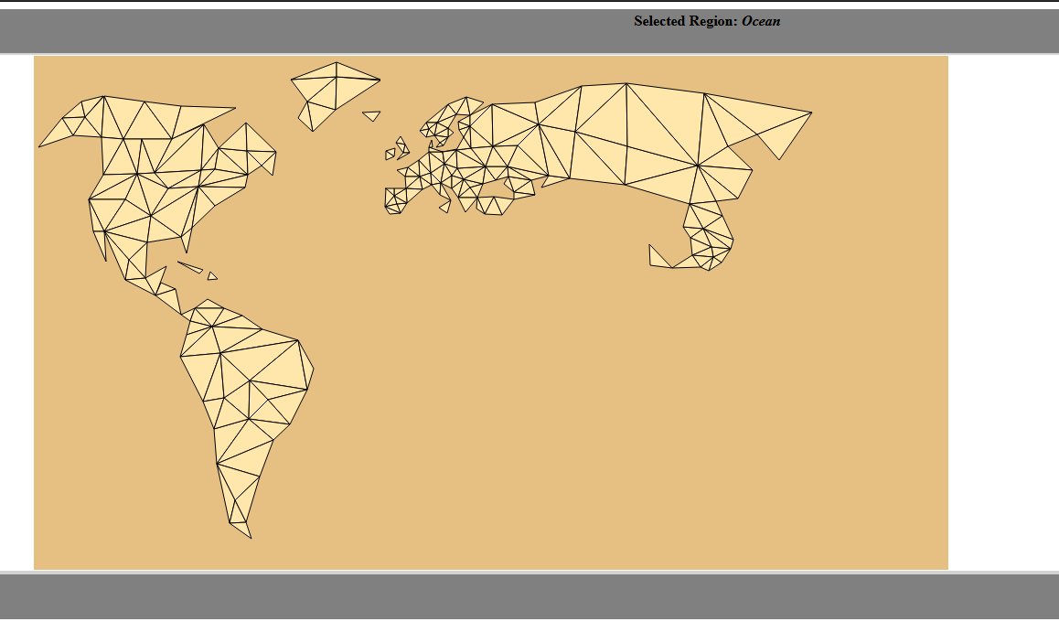

Figure

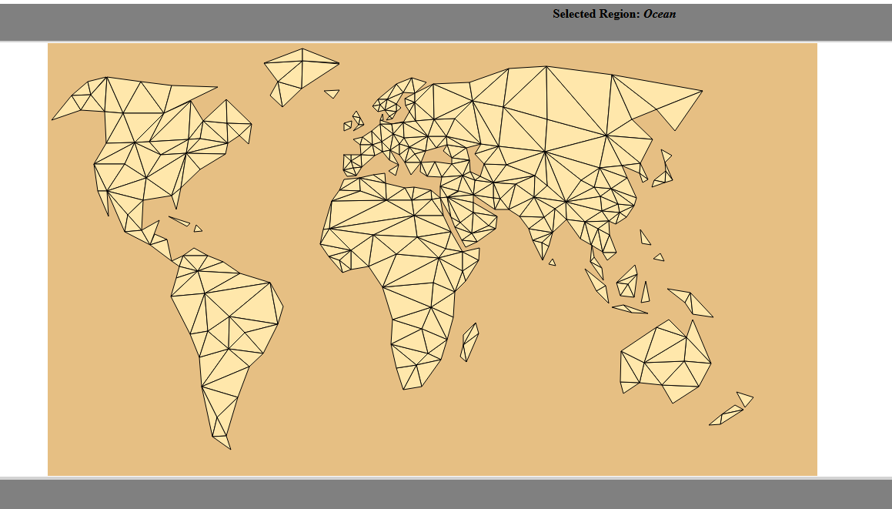

Figure