# Supporting Product Development by a Trend Analysis Tool applying Aspect-Based Sentiment Detection

**Abstract.** Incorporating product trends into innovation processes is imperative for companies to meet customers’ expectations and to stay competitive in fiercely opposing markets.Currently, aspect-based sentiment analysis has proven an effective approach for investigating and tracking towards products and corresponding features from social media. However, existing trend analysis tools on the market that offer aspect-based sentiment analysis capabilities, do not meet the requirements regarding the use case Product Development. Therefore, based on these requirements, we implemented an automated artifact by following the design science research. We applied our tool to real-world social media data (37,638 Yelp reviews) from one major fast-food restaurant in the US, and thereby demonstrated that our tool is capable of identifying remarkable and fine-grained product trends.

**Keywords:** trend analysis tool, aspect-based sentiment, product development.

# Motivation

Social media such as Yelp or Twitter have evolved rapidly over the last years. These platforms have become increasingly important for interaction in both private and business contexts [1, 2]. As social media is a channel for the exchange of user-generated content and unfiltered voices about products, services and the company in general, social media data contain the so-called “Voice of the Customer” (VoC). Thus, the VoC provides deep insights into customers’ current expectations. To meet customers’ expectations, marketing representatives need to identify and continuously track trending topics regarding product and service features and incorporate the VoC into product innovation processes. For example, identified product features and correspondingly mentioned opinions may indicate shortcomings (e.g., low battery capacity of a smartphone) and which improvements to be made to meet customers’ requirements (e.g., [3]). One possibility to identify these shortcomings in an automated way from social media texts is to conduct aspect-based sentiment analysis [4].

The potential of aspect-based sentiment analysis for tracking fine-grained trends over time has already been recognized in practice and in theory (e.g., [3, 5-9]). This has led to the emergence of trend analysis tools that include aspect-based sentiment analysis functionalities. However, trend analysis tools available on the market have remarkable drawbacks as they do not cover the comprehensive requirements that are deemed essential within the extant literature for the use case Product Development (e.g., [3, 5-9]).

With this work at hand, we make practical as well as theoretical contributions. We address drawbacks of existing software tools by suggesting a comprehensive artifact for automated trend analysis that allows marketing representatives to conduct aspect-based sentiment analysis. To meet several use case specific requirements, we focus especially on the combination of different data analysis methods regarding the particular requirements, leading to a constructive trend analysis. By this, we aim to propose an automated solution for identifying ideas as the basis of (incremental) product innovation. Summing up, the research at hand is guided by the following research question:

*What could an aspect-based sentiment analysis tool that supports trend analysis for Product Development purposes look like, and which requirements should such a tool meet?*

The remainder of this paper is structured as follows: In the next section, we provide conceptual basics and related work. Following on this, we turn to the Design Requirements (DRs) and Design Principles (DPs) for implementing our tool, and to the shortcomings of trend analysis tools on the market. Next, we show the research methodology. After a description of the tool’s design and development as well as its demonstration, the paper concludes with a discussion and its contributions to theory and practice.

# Foundations and Related Work

## Conceptual Background

Social media serves as an important interface between companies and customers. In content communities, users can evaluate e.g., products by disseminating their opinions in form of online customer reviews (OCR). In doing so, customers not only rate products as a whole but express their opinions and attitudes towards different features of the rated items (e.g., service quality in a Yelp restaurant review). In this way, OCR not only help customers to make informed decisions but are also beneficial for driving innovations of products within companies. As OCR include customers’ experiences and expectations of product features [10], unfiltered and in real-time [11], they can serve as a valuable resource for product innovations. Thus, OCR can be harnessed to identify ideas, to either develop new value propositions (i.e., disruptive innovation) or to improve the performance of existing products (i.e., incremental innovation) [12, 13].

To identify ideas for product improvements as well as product development and therefore to drive incremental product innovations, marketing representatives can conduct aspect-based sentiment analysis. The first step of an aspect-based sentiment analysis deals with extracting aspects from OCR. For this purpose, unsupervised as well as supervised techniques can be applied. Topic modeling techniques (e.g., LDA [14]) suggest a possibility to identify aspects without prior knowledge (i.e., unsupervised) [14]. Compared to that, supervised techniques (e.g., artificial neural networks) need first to be trained on training data (e.g., ontologies) to extract the proper aspects (cf. [4]). Subsequently, the expressed tonalities can be identified for each of the aspects [4] by means of automated sentiment analysis techniques [4, 15]. Therefore, aspect-based sentiment analysis offers benefits in terms of Product Development. For marketing representatives that lack the ability to implement aspect-based sentiment analysis themselves, trend analysis tools on the market offer this functionality in a ready-to-use way. However, these tools show remarkable drawbacks as they do not cover the comprehensive requirements that are deemed essential within the extant literature for the use case of Product Development.

## Design Requirements and Available Tools on the Market

In a first step, we have comprehensively searched and consolidated literature (cf. [16]) to identify DRs of a trend analysis tool that applies aspect-based sentiment analysis for Product Development purposes. Based on the attention and importance received, we could derive several DRs (DR1)-(DR10) (see fig. 2) from the extant literature.

Concerning the identification of product features, the tool (DR1) should be capable of extracting the aspects autonomously from social media posts (e.g., [6-8, 17]). However, if marketing representatives have already knowledge documented about a domain problem (e.g., domain ontologies or product trees), the tool (DR2) should provide the option to include this prior knowledge into the automated identification of aspects (cf. [6, 7, 17, 18]). Beyond that, customers’ self-reported opinions of product features play an important role for Product Development. Marketing representatives aim to retain the features that evoke positive perceptions, while features evoking negative perceptions need to be improved. Thus, (DR3) determining the polarity as well as the intensity of the opinions expressed about respective aspects is mandatory [3, 6, 8, 19, 20]. Subsequently, the product features can be adapted so that customers’ requirements are met (e.g., increasing smartphone screen size). However, adapting features may influence perceptions of the features customers currently appreciate (e.g., high battery capacity of the smartphone). Therefore, to support informed improvement decisions, the tool (DR4) needs to identify the dependencies between product features [7, 9, 17]. Furthermore, to be successful and competitive in a targeted market, marketing representatives must decide which product features to propose in which way to meet customers’ expectations within geographical markets. Product trends do also converge over time as they are dynamic developments and not solely static points in time. It is therefore essential that the tool (DR5) can flexibly match aspect-sentiment relations to different geographical (e.g., continents, countries, federal states) and temporal (e.g., days of a week, phases of a day) parameters [3, 5, 17-20]. The huge volume of available social media posts requires the incorporated techniques (DR6) to deal with vast amounts of textual data [8, 9, 18-20]. As past developments of trends are essential for assessing the current state of trending topics, the tool (DR7) needs to allow the user to consider historical data [3, 17-19]. To support Product Development in prioritizing product improvement decisions, the tool (DR8) needs to output aggregated sentiment values for the identified aspects [3, 6, 8, 19, 20] and (DR9) illustrate the frequency of the identified aspects [3, 8, 20, 21]. To immediately identify the most important aspect-sentiment relations, the tool (DR10) should provide means to rank the results in either descending or ascending order [3, 21].

In the second step, we searched the market for available trend analysis tools. We took an up-close look at the most popular tools (e.g., Brandwatch, Meltwater, Symanto) that offer trend analysis by means of aspect-based sentiments. We analyzed the functionality of these tools by installing demo versions. To verify the drawbacks regarding the DRs for each of the tools, we also turned to sales representatives from these companies to confirm our observations. As it turned out, there is indeed a lack of a software tool that meets all the specific requirements for the use case Product Development. Firstly, these tools lack the ability to flexibly match different temporal and geographical parameters to aspect-sentiment relations. Perceptions of product features differ across geolocations (e.g., continents, federal states), trends are temporal developments (e.g., days of a week, phases of a day), and both require different and flexible contexutalizations. Secondly, existing trend analysis tools that apply aspect-based sentiment analysis extract aspects either with or without incorporating prior knowledge. However, we could not observe a trend analysis tool that includes both possibilities. Literature unveils the need for a comprehensive trend analysis tool that meets all the requirements for the use case Product Development. With this research, we aim to close this gap.

# Research Procedure

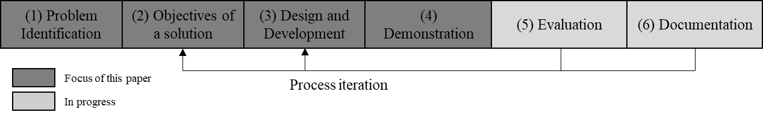In order to develop a systematic artifact for the automated trend analysis in marketing, we followed the Design Science (DS) approach [22, 23] and aligned our research activities with the DS procedure as proposed by [23] (see Fig. 1).

**Fig 1.** Design Science Research (DSR) Procedure

As a first step, (1) corresponding problems and drawbacks of previously existing approaches regarding the automated trend analysis using aspect-based sentiment analysis were identified (see sections 1 and 2.2). Hence, the revised tools supporting trend analysis by aspect-based sentiment detection do not meet the requirements that are indispensable to the successful application. Consequently, our (2) objective is to address drawbacks of existing software tools by suggesting a comprehensive artifact for automated trend analysis that allows marketing representatives to conduct aspect-based sentiment analysis (see sections 2.2 and 4). The third step of our DS process model contains the (3) design and development (see section 4) of an artifact. To fill the gaps identified within phase (1), we focus on the design of the technical realization of the tool by combining different machine learning techniques, following our derived DPs. Thus, our approach was established to support the trend analysis and to eliminate the existing disadvantages. By (4) demonstrating our artifact (see section 5.1), we highlight the application of our tool on 37,638 Yelp reviews [24]. Thus, we showed the implementation of the requirements identified in literature. In Step 5 the usefulness, applicability and usability of the tool are to be analyzed in a larger field study. Finally, the tool will be further enhanced before it is provided to marketing departments of large companies (6).

The orientation towards the procedure by [23] also makes it possible to align our research with the guidelines of [22] or [25], respectively. According to the design cycle, we present our artifact as the result that has gone through the process of demonstration (application of our approach to a Yelp dataset). In view of the relevance cycle, we identified several DRs from current research literature that guided the design of the artifact, and so the practical application of our artifact brought up several contributions for practice. In view of the rigor cycle, we used several methods to rigorously construct our artifact (e.g. topic modelling, sentiment analysis, etc.) and derived initial findings as contributions to (nascent) design theory.

# Design and Development

First, the composition of meta requirements (MRs) that describe “*what the system is for*” ([26], p. 325) is based on the purpose and scope of the tool that was discussed in the motivation. Thus, we define the solution objectives based on the investigations´ problems and present them in Figure 2. Besides the MRs, the design principles (DPs) are synthesized in a next step. DPs are defined as prescriptive statements that show how to do something to achieve a goal [29]. These DPs are deduced from the DRs that are based on current research literature. The DPs we derive from our results fall into the category of “action and materiality-oriented design principles”, describing what an artifact should enable users to do and how the artifact should be built to do so [30]. The development of the DPs follows the guidelines of [27] and [28].

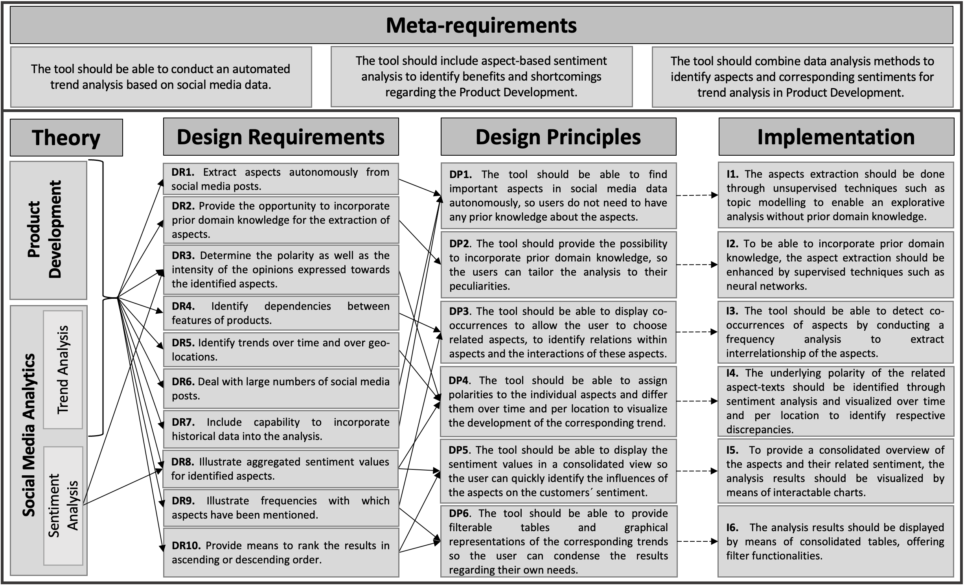

**Fig 2.** Design of the Artifact

Since no particular machine learning technique is capable of accurately representing all DRs, a combination of techniques was essential. Regarding *DP1*, the autonomous extraction of aspects, unsupervised techniques (e.g., topic modeling) are required to enable an explorative analysis without prior domain knowledge. However, as stated by [29] the potential of totally unsupervised techniques is stymied by their purely unsupervised nature. Thus, semi-supervised techniques have arisen in the past, facilitating an effective way to guide the analysis specific to a user by manipulating the analysis process even without structured prior domain knowledge [30]. Therefore, to take advantages of semi-supervised techniques while maintaining the flexibility of unsupervised ones, the known semi-supervised topic modeling technique GuidedLDA found application as it achieves convincing analysis results [30]. Besides the explorative analysis, the artifact must provide the ability to incorporate prior domain knowledge (*DP2*). Thus, the artifact provides a supervised aspect extraction using deep learning. Specifically, it uses a convolutional neural network (CNN) as proposed by [31], using two types of pre-trained embeddings for the aspect extraction: a general-purpose embedding and a domain-specific embedding, containing domain related information used by the CNN to learn the specific domain peculiarities. Consequently, the analysis can easily be adapted and tailored to the users’ own circumstances by changing the underlying domain-embedding, resulting in a highly generic and customizable artifact. With respect to *DP3*, the artifact must depict co-occurrences of the related aspects to detect their interrelationship. As probabilistic topic modeling techniques such as GuidedLDA infer their resulting topics based on various probabilistic distributions, depicting the relations of the underlying topic words (and thus the resulting aspects) [32], the identification of their interrelationships is met through the nature of topic modelling itself. Considering the use of the CNN, the artifact depicts the co-occurrences of the aspects by conducting a frequency analysis. Here, sub-aspects are identified for each extracted (main-)aspect by analyzing their respective occurrence in the context of the related main-aspect, resulting in an n-dimensional occurrence-tree. To determine the tonality of each aspect (*DP4*), the "Valence Aware Dictionary for sEntiment Reasoning" (VADER) [33] technique (a lexicon and rule-based sentiment analysis technique specifically attuned to sentiments expressed in social media) has been implemented. To further consolidate and visualize (*DP5*) the underlying aspects’ sentiment as well as its evolution over time, corresponding line-charts are implemented using the well-known python library matplotlib [34]. Finally, to ensure an adequate illustration of the analysis results (*DP6*), the extracted aspects, the corresponding sentiment values and their means, but also specific references to the extracted aspects are displayed using filterable tables and lists as demonstrated in the following section.

# Demonstration and Discussion of the artifact

## Demonstration of the artifact

To examine the tool’s ability to identify meaningful and sound trends (including related aspects and their sentiment), we applied it to a real-world dataset. Therefore, we consulted the academic Yelp dataset [24], represented by a subset of real-world reviews and business in the US from one of the most popular online communities for crowd-sourced reviews. The dataset, which comprises a total of ~8.6 million OCR concerning 160,585 businesses in different fields such as restaurants, cultural sites and sports facilities spans the period from October 13th, 2004 to January 28th, 2021. To demonstrate our tool, we narrowed the data to the multi-faceted field of the food and restaurant industry. Specifically, we narrowed the analysis to the reviews of a fast-food restaurant with multiple franchises in various locations to extract the relevant aspects and associated customer perceptions, resulting in 37,638 reviews. The evaluation of the analysis and the tool’s usability will be carried out, as described in section 6, within future work.

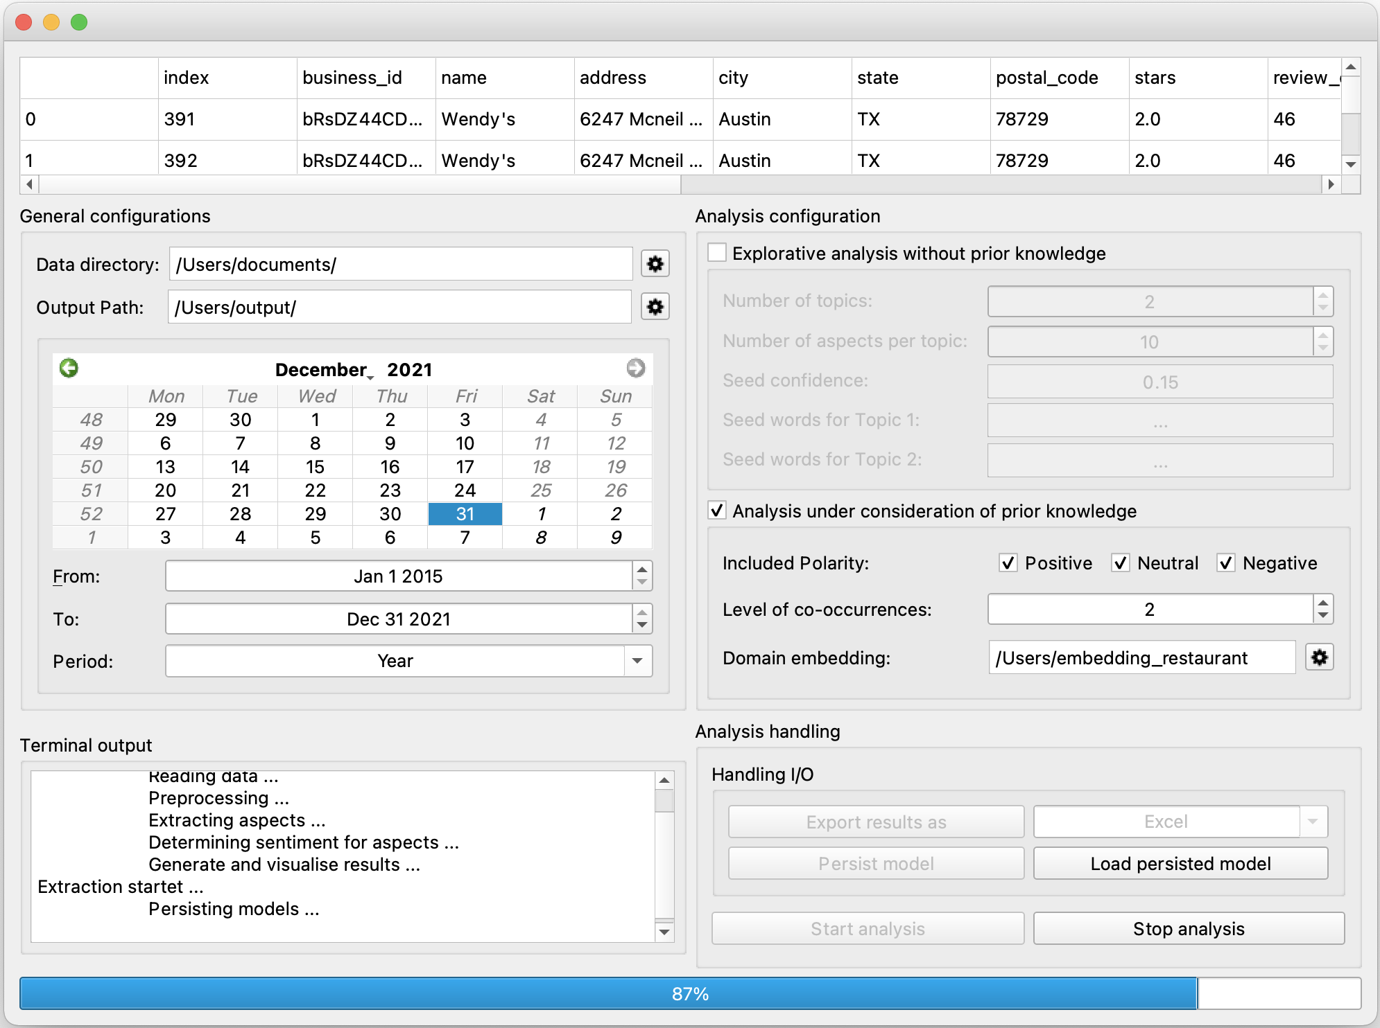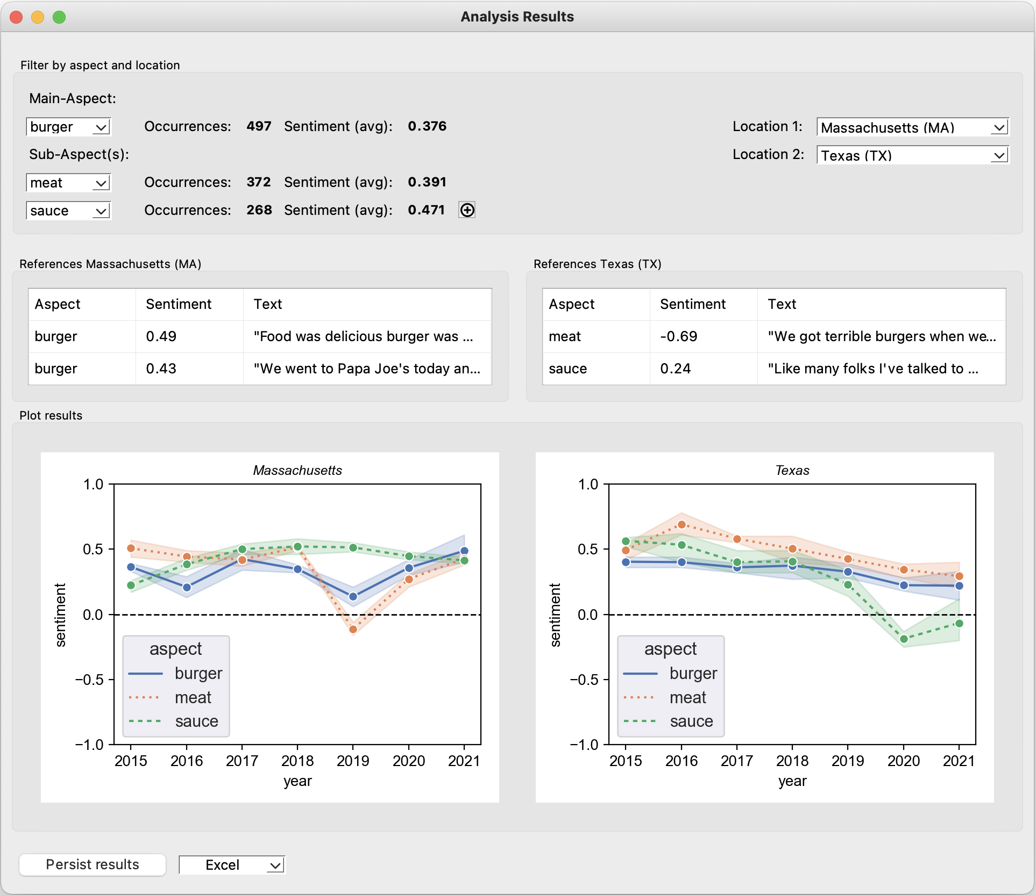

**Fig 3.** Configuration and Result View of the Artifact

Figure 3 represents the tool’s configuration view (left) and results view (right). By the configuration view, the underlying analysis can be customized to the one’s own needs.

Here, in case of not all periods of time included within the data being deemed necessary, a specific period can be individually defined. For the purposes of our demonstration, the analysis was conducted using data spanning the years 2015 to 2021. To further account for the two different analysis settings (with/without the incorporation of prior domain knowledge), both were implemented using dynamic Graphical User Interface (GUI) elements to enable a distinctive configuration. Concerning the demonstration, the analysis under consideration of prior knowledge has been conducted. Therefore, all sentiment levels (*positive, neutral, negative*) are considered. Moreover, the level of co-occurrences has been set to two, resulting in a two-dimensional occurrence-tree. The domain knowledge used was extracted from the renowned dataset of the 2016 SemEval task [35]. By using this appropriate word embedding tailored to the use case of restaurant reviews, the CNN is trained in the domain of the food and restaurant industry.

The result view represents the sentiments of the extracted aspects with respect to the years, resulting in the monitoring of their evolution based on their customer perceptions. Here, both locations refer to the same aspects (main-aspect: *burger*; sub-aspects: *meat, sauce*), facilitating a comparison of their temporal and location-based discrepancies. In Massachusetts (MA), the main-aspect *burger* exhibits slight oscillation across the years but generally remains stable. The worst average customer perception occurs in 2019 and is represented by a slightly positive sentiment score of 0.131. Furthermore, the two sub-aspects *meat* and *sauce* differ strongly in their course in 2019. Here, the course of *meat* collapses drastically (-0.109), while the course of *sauce* remains nearly constant (0.503) compared to the previous year, leading to the assumption that the negative reflections of the *meat* aspect may influence the main-aspect *burger*. Moreover, this assumption is supported by the development of the respective aspects. Here it becomes apparent that the significant improvement of the aspect *meat* also potentially causes an improvement of the main aspect *burger*, supporting the conclusion that our tool is able to identify meaningful and sound trends based on the corresponding aspects and their customer perception. The results provide further convincing evidence that our tool can identify location-based discrepancies in the evolution of trends. Thus, it can be seen that the customer perceptions of the aspects differ across the respective locations, as they overall remain quite constant in MA but consistently decreases in Texas (TX).

Generally, the development of our tool was based on the DPs as shown in Figure 2, which were all implemented as described in section 4. Accordingly, all expectations posed in regard to our artifact were technically realized. In addition, several trends and their evolution could be identified by applying our tool to a representative real-world dataset, validating its functionality. To subsequently evaluate its practical applicability by means of an identification of meaningful and sound trends, an evaluation will be conducted in future work.

## Discussion of the Demonstration

The implementation of both the MRs and the DPs enabled us to design and develop a tool which has provided interesting results. As we establish the opportunity to extract the aspects in either a supervised or an unsupervised way (DP1, DP2), we can identify in the first instance aspects and/or product features which are discussed in the social media data under consideration. This allows us to identify those aspects which are most important from the customer´s point of view and, above all, which must be considered in Product Development [5, 9, 22, 24]. Figure 4 shows that the most frequently named aspects in our data are *burger, meat* and *sauce* (497, 372 and 268 occurrences). This means that when reviews about the restaurant are written, customers address mainly these three aspects. In the case of Product Development, the restaurant can start screening these aspects as they are particularly important for the customers. The extraction of aspects is possible on the one hand via a CNN including word embedding, providing the restaurant to incorporate prior domain knowledge (DP2) such as aspects about food, drinks, and processes in the restaurant. Therefore, the extraction of the aspects are tailored precisely to the company. But, on the other hand if the restaurant wants to extract aspects without exerting any influence, the tool can also identify them autonomously.

Moreover, the demonstration of the artifact has also shown that the customers have spoken differently about the three aspects. Here, our results show that users spoke about *sauce* more positively (0.471) over the years than about the aspects *burger* (0.376) and *meat* (0.391). However, the results become even more interesting when the related sentiment values are observed over time. Thus, numerous opportunities for improving products can be identified, and certain features can be given greater importance [5, 19]. Figure 4 shows that for MA the values of the individual aspects can change considerably: While in 2015-2018 the sentiment values of *meat* range between 0.40 and 0.52, in 2019 it slipped down into the negative range with -0.12. After this decline, the opinion about *meat* then improved again in 2020-2021. At the same time as the sentiment value of *meat* has fallen, that of the *burger* has fallen too. In this context, it is therefore possible that the negative sentiment about the *sauce* had also influenced the customers’ opinion about *burger*. If a company did not have this fine-grained information gained through the aspect-based sentiment analysis and wanted to adjust the product in 2019 based on the negative reviews, it is possible that it would have changed product features which were actually rated positively. Also, in TX, the consideration of the aspects is inevitable as the results show that the *sauce* needs to be changed so that the customer’s opinion about it and therefore the opinion of the whole burger can be improved again. Already existing trend analysis tools often include sentiment analysis to show the general tonality about the company or the product over time – without considering that different aspects influence the product’s evaluation. However, this leads to a distortion of the results and the benefit for companies is no longer a given.

Furthermore, including geolocations and therefore considering location-based discrepancies can also create significant benefits. Customers’ product requirements can differ across different geographical markets. To be competitive in a targeted market, companies need to know which features should be designed in which way to meet the local customers’ expectations [17, 36]. This becomes particularly evident when comparing MA and TX (see fig. 4). While we can see in terms of the restaurant in MA that the *burger* exhibits a positively connotated trend over the years, the sentiment over time in TX shows worse values. Especially in 2020 and 2021, the sentiment values of the *burger* differ immensely (MA: 0.35, 0.45; TX: 0.28, 0.22). In both locations, there are different reasons for the burger’s better (MA) or worse (TX) rating. While in TX the *sauce* must be adjusted to the taste of the people, this is not necessary in MA due to the steady positive values. Without the inclusion of the geolocations and also the sentiment values, these discrepancies in the results would not have been revealed, which clearly is a benefit in comparison to other existing tools.

# Conclusion, Contribution and Outlook

Assessing and identifying people’s opinions about a particular aspect and its future impact (thus a social media trend), is difficult, especially given the vast amount of social media data. Thus, techniques for analyzing textual social media data, e.g., aspect-based sentiment analysis and topic modeling, have gained in importance, as companies need to be aware of customers’ expectations regarding products. However, prior literature and existing tools do not incorporate them to identify future trends, do not include external parameters (such as geolocation) and do not cover specific requirements (simultaneous identification of trends with/without prior knowledge) crucial in the field of Product Development (see sections 2.2), although the early identification of new and auspicious ideas and trends means a competitive advantage for companies [19]. Thus, we provide a comprehensive tool by combining several machine learning approaches and transfer these in a highly responsive and platform-independent GUI. Especially with the demonstration of our tool on 37,638 OCR from Yelp we have shown that considering all identified requirements is necessary to analyze trends.

Beyond creating value for practitioners, theoretical contributions in the research area of IS are also provided. To acknowledge the importance of both DSR perspectives, emphasizing the designed artifact on the one hand [22, 37] and the design theory as a necessary and important contribution on the other hand [26], we have related our DSR contribution to the category “design artifacts” according to [38], including both: the demonstration of the artifacts practical benefit and design theory contributions [39]. Therefore, by providing a tool for automated trend analysis that can identify aspects that are discussed within social media, we enable companies to gain deep insights into customers’ current opinions and future expectations to tailor their products. Hence, to meet these customers’ needs, a company has to identify and continuously track product features by incorporating the VoC into internal Product Development processes. Thus, as tracking evolving and changing customer requirements is imperative to meet customers’ wishes [36, 40], companies can respond to them quickly and with minimal effort as huge amounts of social media data can be processed with our tool. Compared to the available trend analysis tools, our tool meets the specific requirements set out within the extant literature regarding Product Development. In particular, our tool can flexibly match different temporal and geographical parameters to identify aspect-sentiment relations and it provides users the possibility to extract the aspects either with or without prior domain knowledge. However, to know not only which aspects of the product are relevant but also how they need to be changed to meet the customer’s expectations (remove existing aspects of the product, others need to be enhanced), a further contribution is the implementation of aspect-based sentiment analysis. With the realization of (DP4)-(DP6), we created a tool with which companies can track the overall customer perceptions. Beyond that, customer perceptions for specific periods or geolocations can also be displayed to track fine-grained variabilities. On the one hand, this makes it possible to visualize influences, affecting the sentiment. On the other hand, downward trends in sentiment can be counteracted and upward trends can be strengthened. Hence, this combined with the integration of geolocations can especially support large companies with multiple branches in their efforts to easily perceive location-specific sentiment changes and explicitly react to them. As we have combined different machine learning approaches and designed our tool modularly, companies can adapt the analysis to their specific needs. In summary, companies can benefit from our comprehensive and modular artifact by analyzing large amounts of data in a way best suited to their circumstances, aiming to analyze trends regarding their aspect-based sentiment values.

Besides our technical contribution (i.e., the artifact), we achieved prescriptive theoretical contributions as a further outcome of our DSR project. Therefore, we formulated and proposed DPs based on the DRs (see section 2.2) derived from current research literature. By applying them in the course of the design and development of the artifact followed by the demonstration, an implicit empirical grounding of the DPs was achieved. Our DPs capture design-related knowledge and can therefore support the development of further IS (design) theories and new artifacts. For designing further (trend analysis) tools in related areas, our DPs can be applied as we have formulated them generally by describing what the artifact should enable users to do and how it should be built. For example, by DP4, the importance to differ aspects by either time, geolocation or further external parameters (e.g., customers’ characteristics) is highlighted. By considering these external parameters, the alignment to them will lead to a more targeted trend analysis tool since their incorporation have a direct impact on the sentiment and therefore on the analysis results. Thus, for researchers that intend to design a trend analysis tool, we suggest considering the influences that are evoked by external factors. So, with the compilation of the DPs, we made a first step towards contributing to nascent design theory. To take a next step towards a more mature design theory, we intend to evaluate our DPs by further evaluating our tool. Therefore, we will first evaluate our tool in a formative and artificial environment (i.e., a laboratory experiment). In the experiment, participants will use it to identify relevant aspects and associated customer perceptions in product reviews. Subsequently, they will complete a questionnaire to indicate their perceptions of the analysis quality and tool usability. This allows us to identify difficulties and improve our tool (whereby our DPs can be confirmed or adapted if necessary) before conducting a more elaborate evaluation in a more natural setting as a further part of the design cycle [41]. This second evaluation will be a field study with a large restaurant chain that plans to integrate a software artifact to support its marketing departments.

However, there are also some limitations to this research: Although we included a large set of investigations, we could identify probably even more requirements the tool should meet in further literature. Nevertheless, the identified DRs are undoubtedly important for Product Development in other areas and other DRs could be identified.

References

1. Kaplan, A.M., Haenlein, M.: Users of the world, unite! The challenges and opportunities of Social Media. Business Horizons 53(1), 59-68 (2010).
2. Kim, Y.K., Lee, D., Lee, J., Lee, J.-H., Straub, D.W.: Influential users in social network services: the contingent value of connecting user status and brokerage. ACM SIGMIS: The Database for Advances in Information Systems 49(1), 13-32 (2018).
3. Tuarob, S., Tucker, C.S.: Quantifying product favorability and extracting notable product features using large scale social media data. JCISE 15(3) (2015).
4. Schouten, K., Frasincar, F.: Survey on aspect-level sentiment analysis. IEEE Transactions on Knowledge and Data Engineering 28(3), 813-830 (2015).
5. Tucker, C.S., Kim, H.: Predicting emerging product design trend by mining publicly available customer review data. In: 18th International Conference on Engineering Design (2011).
6. Mirtalaie, M.A., Hussain, O.K., Chang, E., Hussain, F.K.: Sentiment analysis of specific product’s features using product tree for application in new product development. In: International Conference on Intelligent Networking and Collaborative Systems, pp. 82-95 (2017).
7. Mirtalaie, M.A., Hussain, O.K., Chang, E., Hussain, F.K.: Extracting sentiment knowledge from pros/cons product reviews: Discovering features along with the polarity strength of their associated opinions. Expert Systems with Applications 114, 267-288 (2018).
8. Mirtalaie, M.A., Hussain, O.K.: Sentiment aggregation of targeted features by capturing their dependencies: Making sense from customer reviews. IJIM 53 (2020).
9. Vo, A.-D., Nguyen, Q.-P., Ock, C.-Y.: Opinion–aspect relations in cognizing customer feelings via reviews. IEEE Access 6, 5415-5426 (2018).
10. Hicks, A., Comp, S., Horovitz, J., Hovarter, M., Miki, M., Bevan, J.L.: Why people use Yelp.com: An exploration of uses and gratifications. Computers in Human Behavior 28(6), 2274-2279 (2012).
11. Yan, Z., Xing, M., Zhang, D., Ma, B., Wang, T.: A context-dependent sentiment analysis of online product reviews based on dependency relationships. In: 35th ICIS (2014).
12. Ye, H.J., Kankanhalli, A.: User service innovation on mobile phone platforms: Investigating impacts of lead userness, toolkit support, and design autonomy. MIS Quarterly 42(1), 165-188 (2018).
13. Axtell, C.M., Holman, D.J., Unsworth, K.L., Wall, T.D., Waterson, P.E., Harrington, E.: Shopfloor innovation: Facilitating the suggestion and implementation of ideas. Journal of Occupational and Organizational Psychology 73(3), 265-285 (2000).
14. Blei, D.M., Ng, A.Y., Jordan, M.: Latent dirichlet allocation. JMLR 3, 993-1022 (2003).
15. Liu, B.: Sentiment analysis and opinion mining. Synth. Lect. Hum. Lang. Technol. 5(1) (2012).
16. Vom Brocke, J., Simons, A., Riemer, K., Niehaves, B., Plattfaut, R., Cleven, A.: Standing on the shoulders of giants. Communications of the AIS 37(1) (2015).
17. Han, Y., Moghaddam, M.: Analysis of sentiment expressions for user-centered design. Expert Systems with Applications 171 (2021).
18. Cheng, L.-C., Chen, K., Lee, M.-C., Li, K.-M.: User-Defined SWOT analysis – A change mining perspective on user-generated content. Information Processing & Management 58(5) (2021).
19. Jeong, B., Yoon, J., Lee, J.-M.: Social media mining for product planning: A product opportunity mining approach based on topic modeling and sentiment analysis. IJIM 48, 280-290 (2019).
20. Zhang, J., Zhang, A., Liu, D., Bian, Y.: Customer preferences extraction for air purifiers based on fine-grained sentiment analysis of online reviews. Knowledge-Based Systems 228 (2021).
21. Yu, J., Zha, Z.-J., Wang, M., Chua, T.-S.: Aspect ranking: identifying important product aspects from online consumer reviews. In: 49th annual meeting of the ACL, pp. 1496-1505 (2011).
22. Hevner, A.R., March, S.T., Park, J., Ram, S.: Design science in information systems research. MIS Quarterly, 75-105 (2004).
23. Peffers, K., Tuunanen, T., Rothenberger, M.A., Chatterjee, S.: A design science research methodology for information systems research. JMIS 24, 45-77 (2007).
24. Yelp open dataset, <https://www.yelp.com/dataset>, Accessed on 15.12.2021.
25. Hevner, A.: A three cycle view of design science research. SJIS 19(2) (2007).
26. Gregor, S., Jones, D.: The anatomy of a design theory. Journal of the AIS 8(5) (2007).
27. Chandra, L., Seidel, S., Gregor, S.: Prescriptive knowledge in IS research: Conceptualizing design principles in terms of materiality, action, and boundary conditions. In: 48th HICSS (2015).
28. Gregor, S., Chandra, L., Seidel, S.: Research perspectives: The anatomy of a design principle. Journal of the AIS 21(6) (2020).
29. Chang, J., Gerrish, S., Wang, C., Boyd-Graber, J.L., Blei, D.M.: Reading tea leaves: How humans interpret topic models. In: Advances in neural information processing systems, pp. 288-296 (2009).
30. Jagarlamudi, J., Daumé III, H., Udupa, R.: Incorporating lexical priors into topic models. In: 13th Conference of the European Chapter of the ACL, pp. 204-213 (2012).
31. Xu, H., Liu, B., Shu, L., Philip, S.: Double Embeddings and CNN-based Sequence Labeling for Aspect Extraction. In: 56th Annual Meeting of the ACL, pp. 592-598 (2018).
32. Crain, S.P., Zhou, K., Yang, S.-H., Zha, H.: Dimensionality reduction and topic modeling: From latent semantic indexing to latent dirichlet allocation and beyond. Mining text data, 129-161 (2012).
33. Hutto, C., Gilbert, E.: Vader: A parsimonious rule-based model for sentiment analysis of social media text. In: International AAAI Conference on Web and Social Media (2014).
34. Hunter, J.: Matplotlib: A 2D graphics environment. Comput. Sci. Eng 9(3), 90-95 (2007).
35. Pontiki, M., Galanis, D., Papageorgiou, H., Androutsopoulos, I., Manandhar, S., Al-Smadi, M., Al-Ayyoub, M., Zhao, Y., Qin, B., De Clercq, O.: Semeval-2016 task 5: Aspect based sentiment analysis. In: International workshop on semantic evaluation, pp. 19-30 (2016).
36. Lozano, M.G., Schreiber, J., Brynielsson, J.: Tracking geographical locations using a geo-aware topic model for analyzing social media data. Decision Support Systems 99, 18-29 (2017).
37. March, S.T., Smith, G.F.: Design and natural science research on information technology. Decision Support Systems 15(4), 251-266 (1995).
38. Baskerville, R., Baiyere, A., Gregor, S., Hevner, A., Rossi, M.: Design science research contributions: Finding a balance between artifact and theory. Journal of the AIS 19(5) (2018).
39. Gregor, S., Hevner, A.: Positioning and presenting design science research for maximum impact. MIS Quarterly, 337-355 (2013).
40. Hong, L., Ahmed, A., Gurumurthy, S., Smola, A.J., Tsioutsiouliklis, K.: Discovering geographical topics in the twitter stream. In: 21st International Conference on WWW, pp. 769-778 (2012).
41. Venable, J., Pries-Heje, J., Baskerville, R.: FEDS: a Framework for Evaluation in Design Science Research. European Journal of Information Systems 25,77-89 (2016).