PROJECT REPORT

Cyber Kill Chain Simulator
A Self-Hosted Red Team vs. Blue Team Cyber Range

Deployment, Configuration & Attack–Detection Demonstration
Covering two deployments: the full-featured build and a simplified build

Field | Details
Student Name | Jawad Ali ,Ahmed ALI, Muhammad Mubashir
Team Name | Aks Cyber Tech
Course | [Course Title]
Submitted To | Mam Arooosa Tariq
Submission Date | 14-8-2026

1. Introduction
Cyber kill Chain is a self-contained, fully local cyber range built with Docker. It simulates a real-world attack-and-defense scenario: an automated Red Team (attacker) launches a sequence of reconnaissance and exploitation techniques against deliberately vulnerable target machines, while a Blue Team stack — built around the open-source SIEM platform Wazuh — monitors, detects, logs, and (in the full version) actively blocks the attacker in real time.
The purpose of this project was to gain hands-on experience with core cybersecurity concepts — the cyber kill chain, intrusion detection, SIEM dashboards, active response/blocking, and containerized lab environments — by deploying and operating a working system rather than only studying the theory.
Two versions of the project were deployed over the course of this work:
- Version 1 — Full Build (“Fully Feature Cyber Kill Chain“): the complete cyber range with two vulnerable targets, two Wazuh agents, a full multi-stage attack script, live blocking, and a scoreboard.
- Version 2 — Simplified Build (“Simple Cyber Kill Chain”): a smaller, streamlined version of the same idea built afterwards, with a single target and a shorter attack flow, aimed at a cleaner and faster demonstration.
Both deployments, including the setup process, the problems encountered along the way, and how each was resolved, are documented step by step in this report.

2. Lab Environment & Tools Used
Component | Details
Host OS | Windows 10/11
Virtualization Layer | WSL2 (Windows Subsystem for Linux) — Ubuntu distribution
Container Engine | Docker Desktop (with WSL2 integration enabled)
Orchestration | Docker Compose
Blue Team / SIEM | Wazuh (Manager, Indexer, Dashboard)
Red Team Toolkit | Kali Linux container — Nmap, Metasploit Framework, Hydra
Vulnerable Targets | DVWA (Damn Vulnerable Web Application), Metasploitable2

3. Project 1 — Full Build (“Fully Cyber Kill Chain”)
This was the first version deployed. It is the complete cyber range: two vulnerable targets (DVWA and Metasploitable2), a dedicated Wazuh agent watching each target, a full multi-phase automated attack (recon → scanning → exploitation → brute force), and live active-response blocking on the Blue Team side.

3.1 Architecture Overview
Service | Container Name | Role
wazuh.manager | rba-wazuh-manager | Detection engine + active response (auto-blocking)
wazuh.indexer | rba-wazuh-indexer | Stores and indexes all security events
wazuh.dashboard | rba-wazuh-dashboard | Live web dashboard for monitoring
target.dvwa | rba-target-dvwa | Target 1 — deliberately vulnerable web application
wazuh.agent | rba-wazuh-agent | Watches DVWA logs and enforces blocks on it
target.metasploitable2 | rba-target-metasploitable2 | Target 2 — classic vulnerable Linux box (FTP, SSH, etc.)
wazuh.agent2 | rba-wazuh-agent2 | Watches Metasploitable2 and enforces blocks on it
red.kali | rba-red-kali | Red Team attacker (Metasploit + Nmap + Hydra)

3.2 Deployment Steps

Step 1 — Prepare the project folder
The project archive was extracted and moved into the Linux home directory inside WSL (rather than being run directly from the Windows filesystem mount), and the shell scripts were made executable:
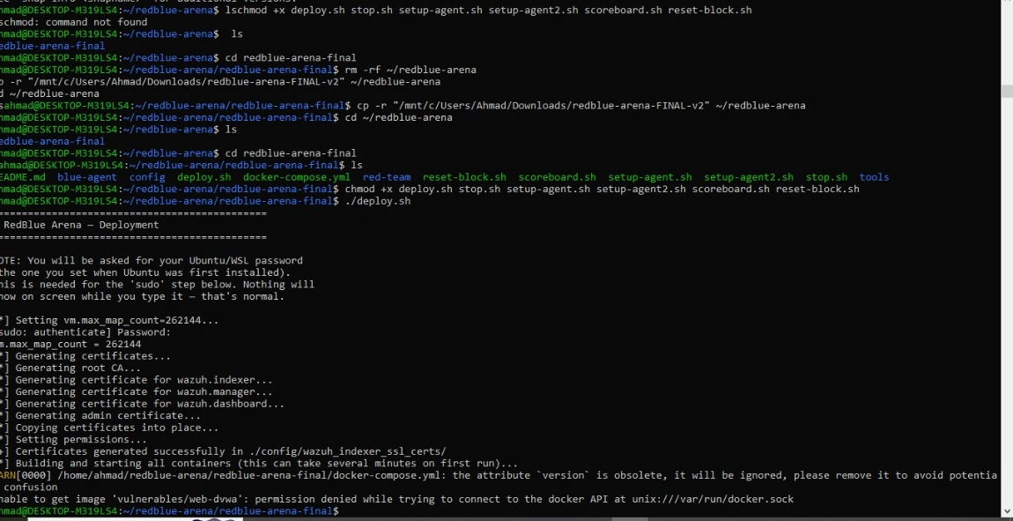

Step 2 — First deployment attempt

Running the deployment script began the automated setup: setting the vm.max_map_count kernel parameter, generating TLS certificates for the Wazuh indexer/manager/dashboard, and building/starting all containers:
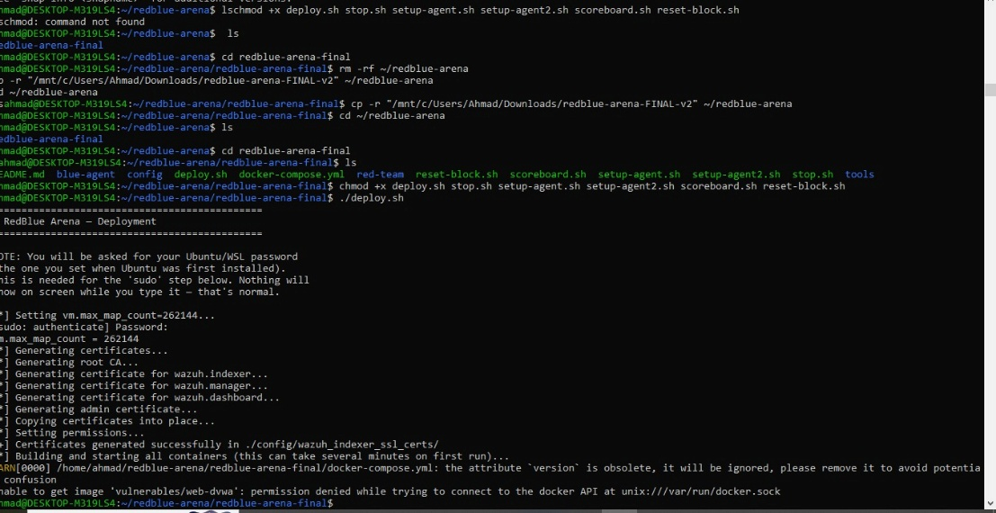

Step 3 — Issue #1: Docker permission denied
The first run failed while pulling images, with the following error:
unable to get image 'vulnerabilities/web-dvwa': permission denied while trying
to connect to the docker API at unix:///var/run/docker.sock
Cause: the Linux user inside WSL was not a member of the docker group, so it had no permission to talk to the Docker daemon socket.
Fix applied:
sudo usermod -aG docker $USER
followed by a full WSL restart (from Windows PowerShell) so the new group membership would take effect:
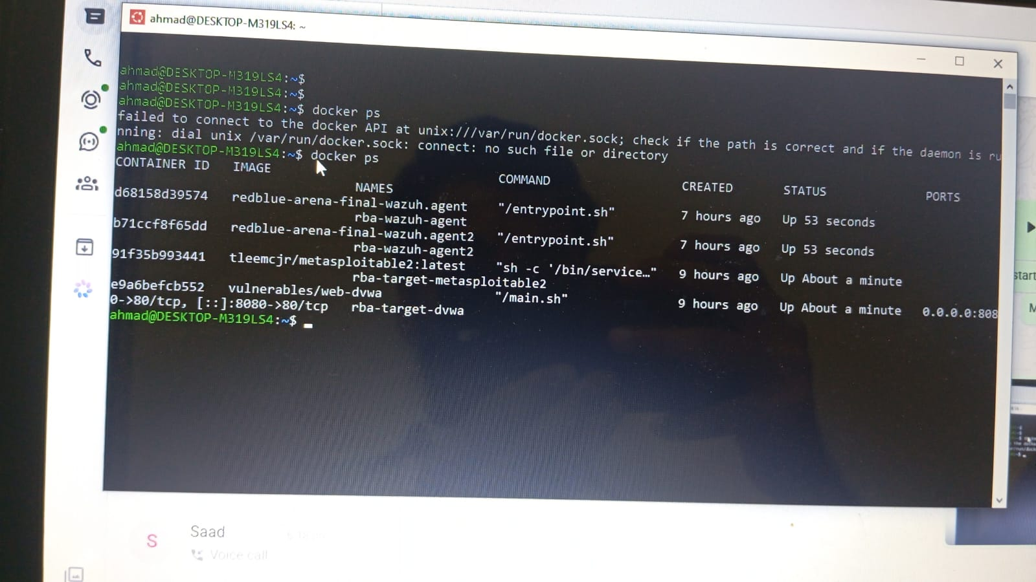

Step 4 — Issue #2: Docker socket not found
After fixing the permission issue, a second, different error appeared:
failed to connect to the docker API at unix:///var/run/docker.sock:
dial unix /var/run/docker.sock: connect: no such file or directory
Cause: Docker Desktop’s WSL2 integration was not enabled for the Ubuntu distribution, so the Linux side had no Docker daemon/socket to talk to at all.
Fix applied (in Docker Desktop → Settings):
- Opened Docker Desktop → Settings (gear icon).
- Navigated to Resources → WSL Integration.
- Enabled “Enable integration with my default WSL distro” and toggled the Ubuntu distro ON.
- Clicked Apply & Restart and let Docker Desktop restart.
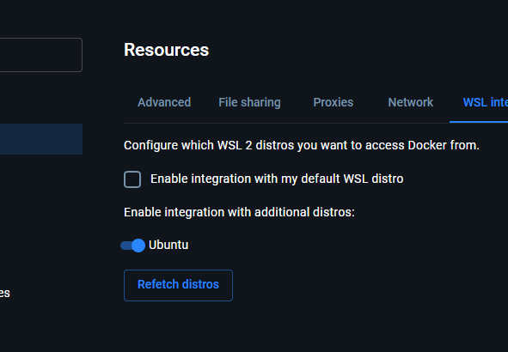

After the restart, docker ps ran cleanly with no errors, confirming the daemon was now reachable from WSL.
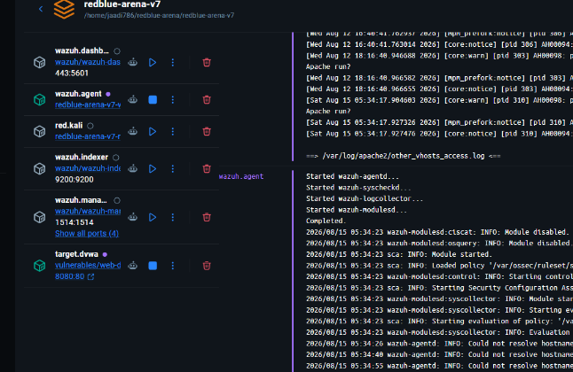

Step 5 — Issue #3: Credential helper error while building custom images
On the next deploy attempt, all five pre-built images (Wazuh indexer/manager/dashboard, Metasploitable2, DVWA) pulled successfully, but the three custom images that had to be built locally (red.kali, wazuh.agent, wazuh.agent2) failed with:
WSL ERROR: UtilAcceptVsock:273: accept4 failed 110
...
red_kali: failed to solve: error getting credentials - err: exit status 1, out: ``
Cause: the Docker config file referenced a Windows-side credential helper (desktop.exe) that is not reachable from within the WSL Linux environment, so every local image build failed at the credential-lookup stage.
Fix applied — the broken credential store entry was removed from the Docker config:
cat ~/.docker/config.json
# showed: { "credsStore": "desktop.exe" }

echo '{}' > ~/.docker/config.json
cat ~/.docker/config.json # confirmed it now shows {}
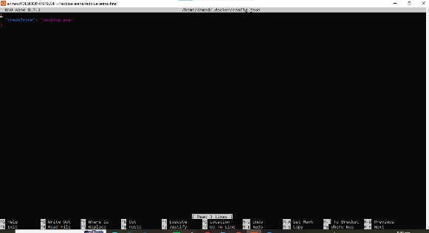

Step 6 — Successful deployment
With all three issues resolved, deploy.sh was re-run. This time every image pulled or built successfully, and all 8 containers came up cleanly:
[+] up 28/28
Image redblue-arena-final-wazuh.agent2 Built
Image redblue-arena-final-red.kali Built
Image redblue-arena-final-wazuh.agent Built
Container rba-target-dvwa Started
Container rba-target-metasploitable2 Started
Container rba-wazuh-manager Started
Container rba-wazuh-indexer Started
Container rba-wazuh-agent Started
Container rba-wazuh-dashboard Started
Container rba-wazuh-agent2 Started
Container rba-red-kali Started

Deployment started. Give it 1-2 minutes, then:
- Wazuh Dashboard : https://localhost (admin / SecretPassword)
- DVWA Target : http://localhost:8080
- Run the attack : docker exec -it rba-red-kali bash /root/attack.sh
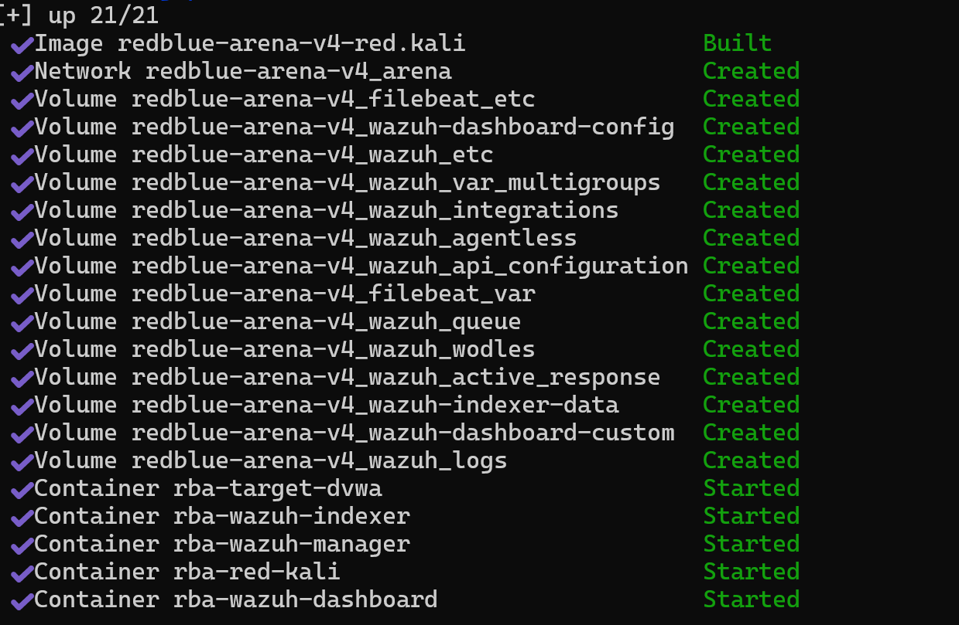

Step 7 — One-time agent setup
Each Wazuh agent was linked to its target's log files (a one-time step so that attacks against a target actually generate alerts on the dashboard):
./setup-agent.sh
./setup-agent2.sh

Step 8 — DVWA setup
http://localhost:8080 was opened, “Create / Reset Database” was clicked, and login was performed with admin / password.
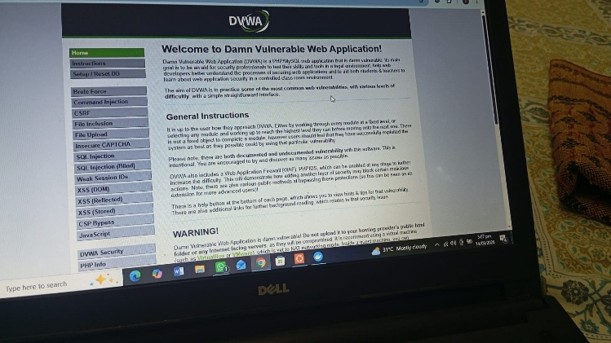

Step 9 — Running the Red Team attack
The full automated attack sequence was launched against both targets:
docker exec -it rba-red-kali bash /root/attack.sh
Attack sequence executed:
- Nmap reconnaissance scan on DVWA.
- Deep vulnerability scan (OS detection, scripts, traceroute).
- Web path / directory probing.
- SQL injection attempts against DVWA.
- Metasploit vulnerability scanner run against DVWA.
- Nmap reconnaissance on Metasploitable2.
- Real exploit — the well-known vsftpd 2.3.4 backdoor, opening an actual remote shell and running id on the target to prove real code execution.
- Brute-force attack — Hydra guessing SSH credentials on Metasploitable2.
- Blue Team response check — both targets re-tested to confirm whether the attacker had been auto-blocked.
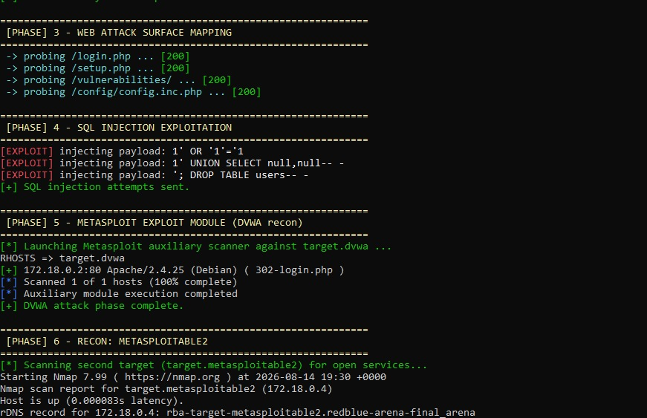

Step 10 — Confirming Blue Team detection & blocking
The Wazuh dashboard was opened at https://localhost (self-signed certificate warning accepted) and logged into with admin / SecretPassword. Under Threat Hunting, filters were cleared, the time range was set to “Last 24 hours”, and the query rule.level:>=6 was used to isolate high-severity alerts generated by the attack.
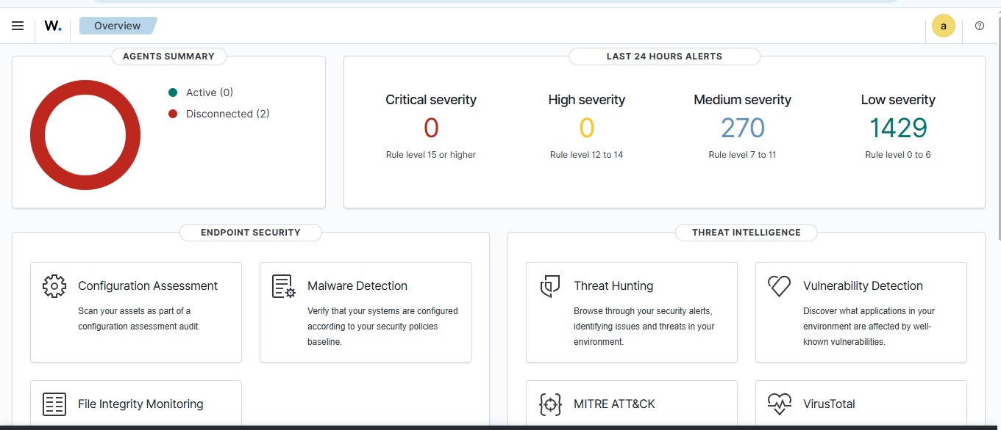
The live alert count was also watched from a second terminal:
./scoreboard.sh
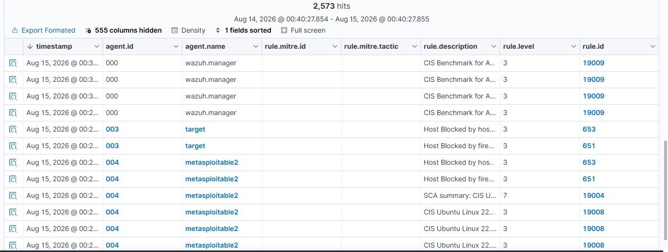
Finally, the actual firewall-level block was verified directly on both agents:
docker exec rba-wazuh-agent iptables -L -n
docker exec rba-wazuh-agent2 iptables -L -n
Both showed a DROP rule for the Kali attacker's IP address, confirming the Blue Team had automatically detected and blocked the attack, not just logged it.

3.3 How the Defense Works
Wazuh's manager runs two active-response layers, automatically triggered by any alert of severity level 6 or higher from either agent:
- firewall-drop — adds an iptables DROP rule for the attacker's IP. This is what actually cuts off traffic.
- host-deny — also records the IP in /etc/hosts.deny as a second, more traditional layer of blocking.
Brute-force detection uses Wazuh's built-in SSH rules (no custom rule-writing was needed) — repeated failed logins are automatically recognized and scored. Both blocks auto-expire after 120 seconds, and can be reset early with ./reset-block.sh to allow a re-run of the demo.

3.4 Stopping the Environment
./stop.sh

4. Startup — Simplified Build
Before successfully completing the full build, a second, simplified version of the same project was created and deployed. The goal of this version was a cleaner, faster demonstration: it keeps the same core idea (Red Team attacks, Blue Team detects) but reduces the moving parts down to a single target and a shorter attack flow, and pins Wazuh to a stable, well-tested version (4.9.2) to avoid the intermittent “image not found” issues that can happen right after a newer release.

4.1 What Was Simplified Compared to Project 1
Aspect | Project 1 (Full Build) | Project 2 (Simplified Build)
Targets | DVWA + Metasploitable2 (2 targets) | DVWA only (1 target)
Wazuh Agents | Two agents (one per target) | One agent (for DVWA)
Attack Tools Used | Nmap, Metasploit, Hydra brute force, real vsftpd exploit | Nmap + Metasploit against DVWA
Active Blocking | Yes — live iptables auto-block + host-deny | No — detection & logging/dashboard only
Extra Utilities | scoreboard.sh (live counter), reset-block.sh | Not included (smaller script set)
Wazuh Version | Latest tag | Pinned to 4.9.2 (stable)

4.2 Architecture Overview
Service | Container Name | Purpose
wazuh.manager / indexer / dashboard | rba-wazuh-* | Blue Team SIEM + live dashboard
target.dvwa | rba-target-dvwa | Deliberately vulnerable web app (the “victim”)
red.kali | rba-red-kali | Red Team attacker with Metasploit + Nmap

4.3 Deployment Steps

Step 1 — Prepare the project folder
cd ~/redblue-arena-v7
chmod +x deploy.sh stop.sh

Step 2 — Deploy
Because the WSL/Docker configuration issues (group membership, WSL integration, credential store) had already been fixed while deploying Project 1, this second deployment went smoothly without repeating those problems:
./deploy.sh
The script generated TLS certificates locally with openssl, then built and started all containers (image download + indexer bootstrap took a few minutes on first run).
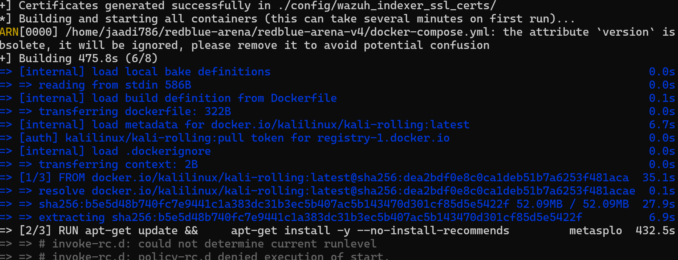

Step 3 — Verify all containers are running
docker ps
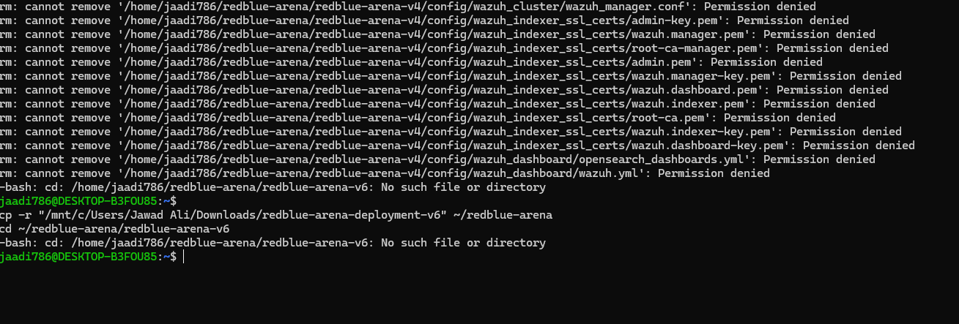

Step 4 — One-time agent setup
The Wazuh agent was connected to DVWA's Apache logs (without this step, the dashboard stays empty even during an attack):
chmod +x setup-agent.sh
./setup-agent.sh

Step 5 — DVWA setup
http://localhost:8080 was opened, the database was created/reset, and login was performed with admin / password.

Step 6 — Run the attack
docker exec -it rba-red-kali bash /root/attack.sh

Step 7 — Watch the Blue Team detect it
The Wazuh dashboard was opened at https://localhost (self-signed certificate warning accepted) and logged into with admin / SecretPassword to confirm the attack traffic was picked up and logged as alerts.

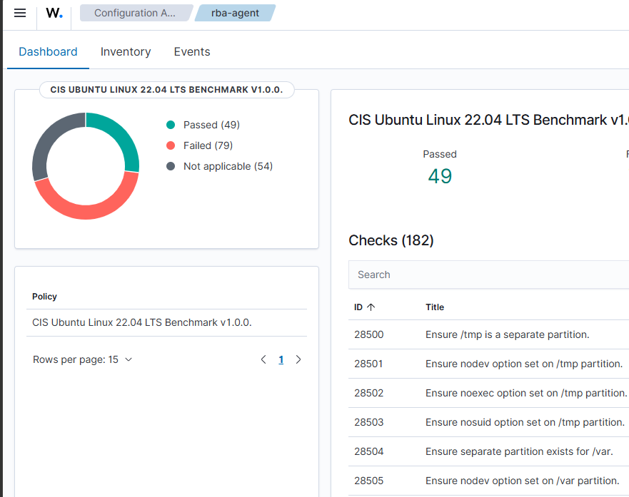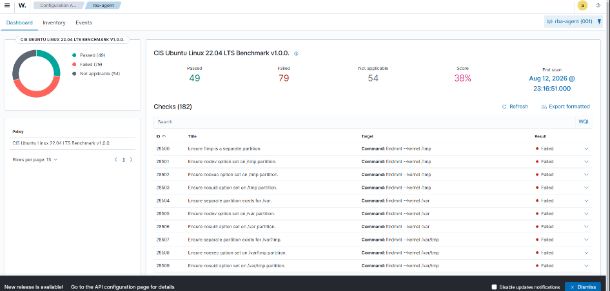

Step 8 — Stop / clean up
./stop.sh

5. Summary of Issues Encountered & Fixes
# | Issue | Root Cause | Fix
1 | permission denied at /var/run/docker.sock | WSL user not in the docker group | sudo usermod -aG docker $USER, then restart WSL (wsl --shutdown)
2 | connect: no such file or directory on docker.sock | Docker Desktop WSL2 integration not enabled for the distro | Enabled the distro under Docker Desktop → Settings → Resources → WSL Integration → Apply & Restart
3 | error getting credentials (image build failure) | ~/.docker/config.json pointed to a Windows-only credsStore (desktop.exe) unreachable from WSL | Replaced the file contents with {}

6. Conclusion
This project provided direct, hands-on experience with building and operating a working Red Team vs. Blue Team cyber range end to end — not just running pre-made software, but also diagnosing and fixing real environment problems (Docker permissions, WSL2/Docker Desktop integration, and credential-store configuration) that are common in any real-world containerized deployment.
Deploying the full build first (Project 2) demonstrated the complete kill-chain — reconnaissance, scanning, exploitation, brute forcing, and a real remote-shell exploit — alongside a Blue Team that not only detects but actively blocks the attacker in real time. Building the simplified version afterwards (Project 1) reinforced the same concepts in a smaller, faster-to-demo form, and confirmed that once the underlying Docker/WSL environment was correctly configured, further deployments went smoothly.
Overall, the project met its objective: showing, in practice, how a SIEM-based Blue Team can detect and respond to an active attack against vulnerable targets.

Key URLs & Credentials Reference
Resource | URL / Command | Credentials
Wazuh Dashboard | https://localhost | admin / SecretPassword
DVWA Target | http://localhost:8080 | admin / password
Run Attack (Project 1) | docker exec -it rba-red-kali bash /root/attack.sh | —
Run Attack (Project 2) | docker exec -it rba-red-kali bash /root/attack.sh | —

