
Late Bhausaheb Hiray S.S. Trust’s
Institute of Computer Application
C E R T I F I C A T E
This is to certify that of MCA Semester - I with Roll No. has completed all practical of MCAL14 Web Technologies Lab under the guidance of Dr.Avantika Mahadik, in this college during the year 2024-2025.

CO | Attendance | Performanc e during Lab session | Innovatio n in problem solving  techniques | Mock Viva during Lab  session | Journal
CO1
CO2
CO3
CO4

Subject In-Charge Director

External Examiner

Index

Sr. No | Title | Date | CO | Sign
1 | Create an application to demonstrate Node.js Modules |  | CO1
2 | Create an application to demonstrate various Node.js Events |  | CO1
3 | Create an application to demonstrate Node.js Functions |  | CO1
4 | Using File Handling demonstrate all  basic file operations (Create, write, read, delete) |  | CO1
5 | Create an HTTP Server and perform operations on it |  | CO1
6 | Create an application to establish a connection with the MySQL database and perform basic  database operations on it |  | CO2
7 | Create an application in React JS to implement component life cycle |  | CO3
8 | Create an application to implement class and functional component in React JS |  | CO3
9 | Create an application in React JS to import and export the files (components) |  | CO3 CO4
10 | Create an application to implement state and props |  | CO3 CO4
11 | Create an application in React JS to use DOM events |  | CO3 CO4
12 | Create an application in React JS form and add client and server side validation |  | CO4
13 | Create an application to implement React Hooks |  | CO4
14 | Create SPA using React Router |  | CO4

Practical No. 1

Create an application to demonstrate Node.js Modules.

AIM:-1(A) Core Module/Built in Modules DISCRIPTION:-
Node.js modules are reusable pieces of JavaScript code that can be imported and exported between files. They allow developers to break applications into smaller, manageable chunks. Node.js provides built-in modules such as fs (file system), http (server creation), and path (file paths).

CODE:- 1 .OS
var os = require('os'); console.log(os.EOL); console.log(os.arch());
console.log(os.hostname()); console.log(os.totalmem()); console.log(os.freemem()) ; console.log(os.platform()); console.log(os.type());
console.log(os.userInfo()) ;

OUTPUT:-
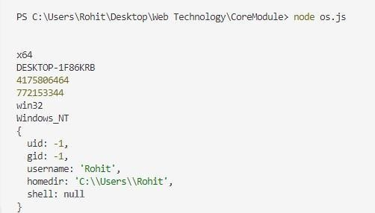
CODE:- 2. URL
var url =require('url');
console.log(url.parse('https://google.com')); console.log(url.domainToASCII('google.com'));
console.log(url.domainToUnicode('xn--espaol-zwa.com'));

OUTPUT:-
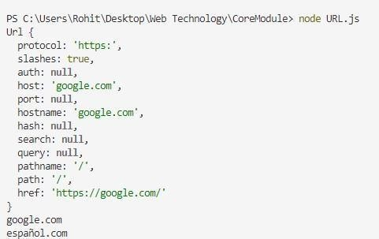

CODE:- 3. PATH
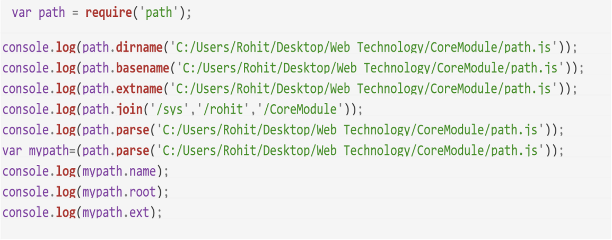

OUTPUT:-
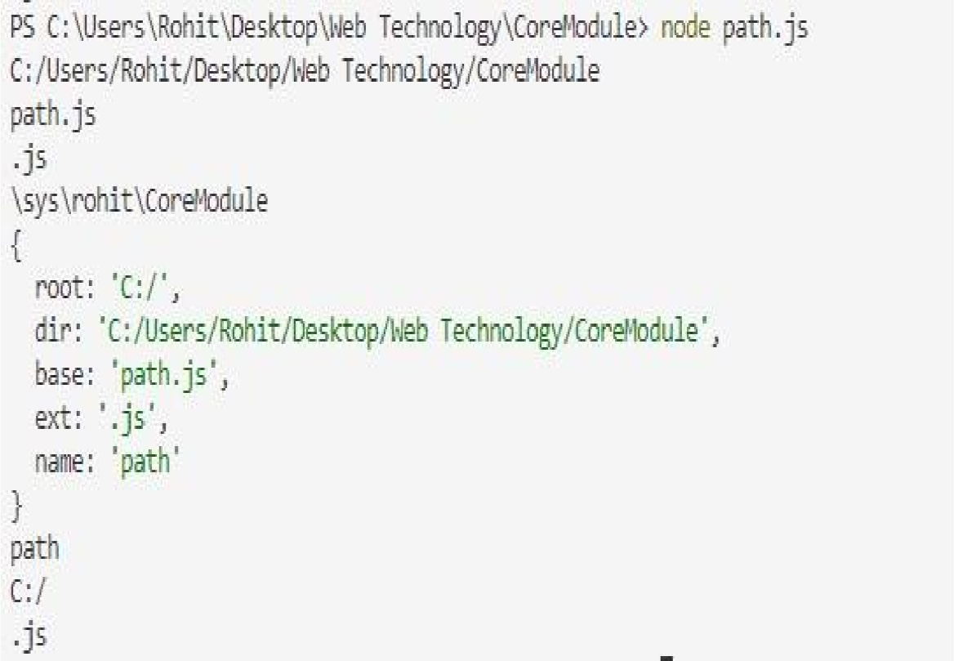

CODE:- 4. HTTP
const http = require('http');

// Create an HTTP server
const server = http.createServer((req, res) => {
// Set the response header
res.writeHead(200, { 'Content-Type': 'application/json' });

// Define a simple route
if (req.url === '/' && req.method === 'GET') {
res.end(JSON.stringify({ message: 'Welcome to the HTTP Web Service!' }));
} else if (req.url === '/api' && req.method === 'GET') { res.end(JSON.stringify({ message: 'This is the API endpoint!' }));
} else {
// Handle 404
res.writeHead(404, { 'Content-Type': 'application/json' }); res.end(JSON.stringify({ error: 'Resource not found' }));
}
});

// Start the server const PORT = 3000;
server.listen(PORT, () => {
console.log(`Server is running on http://localhost:${PORT}`);
});

OUTPUT:-
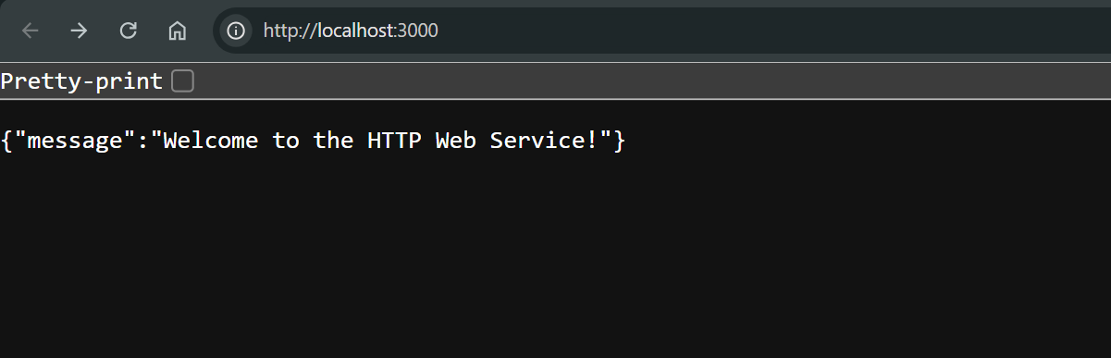
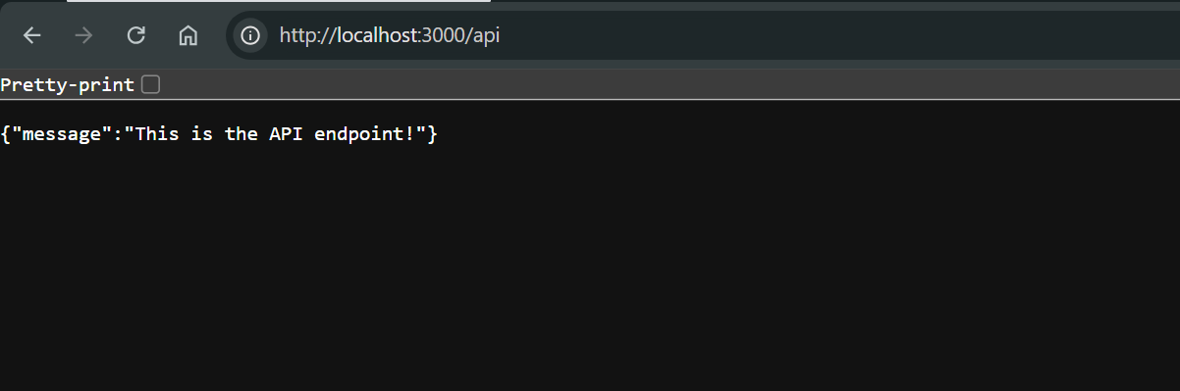

AIM:-1(B) Customizable Module/local Modules DISCRIPTION:-
Additionally, custom modules can be created using the exports or module.exports keyword. To include a module, the require() function is used. Modules encourage code reusability, separation of concerns, and easy maintenance. For example, a module containing database operations can be created and reused in multiple files.
Node.js also supports third-party modules via npm (Node Package Manager), such as express for web applications or axios for HTTP requests.

CODE:-

calc.js
exports.add = function (x, y) { return x + y;
}
exports.sub = function (x, y) { return x - y;
}
exports.mul = function (x, y) { return x * y;
}
exports.div = function (x, y) { return x / y;
}

usingmodule .js
var cal = require('./calc'); var x = 50; var y = 100; console.log("Adddition=", cal.add(x, y));
console.log("Subtraction=", cal.sub(x, y)); console.log("Multiplication=", cal.mul(x, y)); console.log("Divison=", cal.div(x, y));

OUTPUT:-
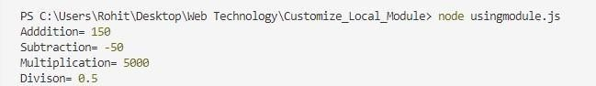

AIM:- Create an application to demonstrate various Node.js Events DISCRIPTION:-
Node.js events are a core feature of its asynchronous programming model. It uses the events module to create and manage events. The EventEmitter class allows binding functions (listeners) to events, which are triggered upon specific occurrences. For instance, an HTTP server triggers a request event when it receives a request. Custom events can also be created using emit() and on(). This event-driven model enhances Node.js's performance, making it ideal for I/O-heavy and real-time applications like chat apps and live notifications.

CODE:-
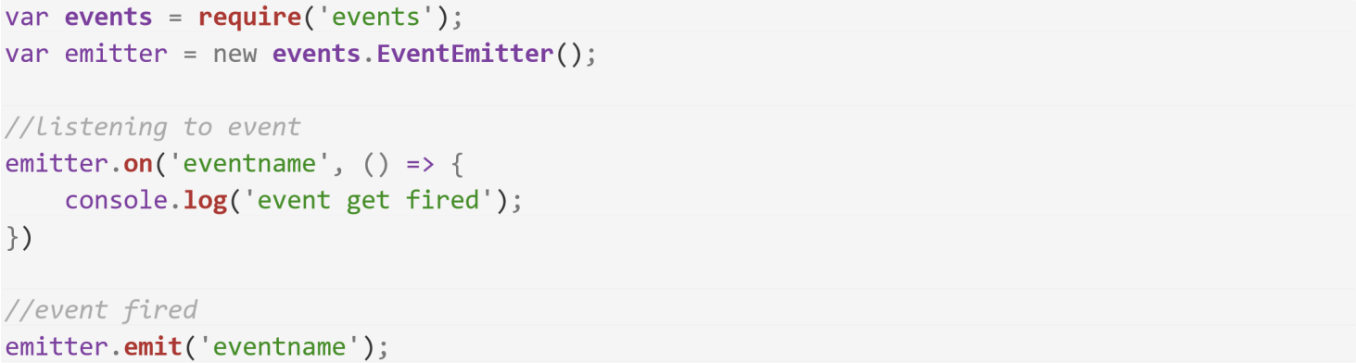

OUTPUT:-

Practical No. 3
AIM:- Create an application to demonstrate Node.js Functions DISCRIPTION:-
Functions in Node.js are essential for structuring code. They can be standard JavaScript functions or asynchronous ones using async/await or callbacks. Functions enable modularity and reusability of code. For example, a function to connect to a database or fetch an API response can be reused multiple times. Node.js supports higher-order functions, closures, and anonymous functions. Asynchronous functions help manage non-blocking operations, critical for handling multiple user requests efficiently.

CODE:-

function.js
//function in nodejs
var div = function (a, b) { return (a / b);
}
console.log("Division=", div(10, 5));
//arrow function format in node js var add = (a, b) => (a + b);
console.log("Addition=", add(12, 13));

OUTPUT:-
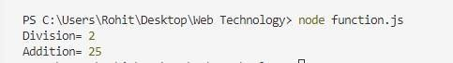

CODE:-
anonymousvalue.js

// Define variables

var middlename = "Samir";

let myname = { firstname: "Sachin", lastname: "Patil" };

// Immediately Invoked Function Expression (IIFE)

(function () {

console.log(myname.firstname, middlename, myname.lastname);

console.log("This is Hiray College");

})(myname);

// Log the middle name

console.log(middlename);

// Use setTimeout correctly

setTimeout(function () {

console.log("It gets executed after 5 seconds");

}, 5000);

OUTPUT:-

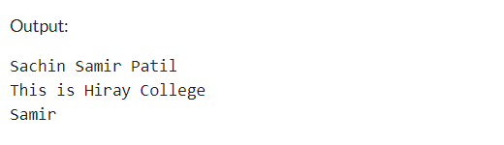

Practical No. 4
AIM:- Using File Handling demonstrate all basic file operations (Create, write, read, delete)

DISCRIPTION:-
Node.js supports file handling through the fs module, enabling developers to perform file operations such as creating, reading, writing, and deleting files. The fs.writeFile() function creates and writes to a file, while fs.readFile() reads file content. To delete files, the fs.unlink() method is used. Both synchronous and asynchronous methods are available. Asynchronous methods are preferred for non-blocking execution. File
handling is crucial for tasks such as logging, data storage, and file-based communication.

CODE:-
Read.js
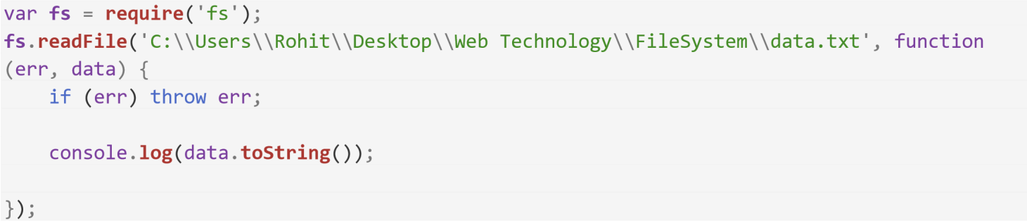

OUTPUT:-
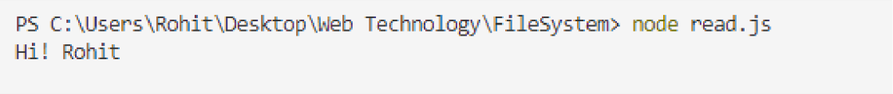

CODE:-
async.js
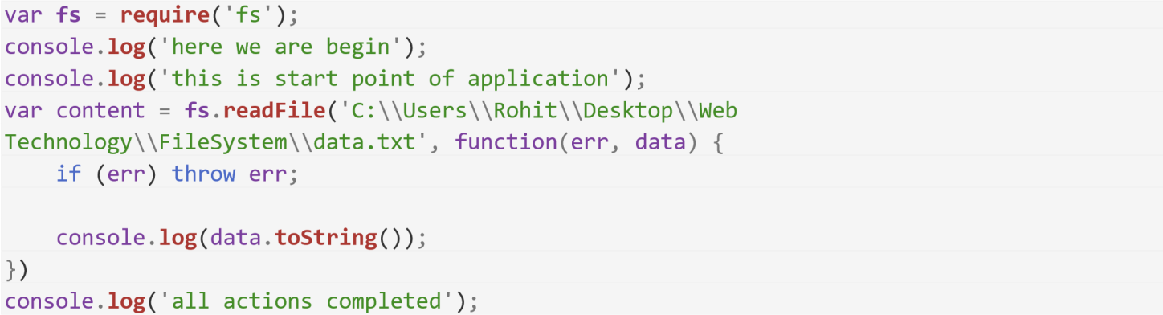

OUTPUT:-
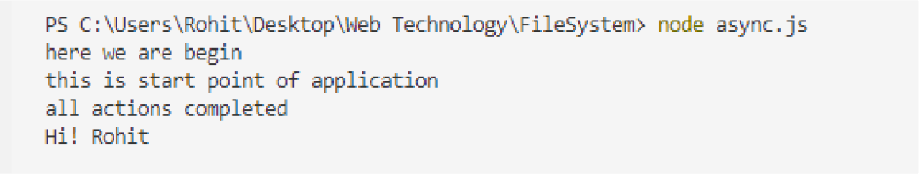

Practical No. 5
AIM:- Create an HTTP Server and perform operations on it

DISCRIPTION:-
Node.js provides the http module to create servers that handle client requests. A basic HTTP server can be created using the createServer() function, which listens for requests on a specified port. Developers can handle HTTP methods such as GET and POST, manage responses, and route requests. For example, an HTTP server can serve static files or APIs. The asynchronous nature of Node.js ensures high performance for concurrent user requests.

CODE:-
const express = require('express'); const app = express();

// Middleware to parse JSON requests app.use(express.json());

// Define routes
app.get('/', (req, res) => {
res.json({ message: 'Welcome to the HTTP Web Service!' });
});

app.get('/api', (req, res) => {
res.json({ message: 'This is the API endpoint!' });
});

// Handle 404 app.use((req, res) => {
res.status(404).json({ error: 'Resource not found' });
});

// Start the server const PORT = 3000; app.listen(PORT, () => {
console.log(`Server is running on http://localhost:${PORT}`);
});

OUTPUT:-
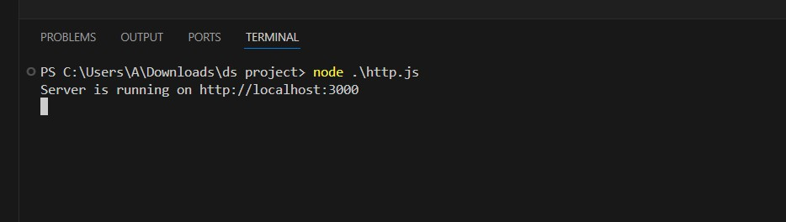


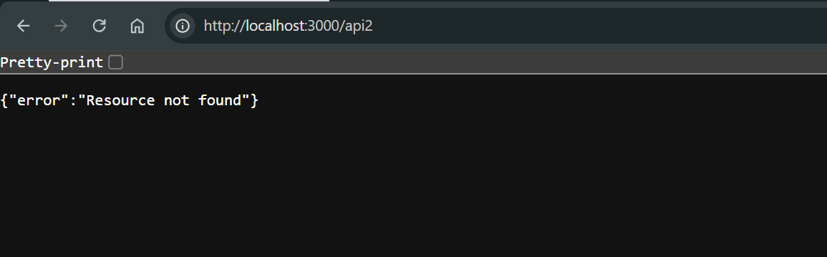

Practical No. 6
AIM:- Create an application to establish a connection with the MySQL database and perform basic database operations on it

DISCRIPTION:-
To connect to a MySQL database, the mysql or mysql2 package is used in Node.js. A connection is established using a configuration object containing the host, user, password, and database name. Operations such as INSERT, SELECT, UPDATE, and DELETE can be performed using SQL queries. Asynchronous methods like callbacks or promises ensure smooth data interaction without blocking the event loop. This is essential for applications requiring persistent data storage, such as user management systems.

CODE:-
Createtable.js
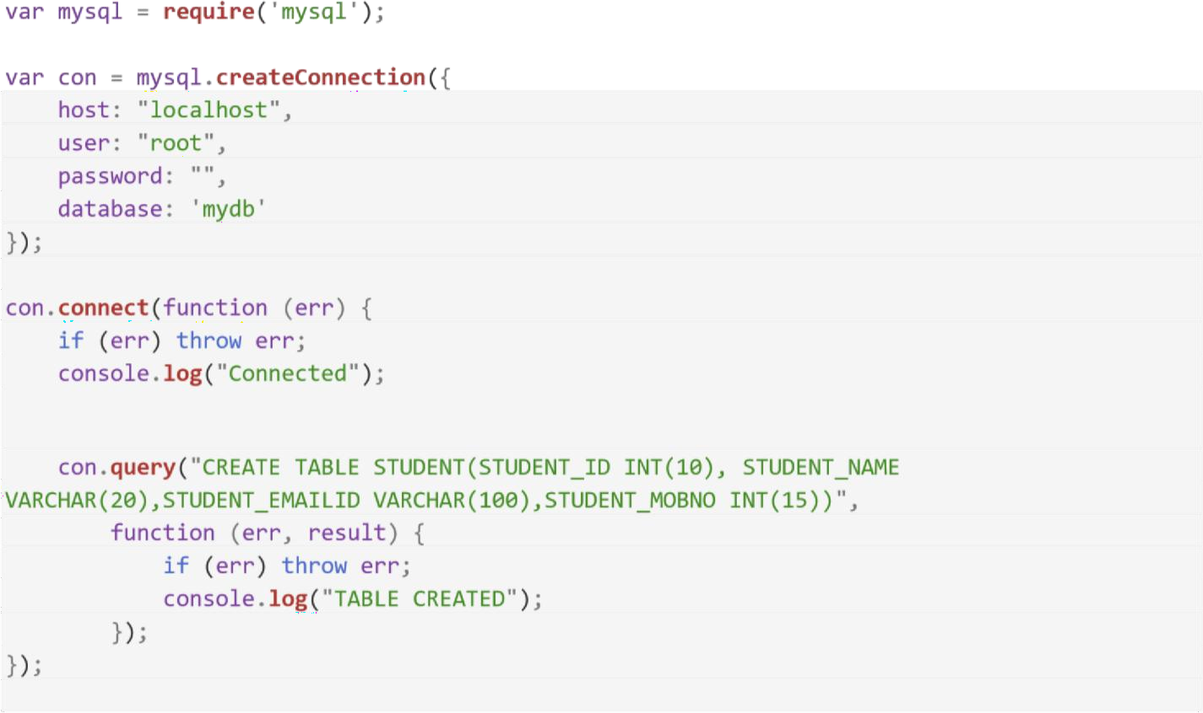

OUTPUT:-
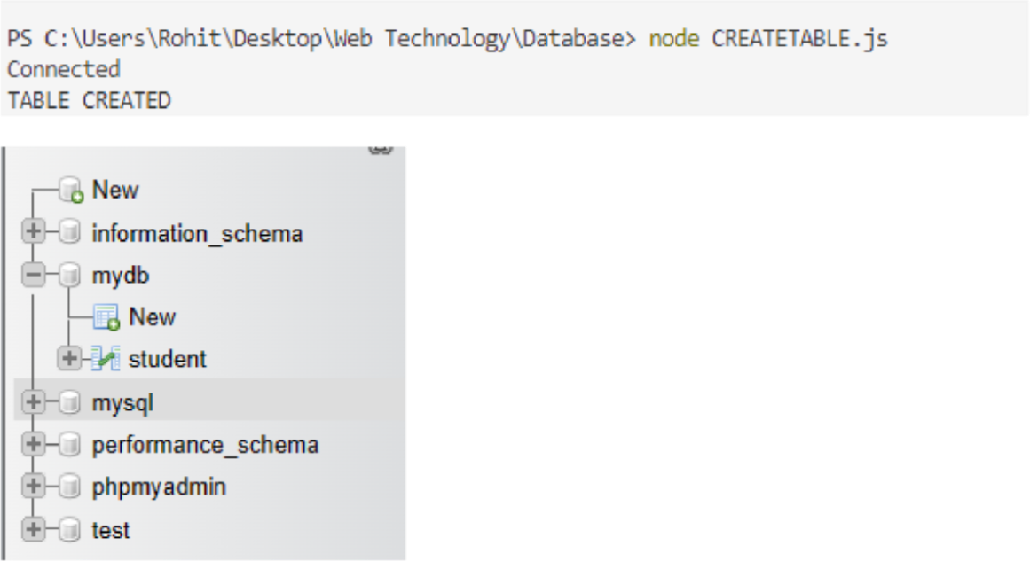

Practical No. 7
AIM:- : Create an application in ReactJS to implement component life cycle DISCRIPTION:-
constructor():
React components have a lifecycle with distinct phases: mounting, updating, and unmounting. Lifecycle methods, such as componentDidMount, componentDidUpdate, and componentWillUnmount, allow developers to perform specific actions during these phases. For instance, componentDidMount is used to fetch initial data. React’s lifecycle methods help manage state, API calls, and cleanups, ensuring smooth application performance.

CODE:-
// 1. Component Life Cycle (Class Component) import React, { Component } from 'react';
class LifeCycleDemo extends Component { constructor(props) {
super(props); this.state = { count: 0 };
console.log('Constructor called');
}

componentDidMount() {
console.log('Component did mount');
}

componentDidUpdate() {
console.log('Component did update');
}

componentWillUnmount() {
console.log('Component will unmount');
}

incrementCount = () => {
this.setState({ count: this.state.count + 1 });
};

render() {
console.log('Render method called');

return (
<div>
<h1>Lifecycle Methods</h1>
<p>Count: {this.state.count}</p>
<button onClick={this.incrementCount}>Increment</button>
</div>
);
}
}
export default LifeCycleDemo;

OUTPUT:-
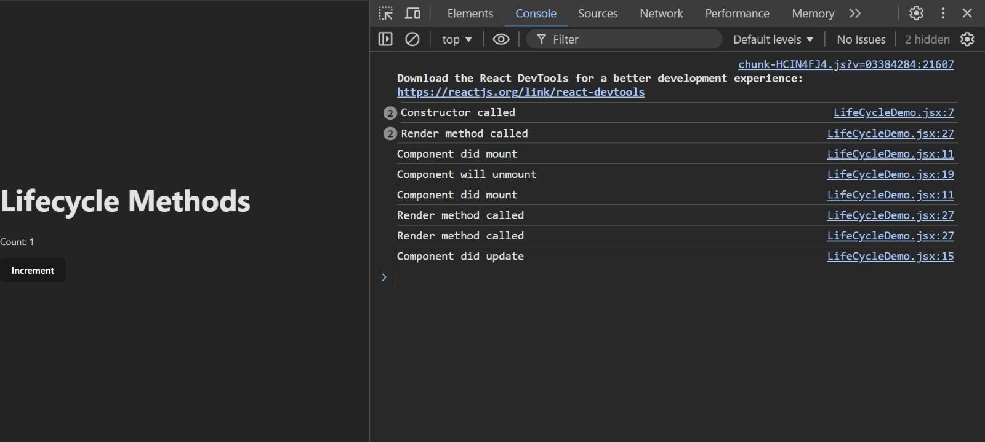

Practical No. 8
AIM:- : Create an application to implement class and functional component in ReactJS DISCRIPTION:-
Class components in React use class syntax and can manage state using this.state and lifecycle methods. Functional components, on the other hand, are simpler and use functions to render UI. With the introduction of React Hooks, functional components can also manage state (useState) and lifecycle (useEffect). Functional components are lightweight, easier to test, and encourage cleaner code. Both are used based on application requirements.

CODE:-

ClassComponent.jsx
import { Component } from "react";
class ClassComponent extends Component { render() {
return <h1>This is a Class Component</h1>;
}
}
export default ClassComponent;

Functional
import ClassComponent from "./ClassComponent.jsx";

const Functional = () => { return (
<div>
<ClassComponent />
<h2>This is Functional Component</h2>
</div>
);
};
export default Functional;

main
import { createRoot } from "react-dom/client"; import Functional from "./Functional";

createRoot(document.getElementById("root")).render(<Functional />);

OUTPUT:-
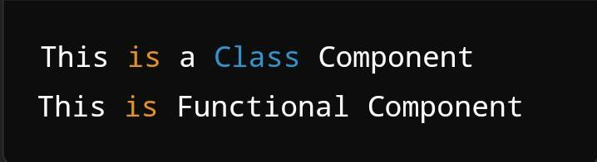

Practical No. 9
AIM:- : Create an application in ReactJSto import and export the files (components) DISCRIPTION:-
In ReactJS, import and export enable modular code by separating components into different files. Components, functions, or variables can be exported using export or export default. These can then be imported into other files using import. This separation improves maintainability and reusability. For example, a reusable button component can be created and imported into multiple pages.

CODE:-

// File: Header.js
export const Header = () => { return (
<header>
<h1>Header Component</h1>
<nav>
<a href="/home">Home</a> | <a href="/about">About</a> | <a href="/contact">Contact</a>
</nav>
</header>
);
};

// File: Footer.js
export const Footer = () => { return (
<footer>
<p>© 2024 Your Company</p>
</footer>
);
};

// File: App.js
import React from 'react';
import { Header } from './Header'; import { Footer } from './Footer';

function App() { return (
<div>
<Header />
<main>
<h1>Welcome to Our Website</h1>
<p>This is the main content area.</p>
</main>
<Footer />
</div>
);
}

export default App;

OUTPUT:-
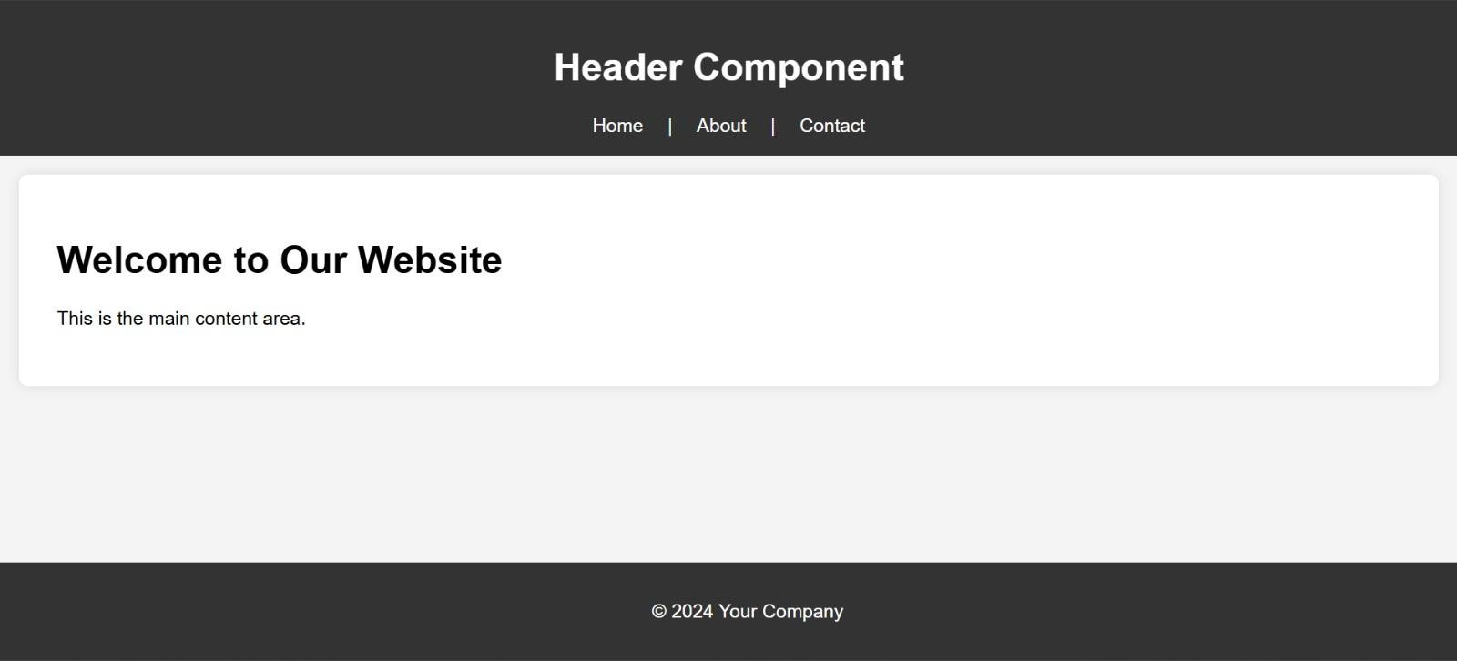

Practical No. 10
AIM:- : Create an application to implement state and props DISCRIPTION:-
State and props are the two primary data-handling methods in React. State represents the dynamic data of a component and is managed internally. Props are read-only inputs passed from parent to child components. Together, they allow components to be dynamic and
interactive. For example, a parent component can pass a user’s name as a prop to a child component to display it.

CODE:-

//ParentComponent.jsx
import { useState } from "react";
import ChildComponent from "./ChildComponent";

const ParentComponent = () => {
const [userName, setUserName] = useState("Vitthal");

const changeUserName = () => { setUserName("Korvan");
};

return (
<div>
<h1>Welcome, {userName}!</h1>
<ChildComponent name={userName} />
<button onClick={changeUserName}>Change User Name</button>
</div>
);
};

export default ParentComponent;

//ChildComponent
const ChildComponent = ( { name } ) => {
return <h2>Message is: Hello, {name}!</h2>;
};

export default ChildComponent;

//Main.jsx
import { createRoot } from "react-dom/client";
import ParentComponent from "./ParentComponent";

createRoot(document.getElementById("root")).render(<ParentComponent />

OUTPUT:-






Practical No. 11
AIM:- : Create an application in ReactJSto use DOM events DISCRIPTION:-
React uses synthetic events, which are wrappers around browser-native DOM events. Events such as onClick, onChange, and onSubmit are used to handle user interactions. For example, a button click can trigger a function to update state or send an API request. React’s event system ensures cross-browser compatibility and optimizes performance by delegating events.

CODE:-

//App.jsx
import React from "react";

const App = () => { function handleClick() { alert("Button clicked!");
}

function handleInputChange(event) {
console.log("Input value:", event.target.value);
}

function handleFocus() { console.log("Input focused");
}

return (
<>
<input type="text" onChange={handleInputChange} />
<input type="text" onFocus={handleFocus} />

<button onClick={handleClick}>Click Me</button>
</>
);
};

export default App;

//Main.jsx
import { StrictMode } from "react";
import { createRoot } from "react-dom/client"; import App from "./App.jsx";
createRoot(document.getElementById("root")).render(
<StrictMode>
<App />
</StrictMode>
);

OUTPUT:-
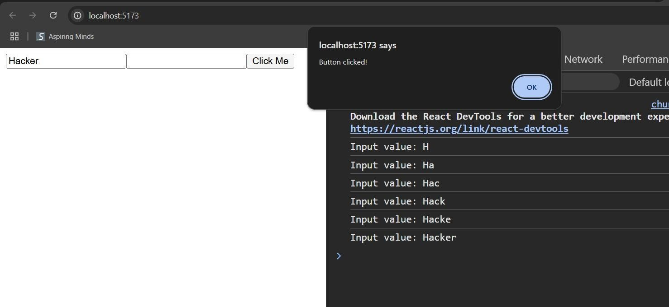

Practical No. 12
AIM:- : Create an application in ReactJSform and add client and server side validation DISCRIPTION:-
React forms handle user input through controlled components, where form elements' values are bound to state. Validation can be added using functions that check for specific conditions (e.g., email format, required fields). Server-side validation is also performed by sending the form data to a backend server. Libraries like Formik and React Hook Form simplify form handling and validation.

CODE:-

//FormValidation.jsx
import { useState } from "react";

const FormValidation = () => {
const [email, setEmail] = useState(""); const [error, setError] = useState("");

const validateEmail = (email) => {
const regex = /^[\w-\.]+@([\w-]+\.)+[\w-]{2,4}$/g; return regex.test(email);
};

const handleSubmit = (e) => { e.preventDefault();
if (!validateEmail(email)) {
setError("Invalid email address");
} else {
setError("");
alert("Form submitted successfully");
}
};

return (
<form onSubmit={handleSubmit}>
<label>Email:</label>
<input

type="text" value={email}
onChange={(e) => setEmail(e.target.value)}
/>
{error && <p style={{ color: "red" }}>{error}</p>}
<button type="submit">Submit</button>
</form>
);
};

export default FormValidation;

//Main.jsx
import { StrictMode } from 'react'
import { createRoot } from 'react-dom/client'
import FormValidation from './FormValidation.jsx'

createRoot(document.getElementById('root')).render(
<StrictMode>
<FormValidation />
</StrictMode>,
)

OUTPUT:-
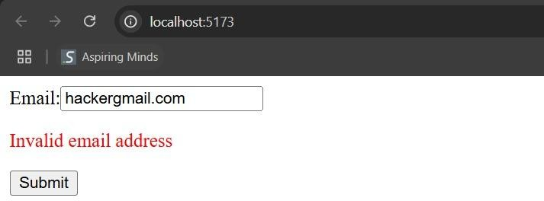

Practical No. 13 AIM:- : Create an application to implement React Hooks DISCRIPTION:-
React Hooks, introduced in React 16.8, enable state and lifecycle management in functional components. Common hooks include useState for managing state, useEffect for side effects, and useContext for context management. Hooks simplify React development by eliminating the need for class components while offering a cleaner, more concise syntax.

CODE:-

//HooksDemo.jsx
import { useState, useEffect } from "react";

const HooksDemo = () => {
const [count, setCount] = useState(0);

useEffect(() => {
console.log("Component mounted or count updated"); return () => {
console.log("Cleanup on component unmount");
};
}, [count]);

return (
<div>
<h1>Count: {count}</h1>
<button onClick={() => setCount(count + 1)}>Increment</button>
</div>
);
};

export default HooksDemo;

//Main.jsx
import { StrictMode } from 'react'
import { createRoot } from 'react-dom/client'

import HooksDemo from './HooksDemo.jsx'

createRoot(document.getElementById('root')).render(
<StrictMode>
<HooksDemo />
</StrictMode>,
)

OUTPUT:-
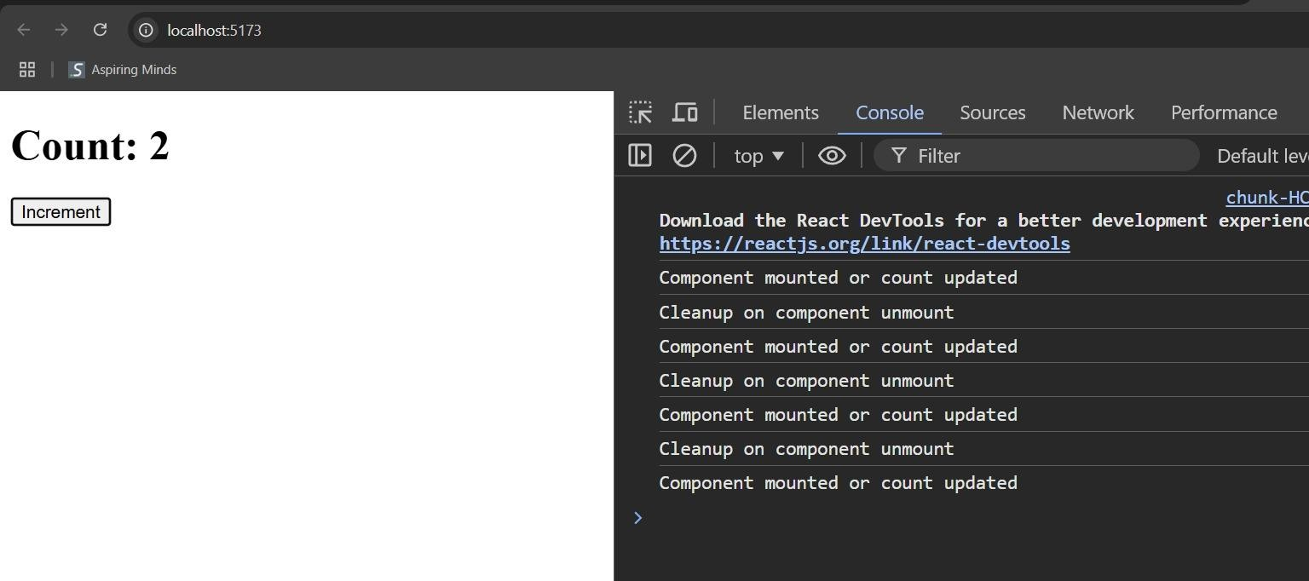

Practical No. 14 AIM:- : Create SPA using React Router

DISCRIPTION:-
Single Page Applications (SPAs) using React Router enable seamless navigation without reloading the page. The react-router-dom package provides components like BrowserRouter, Route, and Link to create routes and manage navigation. SPAs
improve performance and user experience by dynamically rendering content based on the route without server-side page reloading.

CODE:-

npm install react-router-dom
//Home.jsx
const Home = () => { return (
<div>
<h1>Welcome to Home Page</h1>
<p>This is the home page of our single-page application.</p>
</div>
);
};

export default Home;

//About.jsx
const About = () => { return (
<div>
<h1>Welcome to About Page</h1>
<p>This is the About page of our single-page application.</p>
</div>
);
};

export default About;

//Contact.jsx

const Contact = () => { return (
<div>
<h1>Contact Us</h1>
<p>Feel free to contact us via the form below.</p>
</div>
);
};

export default Contact;

//App.jsx
import { BrowserRouter as Router, Routes, Route, Link } from "react-router-dom"; import Home from "./components/Home";
import About from "./components/About";
import Contact from "./components/Contact";

const App = () => { return (
<Router>
<nav>
<ul>
<li>
<Link to="/">Home</Link>
</li>
<li>
<Link to="/about">About</Link>
</li>
<li>
<Link to="/contact">Contact</Link>
</li>
</ul>
</nav>

<Routes>
<Route path="/" element={<Home />} />
<Route path="/about" element={<About />} />
<Route path="/contact" element={<Contact />} />

</Routes>
</Router>
);
};

export default App;

//Main.jsx
import { StrictMode } from 'react'
import { createRoot } from 'react-dom/client' import App from './App.jsx'

createRoot(document.getElementById('root')).render(
<StrictMode>
<App />
</StrictMode>,
)

OUTPUT:-
