Grade:________

**Mobile Application Development Projects**

**Enrique A. Sanchez**

**Second Term Exam**

**Student number:** _______________________

En este examen me comprometo a conducirme con honestidad y a no servirme de medios no autorizados o ilícitos para realizarlo.

**Setup:**

1. Go to <https://github.com/enrikesancheztec/secondPartial>

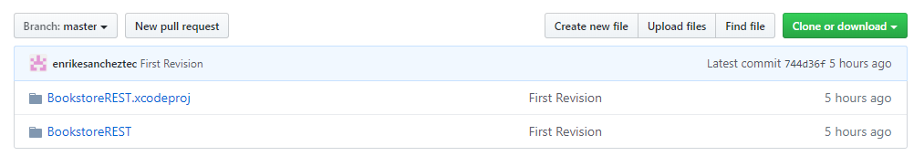

1. Download the project. DO NOT CLONE IT

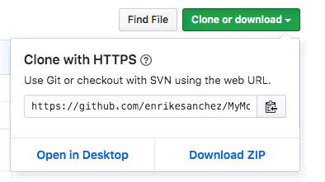

1. Unzip the file
2. Open the file in xcode

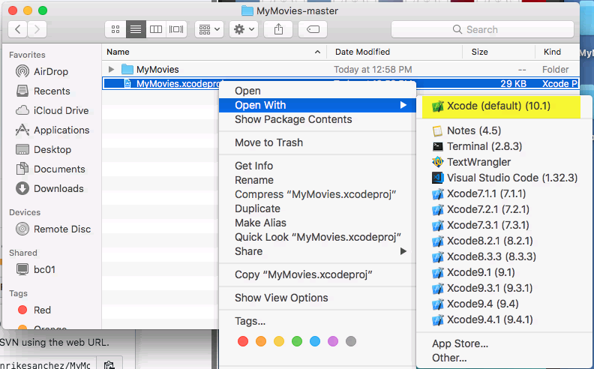

1. Run the Application in the Simulator

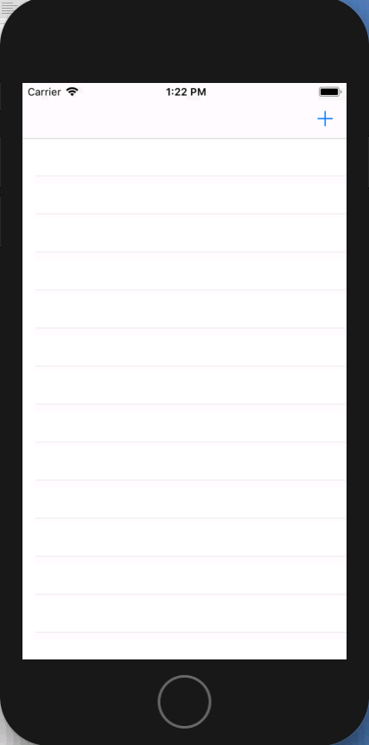

1. Check the source code and get familiarized with it
2. Create a private project in github and give permissions for the teacher (enrikesancheztec)
3. Perform an initial commit with the created project.
4. Perform an additional commit for EACH question solution. Don’t commit an answer in more than one commit. Don’t commit together 2 or more answers
5. Each question will be graded using these criteria:

|  |  |  |
| --- | --- | --- |
| **Grade** | **Description** | **Points** |
| N | Not achieved | 0 |
| P | Partially achieved | 50 |
| L | Largely achieved | 85 |
| F | Fully achieved | 100 |