PROJECT N°4
Secure Internal Network Administration
ALMASSAR Enterprise Infrastructure

Company: | ALMASSAR
Student: | Jaafar Trabelsi
Institution: | International University of Rabat (UIR)
Academic Year: | 2025/2026

1. Introduction and Objectives

The objective of this project is to design, deploy, and administer a secure internal network infrastructure for the ALMASSAR company. The company is divided into three distinct operational departments: Purchases, Clients, and Human Resources.

To ensure both high performance and robust security, the network architecture isolates these departments into separate logical segments while allowing controlled inter-departmental communication via a core backbone. Furthermore, the infrastructure provides essential enterprise services, including DHCP, DNS, NAT, HTTPS, and FTPS, ensuring secure internal and external data flow.
2. Network Topology and Addressing

The network was deployed using the GNS3 simulation platform. A central backbone network connects distinct departmental gateways, allowing routed communication while enforcing security boundaries.

The IP addressing scheme is organized as follows:

Department | IP Subnet
Purchases Department | 172.17.1.0/24
Clients Department | 172.17.4.0/24
Human Resources Department | 172.17.6.0/24
Enterprise Services (Kali Linux) | 192.168.42.0/24

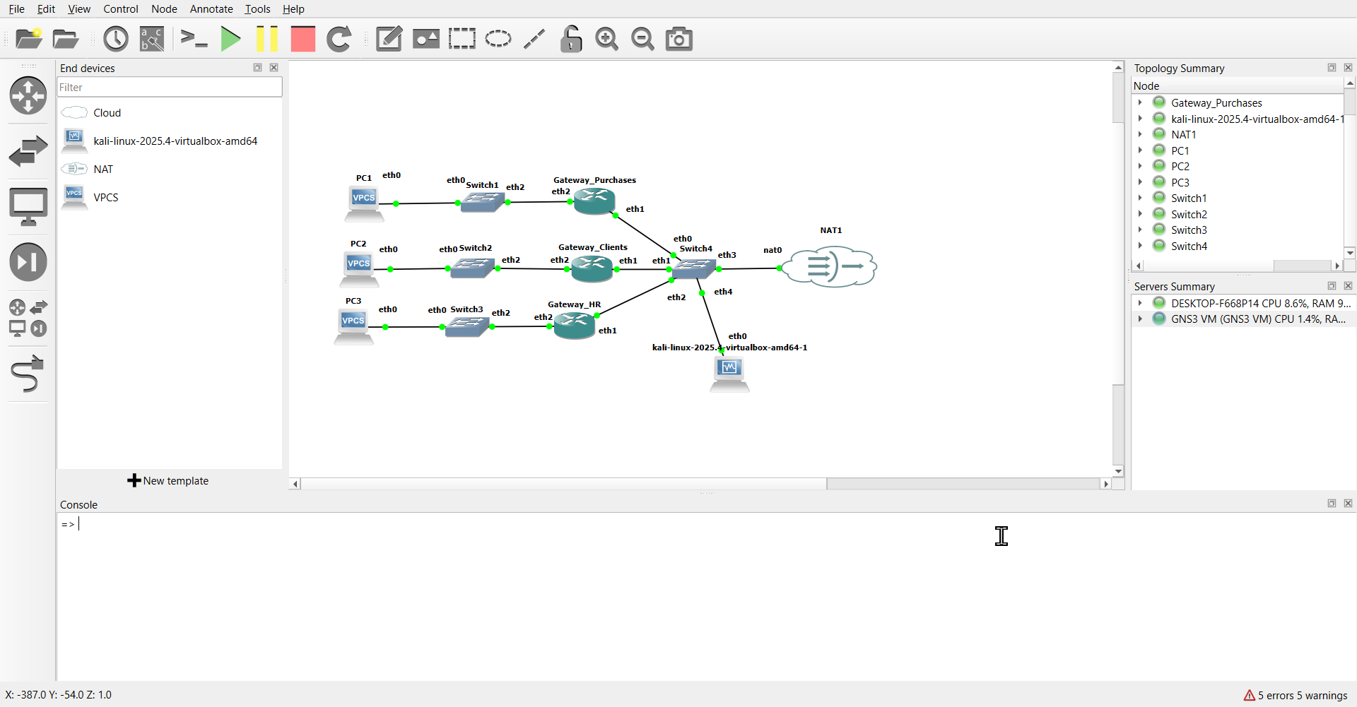
3. Enterprise Services Implementation

3.1 Dynamic Host Configuration Protocol (DHCP)
To support automated IP address assignment for end-user devices, a centralized DHCP server was configured on the Kali Linux machine. The MikroTik gateways were configured as DHCP relays to forward broadcast requests from the distinct departmental subnets to the central server.
3.2 Domain Name System (DNS)
A local name resolution service was implemented using BIND9 to allow users to access internal resources using human-readable domain names rather than IP addresses. The enterprise domain almassar.uir.ma was created, with forward lookup zones resolving requests to the central server at 192.168.42.48.
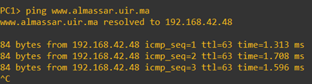
3.3 Secure Web Server (HTTPS)
To host ALMASSAR's internal web applications securely, an Apache2 web server was deployed. To meet cybersecurity requirements, port 80 (HTTP) was secured by generating a custom self-signed X.509 RSA certificate specifically for the ALMASSAR organization, ensuring that all traffic is encrypted via TLS.
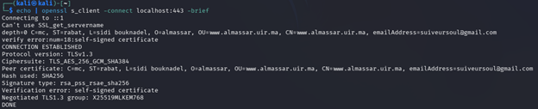
3.4 Secure File Transfer (FTPS)
To facilitate the secure exchange of documents across the enterprise, the vsftpd service was installed. The configuration was hardened by disabling anonymous access and enforcing SSL/TLS encryption using the previously generated ALMASSAR certificate, thereby preventing packet sniffing of credentials and data.

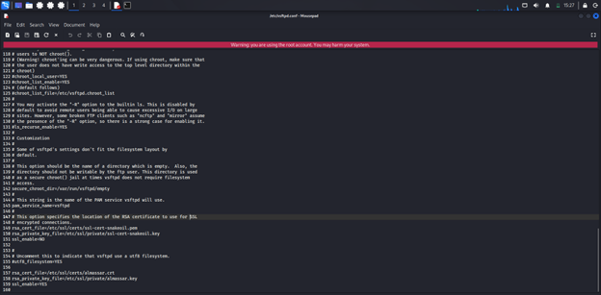
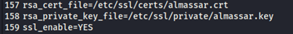
4. Network Security and Routing

4.1 Departmental Isolation (Firewall Filtering)
A core requirement of the ALMASSAR network is that communication between departments must be strictly controlled. To implement a Zero Trust model, firewall rules were applied to the MikroTik forward chains.

Example Rule
A rule was established to explicitly drop all ICMP traffic originating from the Purchases department (172.17.1.0/24) destined for the Human Resources department (172.17.6.0/24).
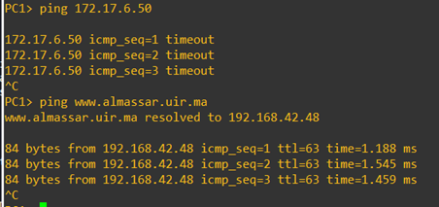
4.2 Network Address Translation (NAT) & Internet Access
To provide the internal users with controlled access to the external Internet, an IP Masquerade rule was configured on the edge router. This allows the private departmental IP addresses to be translated into a publicly routable IP address.
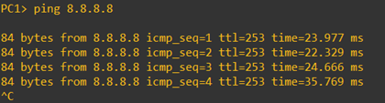
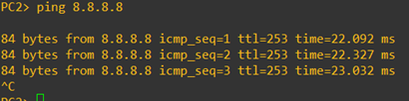
5. Conclusion

The ALMASSAR enterprise network infrastructure has been successfully modeled, deployed, and secured according to the organizational requirements. The logical separation of departments via routed backbone architecture significantly reduces broadcast domains and improves overall performance.

Furthermore, the successful integration of hardened enterprise services—including centralized DHCP, DNS, HTTPS, and FTPS—alongside strict firewall and NAT policies, ensures a resilient, scalable, and highly secure environment for daily corporate operations.

All project objectives have been met. The infrastructure demonstrates a production-grade approach to enterprise network security with departmental isolation, authenticated services, and encrypted communications.

