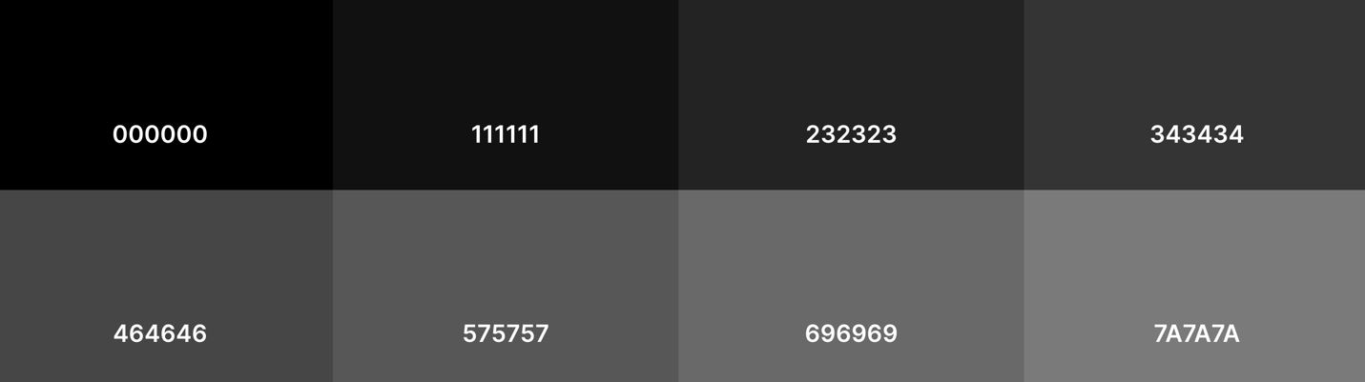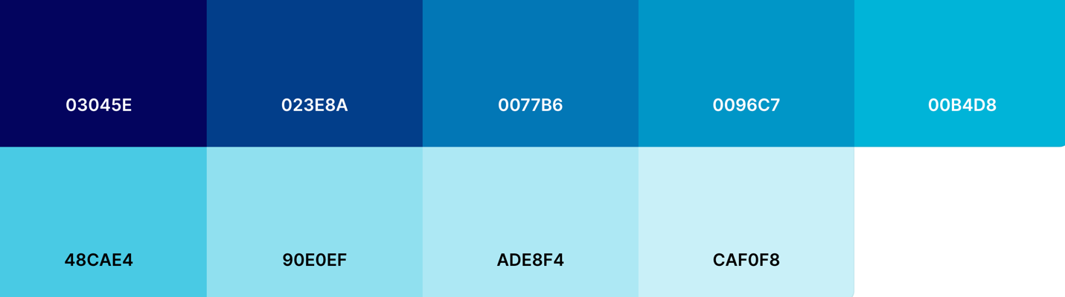

# **This is a heading.**

# **This is a heading.**

# **This is a heading.**

# **This is a heading.**

# **This is a heading.**

Normal Text.

Emphasis.