Not Just Scanner Bias: A Layered Audit of a Deep Brain-Age Model Beyond Accuracy
Adharshan N*  School of Computer Science and Engineering  Vellore Institute of Technology  Chennai, India  adharshan2706@gmail.com | Jaaiwanth K*  School of Computer Science and Engineering  Vellore Institute of Technology  Chennai, India  jaaiwanth90@gmail.com | Shridevi S†  Centre for Neuroinformatics  Vellore Institute of Technology  Chennai, India  [faculty email]
*Equal contribution. †Corresponding author.

Abstract—Brain-age models predict chronological age from structural MRI, and the brain-age gap is studied as a marker of brain health. When such a model shows a disparity between acquisition sites, the disparity is often attributed to scanner differences without a test. We present a layered, pre-specified audit of a UK Biobank-pretrained SFCN fine-tuned on 485 T1-weighted IXI scans from three London sites. The model is accurate (test MAE 3.71 years, r=0.966) and its errors do not differ by sex (equivalence within ±2 years). Scans from one site (IOP) receive a brain-age gap about 4–5 years lower than the reference site. The offset replicates across splits and in 5-fold cross-validation over all 412 non-test subjects ([CV IOP offset, n=61]), survives eight ways of handling age, including age matching and a nonlinear adjustment, and is already present in the pretrained model before any training on IXI (−3.3 years, p=5×10⁻⁶). The model is sensitive to acquisition appearance: the site is linearly decodable from its features (91% vs a 50% permutation ceiling), and giving Hammersmith brains IOP's intensity appearance lowers their predicted age by 3.9 years. Yet this sensitivity does not explain the disparity: intensity, matched image smoothness, head size, education, BMI, ethnicity, and removing site information from the features with ComBat, ComBat-GAM or age-conditional concept erasure all leave the offset in place. Naive concept erasure appears to remove it only by also erasing age information. Attribution maps pass randomisation and deletion tests under two baselines, and conformal intervals give valid coverage per site. We summarise the audit as a protocol-based fairness passport with graded, pre-specified verdicts.
Index Terms—Brain age, MRI, fairness, site effects, shortcut learning, explainable AI, harmonisation, conformal prediction.
I. INTRODUCTION
Brain-age models learn to predict a person's chronological age from a structural MRI scan [1], [2]. The brain-age gap (BAG) between predicted and chronological age is interpreted as accelerated or delayed brain ageing and has been associated with mortality and neurological disease [3]. Deep convolutional networks predict age with errors of a few years [4]–[7].
Accuracy alone does not make a model trustworthy. A model can be accurate on average and biased for a subgroup [8]–[11]; it can exploit non-biological shortcuts such as hospital-specific acquisition properties [12]–[14]; and the explanations used to inspect it can themselves be unfaithful [15], [16]. In multi-site MRI, scanner differences are a well-known source of site effects [17]–[19], and differences in brain-age gap between datasets can largely reflect their age distributions [20].
These concerns meet in a common situation: a brain-age model shows a disparity between sites, and the disparity is attributed to the scanner. That attribution is rarely tested. We audit a widely used network on the public IXI dataset and treat “scanner bias” as a hypothesis to be tested rather than assumed. Our narrative follows the evidence: (1) the model is accurate; (2) it shows a replicated site disparity that is not an artefact of age handling and exists before fine-tuning; (3) the model is sensitive to acquisition appearance; (4) but that sensitivity does not explain the disparity; (5) a disparity should therefore not be labelled scanner bias without such tests.
Our contributions are:
• A pre-specified, layered audit protocol (Fig. 1) with graded verdicts based on equivalence tests, minimum detectable effects and replication, released as a reusable passport schema in the spirit of model cards [21].
• A site disparity shown to be robust to eight age-handling choices, to cross-validation over all non-test subjects and to independent training runs, and present in the pretrained model before any exposure to IXI.
• Direct evidence of acquisition sensitivity (site decodability against a permutation null; an age- and sex-standardised intensity-swap stress test), and a systematic rule-out showing that neither acquisition properties we can measure nor recorded cohort characteristics explain the disparity.
• A methodological warning: concept erasure that ignores the age–site confound appears to remove the disparity by removing age information.
• Validated explanations and uncertainty: attribution maps tested under two deletion baselines and against Integrated Gradients, and conformal intervals with per-site (Mondrian) coverage.

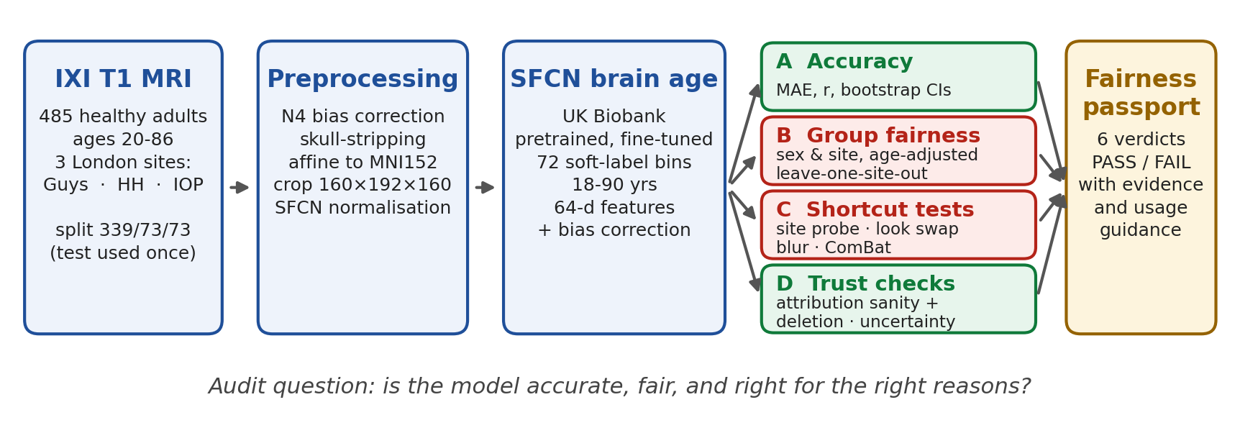
Fig. 1. Overview of the audit. The fine-tuned SFCN is frozen and audited on held-out subjects; cross-validated models over all non-test subjects provide the primary estimates for group effects, and four audit layers are summarised as a protocol-based fairness passport.

II. RELATED WORK
Brain-age prediction. Deep 3D CNNs trained on raw images [4], DeepBrainNet [6], the lightweight SFCN [5] and its multi-cohort descendants [7] predict age within a few years. Brain-age estimates regress towards the mean age, so a bias correction is standard; whether to correct the prediction or include age as a covariate remains debated [22]–[24].
Fairness and shortcuts in medical imaging. Imbalanced data produce biased classifiers [8] and under-served groups are underdiagnosed [9]; see [10]. For brain age, race and sex bias was analysed in UK Biobank [11], and a multi-cohort evaluation found dataset differences largely explained by age distributions, with a small ethnicity effect in some models [20]. Models encode protected attributes they were not trained on [25], measurable with linear probes [26]; decodability does not imply use, which motivates erasure-based tests [27].
Site effects and harmonisation. Scanner signatures are learnable [17]. ComBat [18], [28] and its nonlinear-age extension ComBat-GAM [29] remove site effects from derived measures; adversarial unlearning removes them during training [19], [30]; histogram matching standardises intensity [31].
Faithful explanations and uncertainty. Grad-CAM [32], HiResCAM [33] and Integrated Gradients [34] are common attribution methods; they should pass randomisation [15] and perturbation tests [16], [35]. Network confidence is often miscalibrated [36]; deep ensembles [37] and conformal prediction [38], [39], including group-conditional (Mondrian) variants, provide checked or guaranteed coverage.
III. DATA
IXI [40] provides T1-weighted MRI and demographics for healthy adults scanned at Guy's Hospital (Guys; Philips 1.5 T), Hammersmith Hospital (HH; Philips 3 T) and the Institute of Psychiatry (IOP; GE 1.5 T). Labels were rebuilt from the official spreadsheet after an identifier error in an early table was found; two independent rebuilds agreed, and no result based on the erroneous labels was reported. Of 502 subjects with a scan and a demographic index entry, 17 were excluded (10 without a record, 2 without age, 2 with contradictory duplicates, and 3 with clean labels that were not part of the shared team split; the list is released). The remaining 485 were split 339/73/73 into train, validation and test, stratified by site (Table I). IOP recruited younger participants (Fig. 2), so every group comparison adjusts for age, and Section V-C tests whether that adjustment is adequate.
TABLE I
Subjects per acquisition site
Site | Scanner | n | Mean age | Test n
Guys | Philips 1.5 T | 275 | 50.6 | 42
HH | Philips 3 T | 149 | 47.7 | 22
IOP | GE 1.5 T | 61 | 42.5 | 9

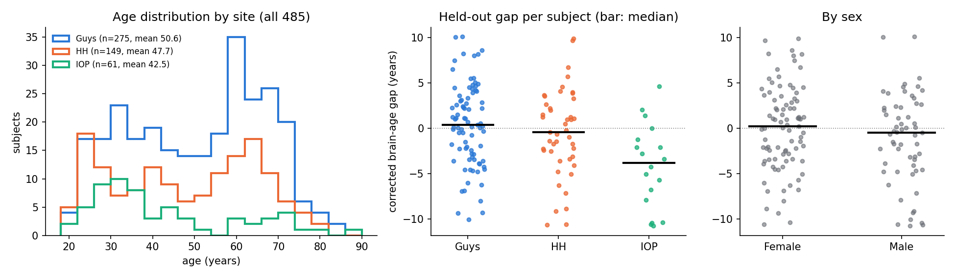
Fig. 2. Left: age distribution by site (all 485 subjects). Middle and right: corrected brain-age gap of every held-out subject by site and by sex (bar: median).

IV. METHODS
A. Preprocessing and model
Each scan underwent N4 bias-field correction [41], skull-stripping with ANTsPyNet [42], affine registration to the MNI152NLin6Asym 1 mm template [43], a centre crop to 160×192×160 voxels and SFCN's intensity normalisation (division by the mean over the full 182×218×182 box). SFCN [5] has five convolution–batch-norm–max-pool–ReLU blocks and a 1×1×1 block, global average pooling to 64 features and a 1×1×1 convolution over one-year age bins; the prediction is the expected value of the bin distribution. We replaced the UK Biobank head (ages 42–82) with 72 bins for 18–90, warm-starting overlapping bins, and fine-tuned with Gaussian soft labels (σ=2 years) and a KL loss: the head for 5 epochs (learning rate 10⁻³), then the whole network with AdamW [44] (head 10⁻³, backbone 10⁻⁴), early stopping on validation MAE (patience 15). The checkpoint at epoch 30 was frozen. Bias correction followed [3]: ŷ=a y+b fitted on validation (a=0.832, b=8.30), corrected prediction (ŷ−b)/a.
Cross-validated replication. To estimate group effects on more than 18 held-out IOP subjects without touching the test set, the 412 train+validation subjects were split into 5 site-stratified folds; each fold was predicted by a model trained on the other four (85% training, 15% inner validation for early stopping and for that fold's bias correction). Full fine-tuning was infeasible on our CPU hardware, so the first three blocks were kept at the UK Biobank weights, which never saw IXI, and the remaining blocks and head were trained with the same objective and schedule. Every non-test subject thus receives an out-of-sample prediction (61 IOP). Training was repeated with [2] seeds, and the fold models' average forms an ensemble for the locked test set.
B. Analysis plan
Fixed before the test set was evaluated: the split, the exclusions, the bias-correction procedure, the attribution layer and method, and the regression model for group effects. Fixed before the cross-validation results were seen (and committed to the public repository with a timestamp): the equivalence margin, the graded verdict rules and the passport criteria below. The remaining analyses are tests of explanations for an effect already observed and are reported as such.
C. Group fairness and graded verdicts
Group effects were estimated with \mathrmoutcome ~ sex+site+age (OLS, HC3 errors [45]) for corrected BAG and absolute error, with bootstrap CIs [46]. Each effect received a pre-specified verdict with margin ±2 years (about half the MAE): PASS if equivalence is shown by two one-sided tests [47] (90% CI within the margin); INCONCLUSIVE if the 95% CI includes zero without equivalence; CONCERN if it excludes zero but the effect is within the margin or does not replicate; FAIL if it excludes zero, exceeds the margin and replicates in an independent split. We report the minimum detectable effect at 80% power and Holm-adjusted [48] p-values across all group comparisons. Leave-one-site-out models (trained without one site) measured generalisation to an unseen site.
D. Robustness of the site effect to age
The IOP-vs-Guys effect was re-estimated under: (a) no bias correction; (b) correction fitted on validation; (c) correction fitted on train; (d) age as a covariate of the raw prediction [22]; (e) a B-spline of age (4 df); (f) Guys and HH restricted to IOP's age range; (g) 1:1 age- and sex-matched IOP–Guys pairs (caliper 3 years); and (h) native brain volume added as a covariate, because registration removes head size from the input. We also inspected gaps of the youngest subjects, near the lower edge of the label range.
E. Is the offset learned?
The UK Biobank model never saw IXI, so its predictions for all subjects aged 42–82 (its output range) show whether the offset exists before fine-tuning. In the cross-validation runs, the gaps of training and out-of-sample IOP subjects were recorded at every epoch.
F. Acquisition sensitivity
Site probe. A class-balanced multinomial logistic regression [26] was trained on train subjects' 64-d features with age, age² and sex regressed out and scored on held-out subjects (balanced accuracy), against a null from 30 label permutations.
Stress test. Each held-out brain's intensity distribution was quantile-matched [31] to each site's reference and re-predicted. References came from train subjects and were standardised to a common age and sex mix (per-site regression of the quantile vector on age, age² and sex, evaluated at the pooled mean), because tissue contrast itself carries age information. Effects are relative to matching to the subject's own site. Contrast, noise, blur and non-uniformity were also varied singly on 40 subjects. The test was repeated with the cross-validated models.
G. Explaining the disparity
Image properties. We compared native resolution and three sharpness measures (gradient, Laplacian, smoothness FWHM [49]) across sites, and blurred each held-out Guys and HH brain to IOP's adjusted smoothness.
Removing site from the features. Site was removed from the 64-d features, with parameters from train only, by ComBat [18], [28] (linear age, age², sex preserved), ComBat-GAM-style harmonisation [29] (spline age), and LEACE concept erasure [27], both plain and conditional (erasing site only from the part of the features not explained by age and sex). Age was re-predicted through the model's own head, which reproduces the model exactly on the original features.
Cohort characteristics. IXI records education, ethnicity, height and weight. We compared sites on university degree, ethnicity and BMI and added them as covariates to the site model, using the zero-shot, main and cross-validated predictions. We also report the ethnicity effect itself.
H. Attribution and its validity
Standard Grad-CAM [32] produced empty maps for many subjects, so we used location-wise gradient × activation (HiResCAM-style [33]) at block conv_2 (8 mm cells), chosen before any group comparison. Maps were summarised by Harvard–Oxford region [50], both as shares and as density (share divided by the region's share of brain volume), with FDR correction [51]. Validity: a cascading randomisation check [15]; a deletion test [16], [35] on 60 held-out subjects removing top-, bottom- or randomly-ranked 5/10% of cells with two baselines (heavy smoothing, and the brain's mean intensity, which involves no blur), reporting signed and absolute changes; and agreement with Integrated Gradients [34] (zero baseline, 16 steps) on 20 subjects.
I. Uncertainty
We assessed the model's own predictive distribution (coverage and width of its central 50/80/90/95% ranges, per site), split-conformal intervals from out-of-fold absolute residuals [39], pooled and per site (Mondrian [38]), and the spread of the seed ensemble [37]. Training with σ=2 soft labels sets a floor of about 2 years on the model's own spread.
V. RESULTS
A. Accuracy
The UK Biobank SFCN without fine-tuning had a validation MAE of 10.21 years (r=0.910), because its head cannot predict outside 42–82. Fine-tuning reduced it to 3.90. On the test set, evaluated once, the MAE was 3.71 years [3.10, 4.38] and r=0.966 (Table II). The cross-validated models reached an out-of-sample MAE of [CV MAE] over all 412 non-test subjects, and their ensemble [ensemble test MAE] on the test set. An independently fine-tuned SFCN and DeepBrainNet reached test MAE 4.07 and 4.53.
TABLE II
Accuracy (95% bootstrap CI)
Model and data | MAE (years) | r
Main model, test (raw) | 3.71 [3.10, 4.38] | 0.966
Main model, test (bias-corrected) | 3.89 [3.20, 4.61] | 0.966
CV models, 412 out-of-sample | [pending] | [pending]
CV ensemble, test | [pending] | [pending]
Zero-shot SFCN, validation | 10.21 | 0.910

B. Group fairness
Table III lists every group effect with its verdict. On the test set alone, absolute error is equivalent between sexes and between HH and Guys (PASS), whereas the sex difference in BAG (−0.59, minimum detectable effect 3.1 years) is INCONCLUSIVE: 73 test subjects cannot show equivalence. IOP scans receive a BAG 5.06 years lower than Guys [−8.66, −1.34], replicated in validation (−4.08), giving FAIL. With all 412 cross-validated predictions, [CV verdicts for sex and site]. A model never trained on IOP was 3.30 years [1.62, 4.93] less accurate there, whereas one never trained on HH generalised (+0.25).
TABLE III
Group effects (years) and pre-specified verdicts
Effect | Data | Estimate [95% CI] | MDE | Verdict
Sex, BAG | test | −0.59 [−2.79, 1.61] | 3.1 | INCONCL.
Sex, error | test | −0.64 [−1.94, 0.66] | 1.9 | PASS
HH, BAG | test | +1.06 [−1.48, 3.60] | 3.6 | INCONCL.
HH, error | test | +0.19 [−1.09, 1.48] | 1.8 | PASS
IOP, BAG | test | −5.06 [−8.99, −1.13] | 5.6 | FAIL
IOP, error | test | +1.92 [−1.50, 5.33] | 4.9 | INCONCL.
Sex, BAG | CV | [pending] | [pending] | [pending]
Sex, error | CV | [pending] | [pending] | [pending]
HH, BAG | CV | [pending] | [pending] | [pending]
IOP, BAG | CV | [pending] | [pending] | [pending]
IOP, error | CV | [pending] | [pending] | [pending]
HC3 normal CIs; MDE: minimum detectable effect, 80% power.

C. The IOP offset is not an artefact of age handling
Across all eight age-handling choices, the held-out IOP offset ranged from −3.11 to −4.53 years, with every CI excluding zero (Fig. 3); on the test set alone it ranged from −4.21 to −5.24. It persisted in age-matched pairs (−3.11 [−5.67, −0.33]), with a spline for age (−3.98) and with no correction at all (−3.77). Native brain volume did not differ between IOP and Guys after age and sex adjustment (−16 ml, p=0.38) and did not change the offset (−4.47). The offset is not at the edge of the label range: held-out IOP subjects under 30 had a mean gap of +0.5 years, those over 30 of −5.6 years. In the cross-validated predictions the offset was [CV range across the eight choices].
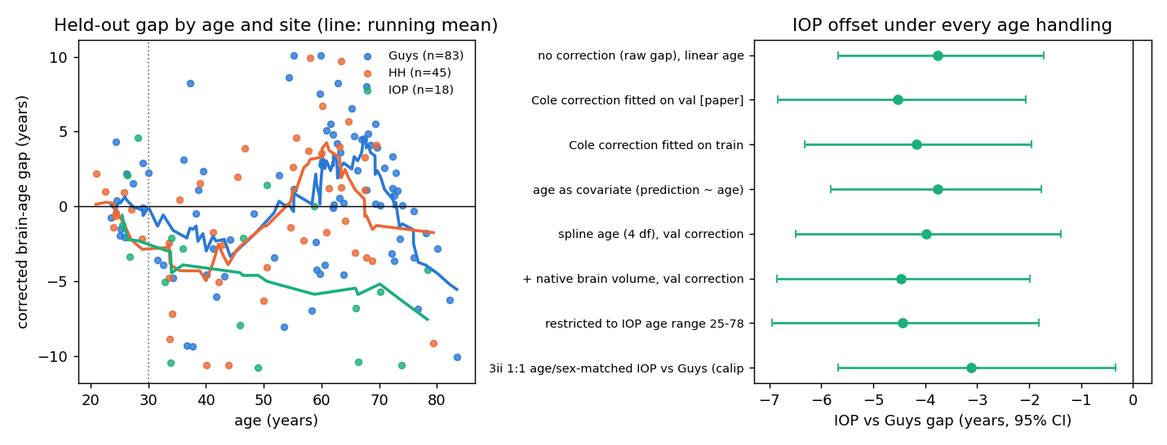
Fig. 3. Left: held-out corrected brain-age gap by age and site (lines: running means). Right: the IOP-vs-Guys offset under eight age-handling choices (95% CI).
D. The offset exists before fine-tuning
The UK Biobank model, which never saw an IXI scan, already predicts IOP brains 3.34 years younger than Guys brains of the same age and sex [−4.71, −1.91] (p=5×10⁻⁶, 241 subjects aged 42–82, 19 IOP). Memorisation of IOP training subjects therefore cannot be its cause. During cross-validated training, [training-dynamics result: train-IOP gap vs out-of-sample IOP gap across epochs].
E. The model is sensitive to acquisition appearance
Site is encoded. The probe identified the site of held-out scans with 91.2% [86.6, 95.2] balanced accuracy after removing age and sex, against a permutation null with mean 34% and 95th percentile 50% (Table IV). This is expected: site is decodable with 99.6% from input intensity quantiles alone and with 92.8% from the pretrained network, so the features inherit an input-level signature; the question is whether the prediction uses it.
TABLE IV
Site probe on held-out subjects (balanced accuracy, %)
Features | Accuracy
Age and sex only | 40.8
Permutation null (mean / 95th pct.) | 34 / 50
Input intensity quantiles | 99.6
Pretrained SFCN (never saw IXI) | 92.8
Fine-tuned SFCN, age/sex removed | 91.2
Cross-validated models (within fold) | [pending]

Appearance moves the prediction. Relative to matching to their own site, HH brains given IOP's age- and sex-standardised appearance became 3.92 years younger [−4.47, −3.38], all 45 of them, and IOP brains given HH's appearance 3.14 years older (18 of 18; Fig. 4). Between Guys and IOP the effect was small (+0.11 and +0.90), and Guys brains given HH's appearance became 3.32 years older. Strong blur (σ=1.5 voxels) lowered predictions by 3.17 years. With the cross-validated models, [CV stress-test replication].

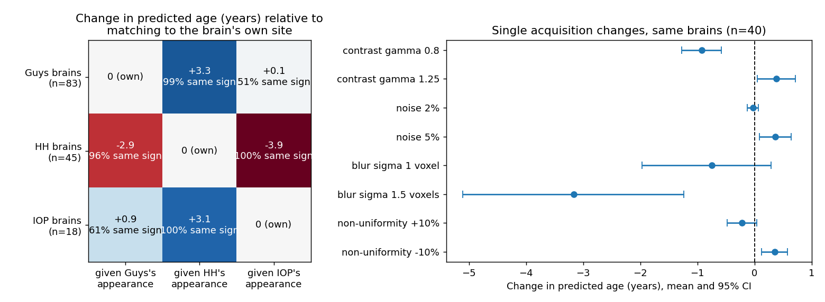
Fig. 4. Acquisition stress test. Left: change in predicted age when each site's held-out brains are given each site's age- and sex-standardised intensity appearance, relative to matching to their own site (share of subjects changing in the majority direction). Right: single acquisition changes on 40 subjects.

F. But acquisition sensitivity does not explain the offset
Table V collects every explanation tested. Intensity: swapping between the Guys and IOP appearances moves predictions by at most about 1 year; without age standardisation of the references this effect was overstated (−0.60/+1.60), because IOP's younger recruitment leaked into its reference. Smoothness: native resolution is identical across sites, yet IOP inputs are smoother (FWHM +0.87 mm); blurring Guys and HH brains to IOP's smoothness did not lower their predictions. Removing site from the features: ComBat erased the site signature (probe 36.3%) with unchanged accuracy, but the offset remained (−3.95); with spline age it remained (−6.80); with age-conditional LEACE it remained (−4.46). Only plain LEACE removed it (+0.40), and only because, IOP's training subjects being younger, it also erased age information correlated with site; the conditional version, which preserves age, does not. Cohort: IOP did not differ from Guys in university degree (68% vs 56%; adjusted p=0.56), ethnicity (p=0.64) or BMI (p=0.49), and adjusting for all three left the offset unchanged in the zero-shot (−2.80 vs −2.74) and main models (−5.26 vs −5.13)[, and in CV].
TABLE V
Explanations tested for the IOP offset (years)
Test (held-out unless noted) | IOP offset
Reference: corrected BAG, held-out | −4.53 [−7.04, −2.01]
Guys→IOP / IOP→Guys appearance swap | +0.11 / +0.90
Guys / HH blurred to IOP smoothness | +0.93 / +0.01
+ native brain volume | −4.47 [−6.86, −1.98]
+ degree, BMI, ethnicity | −5.26 [−7.65, −2.86]
ComBat (linear age) | −3.95 [−6.39, −1.52]
ComBat with spline age | −6.80 [−10.11, −3.49]
LEACE, age-conditional | −4.46 [−7.20, −1.73]
LEACE, plain (removes age information) | +0.40 [−3.01, 3.82]
Zero-shot model, before fine-tuning^* | −3.34 [−4.71, −1.91]
^*Raw prediction, age-adjusted, all subjects aged 42–82.

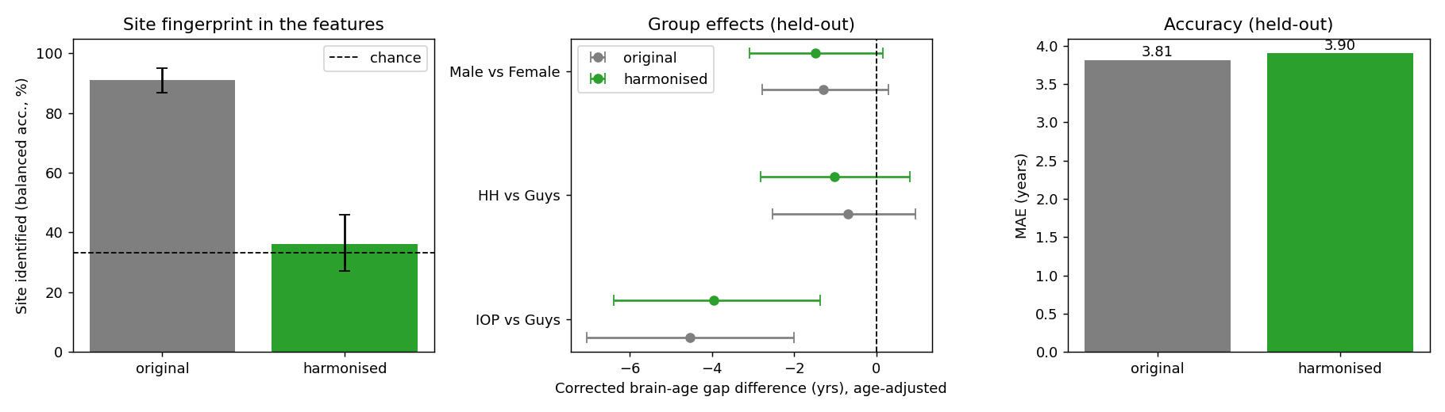
Fig. 5. ComBat harmonisation of the features: the site fingerprint is removed (left) and accuracy is unchanged (right), but the IOP offset remains (middle).

G. Where the model looks, and whether to trust it
Attribution concentrates on deep grey matter around the ventricles, periventricular white matter and the cerebellum; normalised by volume, deep grey matter receives 3.2 times its volume share (Fig. 6). The maps depend on the learned weights (randomisation ρ=0.13). Removing the top-ranked 5% of cells changed predictions far more than random cells under both baselines ([smooth and mean baseline numbers, signed and absolute]), and Integrated Gradients agreed with the maps ([median Spearman, top-10% overlap]). No region differed by sex after FDR correction. By site, HH and IOP place 13–16% less attribution density on deep grey matter and 12–15% less on the hippocampus and amygdala than Guys (q<0.001); these are relative differences in density, not artefacts of region size.
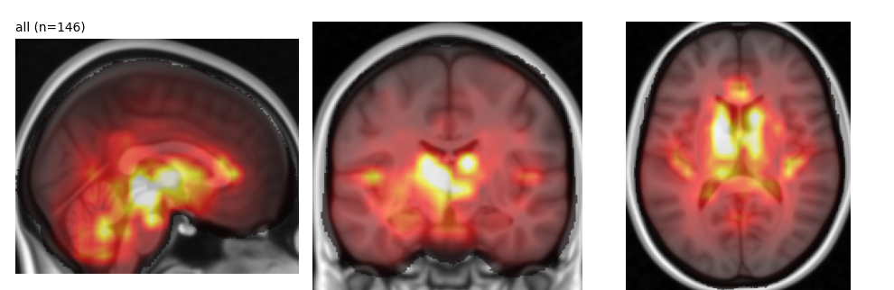
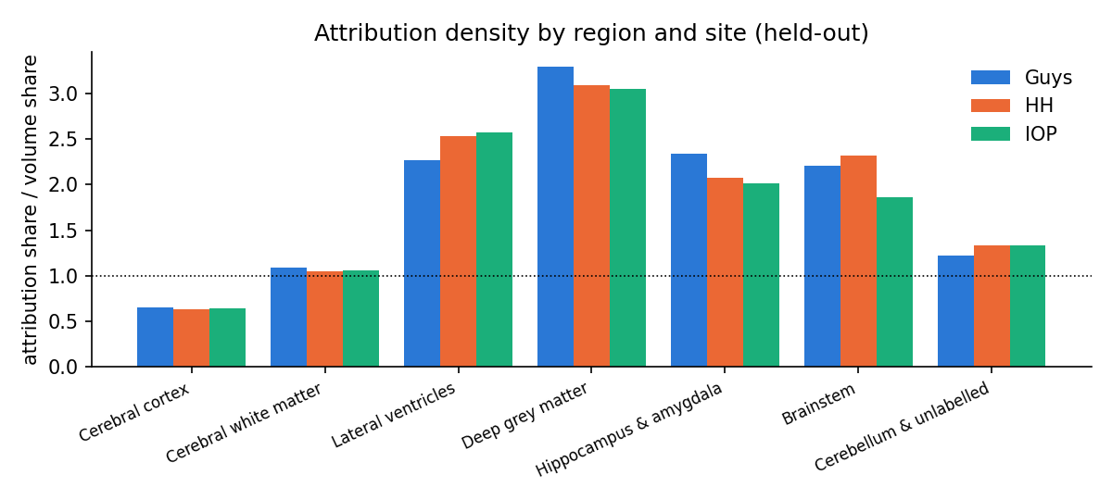
Fig. 6. Top: mean attribution over held-out subjects. Bottom: attribution density (share of attribution divided by share of brain volume) by region and site.
H. Uncertainty
The model's own spread was larger for IOP (8.06 vs 5.66 years for Guys) and doubled when IOP was unseen (12.46 vs 6.13) with 92% coverage, so the model signals unfamiliar data. Out of fold, the model's own 90% range covered [per-site coverage]; pooled conformal intervals [pending]; per-site conformal intervals [pending]. Per subject, uncertainty tracked error only weakly (Spearman 0.16).
I. Model fairness passport
Table VI applies the pre-specified criteria. The full passport, its machine-readable criteria and the script that generates it are released.
TABLE VI
Model fairness passport (pre-specified criteria)
Check | Verdict | Evidence
Accuracy | PASS | MAE 3.71, r 0.966
Fairness by sex | [pending] | error equivalent; gap [pending]
Fairness by site | FAIL | IOP −4 to −5 yrs, replicated, robust to age
Scanner invariance | FAIL | HH\leftrightarrowIOP appearance shifts 3–4 yrs
Faithful explanations | [pending] | randomisation, deletion (2 baselines), IG
Honest uncertainty | [pending] | per-site coverage

VI. DISCUSSION
A replicated disparity that is not an age artefact. IOP's lower brain-age gap survives every age-handling choice we could construct, appears in independent splits and in cross-validation, and is present before fine-tuning. The usual first explanation of site differences in brain age, different age distributions [20], does not account for it.
Sensitive to acquisition, but the sensitivity is not the explanation. The model is not acquisition-invariant: an unchanged HH brain given IOP's appearance loses almost four years. Yet the explanations we can measure—intensity profile, smoothness, head size, recorded cohort characteristics, and the site signature in the features—each leave the IOP offset in place. Two methodological lessons follow. First, references for intensity and erasure must be conditioned on age, because tissue contrast and the site–age confound carry age information: unconditioned versions overstated the intensity effect and made the offset seem to vanish. Second, removing a site signature is not the same as removing a site disparity. A study that had stopped at the stress test, or at plain erasure, would have reported “scanner bias”; the evidence here does not support that label.
What remains. The offset could stem from acquisition properties not modelled here (e.g., spatially varying contrast or vendor-specific reconstruction) or from cohort characteristics IXI does not record. Within IXI, site and cohort are confounded, so these cannot be separated; travelling-subject data would.
Limitations. IOP contributes 61 subjects in total. The cross-validated models fine-tune only the upper blocks, a lighter recipe than the main model. Quantile matching changes only the global intensity distribution, and Gaussian blur did not reproduce IOP's full sharpness profile. Attribution has 8 mm resolution, and deletion tests are themselves affected by distribution shift. We did not evaluate a classical feature-based baseline or a second dataset. Participants are healthy volunteers; no clinical conclusion follows.
Future work. Travelling-subject datasets, a FreeSurfer-feature baseline (if it shows the same offset, the cause lies in the images or cohort rather than a CNN shortcut), site-adversarial fine-tuning [19], and passports for further models and datasets.
VII. CONCLUSION
A fine-tuned SFCN is accurate on IXI and its errors are equivalent between sexes, but it shows a replicated 4–5 year brain-age offset at one site. The offset is robust to how age is handled and exists before fine-tuning. The model is clearly sensitive to acquisition appearance, yet neither that sensitivity nor any measured acquisition or cohort property explains the offset. Site disparities in brain age should be tested, not labelled: a protocol of age-robust estimates, stress tests, age-conditional erasure and graded verdicts shows what can and cannot be concluded.
CODE AND DATA AVAILABILITY
Code, the split and exclusion lists, cross-validation folds, environment, passport criteria and generator, an interactive website and a live demo are at https://github.com/Jaaiwanth/brain-age-fairness-xai. IXI is available under CC BY-SA 3.0 [40].
AUTHOR CONTRIBUTIONS
Adharshan N and Jaaiwanth K contributed equally: both designed the study, verified the labels, built the preprocessing and fine-tuning pipelines (including the independent SFCN and DeepBrainNet replication), performed the analyses, built the website, demo and passport, and wrote the manuscript. Shridevi S supervised the project and reviewed the manuscript.
ACKNOWLEDGMENT
We thank the IXI project for the data and the SFCN authors for releasing their pretrained weights.
REFERENCES
[1] J. H. Cole and K. Franke, “Predicting age using neuroimaging: innovative brain ageing biomarkers,” Trends in Neurosciences, vol. 40, no. 12, pp. 681–690, 2017.
[2] K. Franke and C. Gaser, “Ten years of BrainAGE as a neuroimaging biomarker of brain aging: what insights have we gained?,” Frontiers in Neurology, vol. 10, Art. no. 789, 2019.
[3] J. H. Cole, S. J. Ritchie, M. E. Bastin et al., “Brain age predicts mortality,” Molecular Psychiatry, vol. 23, pp. 1385–1392, 2018.
[4] J. H. Cole, R. P. K. Poudel, D. Tsagkrasoulis et al., “Predicting brain age with deep learning from raw imaging data results in a reliable and heritable biomarker,” NeuroImage, vol. 163, pp. 115–124, 2017.
[5] H. Peng, W. Gong, C. F. Beckmann, A. Vedaldi, and S. M. Smith, “Accurate brain age prediction with lightweight deep neural networks,” Medical Image Analysis, vol. 68, Art. no. 101871, 2021.
[6] V. M. Bashyam, G. Erus, J. Doshi et al., “MRI signatures of brain age and disease over the lifespan based on a deep brain network and 14 468 individuals worldwide,” Brain, vol. 143, no. 7, pp. 2312–2324, 2020.
[7] E. H. Leonardsen, H. Peng, T. Kaufmann et al., “Deep neural networks learn general and clinically relevant representations of the ageing brain,” NeuroImage, vol. 256, Art. no. 119210, 2022.
[8] A. J. Larrazabal, N. Nieto, V. Peterson, D. H. Milone, and E. Ferrante, “Gender imbalance in medical imaging datasets produces biased classifiers for computer-aided diagnosis,” Proceedings of the National Academy of Sciences, vol. 117, no. 23, pp. 12592–12594, 2020.
[9] L. Seyyed-Kalantari, H. Zhang, M. B. A. McDermott, I. Y. Chen, and M. Ghassemi, “Underdiagnosis bias of artificial intelligence algorithms applied to chest radiographs in under-served patient populations,” Nature Medicine, vol. 27, pp. 2176–2182, 2021.
[10] M. A. Ricci Lara, R. Echeveste, and E. Ferrante, “Addressing fairness in artificial intelligence for medical imaging,” Nature Communications, vol. 13, Art. no. 4581, 2022.
[11] C. Piçarra and B. Glocker, “Analysing race and sex bias in brain age prediction,” arXiv preprint arXiv:2309.10835, 2023.
[12] R. Geirhos, J. Jacobsen, C. Michaelis et al., “Shortcut learning in deep neural networks,” Nature Machine Intelligence, vol. 2, pp. 665–673, 2020.
[13] J. R. Zech, M. A. Badgeley, M. Liu, A. B. Costa, J. J. Titano, and E. K. Oermann, “Variable generalization performance of a deep learning model to detect pneumonia in chest radiographs: a cross-sectional study,” PLoS Medicine, vol. 15, no. 11, Art. no. e1002683, 2018.
[14] A. J. DeGrave, J. D. Janizek, and S. Lee, “AI for radiographic COVID-19 detection selects shortcuts over signal,” Nature Machine Intelligence, vol. 3, pp. 610–619, 2021.
[15] J. Adebayo, J. Gilmer, M. Muelly, I. Goodfellow, M. Hardt, and B. Kim, “Sanity checks for saliency maps,” in Advances in Neural Information Processing Systems (NeurIPS), vol. 31, 2018.
[16] S. Hooker, D. Erhan, P. Kindermans, and B. Kim, “A benchmark for interpretability methods in deep neural networks,” in Advances in Neural Information Processing Systems (NeurIPS), vol. 32, 2019.
[17] B. Glocker, R. Robinson, D. C. Castro, Q. Dou, and E. Konukoglu, “Machine learning with multi-site imaging data: an empirical study on the impact of scanner effects,” arXiv preprint arXiv:1910.04597, 2019.
[18] J. Fortin, N. Cullen, Y. I. Sheline et al., “Harmonization of cortical thickness measurements across scanners and sites,” NeuroImage, vol. 167, pp. 104–120, 2018.
[19] N. K. Dinsdale, M. Jenkinson, and A. I. L. Namburete, “Deep learning-based unlearning of dataset bias for MRI harmonisation and confound removal,” NeuroImage, vol. 228, Art. no. 117689, 2021.
[20] L. J. Aguzin Parrilli, M. A. Belzunce et al., “Bias and generalizability of brain age prediction models: A multi-cohort evaluation with anatomical and interpretability insights,” Imaging Neuroscience, vol. 4, Art. no. IMAG.a.1164, 2026.
[21] M. Mitchell, S. Wu, A. Zaldivar et al., “Model cards for model reporting,” in Proc. Conference on Fairness, Accountability, and Transparency (FAT*), pp. 220–229, 2019.
[22] T. T. Le, R. T. Kuplicki, B. A. McKinney et al., “A nonlinear simulation framework supports adjusting for age when analyzing BrainAGE,” Frontiers in Aging Neuroscience, vol. 10, Art. no. 317, 2018.
[23] S. M. Smith, D. Vidaurre, F. Alfaro-Almagro, T. E. Nichols, and K. L. Miller, “Estimation of brain age delta from brain imaging,” NeuroImage, vol. 200, pp. 528–539, 2019.
[24] A. G. de Lange and J. H. Cole, “Commentary: Correction procedures in brain-age prediction,” NeuroImage: Clinical, vol. 26, Art. no. 102229, 2020.
[25] B. Glocker, C. Jones, M. Bernhardt, and S. Winzeck, “Algorithmic encoding of protected characteristics in chest X-ray disease detection models,” eBioMedicine, vol. 89, Art. no. 104467, 2023.
[26] G. Alain and Y. Bengio, “Understanding intermediate layers using linear classifier probes,” arXiv preprint arXiv:1610.01644, 2016.
[27] N. Belrose, D. Schneider-Joseph, S. Ravfogel, R. Cotterell, E. Raff, and S. Biderman, “LEACE: Perfect linear concept erasure in closed form,” in Advances in Neural Information Processing Systems (NeurIPS), vol. 36, 2023.
[28] W. E. Johnson, C. Li, and A. Rabinovic, “Adjusting batch effects in microarray expression data using empirical Bayes methods,” Biostatistics, vol. 8, no. 1, pp. 118–127, 2007.
[29] R. Pomponio, G. Erus, M. Habes et al., “Harmonization of large MRI datasets for the analysis of brain imaging patterns throughout the lifespan,” NeuroImage, vol. 208, Art. no. 116450, 2020.
[30] Y. Ganin, E. Ustinova, H. Ajakan et al., “Domain-adversarial training of neural networks,” Journal of Machine Learning Research, vol. 17, no. 59, pp. 1–35, 2016.
[31] L. G. Nyúl, J. K. Udupa, and X. Zhang, “New variants of a method of MRI scale standardization,” IEEE Transactions on Medical Imaging, vol. 19, no. 2, pp. 143–150, 2000.
[32] R. R. Selvaraju, M. Cogswell, A. Das, R. Vedantam, D. Parikh, and D. Batra, “Grad-CAM: Visual explanations from deep networks via gradient-based localization,” in Proc. IEEE International Conference on Computer Vision (ICCV), pp. 618–626, 2017.
[33] R. L. Draelos and L. Carin, “Use HiResCAM instead of Grad-CAM for faithful explanations of convolutional neural networks,” arXiv preprint arXiv:2011.08891, 2020.
[34] M. Sundararajan, A. Taly, and Q. Yan, “Axiomatic attribution for deep networks,” in Proc. International Conference on Machine Learning (ICML), pp. 3319–3328, 2017.
[35] W. Samek, A. Binder, G. Montavon, S. Lapuschkin, and K. Müller, “Evaluating the visualization of what a deep neural network has learned,” IEEE Transactions on Neural Networks and Learning Systems, vol. 28, no. 11, pp. 2660–2673, 2017.
[36] C. Guo, G. Pleiss, Y. Sun, and K. Q. Weinberger, “On calibration of modern neural networks,” in Proc. International Conference on Machine Learning (ICML), pp. 1321–1330, 2017.
[37] B. Lakshminarayanan, A. Pritzel, and C. Blundell, “Simple and scalable predictive uncertainty estimation using deep ensembles,” in Advances in Neural Information Processing Systems (NeurIPS), vol. 30, 2017.
[38] V. Vovk, A. Gammerman, and G. Shafer, Algorithmic Learning in a Random World. New York: Springer, 2005.
[39] A. N. Angelopoulos and S. Bates, “Conformal prediction: A gentle introduction,” Foundations and Trends in Machine Learning, vol. 16, no. 4, pp. 494–591, 2023.
[40] IXI Dataset. [Online]. Available: https://brain-development.org/ixi-dataset/
[41] N. J. Tustison, B. B. Avants, P. A. Cook et al., “N4ITK: Improved N3 bias correction,” IEEE Transactions on Medical Imaging, vol. 29, no. 6, pp. 1310–1320, 2010.
[42] N. J. Tustison, P. A. Cook, A. J. Holbrook et al., “The ANTsX ecosystem for quantitative biological and medical imaging,” Scientific Reports, vol. 11, Art. no. 9068, 2021.
[43] R. Ciric, W. H. Thompson, R. Lorenz et al., “TemplateFlow: FAIR-sharing of multi-scale, multi-species brain models,” Nature Methods, vol. 19, pp. 1568–1571, 2022.
[44] I. Loshchilov and F. Hutter, “Decoupled weight decay regularization,” in Proc. International Conference on Learning Representations (ICLR), 2019.
[45] J. G. MacKinnon and H. White, “Some heteroskedasticity-consistent covariance matrix estimators with improved finite sample properties,” Journal of Econometrics, vol. 29, no. 3, pp. 305–325, 1985.
[46] B. Efron and R. J. Tibshirani, An Introduction to the Bootstrap. New York: Chapman & Hall, 1993.
[47] D. J. Schuirmann, “A comparison of the two one-sided tests procedure and the power approach for assessing the equivalence of average bioavailability,” Journal of Pharmacokinetics and Biopharmaceutics, vol. 15, no. 6, pp. 657–680, 1987.
[48] S. Holm, “A simple sequentially rejective multiple test procedure,” Scandinavian Journal of Statistics, vol. 6, no. 2, pp. 65–70, 1979.
[49] S. D. Forman, J. D. Cohen, M. Fitzgerald, W. F. Eddy, M. A. Mintun, and D. C. Noll, “Improved assessment of significant activation in functional magnetic resonance imaging (fMRI): use of a cluster-size threshold,” Magnetic Resonance in Medicine, vol. 33, no. 5, pp. 636–647, 1995.
[50] M. Jenkinson, C. F. Beckmann, T. E. J. Behrens, M. W. Woolrich, and S. M. Smith, “FSL,” NeuroImage, vol. 62, no. 2, pp. 782–790, 2012.
[51] Y. Benjamini and Y. Hochberg, “Controlling the false discovery rate: a practical and powerful approach to multiple testing,” Journal of the Royal Statistical Society: Series B, vol. 57, no. 1, pp. 289–300, 1995.

