Agile

Agile in 5mins: <https://youtu.be/zi7uGg6FVM4?si=ELELbaT3SeWgdzra>

Agile in 20 Words:

Agile is a collaborative, adaptive project management methodology emphasizing teamwork, flexibility, and rapid delivery of valuable increments for efficiency.

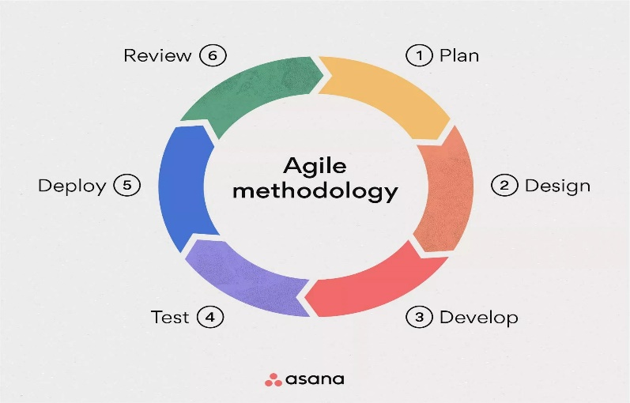 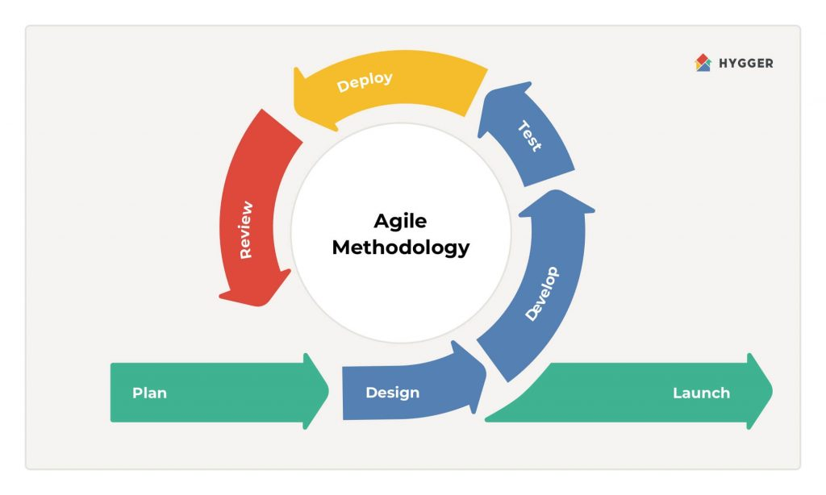

Detailed Explanation:

Agile is a project management approach that prioritizes collaboration, adaptability, and quick delivery of tangible results. It originated in the software development realm but has since been adopted across various industries. The core idea is to break down a project into small, manageable tasks known as "sprints," typically lasting a few weeks.

Key principles include customer satisfaction through continuous delivery of valuable features, adapting to changing requirements even late in the development process, and fostering a collaborative, self-organizing team.

Communication is pivotal, with regular meetings to ensure everyone is aligned and any obstacles are addressed promptly. Agile methodologies, such as Scrum or Kanban, provide frameworks to guide teams in implementing these principles effectively.

In essence, Agile is about remaining flexible, responding to change, and consistently delivering valuable increments, promoting efficiency and customer satisfaction.