**PUBLIC TRANSPORTATION ANALYSIS**

**PHASE 4: DEVELOPMENT PART 2**

**INTRODUCTION:**

Transportation efficiency is a critical factor in urban planning and sustainability. This document initiates the process of analyzing public transportation efficiency using IBM Cognos for visualization. Beginning with an exploration of the concept of transportation efficiency, we aim to collect, process, and clean relevant data to facilitate in-depth analysis. This analysis will provide valuable insights for improving public transportation system.

**Analysis Objectives:**

The primary objectives of this project are to assess and improve public transportation efficiency. This involves evaluating factors such as ridership trends, route optimization, on-time performance, and environmental impact. We seek to leverage IBM Cognos for data visualization to gain actionable insights, enhance decision-making for transportation authorities, and contribute to more sustainable and effective urban mobility systems.

At present we tried visualisations that show how NumberOfBoardings is distributed across routes, stops and a week.

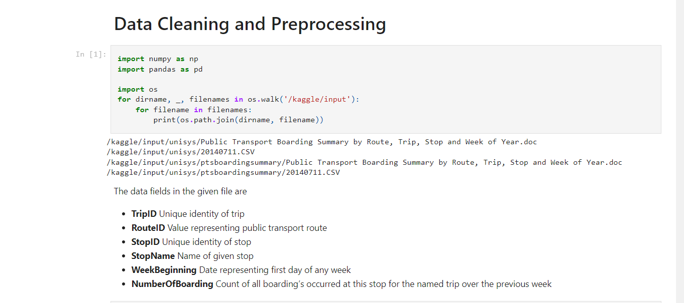

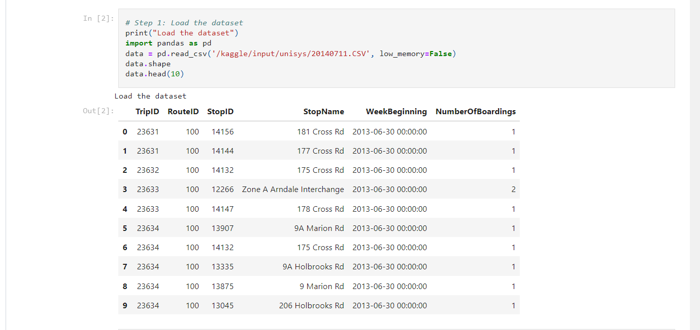

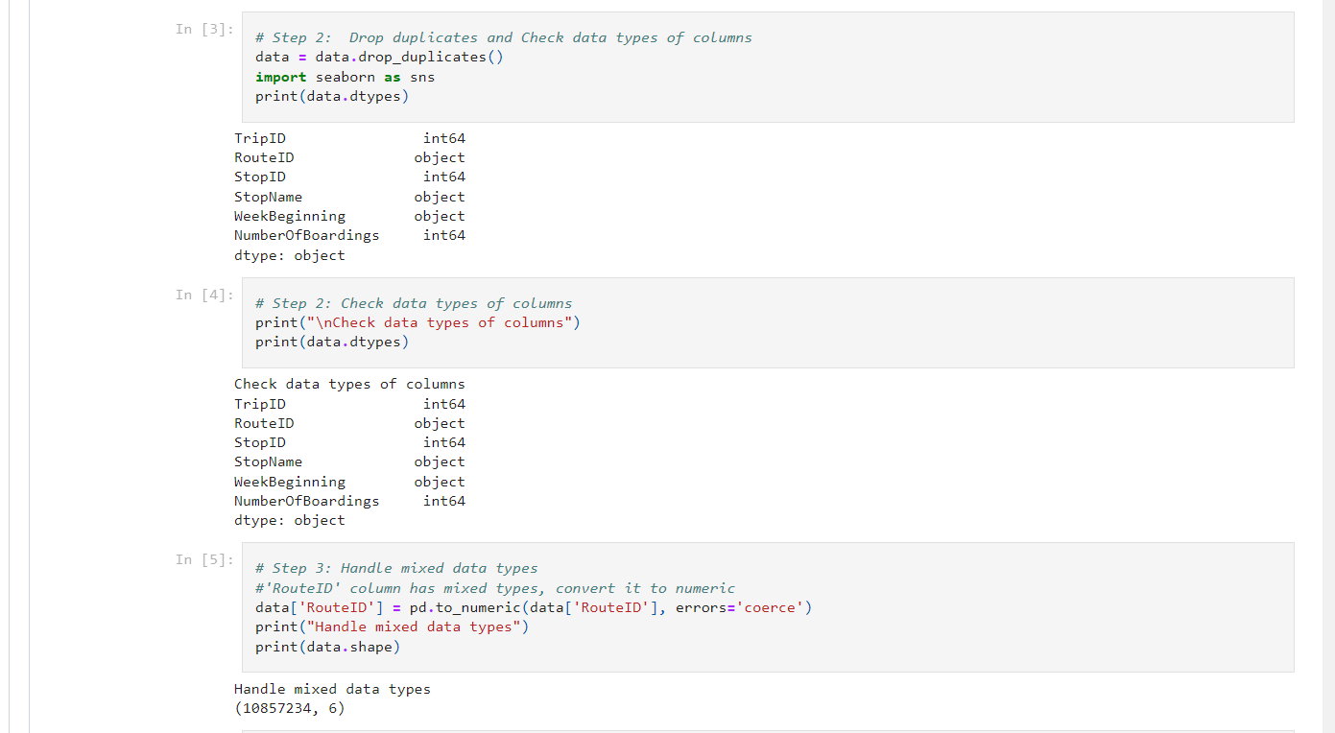

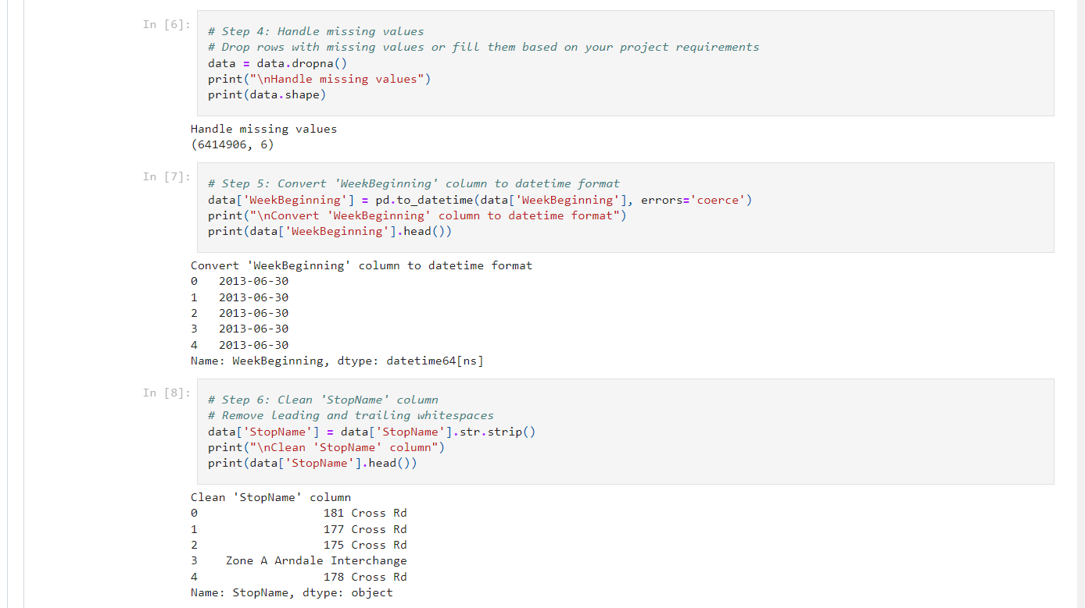

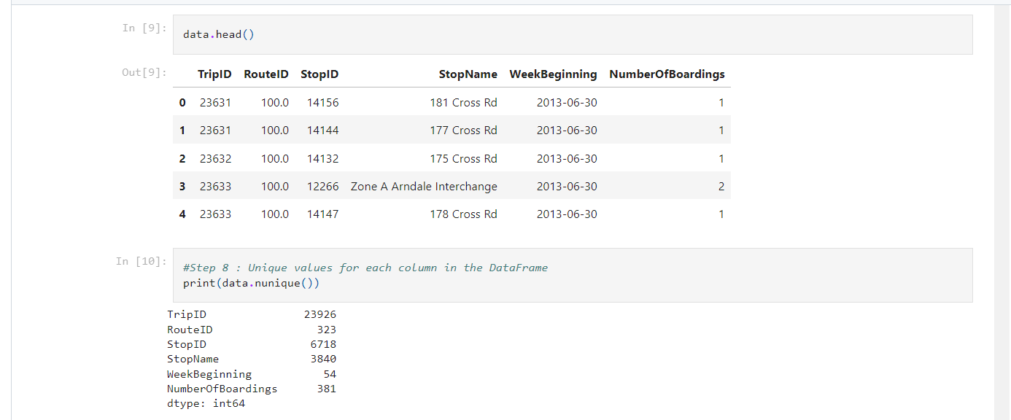

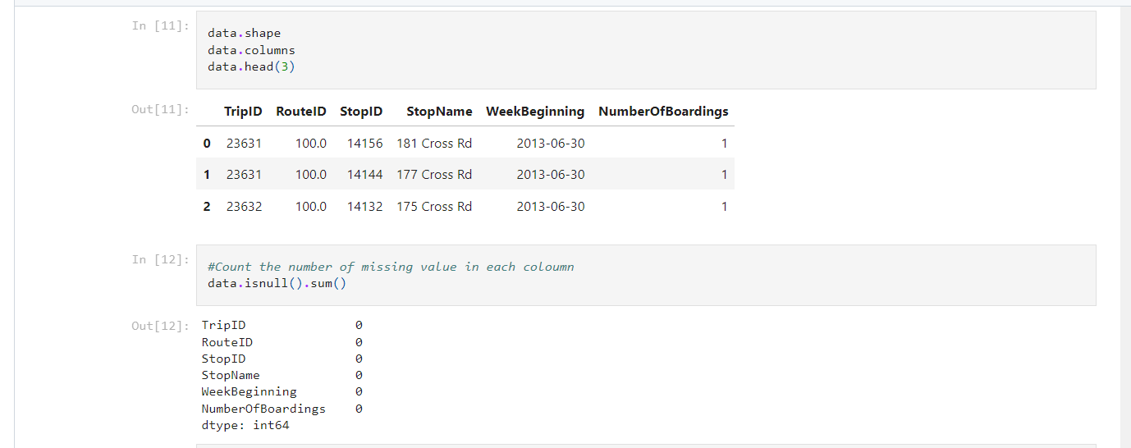

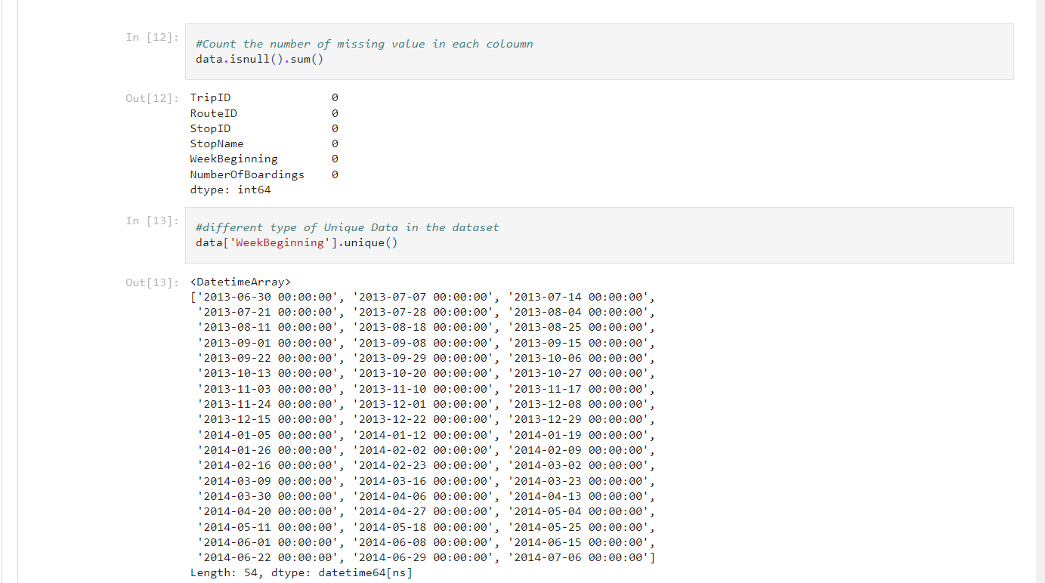

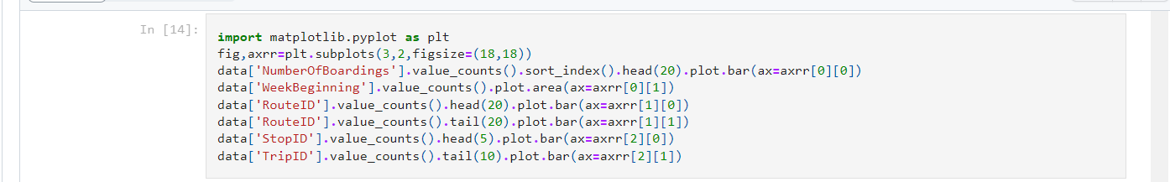

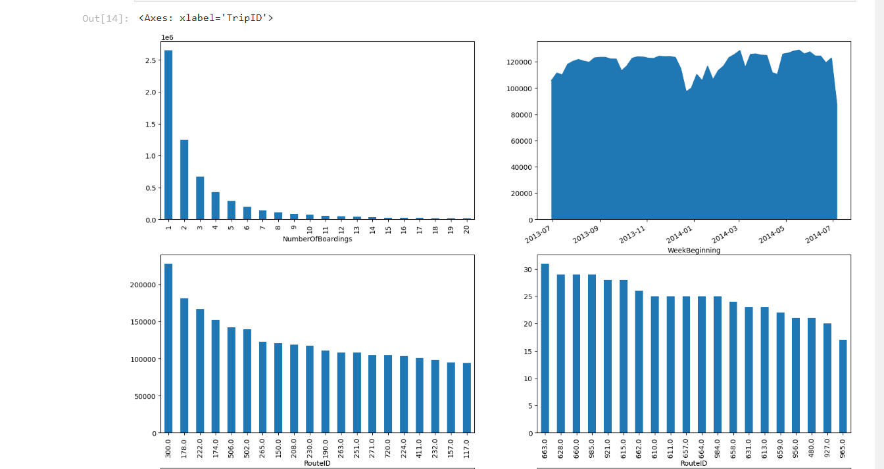

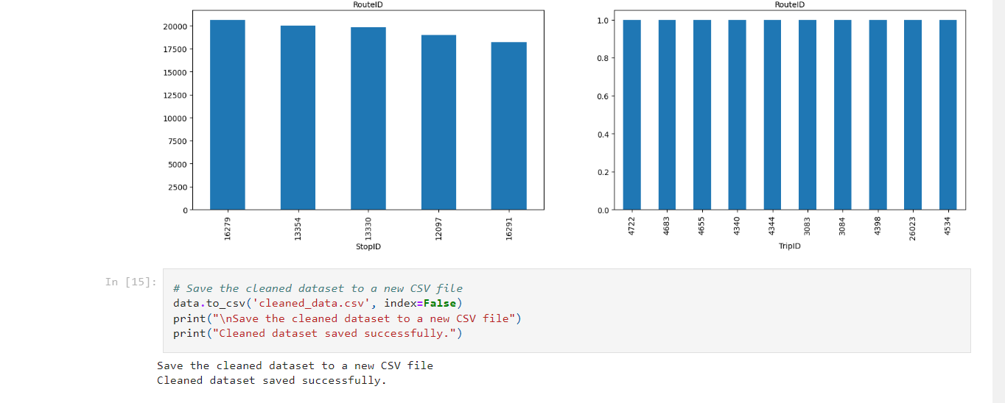

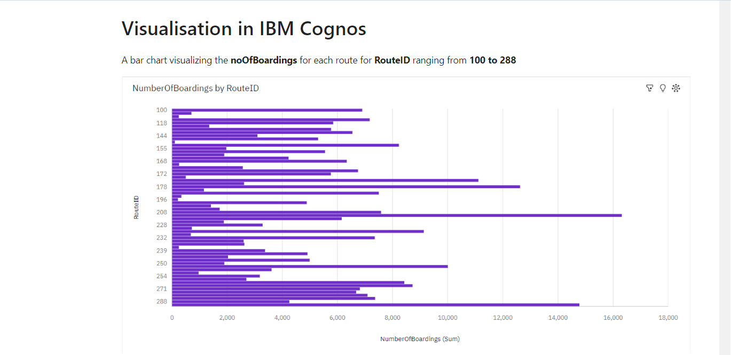

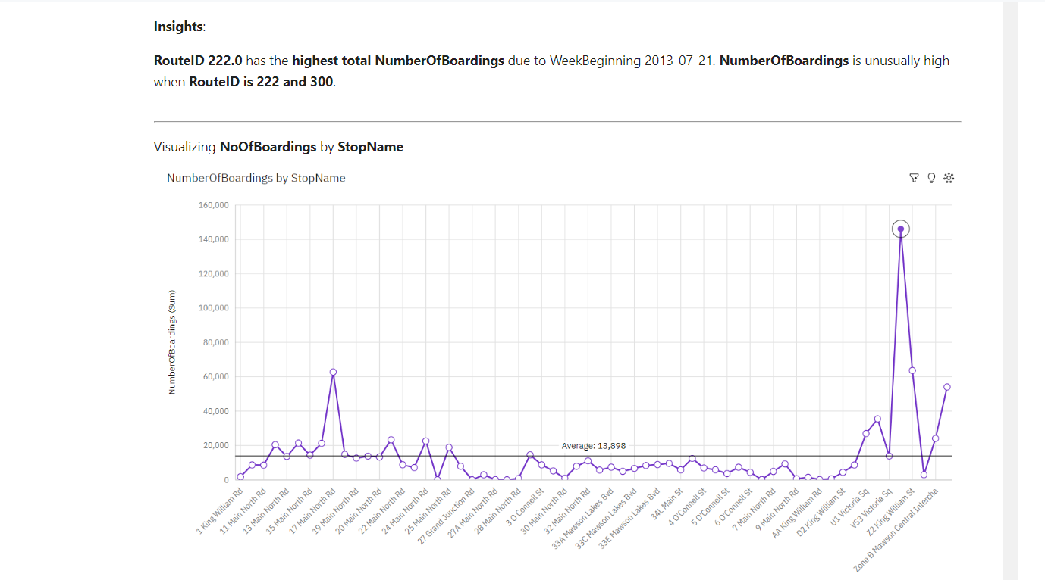

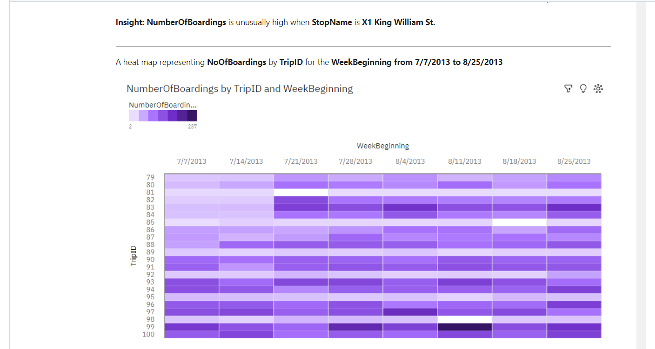

**CONCLUSION:**

In this phase of the project, the dataset was effectively processed and cleaned to ensure its accuracy and reliability. Subsequently, compelling visualizations were generated using IBM Cognos, setting the stage for a comprehensive analysis of public transportation efficiency. These preparatory steps are essential for facilitating informed decision-making and shaping the future of urban transportation systems.