**Software Development Life Cycle**

A. Research about Flipped Learning

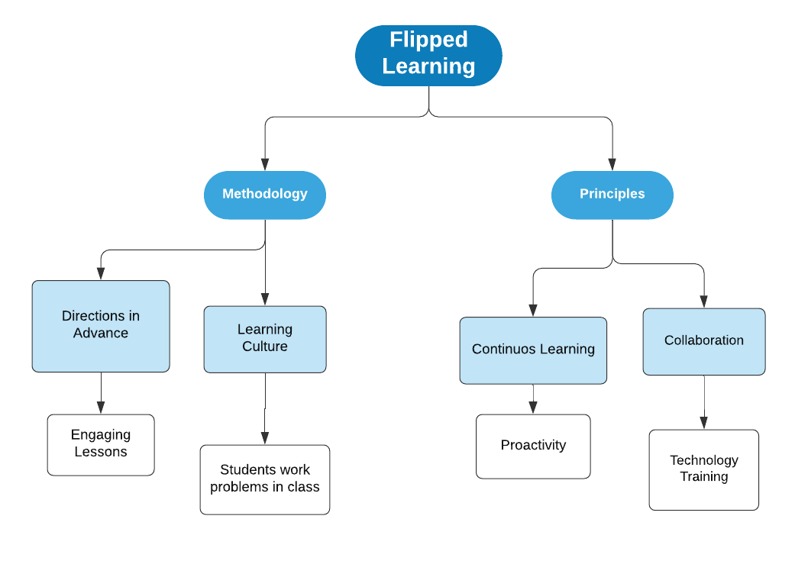

B. Research the following concepts

1. Define the concept of Software Development Life Cycle (SDLC).

*The* ***Software Development Life Cycle*** *(SDLC) refers to a methodology with clearly defined processes for creating high-quality software. in detail, the SDLC methodology focuses on the following phases of software development*

2. Describe the elements of SDCL

* **Requirement´s analysis.**

Project goals will be further aided by analysis of end-user information needs and the removal of any inconsistencies and incompleteness in these requirements.

A series of steps followed by the developer include:

1. Collection of facts: *Obtain end user requirements through documentation, client interviews, observation, and questionnaires.*
2. Scrutiny of the existing system: *Identify pros and cons of the current system in-place, to carry forward the pros and avoid the cons in the new system.*
3. Analysis of the proposed system*: Find solutions to the shortcomings described in step two and prepare the specifications using any specific user proposals.*

* **Design.**

The design functions and operations are described in detail, including screen layouts, business rules, process diagrams, and other documentation. The output of this stage will describe the new system as a collection of modules or subsystems.The design stage takes as its initial input the requirements identified in the approved requirements document. For each requirement, a set of one or more design elements will be produced because of *interviews, workshops,* and/or *prototype efforts.*

* **Implementation.**

Implementation/Coding starts once the developer gets the Design document. The Software design is translated into source code. All the components of the software are implemented in this phase.

* **Verification.**

Testing starts once the coding is complete and the modules are released for testing. In this phase, the developed software is tested thoroughly, and any defects found are assigned to developers to get them fixed.

Retesting, regression testing is done until the point at which the software is as per the customer’s expectation. Testers refer SRS document to make sure that the software is as per the customer’s standard.

* **Maintenance.**

After the deployment of a product on the production environment, maintenance of the product i.e., if any issue comes up and needs to be fixed or any enhancement is to be done is taken care by the developers.

3. Describe with your own words the importance of SDLC.

*It seems to me that it is important to make use of SDLC as it helps to turn a simple project idea into something functional. In addition, this optimizes the processes of the structure that we have from the beginning which benefits the work that is done.*

C. GitHub Repository

<https://github.com/Jaasiel94/EmbeddedProgramming>