The goal of the assignment was to rotate an image about its axis until the image had been rotated by 360 degrees. This was done with different angles, each requiring a different number of rotations. Accomplishing the rotation was done with the use of a rotation matrix, matrix multiplication, and nested for loops that iterated over the pixels in the image. The pixels were translated to have coordinates in which shifted their origin to the center of the Image because the origin by default is at the top left corner of the image. This origin placement would cause issues with the rotation where it would have rotated around the top left corner instead of its center.

I created a rotation matrix method that took an angle as a parameter and returned a rotation matrix based on the angle parameter. I created a matrix multiplication method that took two matrix parameters and return the result of the matrix multiplication. I used the rotation matrix generated by my rotation matrix method and a coordinate vector based on picture row (y) and picture column (x). My rotate image method accepted the angle for rotation, the image to rotate, and the name to save the rotated image as.

|  |  |  |  |  |
| --- | --- | --- | --- | --- |
| Angle Step Size | # Rotations | Absolute Color Error | Pixel Rounding Error | (# Rotations) * (Pixel Displacement) |
| 45⁰ | 8 | 32.243 | 0.0084 | .0672 |
| 60⁰ | 6 | 24.954 | 0.0069 | .0414 |
| 90⁰ | 4 | 0.0 | 0.0 | 0.0 |
| 120⁰ | 3 | 22.084 | 0.0024 | .0072 |
| 180⁰ | 2 | 0.0 | 0.0 | 0.0 |
| 360⁰ | 1 | 0.0 | 0.0 | 0.0 |

After the assignment, I conclude that due to the rounding that takes place when rotating, some values are less accurate than others. When rotating to 90, 180, or 360 degrees, the values for the pixels are not exposed to rounding because their values are already integers. For the in between values we see more color error and pixel error due to this. The chart also shows for that each time another rotation is required, the errors become more prevalent.



Rotation of 45 degrees with 8 rotations.



Rotation of 60 degrees with 6 rotations.

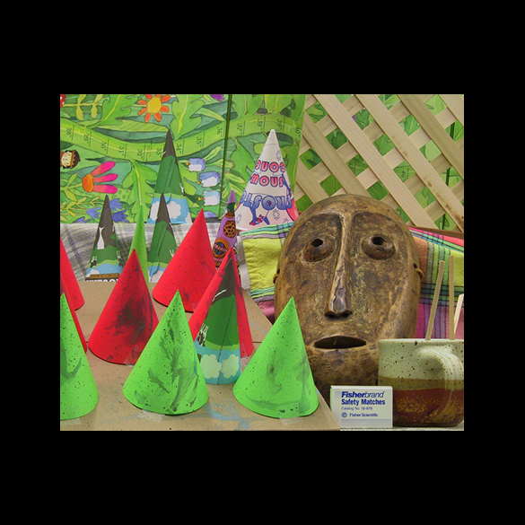

Rotation of 90 degrees with 4 rotations.