DATA CONSULTANT DIVISION
Payroll Checklist Generator Official Guide
Technical reference, workflow guide, and operating manual

This guide explains the Payroll Checklist Generator as a standalone internal app. It covers intake, payroll checklist usage, saved plans, dashboard and vault views, calendar scheduling, and troubleshooting for common operational issues.

Table of Contents
01. System Overview
02. Workflow and Usage Model
03. Screen-by-Screen Reference
04. Administrative Controls
05. Troubleshooting

System Overview
Audience: Payroll implementation specialists, data consulting users, and support personnel coordinating payroll setup work.
This guide explains the Payroll Checklist Generator as a standalone internal app. It covers intake, payroll checklist usage, saved plans, dashboard and vault views, calendar scheduling, and troubleshooting for common operational issues.

Purpose and Scope
- The Payroll Checklist Generator turns payroll setup details into an actionable checklist tied to dates, vendor setup milestones, and testing events.
- The app supports direct bookmarking, browser-based saves, and cross-screen navigation so payroll setup work can continue outside the main DC portal.
- This manual uses dummy data to show complete examples without exposing live operational information.

Workflow and Usage Model
- Users enter payroll setup details, FTP information, and team contacts on intake.
- The app generates checklist phases and timeline dates that can be saved locally or exported.
- The dashboard, plans vault, and calendar provide portfolio and schedule views over the same saved payroll records.

Screen-by-Screen Reference

Payroll Intake Screen
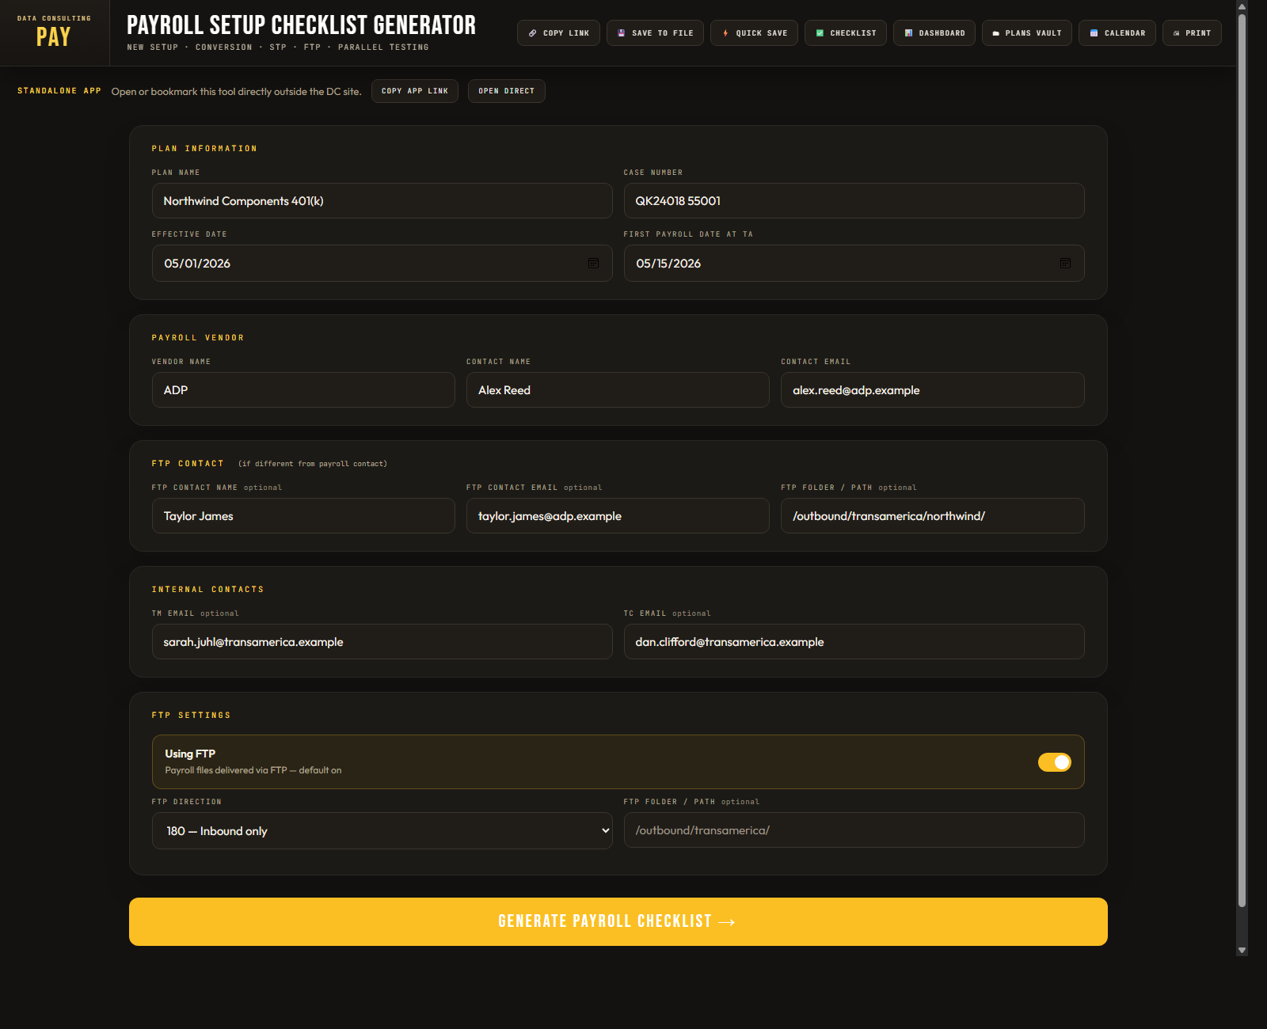
Sample payroll intake using dummy plan, payroll vendor, FTP, and internal contact data.
Element | Purpose
Plan information | Defines the case, effective date, and first payroll milestone.
Vendor and FTP fields | Drive payroll setup tasks, contact cards, and timeline dates.
Internal contacts | Provide TM and TC contact context for email generation and coordination.

Payroll Checklist Workspace
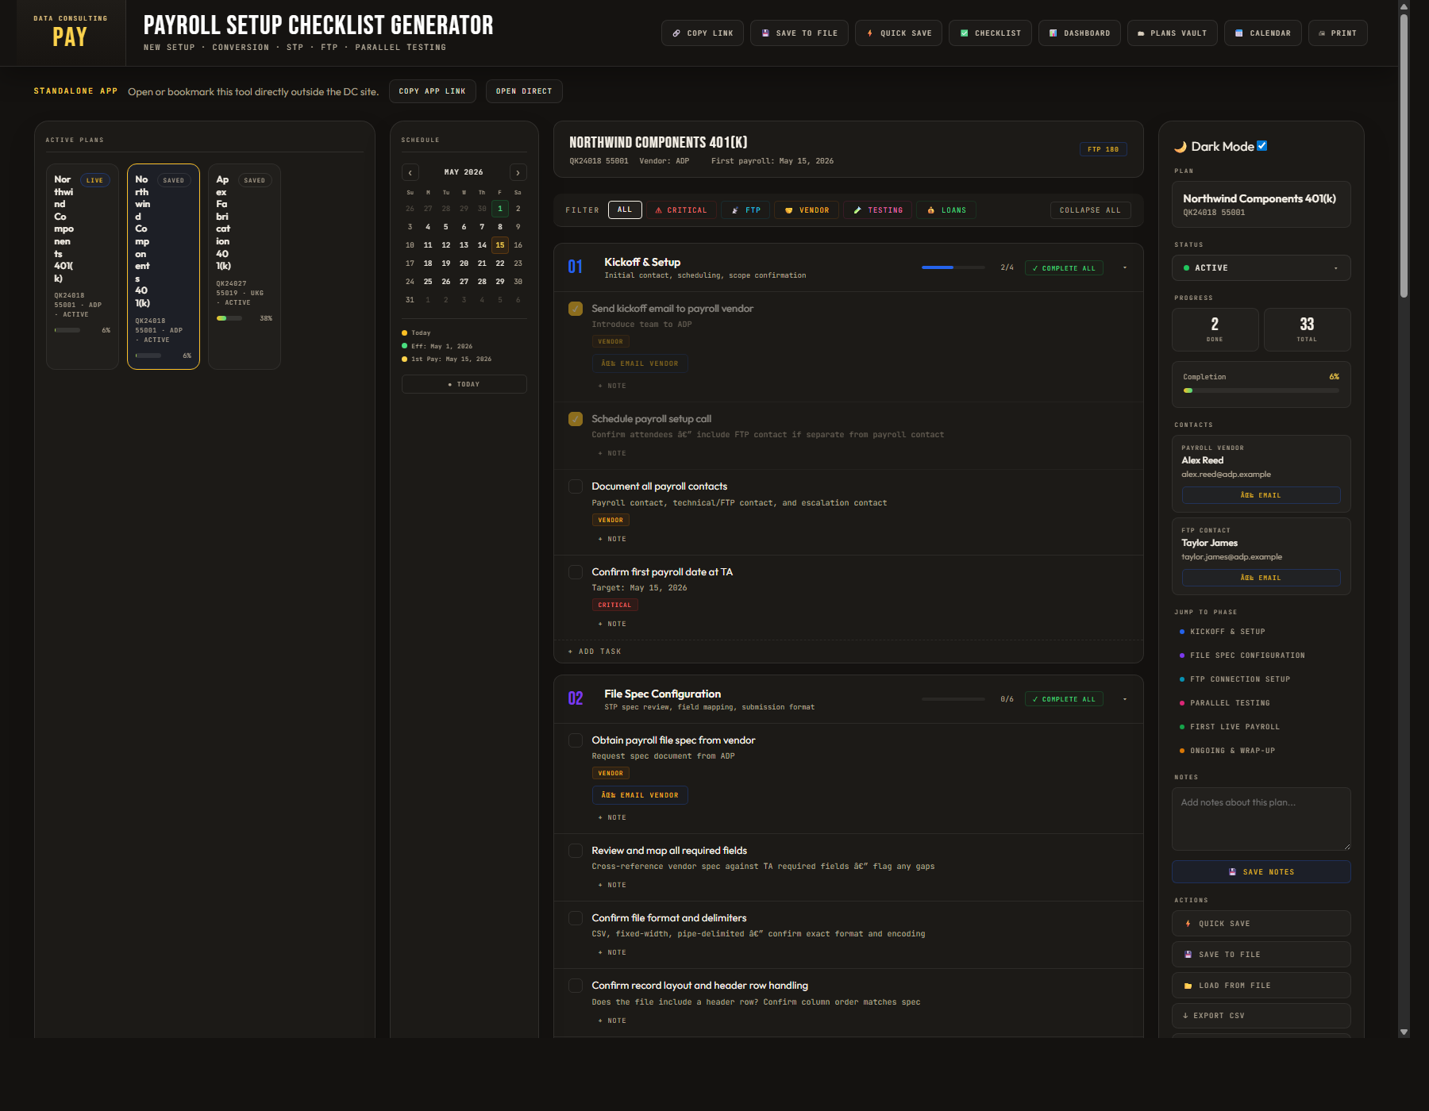
Generated payroll checklist using the cloned four-area structure: active plans, schedule, checklist, and sidebar.
Element | Purpose
Active Plans rail | Shows the current working payroll plan plus saved quick-access plans.
Schedule panel | Displays the payroll timeline beside the task workspace.
Checklist phases | Organize kickoff, file spec, FTP, testing, go-live, and wrap-up tasks.

Payroll Plans Dashboard
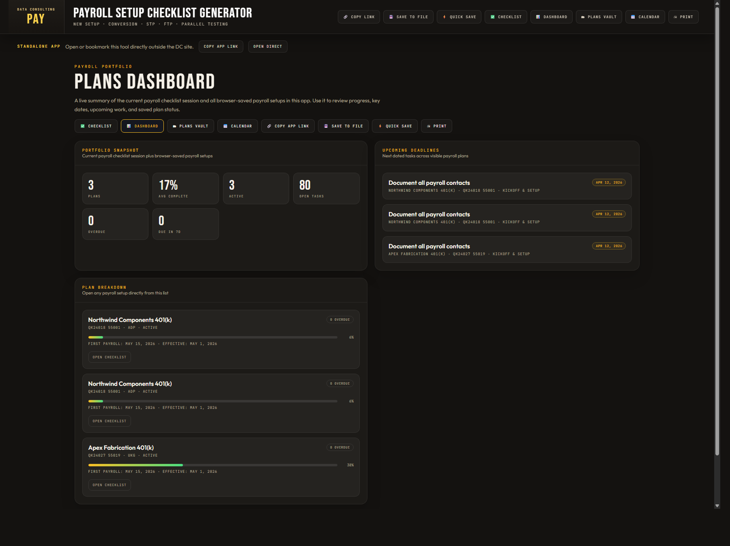
Dashboard view summarizing payroll progress, upcoming work, and saved plan health.
Element | Purpose
Snapshot metrics | Roll up plan count, completion, overdue items, and open tasks.
Deadlines card | Highlights the next dated tasks across visible payroll plans.
Plan breakdown | Provides a direct route back into an operational payroll checklist.

Payroll Plans Vault
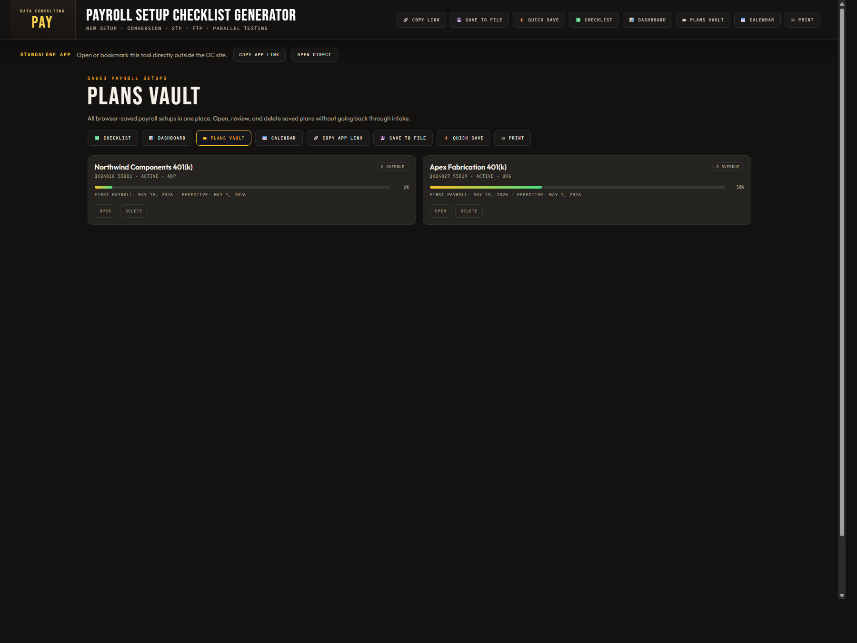
Vault view for saved payroll plans, with open and delete actions.
Element | Purpose
Saved payroll cards | Store plan identity, vendor, status, and progress summary.
Open action | Restores the saved plan into the payroll checklist workspace.
Delete action | Removes plans that should no longer remain in the browser vault.

Payroll Implementation Calendar
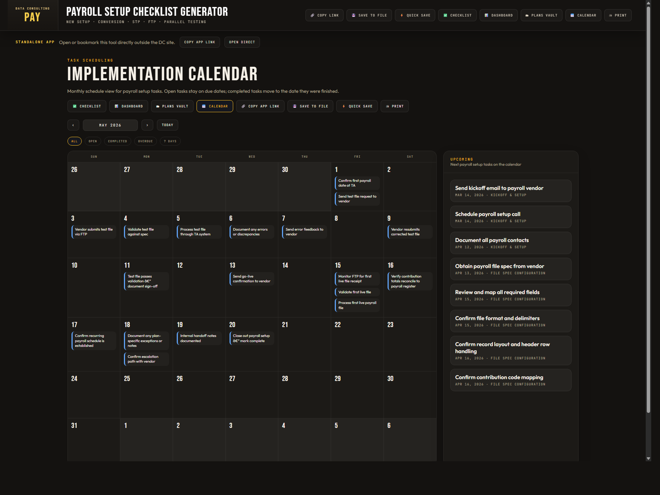
Calendar view showing payroll due dates and completion movement onto actual finish dates.
Element | Purpose
Month navigation | Moves across payroll setup months without leaving the calendar view.
Status filters | Filters all, open, completed, overdue, or near-term items.
Upcoming list | Provides a fast summary of next payroll-dated tasks.

Shared Action Menu
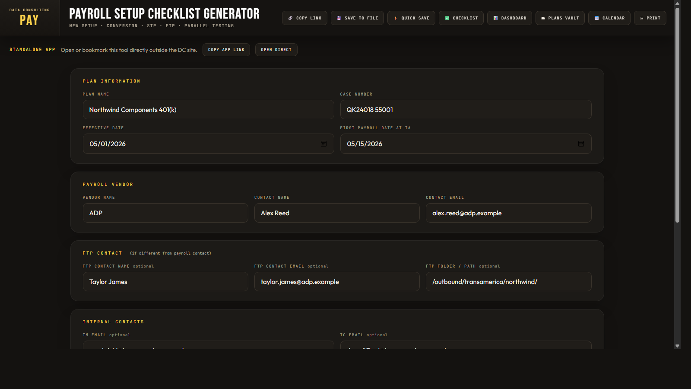
The shared top action menu carried across checklist, dashboard, vault, and calendar screens.
Element | Purpose
Checklist | Returns the user to the operational task workspace.
Dashboard, Vault, Calendar | Move between planning, saved-state review, and scheduling views.
Save actions | Support browser save, file export, and standalone-link behavior.

Administrative Controls
- Capture screenshots with realistic payroll examples that include vendor, FTP, and first-payroll dates so the generated views look complete.
- Document every major screen with more than one screenshot when the app supports stateful navigation.
- Use the same visual manual standard as the Main Checklist Generator so the apps read like one product family.
- Refresh screenshots when the checklist shell, dashboard cards, vault layout, or calendar filters change.

Troubleshooting
- If the checklist screen looks empty after generation, confirm that required plan fields were entered and regenerate from the intake screen.
- If saved plans do not appear in the Active Plans rail, use Quick Save again to refresh the browser store and then reopen the checklist screen.
- If calendar dates seem missing, verify Effective Date and First Payroll Date because payroll scheduling uses those anchors.
- If the standalone app link opens but no data is shown, remember that browser saves are local to the browser profile and file origin.

