DATA CONSULTANT DIVISION
Fixed-Width Report Extraction Console Guide
Technical reference, workflow guide, and operating manual
Updated Mar 2026

This guide explains how the Fixed-Width Report Extraction Console is used as a working internal web app for flat-file parsing, report breakout, and workbook export. It covers source selection, file intake, validation, parsed report review, workbook generation, and source configuration maintenance.

Table of Contents
01. System Overview
02. Workflow and Usage Model
03. Screen-by-Screen Reference
04. Source Configuration Model
05. Export and Output Behavior
06. Administrative Controls
07. Troubleshooting

System Overview
Audience: Data consultants, implementation analysts, reporting support users, and anyone responsible for breaking fixed-width provider files into usable report sheets.
The Fixed-Width Report Extraction Console is a standalone HTML web app that reads inbound flat files, identifies expected record codes by data source, parses each valid line into its report-specific layout, previews the output in-browser, and exports a multi-sheet Excel workbook.
The tool is designed to run locally with no server dependency. All parsing, validation, preview rendering, and workbook generation happen in the browser.

Purpose and Scope
The console exists to replace copy-paste-heavy fixed-width parsing work with a repeatable, source-driven flow. Instead of manually isolating records and splitting columns in Excel, the user selects the correct data source, loads the raw file, reviews accepted versus discarded lines, and exports a formatted workbook with one sheet per parsed report.
The guide uses sample and dummy examples for documentation purposes. Production parsing depends on the active source configuration embedded in the app.

Workflow and Usage Model
A standard user flow has six steps:
- Select the correct data source from the dropdown.
- Enter the case number and plan name that should be used in the export filename.
- Load the inbound text file from the local machine.
- Allow the app to validate record codes and parse matching lines automatically.
- Review summary counts, report list counts, discard reasons, and preview tables.
- Export the final workbook when the parsed output looks correct.

Case Number Rules
The case number field validates known prefixes and formats spacing automatically. Export is blocked until the case number is valid.
Prefix Group | Expected Format
QK, NQ | 5 digits, 3 spaces, 5 digits
TA, TE, TG, JK, TO | 6 digits, 2 spaces, 5 digits

Screen-by-Screen Reference

Launch / Intake View
The opening screen presents the title band, data source selector, report list panel, input controls, summary panel, and parsed report area. The export button remains disabled until a file is loaded and at least one report is parsed successfully.
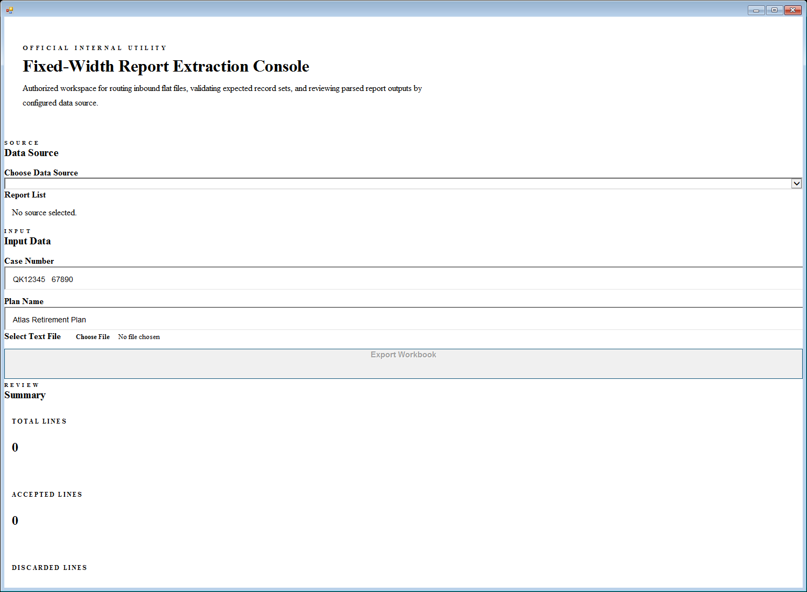
Figure 1. Entry-state view of the console before a file is loaded.

Parsed Review State
After a file is loaded, the app evaluates each nonblank line against the selected source record position and expected report list. Matching lines are grouped by report code, while nonmatching lines are listed in the discard summary. Preview tables show the first 20 rows only so large files remain readable in-browser.
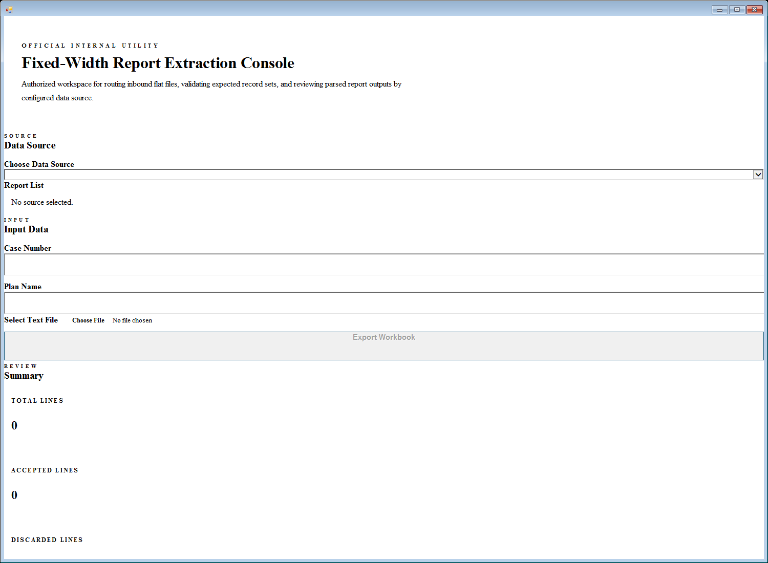
Figure 2. Parsed-state view with summary metrics and report previews.

Summary Panel
The summary panel shows total lines, accepted lines, discarded lines, report codes found, and discard reasons. This is the first place to verify whether the selected source rules match the inbound file.

Parsed Reports Area
Each accepted report appears in its own preview card. Wide layouts scroll horizontally and only the first 20 rows are shown in the browser. The Excel export still includes the full rowset, not just the preview subset.

Source Configuration Model
Data source definitions are embedded in the parser configuration object inside the core JavaScript file. Each source contains a label, record start position, record length, expected report list, and per-report field layouts.
Current configured sources include DATOSAURUS, LEDGERPRO, NEXUSOPS, CLAIMWIRE, FUNDTRACK, NEWPORT, NATIONWIDE, EMPOWER, and ADP.
Each field layout entry includes:
- Header name for the report sheet column
- 1-based fixed-width start position
- Field length
- Type hint used for preview formatting and Excel export

Export and Output Behavior
Exports are generated as a true .xlsx workbook. The output filename follows the pattern:
Case Number - Plan Name - Full Parse.xlsx

Workbook structure:
- Title Page sheet with data source, input file, total lines, and per-report counts
- One worksheet per parsed report, named after the report code
- Centered cell alignment across the workbook
- Bold header row with light blue fill
- Typed export handling for date, decimal, integer, and text fields

Administrative Controls
When source layouts change, update the corresponding entry in the parser configuration and then rebuild the standalone HTML file so the handoff version stays in sync.
Use realistic but non-sensitive test data when validating a new source. Confirm record positions first, then confirm report list filtering, and only after that expand field-level typing.
If a provider specification lists report codes without layouts, do not add those codes to the active report list until the layout block exists. Otherwise the app will flag them as missing layouts during parsing.

Troubleshooting
- If the data source dropdown is empty, the script likely failed before initialization. Check the source configuration object for a brace or comma issue.
- If all lines are discarded, verify the selected data source and confirm the record start and record length values for that provider.
- If a report never appears, confirm that its record code is present in both the expected report list and the layouts block.
- If the export button stays disabled, make sure at least one valid report was parsed and that the case number is in a valid format.
- If Excel output looks wrong, review the field type hints for the affected columns. Unknown or missing types default to text.

