Data Consultant Portal
Official Website Guide and Portal Reference Manual

Purpose: Formal portal guide, training reference, and section-by-section usage document
Primary File: Data_Consultant_Website_v2_10.html
Prepared: March 14, 2026
Scope: Homepage, section navigation, search, walkthroughs, documents, dashboard, projects, and interactive flows

This document explains how the Data Consultant Portal is structured, how users move through the site, which sections contain static reference material versus interactive tools, and how the portal supports day-to-day division work.

Table of Contents
- 1. Portal Overview
- 2. Standard Navigation Model
- 3. Homepage
- 4. Documents & Templates
- 5. Walkthroughs & Procedures
- 6. Projects, Apps, and Standalone Tools
- 7. Task Dashboard
- 8. Interactive Flows
- 9. Search and Discovery
- 10. Recommended Usage Patterns
- 11. Troubleshooting Guide
- 12. Appendix: Section Inventory

1. Portal Overview
The Data Consultant Portal is a centralized internal website that consolidates the division?s documents, walkthroughs, procedures, VBA tools, interactive flows, projects, forms, reference pages, and dashboard utilities into a single navigable experience. It is designed to reduce time spent searching for tribal knowledge and to provide one operating surface for recurring team workflows.
Unlike a simple document library, the portal blends three content types in one place: static references, interactive guided flows, and standalone applications. That mix makes it part knowledge base, part workflow library, and part internal tooling hub.
Portal Function | Description
Reference hub | Hosts documents, templates, procedures, field references, and knowledge content.
Workflow guide | Provides static walkthroughs and guided interactive flow experiences.
Tool launcher | Launches dashboard utilities and standalone checklist generator apps.
Discovery layer | Offers homepage grouping, quick-launch tiles, and global search.
Operational support | Supports common team work such as payroll integration, TIK, balance import, loans, eligibility, deferrals, and Roth basis processing.

1.1 Primary Audiences
- Data Consultants using the site as their day-to-day operational launch point.
- New team members onboarding into common procedures and process paths.
- Experienced users looking for a faster way to launch a tool or reference a walkthrough.
- Process owners maintaining division knowledge and interactive procedural assets.

2. Standard Navigation Model
The portal uses a consistent top masthead and navigation row. Users can move section to section without leaving the site shell, and most major destinations are reachable from either the masthead or the homepage section cards.
Navigation Element | Purpose
Masthead | Persistent header showing site identity and high-level portal counts.
Nav row | Section-to-section page switching across the site.
Homepage quick launch | Immediate entry into the seven interactive flows.
Homepage section cards | Direct entry into the primary content sections.
Global search | Cross-site search overlay used to locate content fast.

Because the site is organized around content groups rather than a single linear flow, users should think of it as a portal. The homepage is the launch layer, and the internal section pages provide the detailed content views.

3. Homepage
The homepage is the main launch surface for the portal. It immediately communicates the size of the knowledge base, the number of interactive flows, and the major categories available in the site.
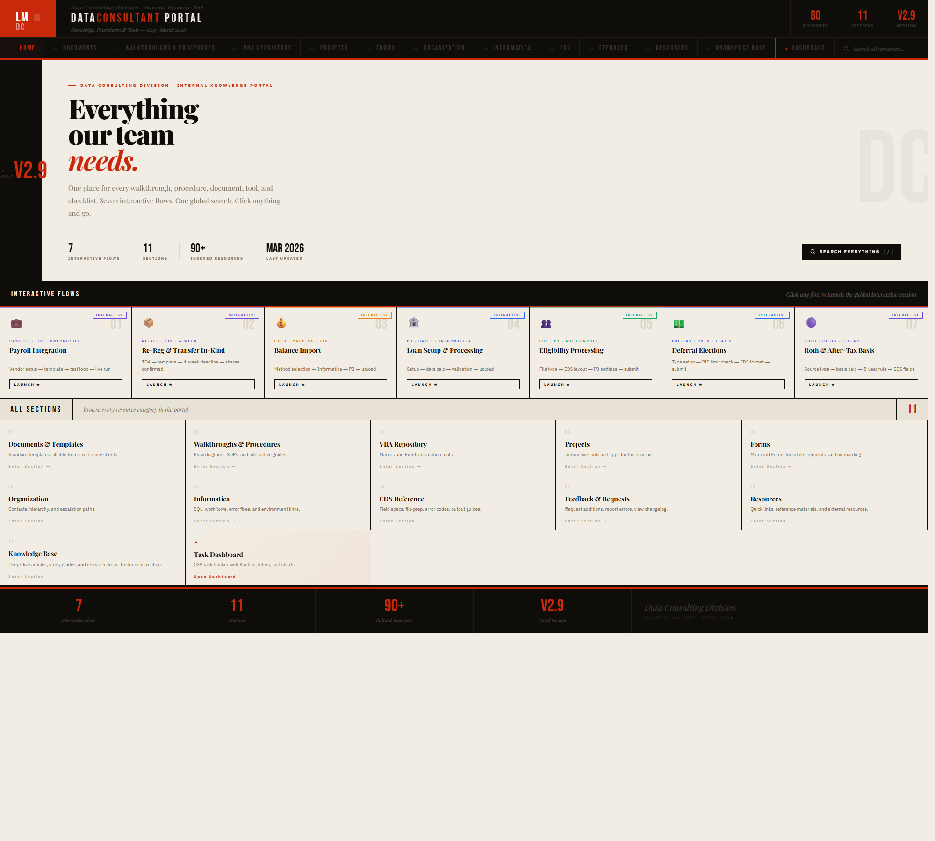
Figure 1. Portal homepage with hero, quick-launch flow tiles, and section entry cards.
Callout Area | What To Notice | Why It Matters
Hero area | The hero explains the role of the portal and highlights the scale of the content library. | This gives users immediate context and confidence about what the site contains.
Quick-launch band | The interactive flow strip provides direct access to the seven guided flows. | This is the fastest route for repeat users who already know which process they need.
All Sections grid | Section cards provide a complete map of the main site sections. | This makes the homepage an orientation tool for new users and a jump-off point for experienced users.
Footer stats | Counts reinforce the number of sections, interactive flows, and resources available. | This supports portal credibility and quick scanning.

3.1 Homepage Use Cases
- Launch a known interactive flow immediately from the quick-launch row.
- Browse the section map to find a content category such as Documents, VBA, Informatica, or EDS.
- Use the search action when the user knows a keyword but not the section location.
- Use the homepage as an orientation page during training or onboarding.

4. Documents & Templates
The Documents section acts as a structured document library. It groups templates, forms, and related reference files into a clear list format with action buttons for download and copy-path style usage.
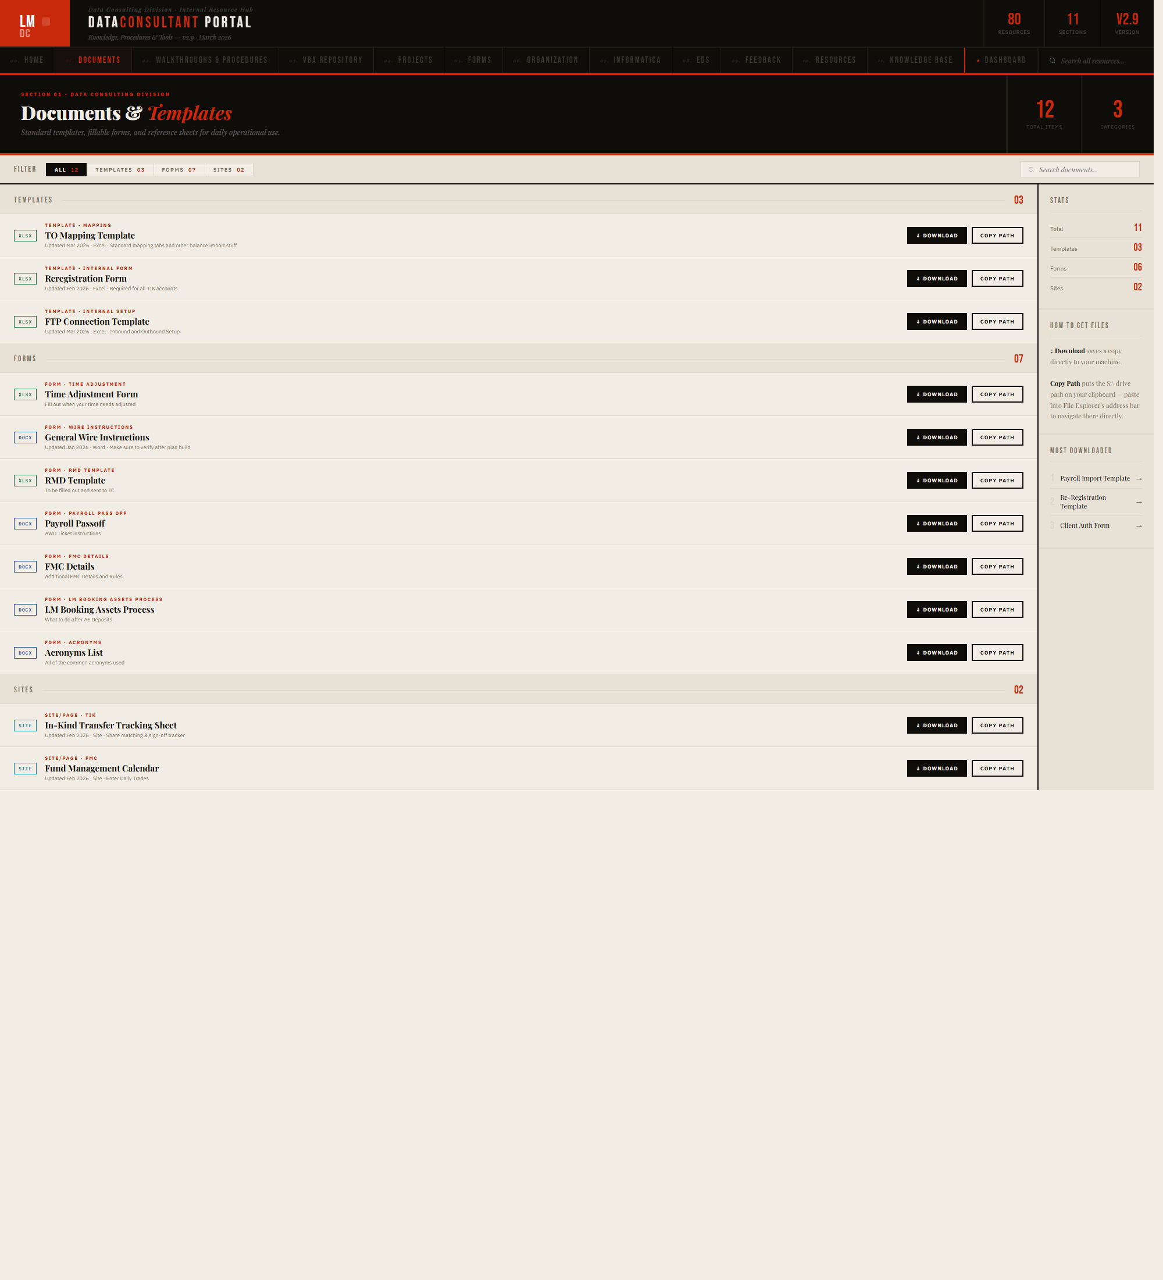
Figure 2. Documents & Templates section with grouped items, filters, and right-side summary panel.
Callout Area | What To Notice | Why It Matters
Section header | The page header identifies the content type and shows item counts. | Users can quickly tell whether they are in a document library page or a process page.
Document list | Rows are grouped by type and display item titles, short descriptors, and actions. | This makes the section useful both as a reference list and as a working file launcher.
Filter row | Category tags allow the content list to be narrowed to subgroups such as templates or forms. | Filtering reduces scrolling and helps users find files faster.
Right sidebar | The summary panel reinforces counts and surfaces quick notes about the section. | This adds context without cluttering the main list.

4.1 What Users Typically Do Here
- Find standard templates that support recurring plan work.
- Open or download frequently used forms and reference sheets.
- Use the section as a curated alternative to searching through shared drives or folders.

5. Walkthroughs & Procedures
The Walkthroughs section is one of the most important pages in the portal. It contains the static procedural walkthroughs and pairs many of them with interactive guided versions. This is the main bridge between documentation and executable workflow support.
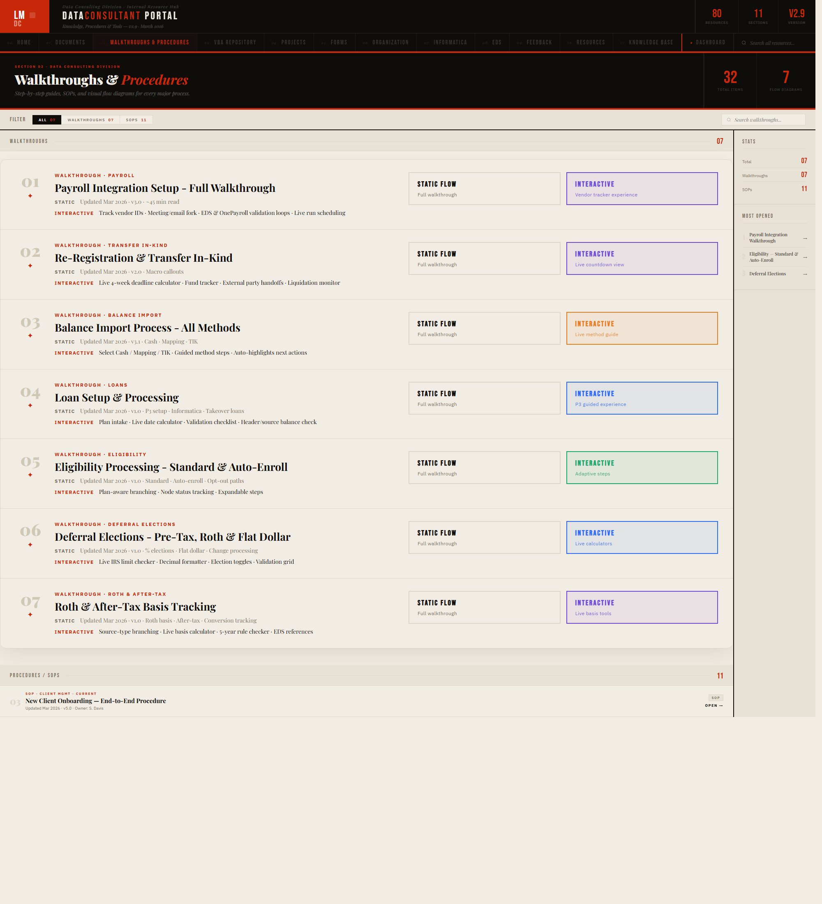
Figure 3. Walkthroughs & Procedures section showing side-by-side static and interactive entry paths.
Callout Area | What To Notice | Why It Matters
Procedure rows | Each row maps to a major operational topic such as Payroll Integration, Re-Registration, or Balance Import. | This creates a consistent index of major division procedures.
Static Flow action | Static walkthrough links serve users who want the full written procedure. | These are best for review, reference, and non-guided reading.
Interactive action | Interactive buttons open guided flow versions for supported procedures. | These are best for step-by-step execution and decision support.
Sidebar metrics | The right panel summarizes total items, static items, and interactive items. | This helps communicate coverage and maturity of the section.

5.1 Static vs. Interactive
Mode | Best Used For
Static walkthrough | Reference reading, full-procedure review, and users who want the written SOP style.
Interactive walkthrough | Step-by-step execution, live decision support, and guided process navigation.

6. Projects, Apps, and Standalone Tools
The portal also acts as a launch surface for custom-built tools and apps. These include the standalone checklist generators and other project pages created for division use. Some tools are embedded in the portal experience, while others open as direct standalone applications so users can bookmark and reuse them outside the main site shell.
- Projects act as an internal tools showcase for division-built utilities.
- The Main Implementation Checklist Generator and Payroll Checklist Generator function more like mini web apps than simple pages.
- This model allows users to start from the portal and then continue work directly inside the app they launched.
- The portal therefore serves both as a content index and as a tool directory.

7. Task Dashboard
The Task Dashboard section provides a different type of utility than the document and walkthrough pages. It is designed for task tracking, CSV import workflows, and at-a-glance operational status. In effect, it extends the portal into work management.
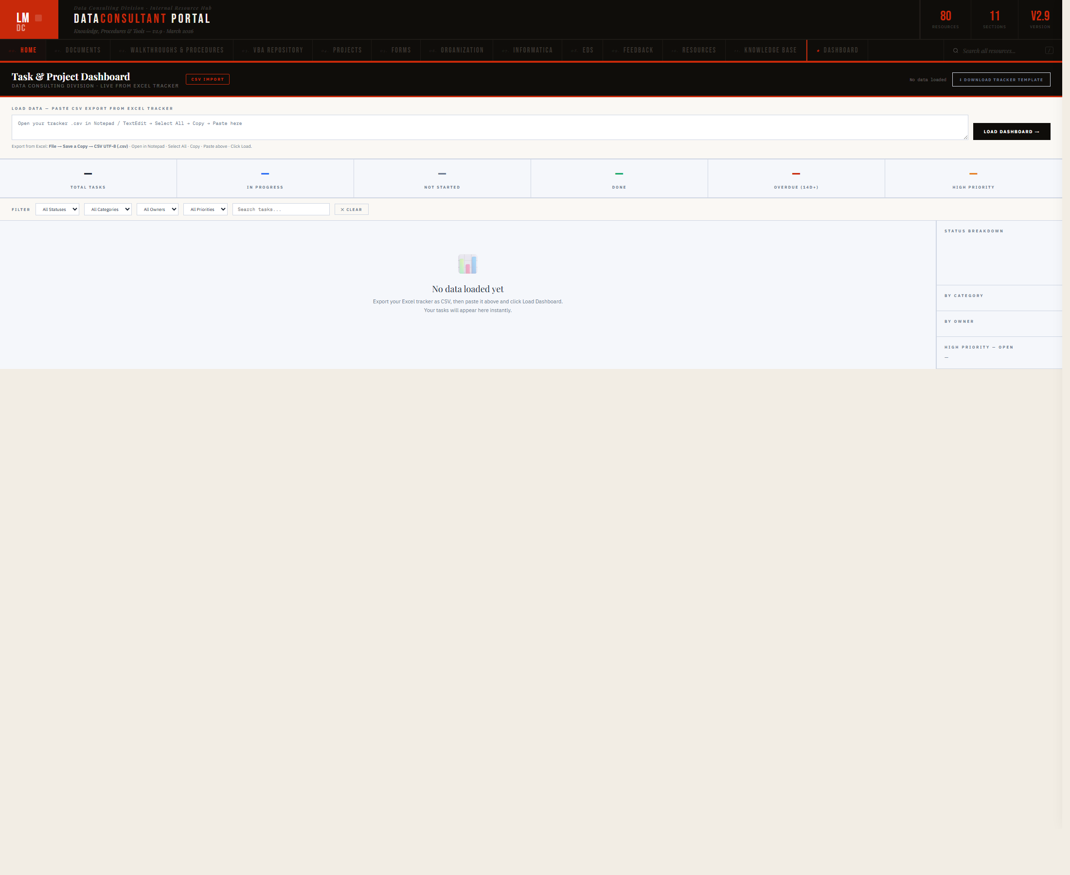
Figure 4. Task & Project Dashboard page showing import, filter, and analysis layout.
Callout Area | What To Notice | Why It Matters
Import controls | The top of the page supports loading task data from export files. | This allows the dashboard to act on user data rather than only static portal content.
Summary strip | Metrics such as total tasks, in progress, done, and overdue are shown across the top. | This gives an immediate status read of the loaded task set.
Main workspace | The center area becomes the active working view once task data is loaded. | This makes the dashboard an operational utility rather than a passive page.
Right-side analysis | Sidebar panels support status and category breakdowns. | This supports faster triage and reporting.

7.1 Dashboard Role in the Portal
- Provides a task-tracking utility directly inside the portal ecosystem.
- Supports CSV-driven work review.
- Acts as a bridge between knowledge content and operational execution.

8. Interactive Flows
Interactive flows are one of the portal?s strongest differentiators. Instead of only listing SOPs, the site also offers guided process pages that walk users through complex tasks. These flows use sidebars, progress states, step checklists, branching logic, calculators, and linked references.
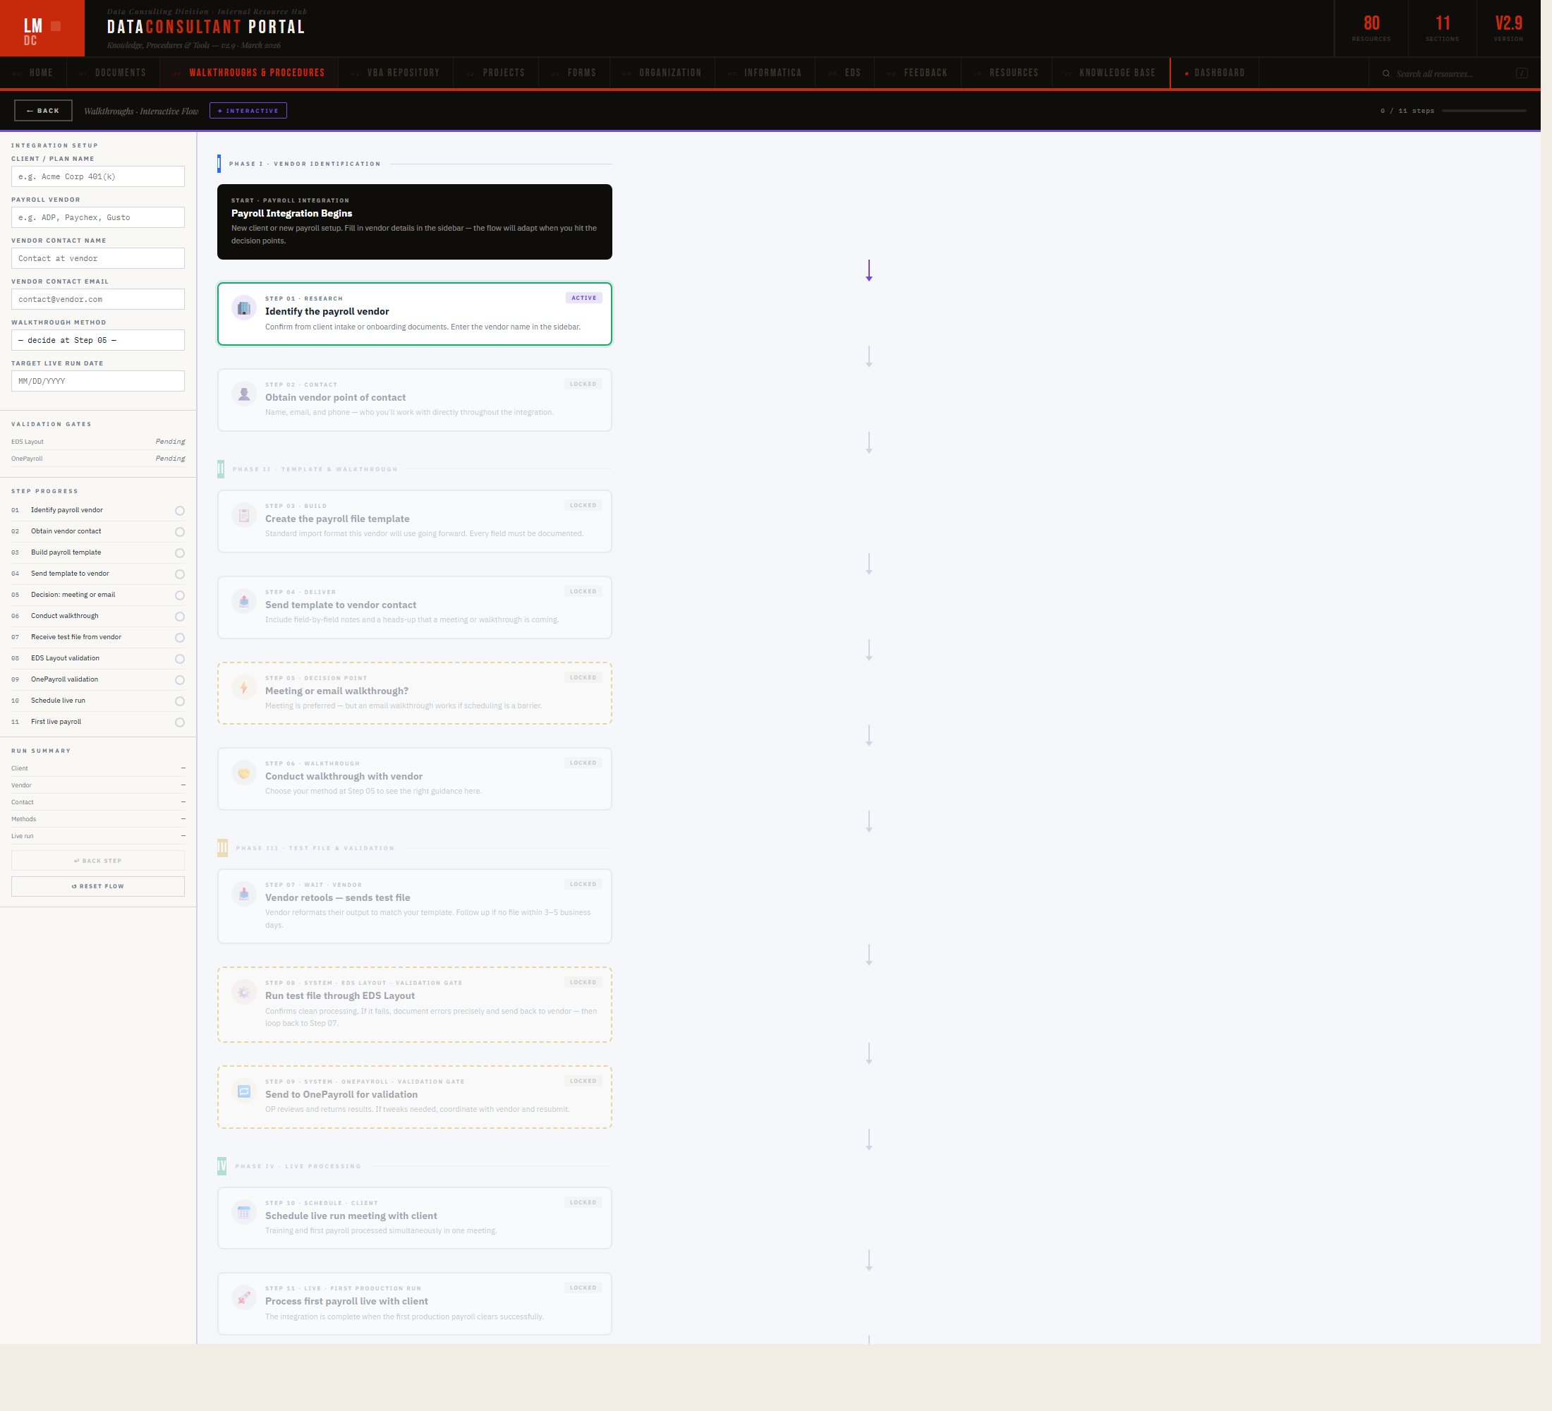
Figure 5. Payroll Integration interactive flow with a guided progression model and supporting sidebar.
Callout Area | What To Notice | Why It Matters
Left sidebar | The sidebar captures context, step progress, and process metadata. | This keeps the user oriented while moving through a complex workflow.
Main flow canvas | The central panel presents the step-by-step guided experience. | This turns a procedure into an executable walkthrough rather than a static document.
Topbar context | The interactive topbar identifies the flow and indicates the current guided environment. | This helps distinguish an interactive mode from the standard portal list pages.
Reset / back logic | The flow supports controlled navigation and reset behavior. | This makes the experience reusable for repeat execution and training.

8.1 Current Interactive Coverage
- Payroll Integration
- Re-Registration / TIK
- Balance Import
- Loans Setup & Processing
- Eligibility Processing
- Deferral Elections
- Roth & After-Tax Basis

8.2 Why Interactive Flows Matter
- They reduce the cognitive load of long written procedures.
- They support training and actual execution at the same time.
- They make process sequencing, decision points, and linked references easier to digest.
- They improve consistency for repeat workflows.

9. Search and Discovery
The portal includes a global search overlay so users can locate content across the site without manually guessing which section holds a given item. Search is especially valuable in a portal that mixes documents, walkthroughs, flows, projects, and references.
- Use search when the user knows a keyword but not the section location.
- Use section pages when the user wants to browse a known content category.
- Use homepage launch cards when the destination type is already known.
Best Starting Point | When To Use It
Homepage | The user is orienting, browsing, or training.
Global search | The user knows a title, keyword, or topic fragment.
Walkthroughs page | The user knows they need a process flow.
Documents page | The user knows they need a template or form.
Interactive flow | The user is actively executing a supported process.

10. Recommended Usage Patterns
- Start from the homepage when beginning a session and choose between quick-launch, section browsing, or search.
- Use Walkthroughs & Procedures as the default operating page when the user is process-oriented.
- Use interactive flows for execution and static walkthroughs for procedure review.
- Launch standalone tools from the portal when a workflow needs app-like state tracking rather than a simple reference page.
- Use the portal as the team?s primary reference shell instead of searching across disconnected folders and documents.

11. Troubleshooting Guide
Issue | Likely Cause | Recommended Response
A page does not switch when clicked | A script issue, stale browser copy, or incorrect file version may be open. | Refresh the page and confirm the intended site file is open.
Search does not surface an expected item | The keyword may not match indexed text closely enough, or the item may belong to a different section than expected. | Try section browsing as a fallback and vary search terms.
Interactive flow navigation feels stuck | The flow may be waiting for the next valid state or may need a reset. | Use the back/reset controls and confirm required context fields are filled in.
A tool opens outside the site shell | The tool is intentionally configured as a standalone app. | Use the direct app link or bookmark the standalone page as needed.
Visual layout seems off | Browser zoom, stale cache, or an older file copy may be involved. | Refresh, confirm zoom level, and make sure the latest file version is open.
A section appears sparse or incomplete | Some pages function mainly as launch surfaces rather than dense content pages. | Use the target page or linked tool the section is meant to launch.

11.1 Portal Maintenance Notes
- The portal mixes static HTML content with JavaScript-driven page switching and interactive experiences.
- When new tools are added, both the homepage launch surfaces and the internal section inventory should be kept in sync.
- Interactive flow behavior should be checked after UI changes, especially reset, back, and launch links.
- Standalone app links should be validated whenever app file names or launch paths change.

12. Appendix: Section Inventory
Section | Primary Role
Home | Launch surface and portal overview.
Documents | Templates, forms, and reference files.
Walkthroughs & Procedures | Static and interactive process guidance.
VBA Repository | Macro and code-related utility resources.
Projects | Internal projects and tool launches.
Forms | Form-based assets and inputs.
Organization | Contacts, hierarchy, and escalation content.
Informatica | Environment and processing references.
EDS | Field specs, errors, and output guidance.
Feedback | Improvement and request intake area.
Resources / Knowledge Base | Broader supporting materials and knowledge content.
Dashboard | Task-oriented utility and analysis area.

Taken together, these sections make the Data Consultant Portal a working platform rather than only a website. It combines reference content, procedural guidance, internal tooling, and discovery in a single environment.

