DATA CONSULTANT DIVISION
Main Checklist Generator Official Guide
Technical reference, workflow guide, and operating manual

This guide explains how the Main Checklist Generator is used as a working implementation app. It covers intake, checklist execution, dashboards, saved plans, calendar usage, administrative timeline controls, and common recovery steps.

Table of Contents
01. System Overview
02. Workflow and Usage Model
03. Screen-by-Screen Reference
04. Administrative Controls
05. Troubleshooting

System Overview
Audience: Implementation consultants, plan coordinators, and support users managing implementation plans.
This guide explains how the Main Checklist Generator is used as a working implementation app. It covers intake, checklist execution, dashboards, saved plans, calendar usage, administrative timeline controls, and common recovery steps.

Purpose and Scope
- The Main Checklist Generator turns implementation intake data into a structured operational checklist with due dates, saved records, dashboards, and calendar reporting.
- The app is designed to operate as a standalone internal web app, not just a static page, so users can bookmark it and manage plans directly.
- The guide uses dummy data examples so screenshots remain readable and safe for reuse in training material.

Workflow and Usage Model
- A user enters intake details, plan type, strategy, dates, contacts, and plan characteristics.
- The app generates the live checklist, timeline rails, phase summaries, and progress counters from that data.
- Users can save plans locally, reopen them from the checklist rail or vault, and review portfolio-level summaries in the dashboard and calendar.

Screen-by-Screen Reference

Intake Screen
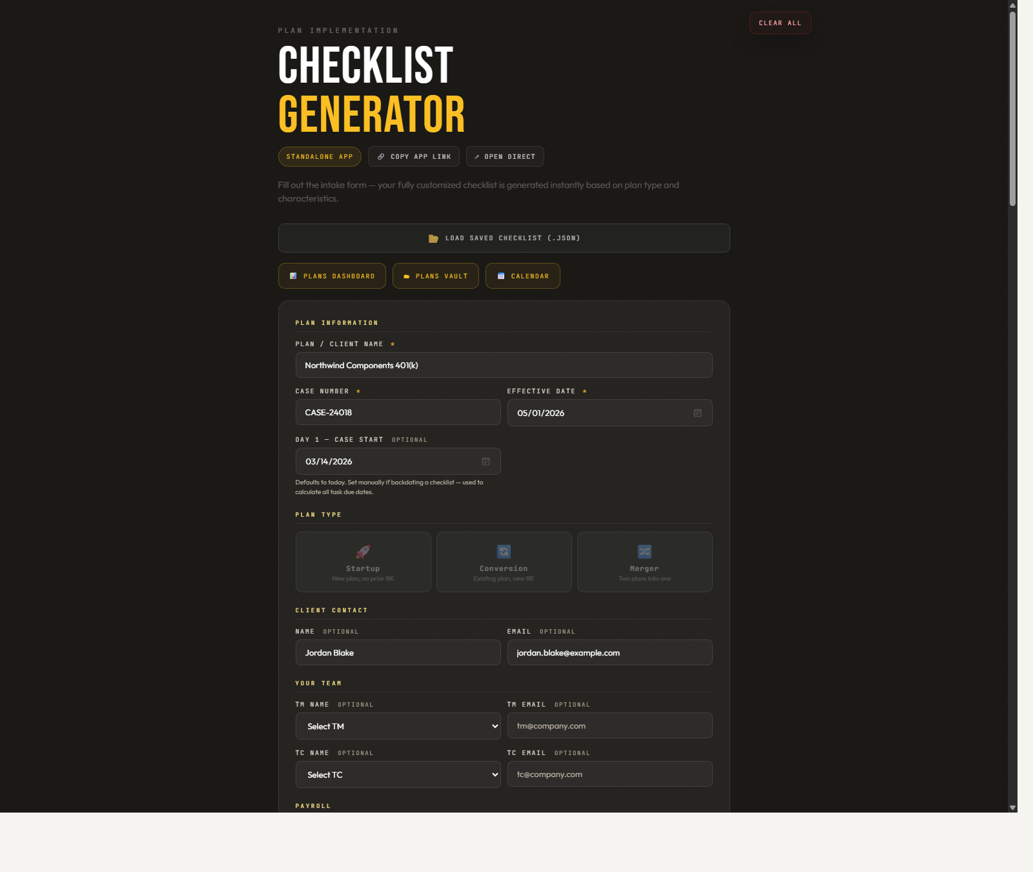
Example intake state using sample conversion data before checklist generation.
Element | Purpose
Plan information | Anchors the case, timeline dates, and plan identity.
Plan type and strategy | Drives task generation, dependencies, and due-date logic.
Team and vendor fields | Feeds dashboard cards, contacts, and downstream checklist context.

Checklist Workspace
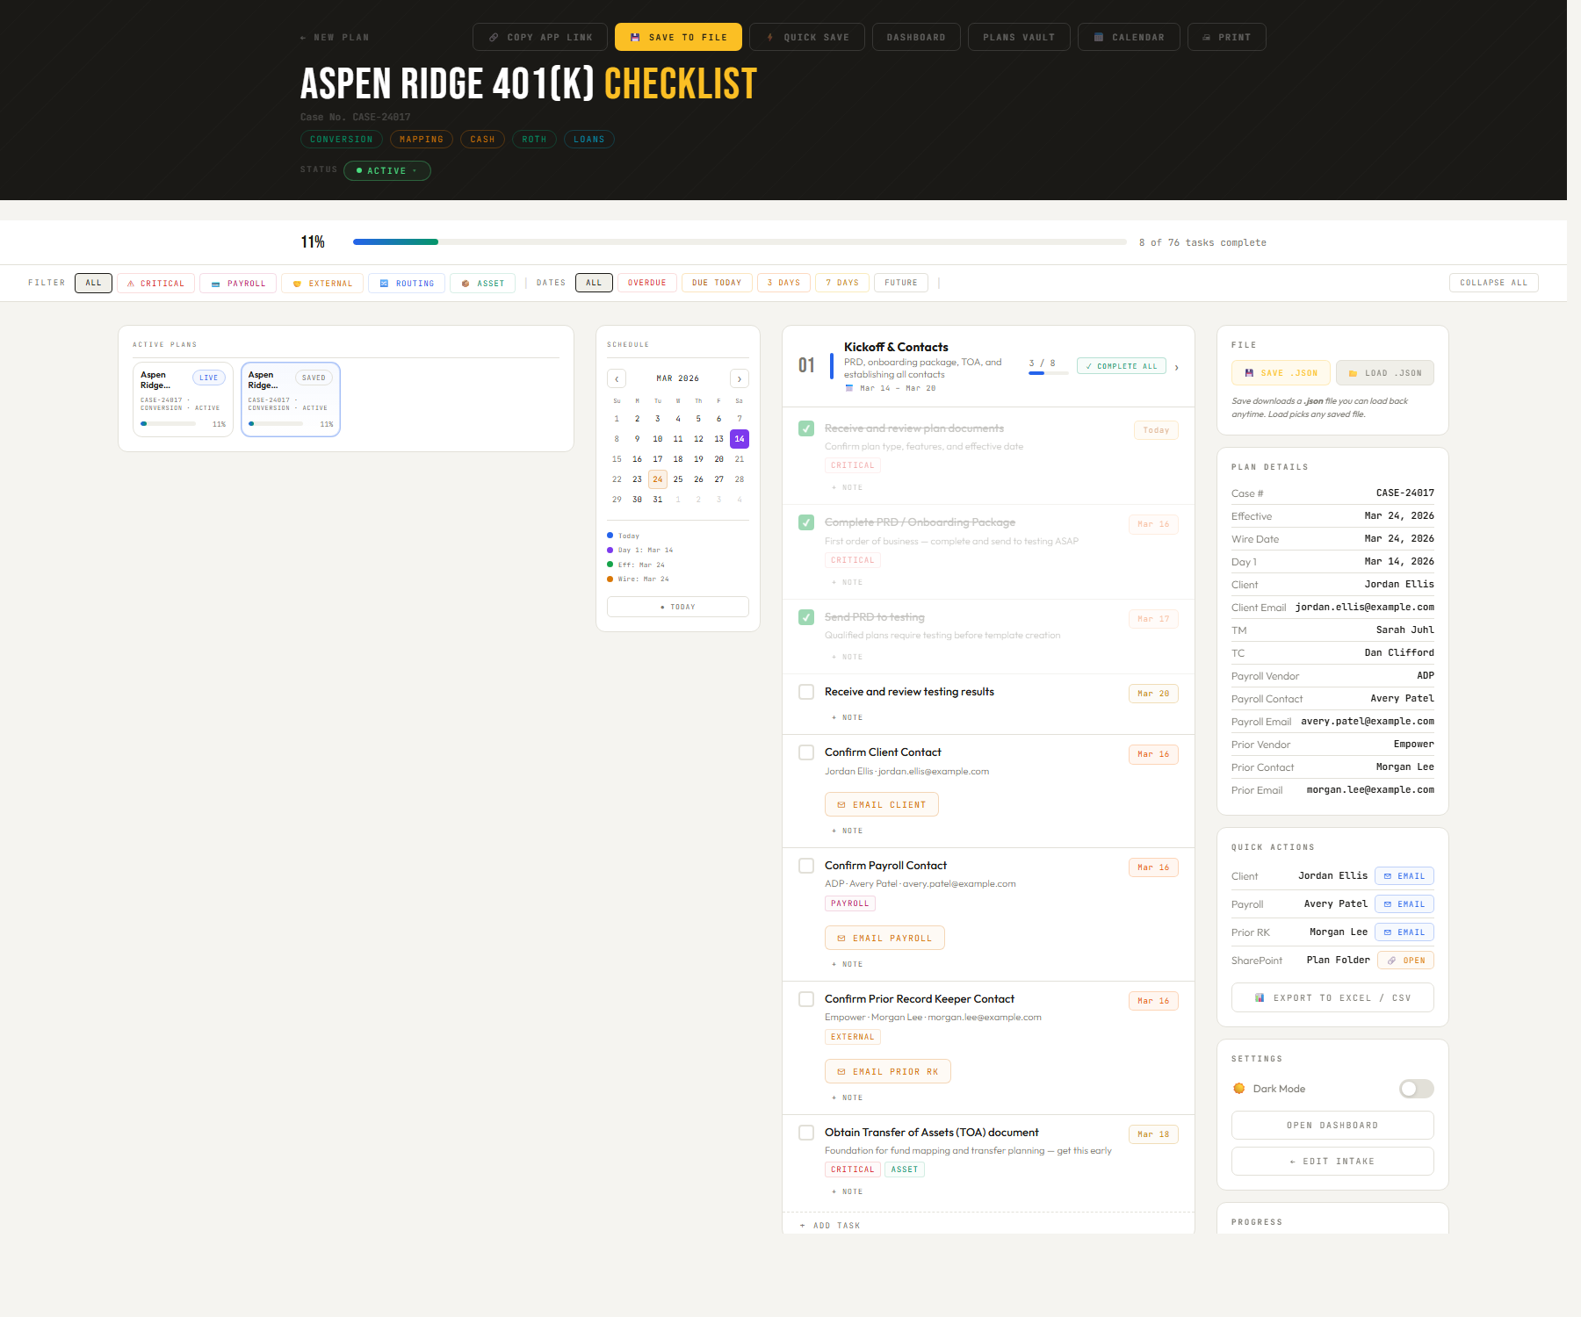
Generated checklist with sample progress, active plans, schedule rail, and operational sidebar.
Element | Purpose
Active Plans | Provides quick switching between the live plan and saved plans.
Schedule rail | Shows date context beside the checklist without leaving the screen.
Phase blocks | Organize tasks, completion controls, and progress counts by implementation phase.

Plans Dashboard
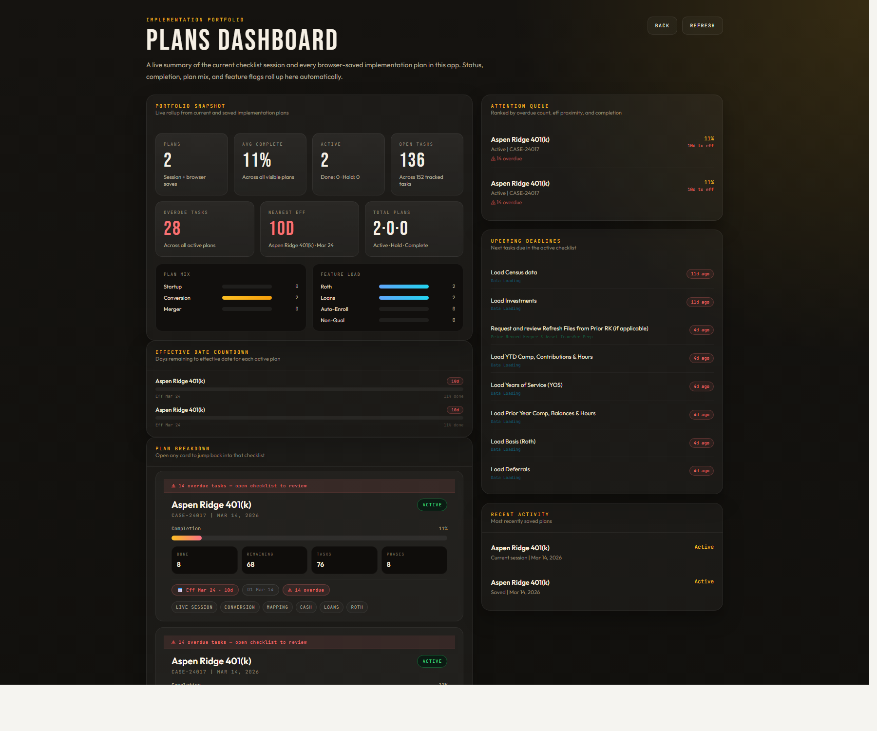
Dashboard view summarizing current and saved plans, due dates, and health metrics.
Element | Purpose
Portfolio snapshot | Shows total plans, average completion, and open workload.
Upcoming deadlines | Surfaces near-term dates that need attention.
Plan breakdown | Lets the user jump back into a selected implementation plan.

Plans Vault
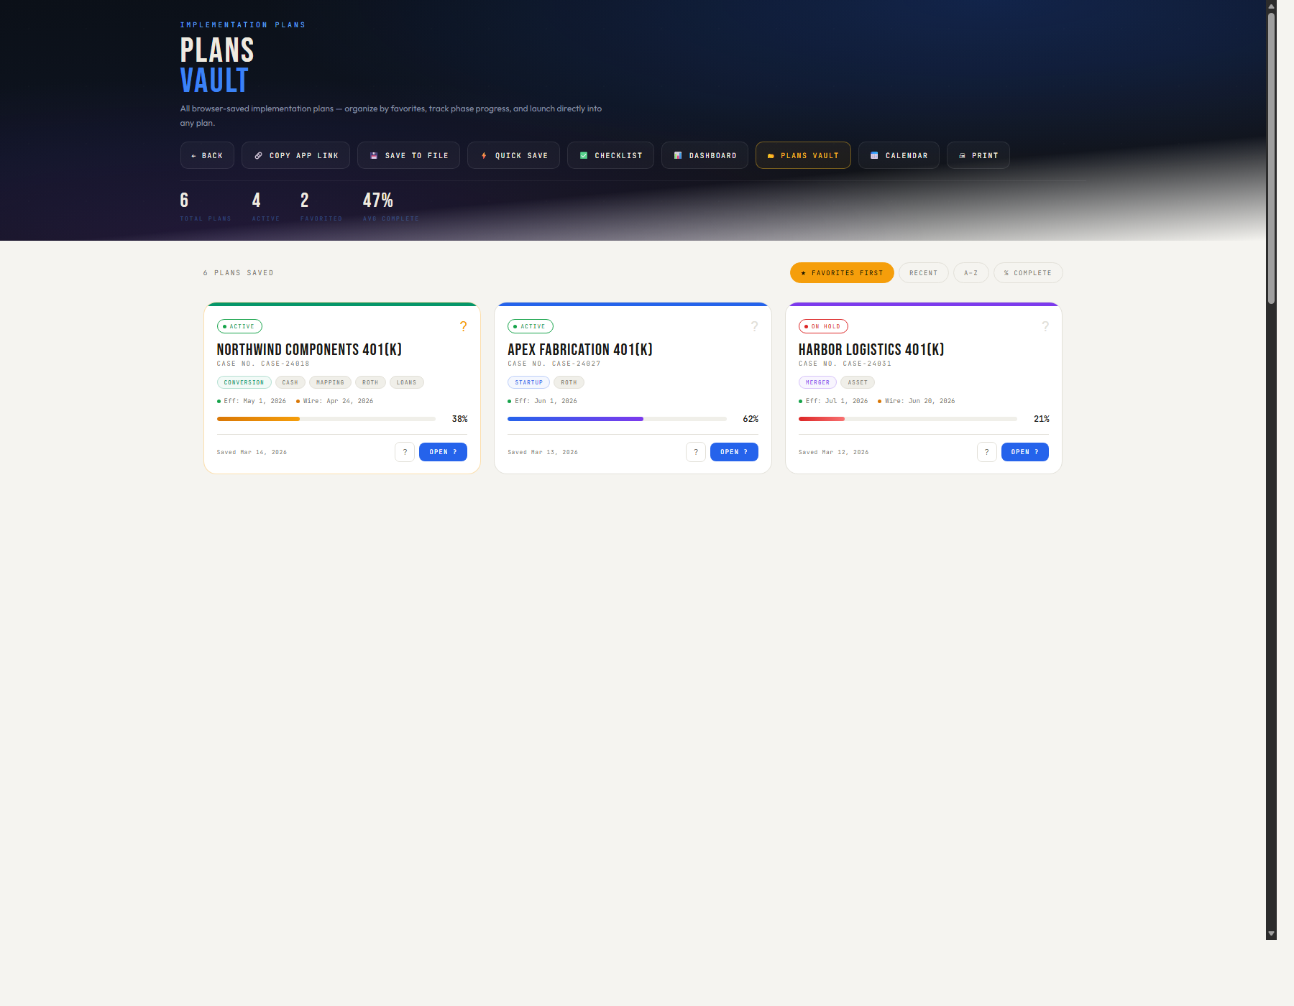
Saved-plan vault with reusable browser-based plan records.
Element | Purpose
Saved cards | Display plan identity, progress, dates, and status in one place.
Open action | Loads a plan directly back into the working checklist.
Delete action | Removes obsolete saved plans from the browser store.

Implementation Calendar
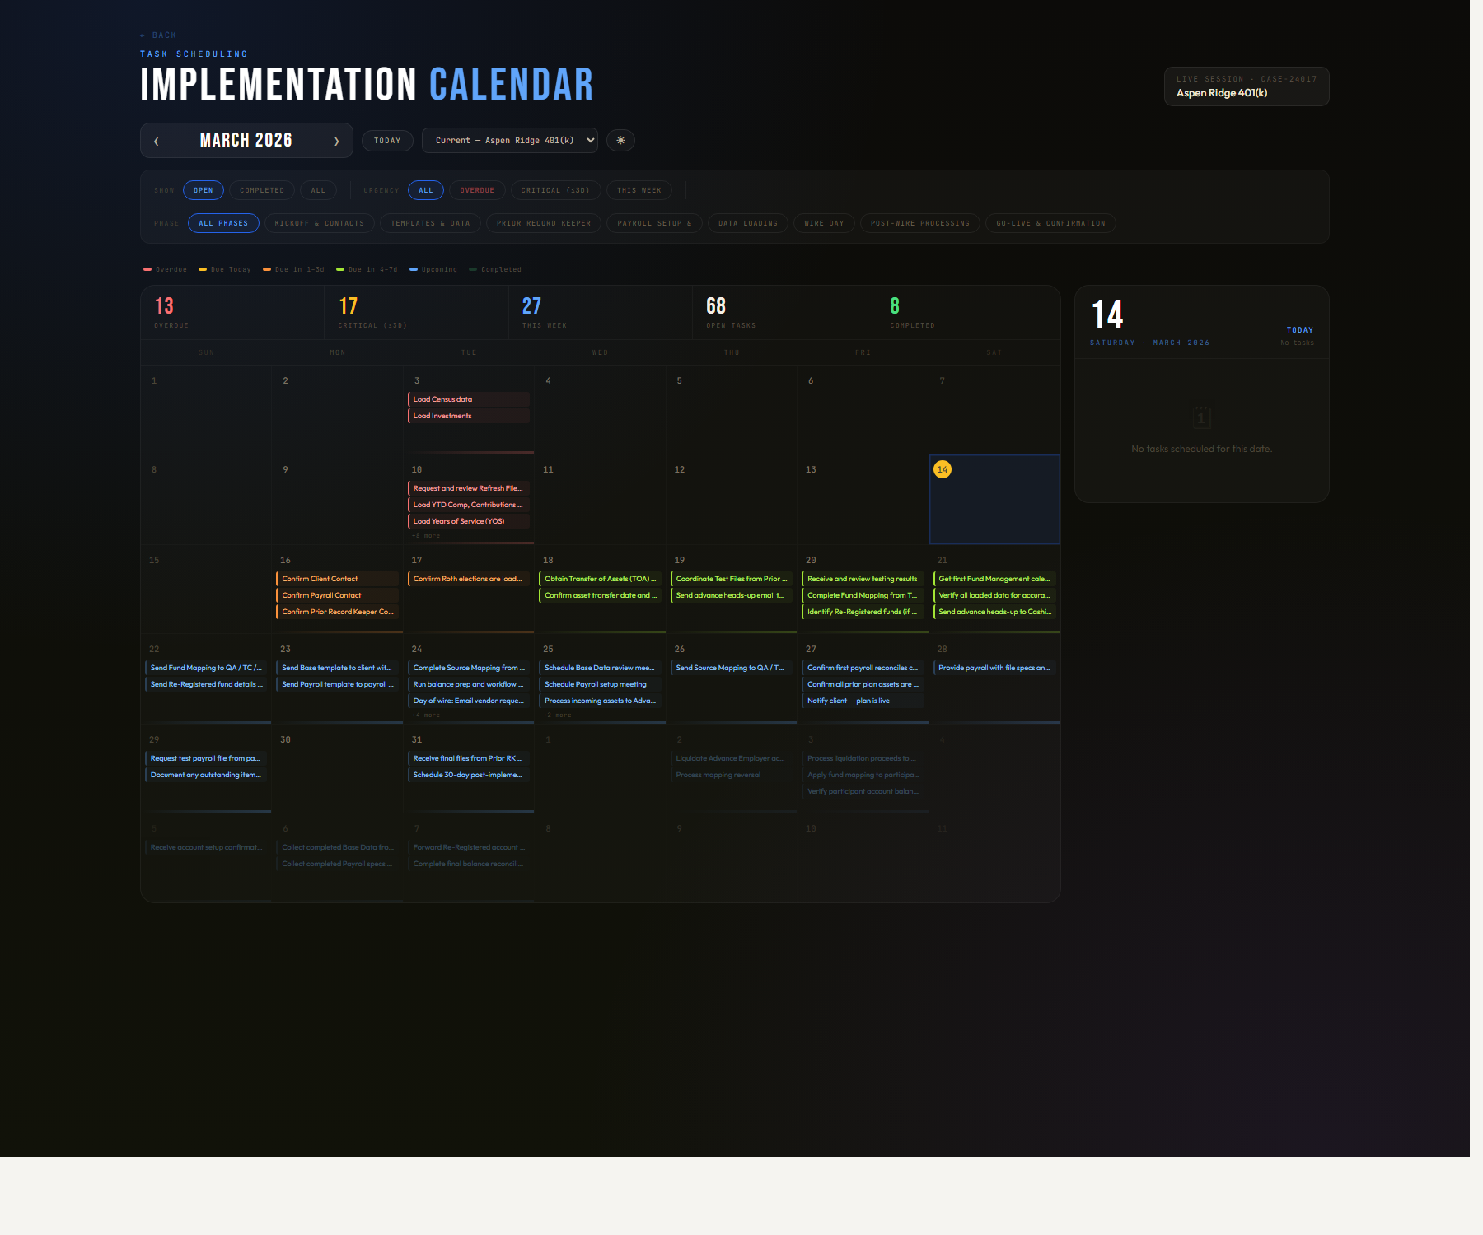
Calendar view showing due tasks, completed dates, and month navigation.
Element | Purpose
Month grid | Maps implementation work onto a calendar timeline.
Filters | Lets the user isolate open, completed, or urgency-based task groups.
Upcoming panel | Summarizes the next dated items without scanning the whole month.

Checklist Filter Controls
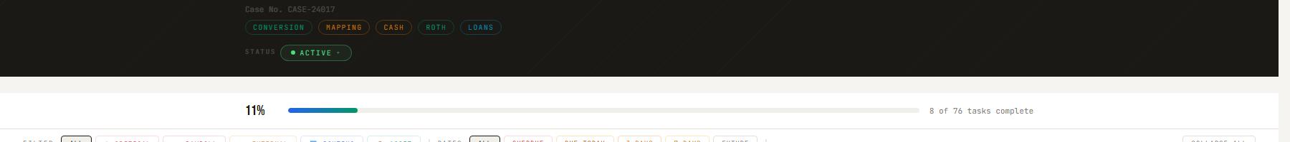
Checklist filter rail with task category and urgency controls in use.
Element | Purpose
Task tags | Filters by business category such as payroll, asset, routing, or critical work.
Date filters | Matches the due-date badge logic so urgency is easy to isolate.
Sticky checklist shell | Keeps navigation and context visible during long working sessions.

Administrative Controls
- Use dummy but realistic data when preparing screenshots or training material so every generated screen looks complete.
- Refresh screenshots whenever navigation, filters, dashboard cards, or date logic change materially.
- Keep screenshots high resolution and cover intake, checklist, dashboard, plans vault, calendar, and at least one filtered state.
- When updating the app, revise this guide alongside the feature change so training material stays operationally accurate.

Troubleshooting
- If buttons appear unresponsive, refresh the page fully and verify the file opened directly rather than through a stale cached tab.
- If saved plans are missing, check browser local storage for the same file origin; browser saves are scoped to the file location and browser profile.
- If dates or due badges look wrong, verify Day 1, Effective Date, and Wire Date values first, then review the task timing rules in the app source.
- If export output looks outdated, reopen the plan, save it again, and rerun the export so current task state is included.

