Behavioural Research in Statistical Methods - Project Report - 1
Experiment : Sentence Memorability
Team : Vishnu Varun | Pavan Karke | Susheel Krishna

1. Introduction :
The present experiment is on memorability in sentences. According to the research, they want to experiment how human beings memorize sentences, and how it is dependent on the words used in the sentence and their memorability and also framing those words. Users have to see sentences randomly displayed on screen and guess whether it is repeated. High-memorability words tend to be concrete, imageable, and emotionally rich, while low-memorability words tend to be abstract and semantically impoverished (Rubin & Friendly, 1986; Shepard, 1967). This hierarchy of memorability, originally documented at the level of individual words and pictures, raises an important question about how memory operates at the level of full sentences.
The experiment used a continuous recognition paradigm with a dual-response design. Participants viewed sentences one at a time and pressed the spacebar (Item Recognition, IR) whenever they believed a sentence had been seen before. After each IR press, a Yes/No question appeared requiring a Word Recognition (WR) judgement confirming or disconfirming their response. This design yields two complementary measures: the Corrected Memorability Score (CMS = Hit Rate − False Alarm Rate), grounded in Signal Detection Theory (Swets et al., 1961), and WR Accuracy. Reaction times (RT) for both IR and WR responses were also recorded as measures of processing effort (Forster & Forster, 2003).
Sentences followed a Subject–Verb–Object (S–V–O) format and varied systematically across two factors: (1) Word Memorability Type — HH (High subject, High object), HL (High subject, Low object), LH (Low subject, High object), LL (Low subject, Low object) — and (2) Sentence Voice (Active / Passive). This yielded 8 experimental conditions with Word Recognitionions. High-Frequency filler sentences (coded HF in the raw logs) were interspersed throughout and served as the basis for computing the global False Alarm Rate. In the raw log files, condition codes HVL, LVH, and LVL map to HL, LH, and LL respectively; this report uses the standard short-form names throughout.
1.1 Hypothesis :
Statement-1 : This tests the effect of the noun types (LL vs. HH/HL/LH) on the sentence's memorability. H0(Null): There is no significant difference in corrected memorability scores between sentences in the LL condition and sentences in the HH, HL, or LH conditions.Ha (Alternative): Sentences in the LL condition will have significantly lower corrected memorability scores than sentences in the HH, HL, or LH conditions.
Statement-2 : This tests the effect of the grammatical structure (Active vs. Passive) on memorability. H0 (Null): There is no significant difference in corrected memorability scores between passive-voice sentences and active-voice sentences. Ha (Alternative): Passive-voice sentences will yield significantly lower corrected memorability scores compared to active-voice sentences.
Statement-3 : Sentences in the LL condition will show significantly lower WR accuracy than sentences in the HH, HL, or LH conditions, extending the memorability deficit to controlled recognition judgements (one-tailed).

2. Method Overview
2.1 Experimental Design
This study used a continuous recognition paradigm. Participants viewed sentences and indicated whether each sentence had been previously presented by pressing the spacebar (IR response). Immediately following an IR press, a Yes/No WR prompt appeared. Sentences were constructed in S–V–O format with verbs held at medium concreteness to isolate noun-level memorability effects. The experiment comprised a practice phase followed by three experimental blocks separated by rest breaks.
Word Memorability was manipulated at four levels (HH, HL, LH, LL) crossed with Voice (Active, Passive), producing 8 experimental conditions. High-Frequency filler sentences (HF) were included to provide a reliable FA baseline. Approximately 10 validation sentences per block served as attention checks.
2.2 Participants
A total of 334 participants were included in the experiment (according to the text file provided with the dataset). But we are performing the analysis on only part of them [232 - 398] which is 114 and we removed some of the participants' data (2 participants). So there are 112. Participants were excluded based on the validation criterion:
- Correct IR > (Wrong IR / 2) + Missed IR (assuming already done before)
- All Blocks that failed this validation test were excluded from memorability score calculation. (assuming that this is already done)
2.3 Variables
Independent Variables:
- Word Memorability Type (HH, HL, LH, LL)
- Voice (Active, Passive)
Dependent Variable:
- Corrected Memorability Score (Primary)
- WR Accuracy, IR Reaction time, WR reaction time (Secondary)
Corrected memorability and WR Accuracy was calculated as:
- Corrected Memorability = Hit Rate − False Alarm Rate
- WR Accuracy = Correct WRs / Total WRs
Hit Rate is the proportion of repeated target sentences in a condition that the participant correctly identified (Hits ÷ (Hits + Misses)). False Alarm Rate is the proportion of first-presentation sentences on which the participant incorrectly pressed the spacebar (which means the sentence is shown for the first time but participant marks it as seen), calculated globally across all non repeat, non-validation presentations and subtracted uniformly from every condition's hit rate.
2.4 Block Validation and Data Processing :
Each session was divided into three blocks separated by rest breaks. To screen for inattentive participants, each block contained validation sentences (Nearly 10). The dataset has a Validation sentence column where true represents the validation sentence. A block was retained only if the participant passed the following criterion:
Correct Validation IRs > (Wrong Validation IRs ÷ 2) + Missed Validation IRs
Correct = correctly identified, Wrong = Incorrectly identified, Missed = did not respond at all.
Processing steps applied to the raw log data:
- Practice phase rows and timing bookkeeping rows were removed for all the users.
- Sessions were splitted into blocks based on Rest Phase Row.
- The attention-check criteria were applied to each block.
- For each block, if its valid, target-type repeat sentences were classified as Hits or Misses.
- False alarms were counted from non-repeat presentations.
- Corrected memorability was computed per condition. The final analysis dataset contained 896 records (112 participants × 8 conditions), with N = 224 observations per condition.

3. Data Preparation
- Loading and cleaning: Data was given to us as logs. We converted them to CSVs first. Practice rows and gap times were not considered. The flag columns like isTarget, isValidation, and isRepeat were converted to Booleans. and numeric columns (Accuracy IR/WR, RT IR, RT WR) were also sparsed.
- Block segmentation: Each session was split into three blocks at 'Rest Phase started' marker rows, producing three separate DataFrames per participant.
- Attention-check validation: The criterion formula was applied to each block. Out of 342 total blocks (114 participants × 3 blocks), 7 blocks were excluded as invalid. Two participants had all three blocks fail and were fully removed. So now 112 are left.
- Signal detection counting: For each valid block, target-type repeat sentences (isRepeat = True, isTarget = True, isValidation = False) were identified. We checked up to three subsequent event rows to determine whether an 'IR pressed' event occurred before the next sentence. If yes, the trial = Hit; else = Miss. Thus, False alarms were counted as 'IR pressed' events following non-repeat, non-validation sentences.
- Corrected memorability: Hit rates and the global FA rate were accumulated across all valid blocks per participant. Corrected memorability (Hit Rate − FA Rate) was then computed for each of the 8 conditions. WR accuracy, IR RT, and WR RT were also computed for each participant. The final dataset contains 896 participant × condition records, aggregated at the participant level.

4. Descriptive Statistics
4.1 Memorability by Word Type

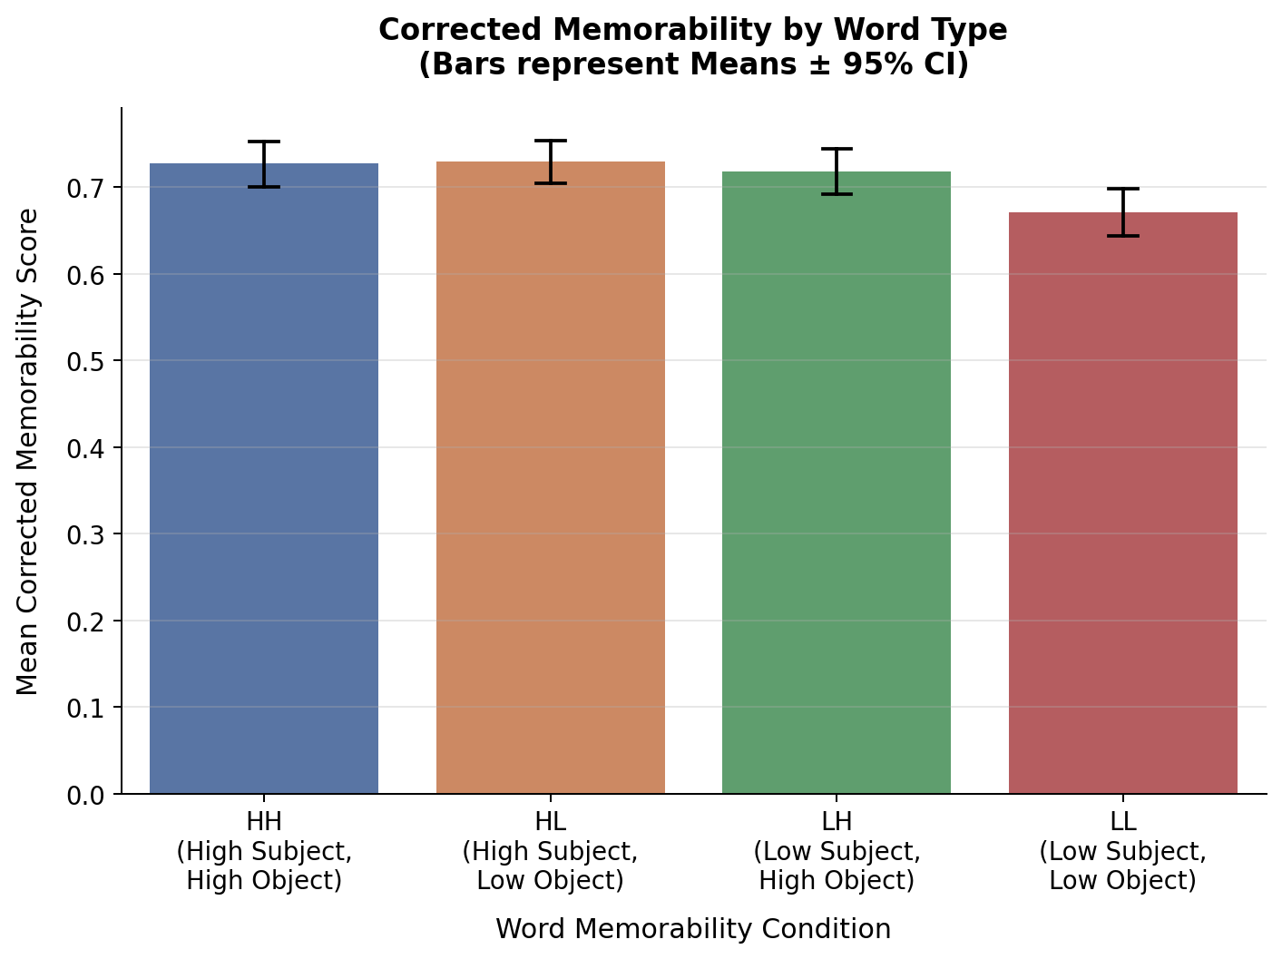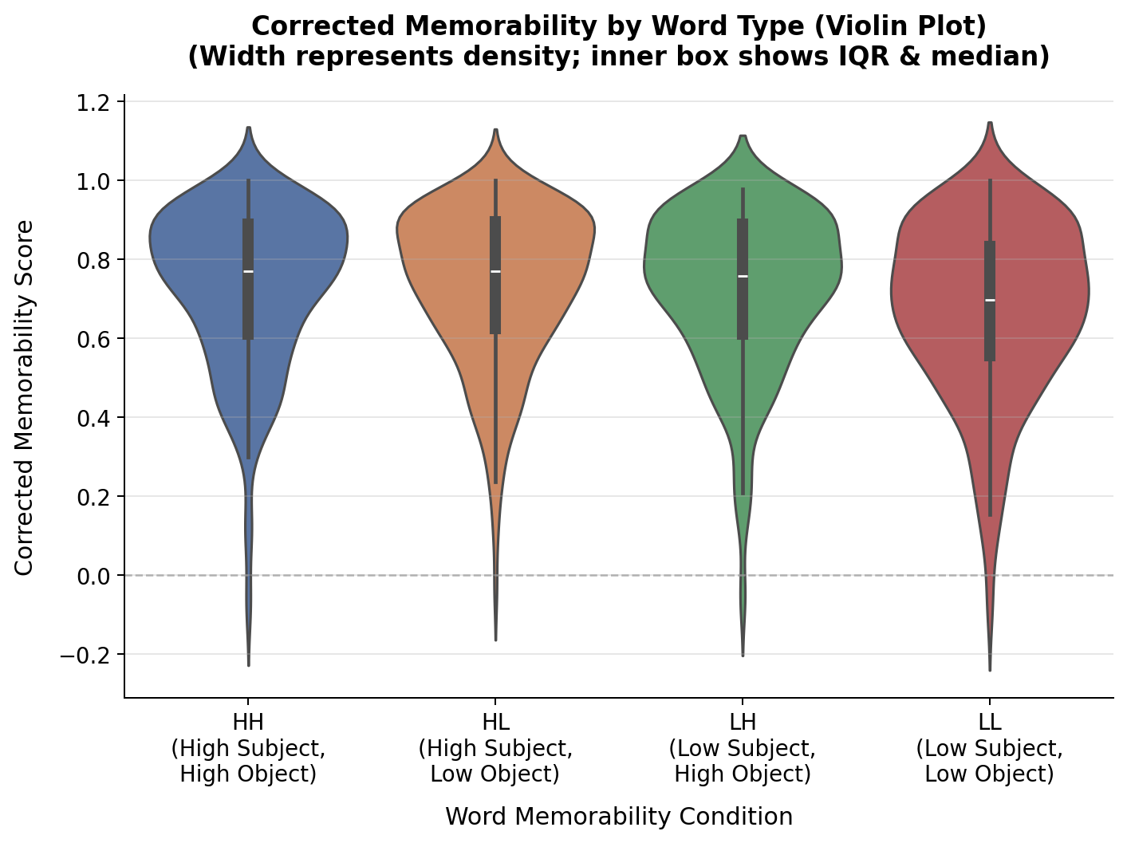
Figure - 1a : shows a bar chart of the mean corrected memorability for each condition, with error bars representing the 95% Confidence Intervals.
Figure - 1b shows a violin plot of corrected memorability by word type with inner box showing the IDR and median
From the above analysis we can see that the HL condition had the highest mean (M = 0.730, Mdn = 0.771), closely followed by HH (M = 0.728, Mdn = 0.771) and LH (M = 0.718, Mdn = 0.757). The LL condition has lowest mean (M = 0.671, Mdn = 0.698), approximately 0.06 units below the top conditions. A difference that is visually apparent in Figure 1a and 1b. All four means are well above zero, confirming that participants reliably recognised repeated sentences far above chance in every condition.
4.2 Memorability by Voice :
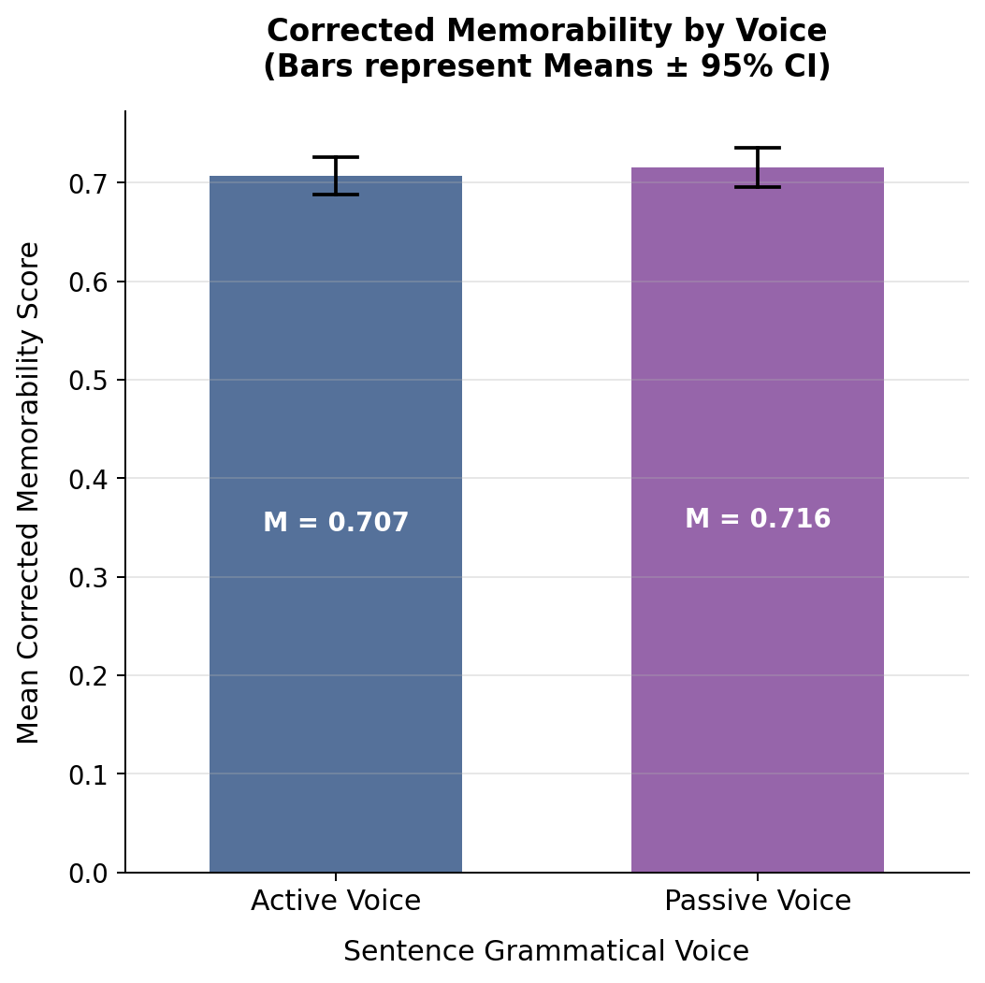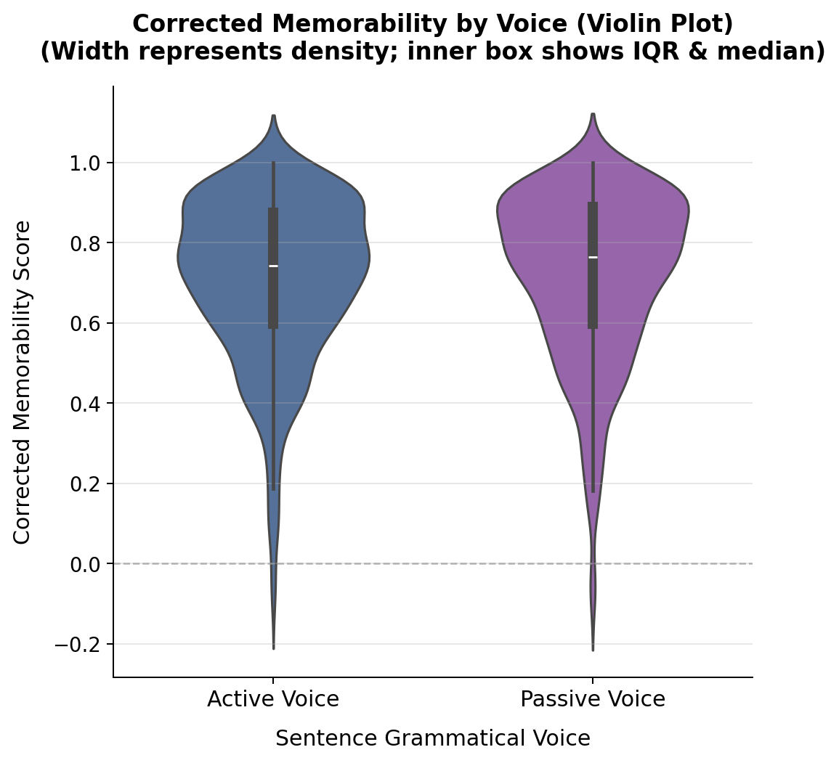
Figure-2a : Bar plot representing Corrected memorability scores by sentence voice along with 95% confidence interval. Figure - 2b : Violin plots representing the Corrected Memorability score with inner box showing IQR and Medians

Active and passive sentences showed nearly identical memorability: means differ by only 0.009 units (Active M = 0.707; Passive M = 0.716) and medians by 0.021 (Active = 0.743; Passive = 0.764). Standard deviations are comparable (≈ 0.20–0.21). Both voice conditions span the same range (approximately −0.09 to 1.00).
Numerically, passive sentences score marginally higher in every word-type condition (Table 3), but the differences are tiny (≤ 0.012) and inconsistent across participants. The SD and IQR are almost identical across active and passive, indicating that voice does not produce systematically more or less variable memory performance.

4.3 Interaction Exploration :
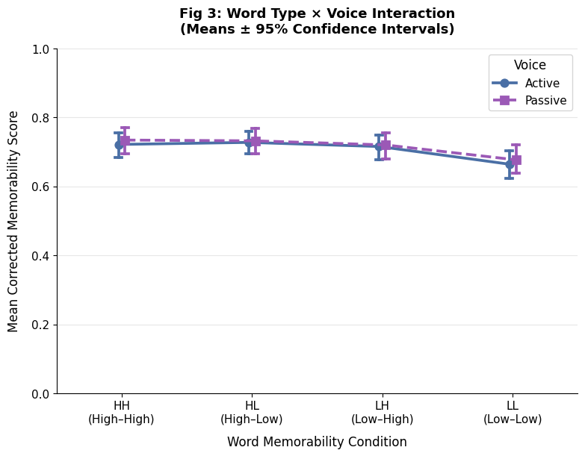
Figure - 3 : Interaction plot: mean corrected memorability by word-type condition and voice. Error bars represent ±1.96 × SEM (approximate 95% CI of the mean). The near-parallel lines and consistent HL ≥ HH > LH > LL ordering across both voice conditions indicate no meaningful interaction between word type and voice.
From the figure - 3 several patterns are worth noting for the interaction between word type and voice. First, passive sentences scored marginally higher than active sentences in every word-type condition — but the gap is consistently small (≤ 0.012) and holds no obvious pattern of widening or narrowing across conditions. Second, and more importantly, the ordering of word types is identical in both voice conditions: HL ≥ HH > LH > LL regardless of voice. This consistent ordering is the clearest early indication of a main effect of word type rather than an interaction.

Does voice affect all word types equally? Based on Figure 3, the lines for Active and Passive run nearly parallel across all four word-type conditions — the gap between the two voice lines are slightly noticeably widen or narrow as word type changes from HH to LL. This suggests that voice does not differentially modulate the memorability advantage conferred by high memorability nouns.
Does the gap between HH and LL change across voices? The HH–LL gap is 0.057 in the Active condition (0.722 − 0.665) and 0.057 in the Passive condition (0.734 − 0.677) essentially identical.

4.4 Word Recognition (WR) Accuracy : 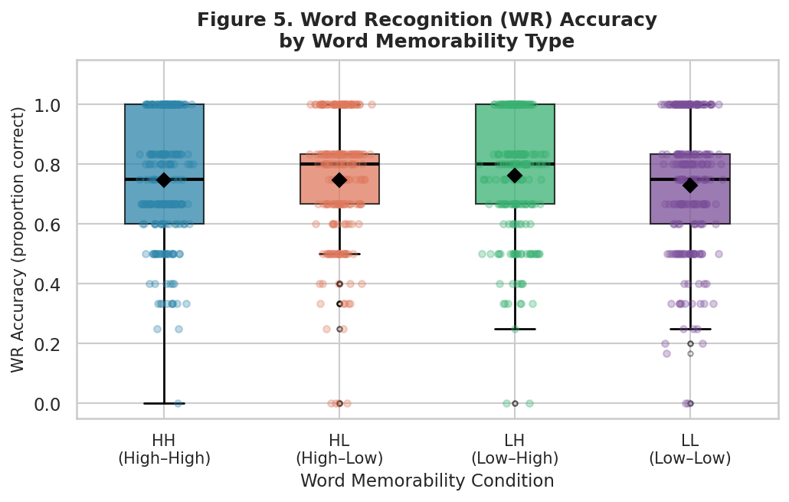
Figure 4 : WR Accuracy by word memorability type. Boxplots with jittered individual observations. ◆ = condition mean.
The LH condition showed the highest WR accuracy (M = 0.762, Mdn = 0.800), followed by HL (M = 0.748) and HH (M = 0.747). The LL condition showed the lowest WR accuracy (M = 0.730, Mdn = 0.750), consistent with the CMS pattern. Figure 4 displays the WR accuracy distributions per condition

5. Normality Assumptions :
Before proceeding with inferential statistics, we tested the assumption of normality using the Shapiro-Wilk test. The corrected memorability scores exhibited a heavily skewed distribution, and the Shapiro-Wilk tests for all conditions were statistically significant (p < 0.001), indicating that the data is strictly non-normal. Thus we need non parametric tests for further analysis. We see that from Figure 5, the graph looks quite different from the actual normal distribution. From Shapiro wilk tests and visual graphs, we can conclude that distribution is not following the Normal distribution. So parametric tests cannot be performed.
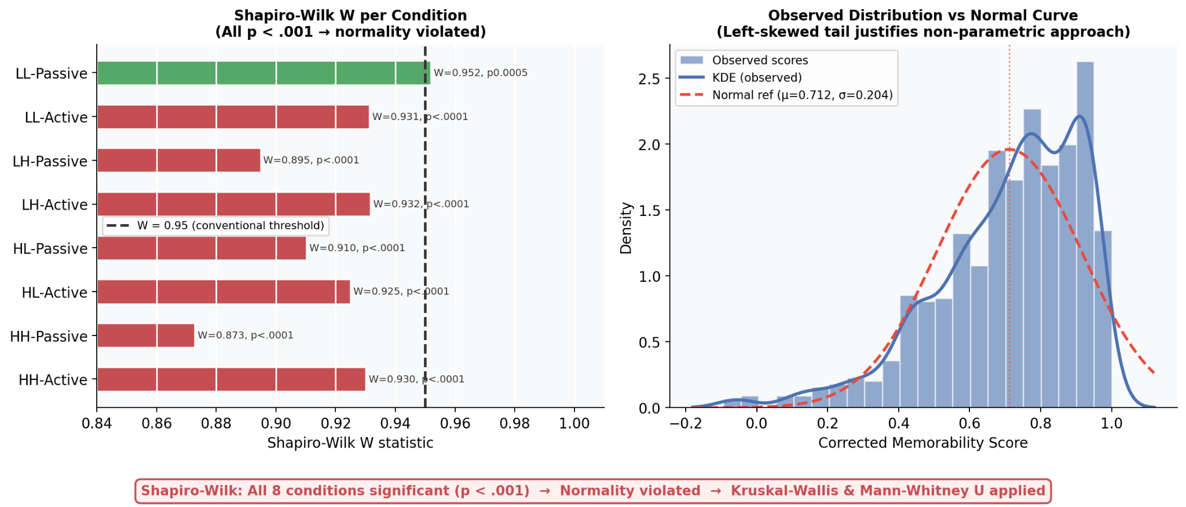
Figure 5 : visualizations of Shapiro-wilk test results and differentiating between expected normal distribution vs actual normal distribution using Shapiro-wilk test.
6. Final Conclusion :
This study examines how the sentence memorability is been influenced by memorability of constituent nouns and the voice type of sentence. Using a continuous recognition paradigm, participants viewed sentences and indicated whether they had seen them before or not. Sentences were simple Subject Verb Objects. They were constructed using four word-memorability conditions (HH, HL, LH, LL) and two voice conditions (active and passive). After cleaning and processing the log data, block validation was applied to remove inattentive responses and corrected memorability scores were computed using hit rate and false alarm rate. The final analysis dataset consisted of 112 participants and 896 participant–condition observations.
Descriptive statistics suggest that sentences containing at least one high-memorability noun generally produced higher memorability scores than sentences composed entirely of low-memorability nouns. The LL condition consistently showed the lowest mean memorability, while HL and HH conditions showed the highest values. In contrast, the difference between active and passive voice conditions was minimal, with very similar means and variability across both voice types. No significant WR accuracy differences were detected between LL and the other conditions, though the LL vs. LH comparison was marginal. The directional pattern is consistent with the corrected memorability score results, suggesting a possible WR accuracy deficit for LL sentences that the current sample size is insufficiently powered to detect reliably. This finding motivates further analysis in Report 2 with extended statistical approaches.
Before performing inferential statistical tests, the assumption of normality was tested using the Shapiro–Wilk test. The results indicated that the corrected memorability scores significantly deviated from a normal distribution across all conditions. Visual inspection of the distributions also supported this finding, indicating that the data are skewed and do not follow the normal distribution. Therefore, parametric statistical tests are not appropriate for this dataset, and alternative statistical approaches must be used for hypothesis testing.
6.1 Limitations :
The current analysis is subject to several limitations. First, only a subset of participants (N = 112 out of 334 total) was analysed; the full dataset may yield different effect magnitudes. Second, the global False Alarm Rate computation averages across all non-repeat sentences regardless of word type, potentially masking condition-specific FA patterns.Finally, only three hypotheses were formally tested, leaving the full multivariate structure of the data unexplored.
6.2. Future Work :
- RT modelling to assess can be done whether processing speed mediates the memorability effect.
- Since the normality assumption is violated, future work will focus on conducting non-parametric statistical tests to formally evaluate the hypotheses.
- Methods such as the Kruskal–Wallis test and Mann–Whitney U test can be used to determine whether the observed differences between word-memorability conditions and sentence voice are statistically significant.
- Applying these tests will allow us to properly test the proposed hypotheses and determine whether the descriptive patterns observed in this analysis represent reliable effects.
- Also we could do a 4 × 2 mixed-design analysis comparing conditions across the full dataset. Compute effect of individual differences in baseline FA rate as a covariate.

7. References :
- Brysbaert, M., Warriner, A. B., & Kuperman, V. (2014). Concreteness ratings for 40 thousand generally known English word lemmas. Behavior Research Methods, 46 (3), 904–911.
- Craik, F. I. M., & Lockhart, R. S. (1972). Levels of processing: A framework for memory research. Journal of Verbal Learning and Verbal Behavior, 11 (6), 671–684.
- Ferreira, F. (2003). The misinterpretation of noncanonical sentences. Cognitive Psychology, 47 (2), 164–203.
- Forster, K. I., & Forster, J. C. (2003). DMDX: A Windows display program with millisecond accuracy. Behavior Research Methods, Instruments, & Computers, 35 (1), 116–124.
- Just, M. A., & Carpenter, P. A. (1992). A capacity theory of comprehension: Individual differences in working memory. Psychological Review, 99 (1), 122–149.
- Paivio, A. (1971). Imagery and verbal processes. Holt, Rinehart, & Winston.
- Rubin, D. C., & Friendly, M. (1986). Predicting which words get recalled: Measures of free recall, availability, goodness, emotionality, and pronunciability for 925 nouns. Memory & Cognition, 14 (1), 79–94.
- Shepard, R. N. (1967). Recognition memory for words, sentences, and pictures. Journal of Verbal Learning and Verbal Behavior, 6 (1), 156–163.
- Swets, J. A., Tanner, W. P., & Birdsall, T. G. (1961). Decision processes in perception. Psychological Review, 68 (5), 301–340.
- Shapiro, S.S. and Wilk, M.B. (1965) An Analysis of Variance Test for Normality (Complete Samples). Biometrika, 52, 591-611. https://doi.org/10.1093/biomet/52.3-4.591
Codebase : Access Github Repo from here
Contributions :
Vishnu Varun – Data preparation , Data processing and block validation, Descriptive statistics (WR section)
Pavan Karke – Introduction; Hypothesis formulation; Experimental design and variables; Descriptive statistics (Memorability by Word Type), Conclusion, Limitations
Susheel Krishna – Descriptive statistics (Memorability by Voice and interaction exploration); Normality analysis (Shapiro–Wilk); and Future Work

