Ezkylle Opiniano 12/02/2025
NW – 301 6BLOCKTECH
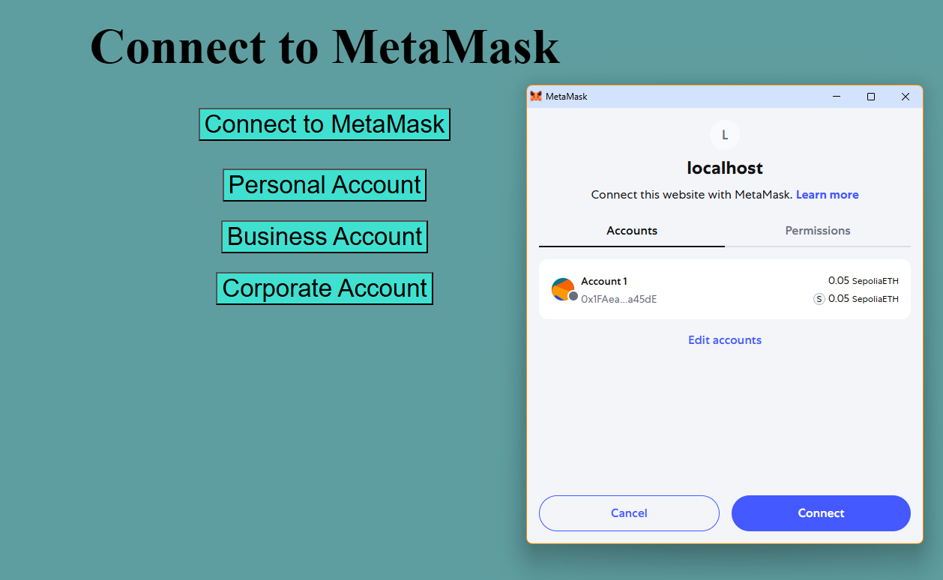
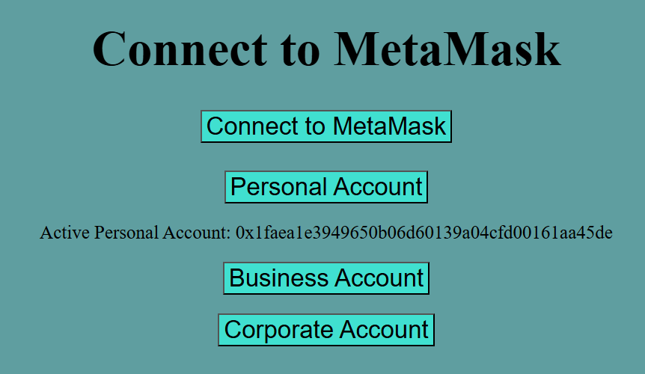

Reflection:
Building your own index.html to view your MetaMask account is a hands-on way to understand how web pages interact with blockchain. It teaches you how to request accounts, display information safely, and handle sensitive data responsibly. This process strengthens your coding skills while reinforcing security awareness and user responsibility. Ultimately, it makes blockchain technology more tangible and empowers you to explore decentralized applications confidently.

