Ezkylle Opiniano 12/02/2025
NW – 301 6BLOCKTECH

axis daughter document sudden giggle still gown donate employ weapon sponsor seminar
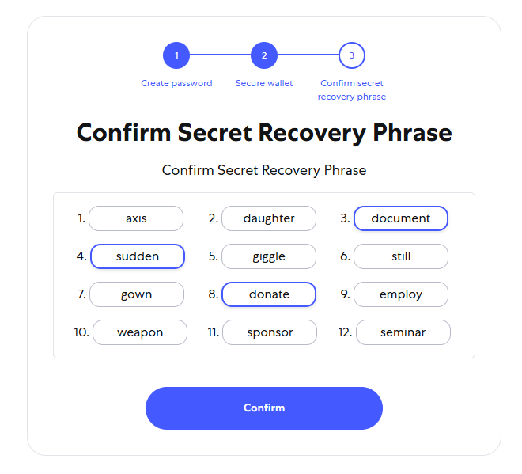
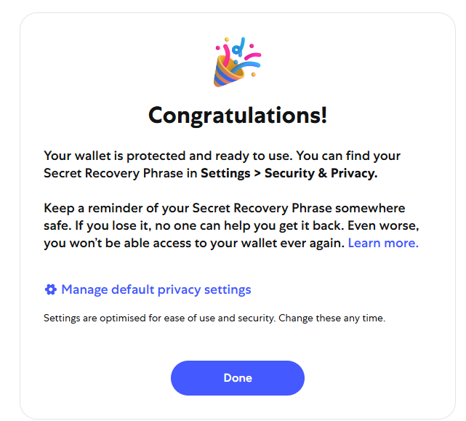
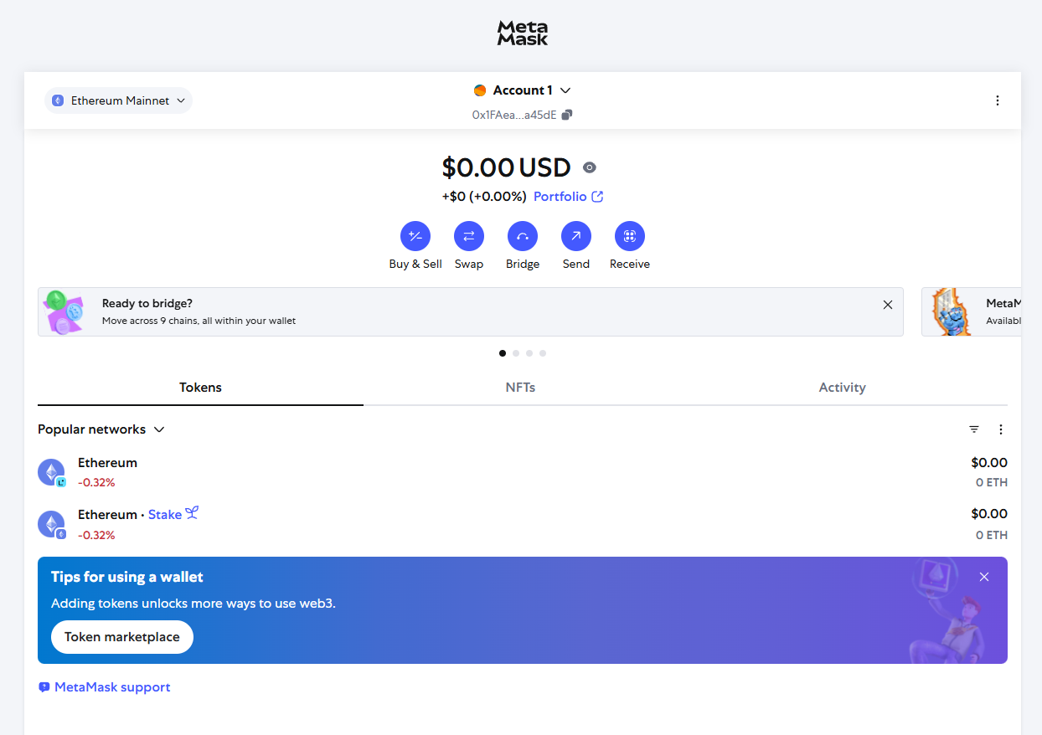
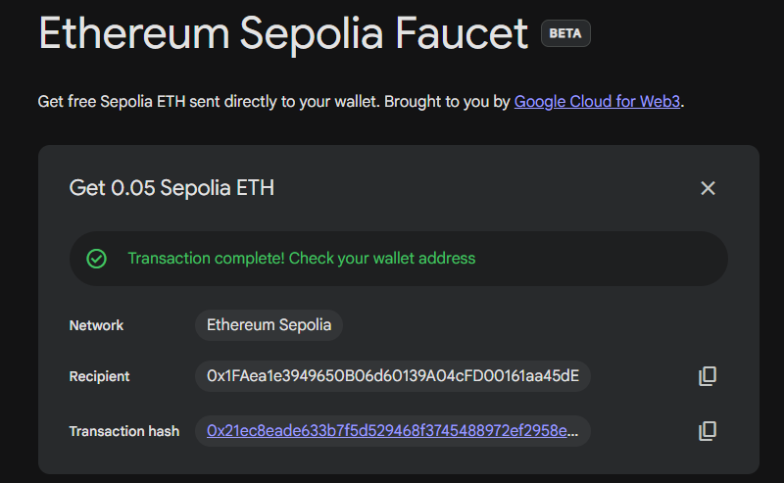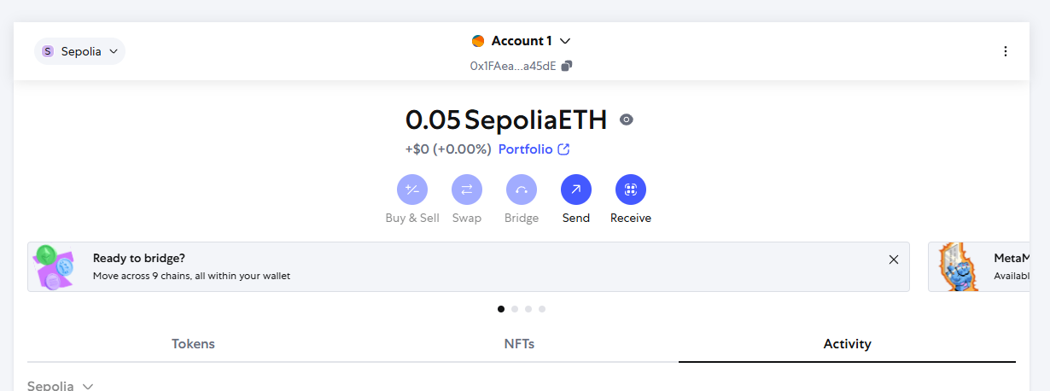

Reflection:

Blockchain technology is transforming how we manage digital assets by offering a decentralized, transparent, and secure way to record transactions. Unlike traditional systems controlled by centralized institutions, blockchain empowers users with direct ownership and control over their data and funds.
MetaMask serves as a key tool in this ecosystem, acting as a personal wallet that connects users safely to blockchain applications. Learning to use MetaMask helps individuals understand the importance of safeguarding private keys and seed phrases critical steps to prevent unauthorized access and loss.
By exploring blockchain and MetaMask, users gain valuable insights into digital security best practices, reducing reliance on vulnerable centralized platforms. This knowledge fosters a stronger sense of personal responsibility and awareness in the evolving digital economy.
In essence, mastering blockchain and MetaMask is not just about technology it's about gaining safer, more confident control over digital identities and assets in a rapidly changing world.

