Design Document

Date: 25/02/17
Author: Jabbar Shaik.

This document is a template of design document designed for Tracks problem given in HaCareem Hackathon.

1. Introduction

Purpose of this Document is to provide an Optimized solution for Cab booking with perfect ETA and location. This document describes the technical architecture of the solution that is provided.
We should have two services here, one is from the Captain point of view and the other is User point of view. Total services that required are
- App for user, from which we get a request for booking a Cab.
- App for Captain, who accepts the user request and fulfills the travel need of the User
- Server which handles the requests and maintain data.

Application Integration:
In this module we communicate with other applications like Google for fetching real time data like location, weather and Traffic.
- Rest will be used for Enterprise Application Integration (EAI).
- //Todo: later we can use MQ or any other service for inter-app communication

2. Application and Projects

This application has typically two projects – client, server. Projects that are pure backend servers (providing API) do not have a client project. We keep the client and server as two independent projects to keep the option open to deploy them separately.
Note: currently we are not developing Client
Server

Tracks

Client

Client will be used by end Users and Server will fulfill the requests from the users.

Build Tools
Tool | Description
Maven | Maven is used to package the contents into a jar file to enable embedding the client into a server side project. The Maven front-end plugin is used to execute the Grunt tasks from within Maven.

Testing
Unit Testing | Unit Test cases will be written in Junit

Server
The server projects are Spring applications which are bootstrapped using the Spring Boot framework (http://projects.spring.io/spring-boot). The minimum Java version is JDK8 .
The following table lists the libraries to be used.

Library | Remarks
Rest-Assured | Rest Assured is used for Integration Testing of ReSTful API (https://code.google.com/p/rest-assured/).
Hibernate | Hibernate 4 is the ORM library of choice
Logback | Logback will be used for Logging
Spring Data JPA | Will be used for providing JPA layer and Repository interfaces
Jackson | Jackson will be used for JSON marshaling and unmarshalling

The Server projects follow the Onion Architecture (https://www.develop.com/onionarchitecture). The domain model is the core and is implemented as standard POJO classes with Hibernate annotations. The Spring Data JPA repository interfaces are also part of the domain.
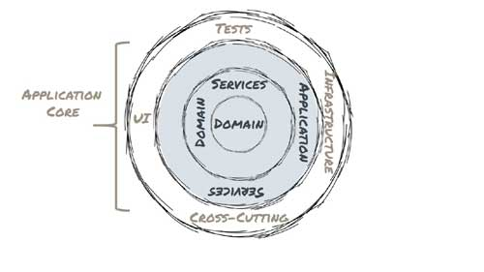
The source folder will be organized to reflect this separation between the layers.
Domain Services are services used cross-object services. Application Services provide the “transactional” glue at the same time ensure that we do not end up with Anemic Domain Model. The application services will also include the ReST endpoints and the JSON-POJO Mappings (using Data Transfer Objects).

The Infrastructure layer consists of the Spring Boot Configuration files as well as the Repository implementations (for example, if we are extending what the Spring Data JPA repository interfaces with additional QueryDSL methods).

3. Design process

Design and approach to the end user requests is defined in “ProjectDescription.pptx”.

4. Project Structure and Explanation

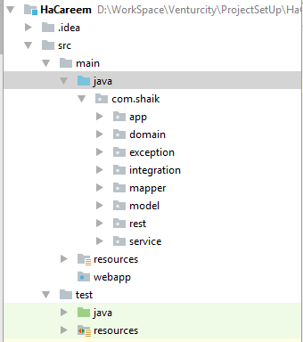

As defined in Onion Architecture, each layer is abstracted in different packages.
//TODO: these individual packages can be moved to different modules.

- Required services are provided in service package.
- The ReST call’s required to communicate with other applications is provided in integrations package.

Software Requirement:
JDK : 1.8
Database : Postgressql
Tools : Maven
Rest-Client : Postman (To test and Access Rest Apis)
Server : Tomcat

