

**Department of Computer Science & Engineering(CSE)**

**Lab -05**

Name : Jabed Iqbal Joy

Student ID : C193049

Semester : 7th

Section : 7BM

Email : c193049@ugrad.iiuc.ac.bd

Contact : 01837844828

Course Code : CSE-4742

Course Title : Computer Graphics Lab

Name of the course Teacher :

**Mahadi Hassan**

Assistant Professor

Department of CSE, IIUC

Date of Submission **:** 23/03/2023

1. Ellipse using polynomial method.

Code:

#include<bits/stdc++.h>

#include<graphics.h>

using namespace std;

void plot4pixels(int,int,int,int);

void ellipse_polynomial()

{

int x,y,r,i,h,k,a,b;

h=200;

k=200;

a=150;

b=100;

x=0;

y=b;

while(x<a)

{

plot4pixels(x,y,h,k);

x++;

y=b*sqrt(((a*a)-(x*x*1.0))/(a*a));

}

plot4pixels(x,y,h,k);

setcolor(8);

}

int main()

{

int gd=DETECT,gm;

initgraph(&gd,&gm,"");

setbkcolor(WHITE);

ellipse_polynomial();

getch();

}

void plot4pixels(int x,int y,int h,int k)

{

putpixel(x+h,y+k,8);

putpixel(x+h,-y+k,8);

putpixel(-x+h,y+k,8);

putpixel(-x+h,-y+k,8);

}

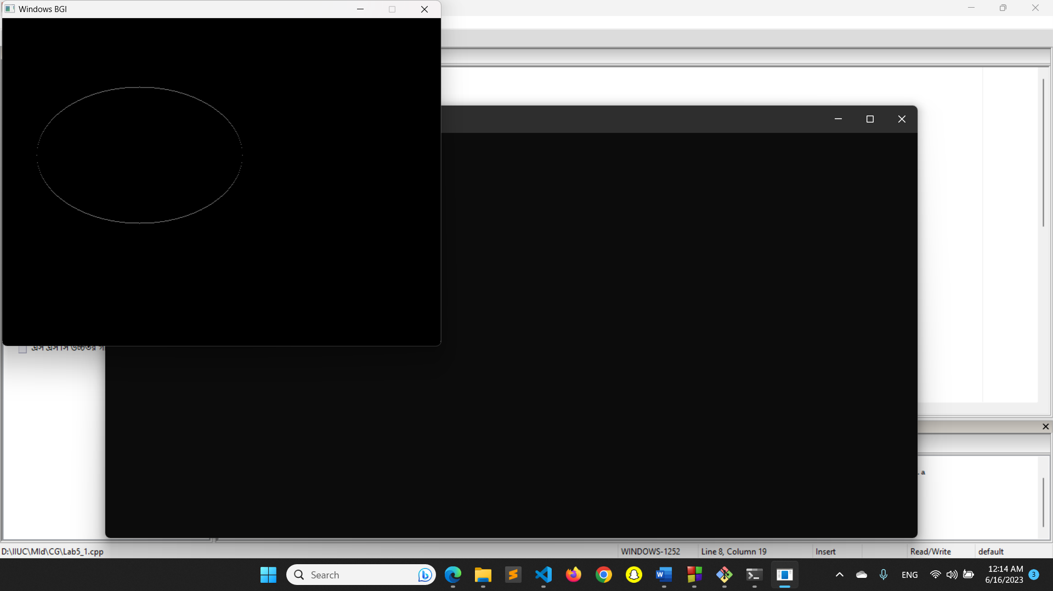

1. Ellipse using Trigonometric method.

Code:

#include<bits/stdc++.h>

#include<graphics.h>

using namespace std;

void plot4pixels(int,int,int,int);

void ellipse_Trigonometric()

{

int x,y,x1,y1,a,b,h,k,theta;

double p=3.14159/180;

h=200;

k=200;

a=150;

b=100;

setcolor(8);

for(theta=0; theta<=90; theta++)

{

x1=a*cos(theta*p);

y1=b*sin(theta*p);

x=int(x1+0.5);

y=int(y1+0.5);

plot4pixels(x,y,h,k);

}

}

int main()

{

int gd=DETECT,gm;

initgraph(&gd,&gm,"");

setbkcolor(WHITE);

ellipse_Trigonometric();

getch();

}

void plot4pixels(int x,int y,int h,int k)

{

putpixel(x+h,y+k,8);

putpixel(x+h,-y+k,8);

putpixel(-x+h,y+k,8);

putpixel(-x+h,-y+k,8);

}

Output:

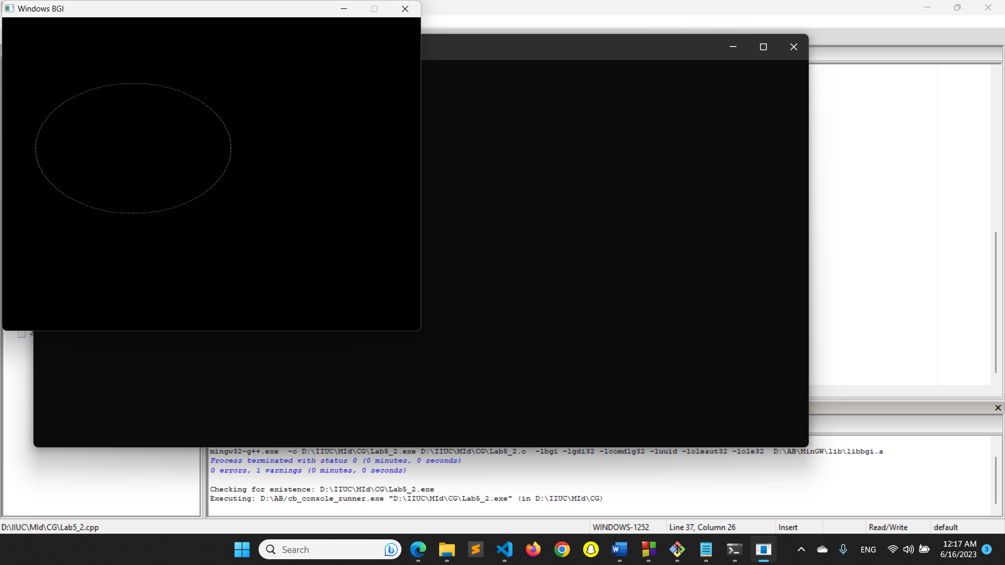

1. Arcs.

Code:

#include<graphics.h>

#include<bits/stdc++.h>

#include<math.h>

using namespace std;

void arc_trigonometric()

{

int x,y,x1,y1,r,h,k,theta,theta1=270,theta2=270+180;

float n=3.14159/180;

h=200;k=200;r=100;

for(theta=theta1; theta<=theta2; theta++)

{

x1=r*cos(theta*n);

y1=r*sin(theta*n);

x=int(x1+0.5);

y=int(y1+0.5);

putpixel(x+h,y+k,WHITE);

}

}

int main()

{

int gd=DETECT,gm;

initgraph(&gd,&gm,"");

setbkcolor(WHITE);

arc_trigonometric();

getch();

closegraph();

}

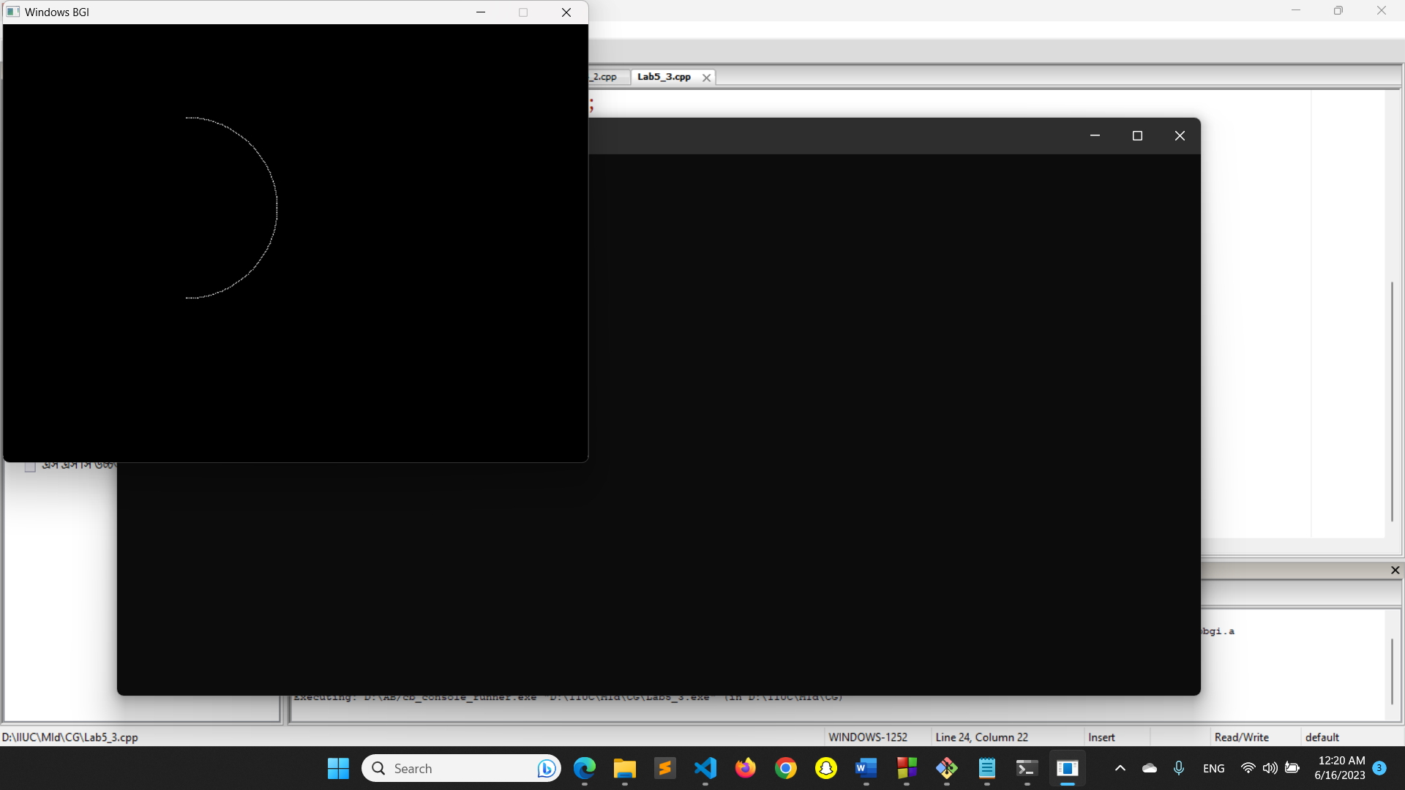

1. Sectors.

Code:

#include<graphics.h>

#include<bits/stdc++.h>

#include<math.h>

using namespace std;

void drawLineDDA(int x1, int y1, int x2, int y2)

{

int dx = x2 - x1;

int dy = y2 - y1;

int length = sqrt(dx*dx + dy*dy);

float xinc = dx / (float)length;

float yinc = dy / (float)length;

float x = x1;

float y = y1;

for (int i = 0; i <= length; i++)

{

putpixel((int)x, (int)y, WHITE);

x += xinc;

y += yinc;

}

}

void sector_trigonometric()

{

int x,y,x1,y1,r,h,k,theta,theta1=220,theta2=320;

float n=3.14159/180;

h=200;k=200;r=100;

for(theta=theta1; theta<=theta2; theta++)

{

x1=r*cos(theta*n);

y1=r*sin(theta*n);

x=int(x1+0.5);

y=int(y1+0.5);

putpixel(x+h,y+k, WHITE);

if(theta==theta1 || theta==theta2) {

drawLineDDA(h,k,x+h,y+k);

}

}

}

int main()

{

int gd=DETECT,gm;

initgraph(&gd,&gm,"");

setbkcolor(WHITE);

sector_trigonometric();

getch();

closegraph();

}

