

**Department of Computer Science & Engineering(CSE)**

**Lab -08**

Name : Jabed Iqbal Joy

Student ID : C193049

Semester : 7th

Section : 7BM

Email : c193049@ugrad.iiuc.ac.bd

Contact : 01837844828

Course Code : CSE-4742

Course Title : Computer Graphics Lab

Name of the course Teacher :

**Mahadi Hassan**

Assistant Professor

Department of CSE, IIUC

Date of Submission **:** 11/05/23

1. Scaling a point about origin.

Code: #include <graphics.h>

#include <stdlib.h>

void scale_point(int x1, int y1, float sx, float sy, int *new_x, int *new_y)

{

// Scale point

*new_x = x1 * sx;

*new_y = y1 * sy;

}

int main()

{

int gd = DETECT, gm;

initgraph(&gd, &gm, "");

// Original point

int x1 = 100, y1 = 100;

circle(x1, y1, 3);

// Scaling factors

float sx = 2.0, sy = 3.0;

// Scale point

int new_x, new_y;

scale_point(x1, y1, sx, sy, &new_x, &new_y);

// Display scaled point

circle(new_x, new_y, 3);

getch();

closegraph();

return 0;

}

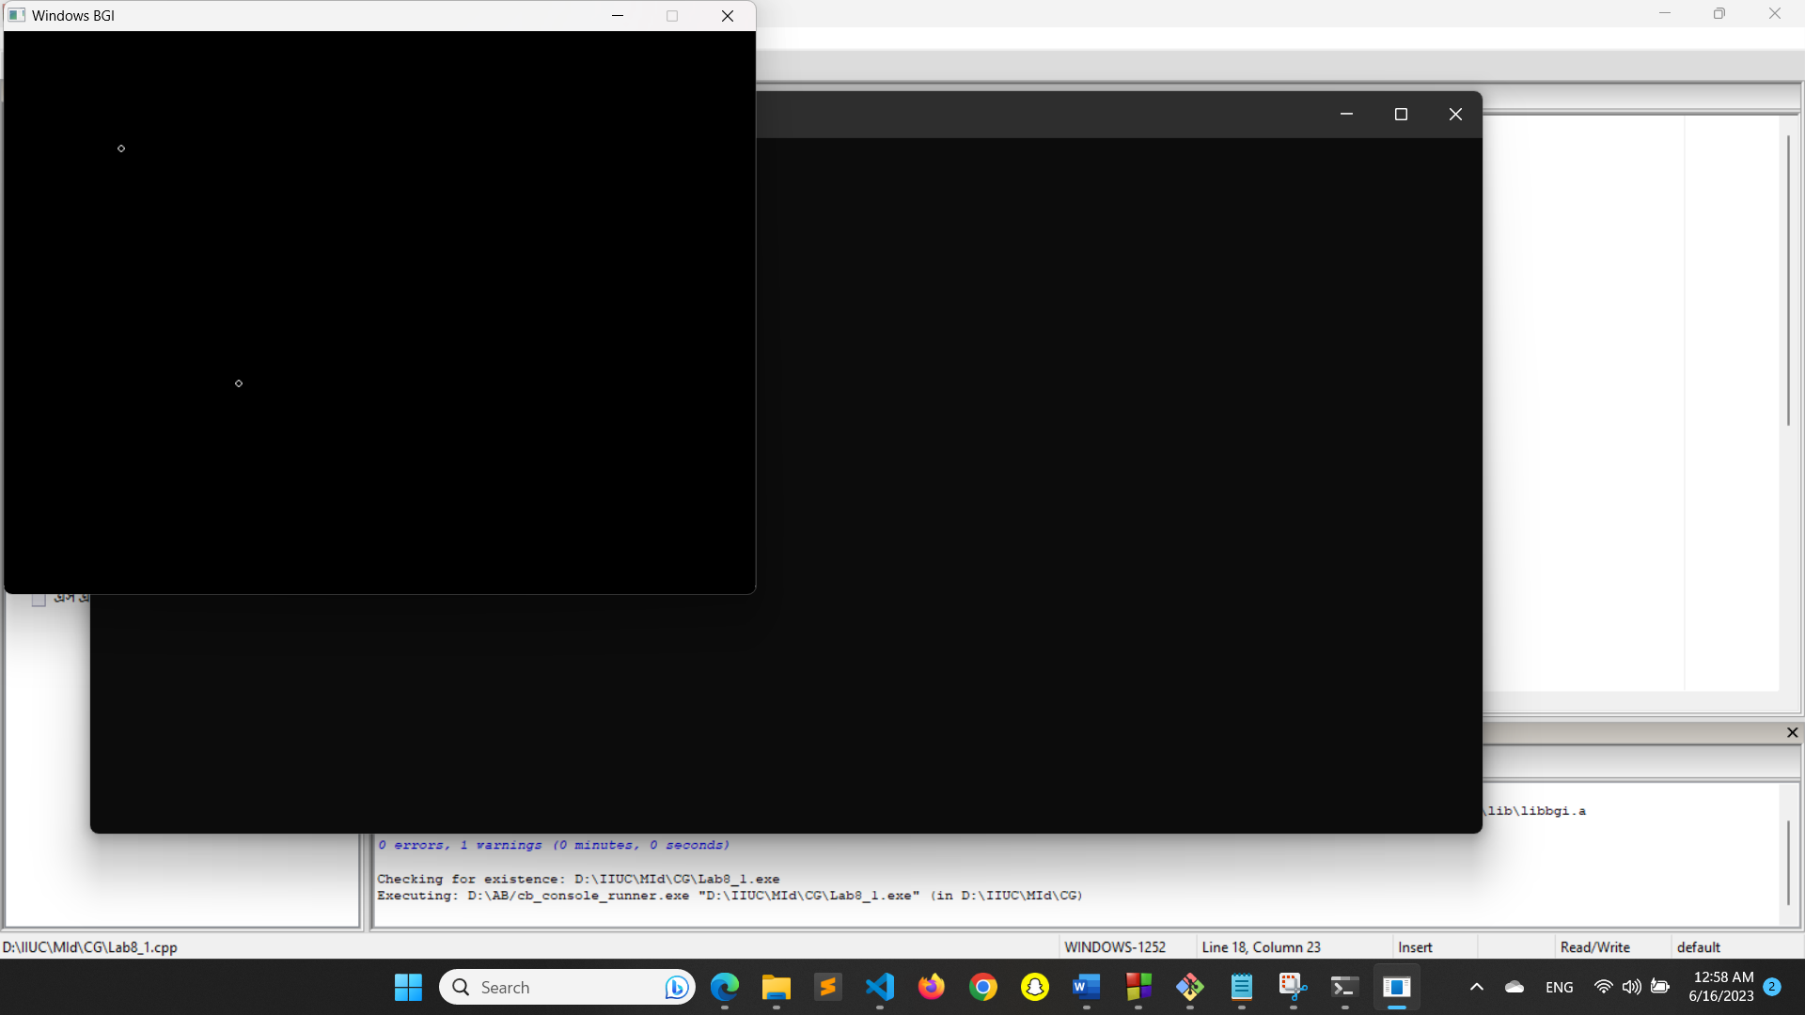

1. Scaling a triangle about origin.

Code:

#include <graphics.h>

#include <stdlib.h>

void scale_triangle(int x1, int y1, int x2, int y2, int x3, int y3, float sx, float sy,

int *new_x1, int *new_y1, int *new_x2, int *new_y2, int *new_x3, int *new_y3)

{

// Scale points

*new_x1 = x1 * sx;

*new_y1 = y1 * sy;

*new_x2 = x2 * sx;

*new_y2 = y2 * sy;

*new_x3 = x3 * sx;

*new_y3 = y3 * sy;

}

int main()

{

int gd = DETECT, gm;

initgraph(&gd, &gm, "");

// Original triangle

int x1 = 100, y1 = 100, x2 = 200, y2 = 200, x3 = 150, y3 = 50;

line(x1, y1, x2, y2);

line(x2, y2, x3, y3);

line(x3, y3, x1, y1);

// Scaling factors

float sx = 2.0, sy = 2.0;

// Scale triangle

int new_x1, new_y1, new_x2, new_y2, new_x3, new_y3;

scale_triangle(x1, y1, x2, y2, x3, y3, sx, sy, &new_x1, &new_y1, &new_x2, &new_y2, &new_x3, &new_y3);

// Display scaled triangle

line(new_x1, new_y1, new_x2, new_y2);

line(new_x2, new_y2, new_x3, new_y3);

line(new_x3, new_y3, new_x1, new_y1);

getch();

closegraph();

return 0;

}

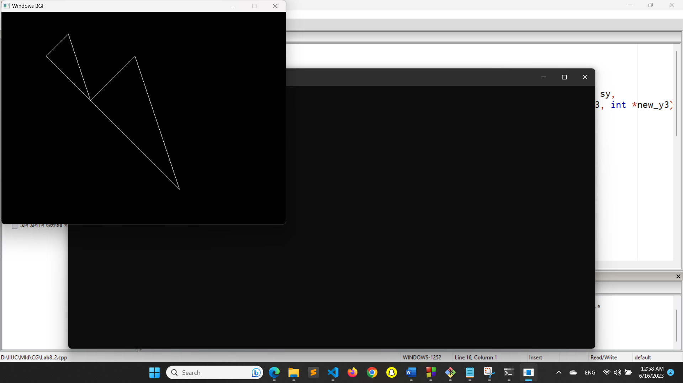

1. Scaling a triangle about another point.

Code:

#include <graphics.h>

#include <stdlib.h>

void scale_triangle(int x1, int y1, int x2, int y2, int x3, int y3, int cx, int cy, float sx, float sy,

int *new_x1, int *new_y1, int *new_x2, int *new_y2, int *new_x3, int *new_y3)

{

// Translate points

x1 -= cx;

y1 -= cy;

x2 -= cx;

y2 -= cy;

x3 -= cx;

y3 -= cy;

// Scale points

x1 *= sx;

y1 *= sy;

x2 *= sx;

y2 *= sy;

x3 *= sx;

y3 *= sy;

// Translate points back to original position

x1 += cx;

y1 += cy;

x2 += cx;

y2 += cy;

x3 += cx;

y3 += cy;

*new_x1 = x1;

*new_y1 = y1;

*new_x2 = x2;

*new_y2 = y2;

*new_x3 = x3;

*new_y3 = y3;

}

int main()

{

int gd = DETECT, gm;

initgraph(&gd, &gm, "");

// Original triangle

int x1 = 100, y1 = 100, x2 = 200, y2 = 200, x3 = 150, y3 = 50;

line(x1, y1, x2, y2);

line(x2, y2, x3, y3);

line(x3, y3, x1, y1);

// Point to scale around

int cx = 150, cy = 150;

circle(cx, cy, 3);

// Scaling factors

float sx = 2.0, sy = 3.0;

// Scale triangle

int new_x1, new_y1, new_x2, new_y2, new_x3, new_y3;

scale_triangle(x1, y1, x2, y2, x3, y3, cx, cy, sx, sy, &new_x1, &new_y1, &new_x2, &new_y2, &new_x3, &new_y3);

// Display scaled triangle

line(new_x1, new_y1, new_x2, new_y2);

line(new_x2, new_y2, new_x3, new_y3);

line(new_x3, new_y3, new_x1, new_y1);

getch();

closegraph();

return 0;

}

