

**An-Najah National University**

**Faculty of Engineering and IT Technology**

**Applications of Artificial Intelligence in Monitoring and Managing Blood Sugar Levels in Diabetic Patients**

**By**

**Jaber Alawneh, Zaid Khalil, and Sufyan Alawneh**

**Supervisor**

**Dr. Aysar Yassin**

**A Report Submitted in Partial Fulfillment of the Requirements of “Communication and Technical Writing Skills (10672114)**

**Summer, 2024**

# Abstract

Diabetes patients continuously face challenges in monitoring and regulating blood sugar levels to avoid severe health complications. This research investigates the role of artificial intelligence (AI) in improving diabetes management through AI-based applications for better monitoring and managing of blood sugar levels in patients. The aim is to explore how AI technologies can be utilized to analyze patient data, enhance the monitoring process, predict fluctuations in blood sugar, and provide personalized guidance for more effective treatment outcomes.

By conducting a comprehensive literature review, analysis of public datasets, and examining case studies, the research evaluates the effectiveness of AI-based solutions in comparison to traditional methods. The findings indicate that AI has the potential to improve the accuracy of predictions and to tailor treatments to individual needs, offering a more effective approach to diabetes management. Additionally, the research addresses the challenges and limitations associated with AI applications, as well as future directions for integrating AI into diabetes care. The study concludes that AI technologies could transform diabetes management, providing enhanced monitoring, personalized care, and ultimately improving patient outcomes.

# Acknowledgment

We would like to express our thanks to Dr. Aysar Yaseen the supervisor of this course for providing us with information that helped with understanding the basic skills for writing a technical report and employing them in different fields.

**Table of Contents**

Abstract 2

Acknowledgment 3

List of Figures 5

List of Tables 6

1.Introduction 7

1.1 Overview 7

1.2 Existing problem 8

1.3 Research Questions 9

1.4 Literature Review 9

1.5 Hypotheses 9

1.6 Objectives and Motivations 10

1.7 Report Organization 10

2.Methodology 10

2.1 System Design and Implementation 11

2.2 Comparative Analysis 13

3. Results and Discussion 15

4. Conclusion and Recommendations 15

5. References 16

# List of Figures

Figure 1 Global Diabetes-Related Deaths by Region (2021) 7

Figure 2 A depiction of a (CGM) device, similar to the Dexcom G6, showcasing real-time blood sugar monitoring 8

Figure 3 Dexcom CGM System Architecture 11

Figure **4** Example of an AGP (Ambulatory Glucose Profile) report 12

# List of Tables

Table 1 Comparison of Traditional vs. AI-Based Glucose Monitoring 13

# 1.Introduction

## 1.1 Overview

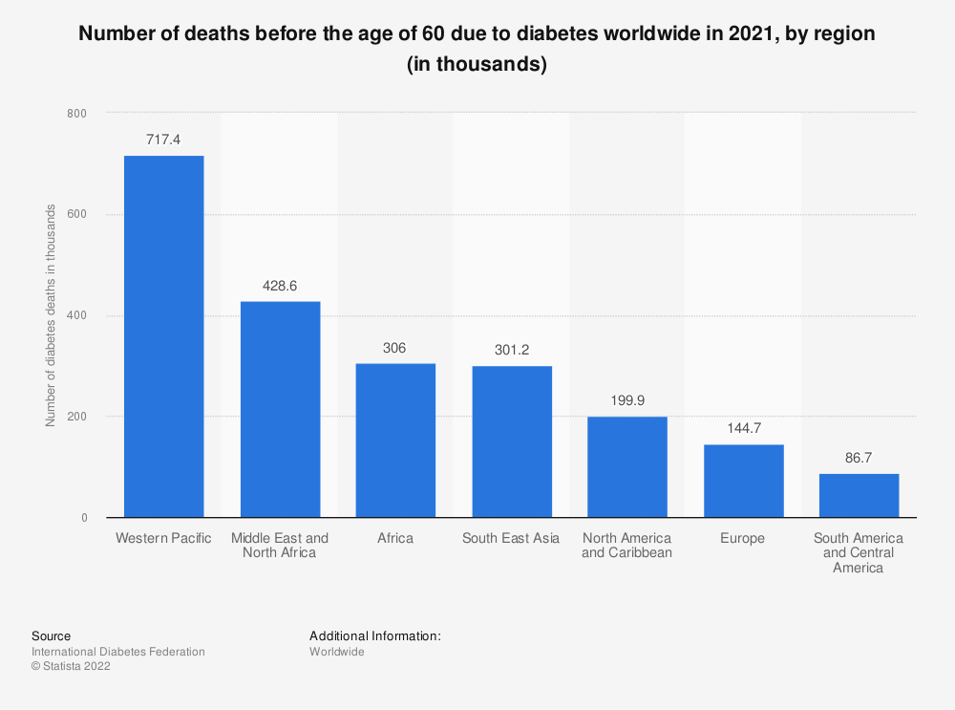This study shows how effective the AI role is in monitoring and managing levels of sugar in diabetic patients’ blood. It’s always a challenge for diabetic patients to maintain their blood sugar levels within the safe and required range. Such a challenge can later put them at risk of many health problems. Figure 1 shows the number of deaths among diabetic patients before the age of 60 in 2021, categorized by region [[1]].

**Figure 1 Global Diabetes-Related Deaths by Region (2021)**

AI techniques were used in this study to analyze patients’ data. A review of case studies that demonstrates the important benefits of such technologies compared with conventional techniques was also conducted. A comprehensive literature review will be performed to explore how AI has been applied in this field of study. Finally, the study will discuss the possible advantages, disadvantages, and future challenges of AI implementation in diabetes management.

## 1.2 Existing problem

It’s always a challenge for patients to keep track of their blood sugar levels. They have consistently asked for improved technological solutions to enhance their lifestyles and reduce the risk of potential health issues. A device used to control blood sugar levels is shown in Figure 2. Such devices are referred to as Continuous Glucose Monitors (CGMs), and one of the most famous devices is the Dexcom G6. The device is made of 3 major components that make the job brief and easy [[2]].

The components are:

* Simple Auto-Applicator: A one-touch applicator inserts a small sensor just beneath the skin.
* Sensor and Transmitter: A slim sensor continuously measures glucose levels and sends data wirelessly to a display device through a transmitter.
* 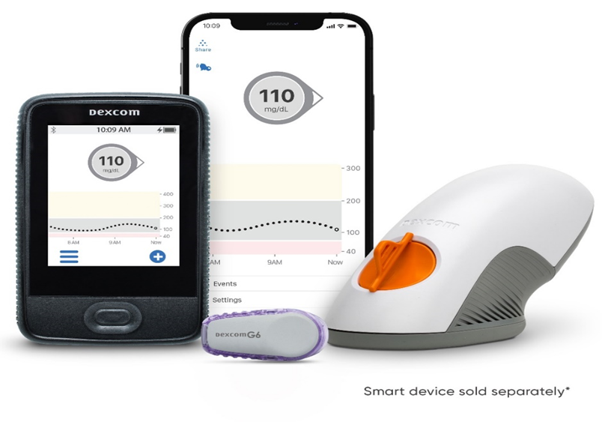Display Device: An Apple or Android-compatible smart device or touchscreen receiver displays real-time glucose data.

**Figure 2 A depiction of a (CGM) device, similar to the Dexcom G6, showcasing real-time blood sugar monitoring**

## ****1.3 Research Questions****

To find the role of artificial intelligence in improving diabetes management, this report addresses the following research questions:

1.How can technologies depending on artificial intelligence be used to analyze diabetic patient data and improve the monitoring process of blood sugar levels?

2.What potential benefits can be achieved using intelligent systems to predict changes in patients’ blood sugar levels?

3.How can artificial intelligence enhance personalized guidance for diabetic patients?

## 1.4 Literature Review

Recent studies have shown that AI plays a vital role in improving diabetes management. AI-based tools, such as machine learning algorithms, enhance the analysis of blood glucose data, providing real-time insights for better management [[3]]. AI can also predict hypoglycemic events and provide timely interventions [[4]]. Additionally, AI has the potential to create personalized treatment plans, leading to improved patient outcomes [[5]].

## 1.5 Hypotheses

It is hypothesized that AI technologies are able to remarkably improve monitoring and managing blood sugar levels in diabetic patients by giving more precise predictions and personalized suggestions and treatments.

## 1.6 Objectives and Motivations

The objectives of this research are:

* To evaluate the effectiveness of AI technologies in monitoring and managing blood sugar levels in diabetic patients.
* To compare AI-enhanced glucose monitoring systems with conventional methods.
* To analyze the potential benefits and limitations of AI in diabetes management.

The motivation behind this study is to find how can modern technologies handle the challenges faced by diabetic patients and improve their quality of life through enhanced monitoring and personalized care.

## 1.7 Report Organization

The report is organized as follows: Section 1 introduction. Section 2 methodology, including system design and comparative analysis. Section 3 results and discussion of findings. Section 4 conclusion and recommendations. Section 5 references.

# 2.Methodology

The methodology of this study focuses on evaluating the effectiveness of (AI) in managing diabetes, particularly through continuous glucose monitoring systems like the Dexcom (CGM) device. The research compares conventional methods of glucose monitoring with AI-enhanced systems to assess improvements in accuracy, prediction, and patient outcomes. Figure 3 illustrates the overall architecture of the Dexcom CGM system, showcasing the data flow from the sensor to the user interface, where AI algorithms process the information.

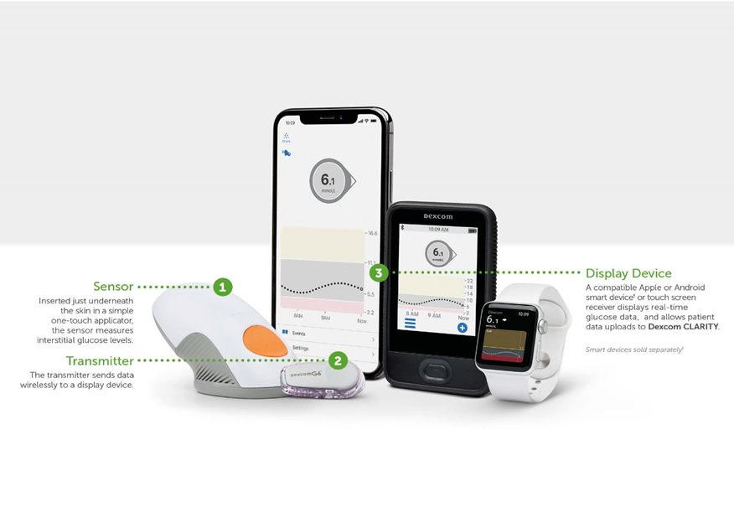

**Figure 3 Dexcom CGM System Architecture**

## 2.1 System Design and Implementation

The Dexcom CGM system was designed to provide real-time glucose monitoring, predictive analytics, and personalized recommendations. The following components are integral to the system:

* Sensor: A small, flexible sensor is inserted under the skin, where it measures glucose levels in the interstitial fluid continuously. The sensor can remain in place for up to 10 days, minimizing patient discomfort and maximizing data collection.
* Transmitter: The transmitter is attached to the sensor and sends glucose data every five minutes to a compatible receiver or smartphone app via Bluetooth. This continuous data transmission is critical for maintaining up-to-date glucose readings.
* Receiver/Smartphone App: The Dexcom app or dedicated receiver displays the glucose readings in real-time, offering patients a graphical representation of their glucose trends. The app also integrates AI algorithms that analyze the data to predict future glucose levels and provide alerts for potential hypo- or hyperglycemia events.
* Data Flow and AI Processing
* The flow of data within the Dexcom CGM system is crucial for understanding how AI enhances diabetes management:
* Data Collection: Continuous glucose readings are captured by the sensor and transmitted to the app or receiver.
* AI-Based Analysis: The AI algorithms within the app process historical and real-time data to identify patterns and predict future glucose levels. These predictions help in providing early warnings and personalized recommendations.
* User Feedback: The system provides real-time feedback to the user, including alerts for potential blood sugar spikes or drops, and suggests actions such as insulin dosage adjustments or dietary changes.

Figure 4 presents a detailed flowchart of data processing within the Dexcom CGM system, from initial data collection to AI-driven decision-making [[6]].

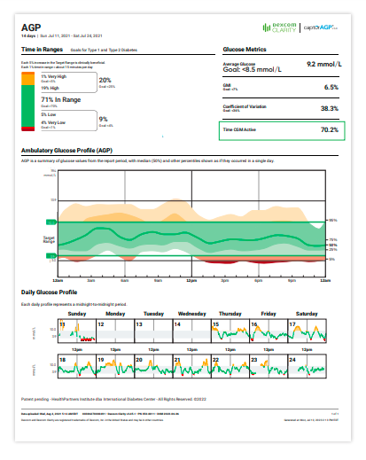

**Figure 4 Example of an AGP (Ambulatory Glucose Profile) report**

## 2.2 Comparative Analysis

To evaluate the effectiveness of AI-enhanced glucose monitoring, the Dexcom CGM system is compared with traditional fingerstick monitoring methods [[7]]. From Table 1 The analysis focuses on several key metrics based on type.

**Table 1 Comparison of Traditional vs. AI-Based Glucose Monitoring**

|  |  |  |  |
| --- | --- | --- | --- |
| **Components and Features** | **Dexcom G7** | **Dexcom G6 Personal** | **Dexcom G6 Pro** |
| Indication | 2 years and older | 2 years and older | 2 years and older |
| Wear Duration | Up to 10 days | Up to 10 days | Up to 10 days per person |
| Calibration | None required | None required | None required |
| Mode | Unblinded | Unblinded | Blinded or Unblinded |
| Dosing | Nonadjunctive | Nonadjunctive | Nonadjunctive (unblinded mode only) |
| Reporting Software | CLARITY | CLARITY | CLARITY |
| Display (Unblinded Mode) | Smart device or receiver | Smart device or receiver | Smartphone |
| Alerts and Alarm | Quiet Mode, Delayed 1st Alert, Urgent Low Alert | Advanced features, Urgent Low Alarm | Urgent Low Alarm |
| Customizable Alerts | Yes | Yes | Yes |
| 12-hour Grace Period | Yes | No | No |
| Size | W: 1.07” x L: 0.94” | W: 1.2" x L: 1.8" | W: 1.2" x L: 1.8" |
| Warm-Up Time | Less than 30 minutes | 2 hours | 2 hours |
| Water Resistance | Up to 2.4 m for 24 hours | Up to 2.4 m for 24 hours | Up to 2.4 m for 24 hours |
| Acetaminophen Blocking | Yes | Yes | Yes |
| Insertion | Automatic | Automatic | Automatic |
| Painless | Yes | Yes | Yes |

A simple explanation of the comparisons based on the previous table:

* Indication: The age ranges the system is approved for. All models are for people aged 2 years and older.
* Wear Duration: How long you can wear the sensor before it needs to be replaced. All models last up to 10 days.
* Calibration: Whether the system requires manual calibration with blood glucose tests. All models do not require manual calibration.
* Mode: Whether the user can see real-time glucose data (Unblinded) or not (Blinded).
* Dosing: Whether the glucose readings can be used to make treatment decisions. All systems provide data for continuous monitoring, not for making dosing decisions.
* Reporting Software: The software used to analyze and track glucose data. All systems use CLARITY software.
* Display (Unblinded Mode): The type of device used to view data when it’s not blinded. G7 and G6 Personal use smart devices or receivers, while G6 Pro uses a smartphone.
* Alerts and Alarm: Notifications about glucose levels, such as urgent low alerts.
* Customizable Alerts: The ability to set and adjust alert settings based on personal preferences.
* 12-hour Grace Period: A feature that allows the sensor to work for up to 12 hours after the official wear period ends. Available on G7 only.
* Size: The dimensions of the sensor, affecting how discreet and comfortable it is.
* Warm-Up Time: How long it takes for the sensor to start working after being applied. G7 has a shorter warm-up time compared to G6.
* Water Resistance: The sensor’s ability to resist water exposure. All models are resistant to water for up to 24 hours.
* Acetaminophen Blocking: The sensor’s ability to ignore glucose readings affected by acetaminophen (a common pain reliever) to ensure accurate readings.
* Insertion: How the sensor is applied. All models use an automatic applicator for easy insertion.
* Painless: Indicates whether the insertion process is designed to be comfortable. All models claim to be painless.

# 3. Results and Discussion

Several advantages were for the AI-enhanced Dexcom CGM system were noticed over traditional fingerstick monitoring methods, it provided uncut real-time data, predictive analytics, and personalized recommendations. The patient management and outcomes are easier are highly improved due to alerts and suggested timely interventions. The comparison showed that AI-based systems provide more accurate predictions and personalized care, putting some new disadvantages and limitations of traditional methods.

# 4. Conclusion and Recommendations

Implementing AI into the field of diabetes generally, and glucose monitoring systems specifically represents a significant advancement in diabetes management. AI technologies improve the accuracy of glucose predictions, provide real-time visual feedback, and offer personalized recommendations that enhance patient care. However, some problems were faced and need to be looked after such as data privacy, algorithm accuracy, and patient adherence need to be addressed. Future research should focus on improving and end these challenges, and try to add more improvements to the system for better user-experience.

# 5. References

1. World Economic Forum, (2020). Diabetes: A silent epidemic that is growing worldwide. Available: <https://www.weforum.org/agenda/2020/12/diabetes-silent-epidemic-world-health/> Last accessed: August 13, 2024.
2. Dexcom, (n.d.). Official website. Available: <https://www.dexcom.com/en-KW> Last accessed: August 13, 2024.
3. Contreras, I., & Vehey, A. (2018). The role of continuous glucose monitoring in diabetes management. Journal of Diabetes Science and Technology, 12(2), 385-392.
4. Spanakis, E. K., & Golden, S. H. (2013). The impact of artificial intelligence on diabetes care. Journal of Diabetes Science and Technology, 7(1), 25-34.
5. Lee, S. I., Celik, S., Logsdon, B. A., Lundquist, A. L., Nehorai, A., Wessel, J., & O'Connell, J. R. (2020). Machine learning algorithms for predicting hypoglycemia and personalized diabetes treatment. Journal of Diabetes Science and Technology, 14(1), 72-82.
6. World Economic Forum, (2020). Diabetes: A silent epidemic that is growing worldwide. Available: <https://www.weforum.org/agenda/2020/12/diabetes-silent-epidemic-world-health/> Last accessed: August 13, 2024.
7. Dexcom, (n.d.). Explore and compare CGM products. Available: <https://provider.dexcom.com/explore-and-compare-cgm-products> Last accessed: August 13, 2024.