PAGE 01: EXECUTIVE SUMMARY | SALES, PROFITABILITY & TARGET PERFORMANCE
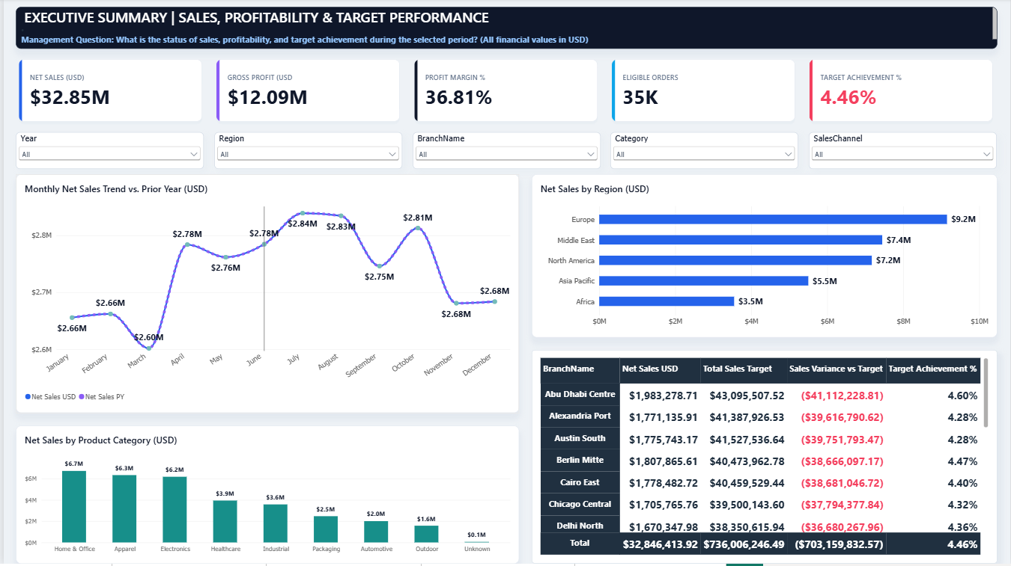
1. Management Question What is the overall status of net sales, profitability, and target achievement across regions, categories, and branches during the selected period?
2. Key Performance Indicators (KPIs Summary)
- Net Sales (USD): $32.85M ($32,846,413.92 across all active regions and channels).
- Gross Profit (USD): $12.09M.
- Gross Profit Margin %: 36.81%.
- Eligible Orders: 35K orders.
- Target Achievement %: 4.46% (Actual Net Sales of $32.85M vs. Total Sales Target of $736.01M, resulting in a negative variance of -$703.16M).
3. Visual & Dimensional Breakdown
- Monthly Sales Trend: Monthly revenue remained relatively stable between $2.60M (lowest in March) and $2.84M (peak in July), with a secondary peak in October ($2.81M) before settling at $2.68M in November and December.
- Regional Performance: Europe leads all territories with $9.2M in Net Sales (approx. 28% of total revenue), followed by the Middle East ($7.4M) and North America ($7.2M), while Asia Pacific ($5.5M) and Africa ($3.5M) represent the smallest regional shares.
- Category Performance: Revenue is heavily anchored by three core categories: Home & Office ($6.7M), Apparel ($6.3M), and Electronics ($6.2M), which collectively generate $19.2M (58.4% of total sales). Secondary categories include Healthcare ($3.9M), Industrial ($3.6M), Packaging ($2.5M), Automotive ($2.0M), and Outdoor ($1.6M).
- Branch Target Matrix: Every single branch exhibits a uniform target achievement rate between 4.28% and 4.60% (e.g., Abu Dhabi Centre achieved $1.98M against a $43.10M target, or 4.60%; Berlin Mitte achieved $1.81M against a $40.47M target, or 4.47%).
4. Executive Finding (Data-Driven Insight — Correlation vs. Causation) The business demonstrates healthy operational profitability with a 36.81% Gross Profit Margin ($12.09M) across 35K eligible orders, driven primarily by strong demand in Europe ($9.2M) and top-tier product categories (Home & Office, Apparel, and Electronics). However, overall Target Achievement stands at a critical 4.46% (-$703.16M variance). Because this ~95.5% shortfall occurs uniformly across all branches (all hovering tightly around 4.3%–4.6% attainment regardless of geography), the data indicates a systemic target-allocation or data-granularity mismatch (e.g., multi-year or company-wide targets unadjusted for branch-level filter granularity) rather than an operational collapse in branch sales execution. (Note: High target variance correlates with top-down quota scaling and does not imply causal failure by branch personnel).
5. Actionable Recommendation
- Re-baseline & Audit Branch Quotas: Immediately audit the Fact_Targets allocation logic with Finance and Sales Operations to align branch quotas ($736.01M total) with historical branch run-rates (~$1.7M–$2.0M per branch annually) so performance tracking becomes realistic and motivating.
- Protect Core Category Margins: Focus commercial growth initiatives on expanding the top three revenue engines (Home & Office, Apparel, Electronics) within mid-tier regions (Asia Pacific and Africa) while maintaining the strong 36.81% margin baseline.
6. Units, Timeframe & Sources of Uncertainty (Data Governance)
- Units & Currency: All monetary figures are standardized in US Dollars (USD); order counts are in thousands (K).
- Time Horizon: Full-year aggregated view (Year = All, January through December).
Sources of Uncertainty & Data Caveats:

- Unclassified Records: Approximately $0.1M in Net Sales is linked to an "Unknown" product category, requiring master-data mapping in Dim_Products.
- Prior Year (PY) Trend Overlap: In the monthly trend chart, the Net Sales PY line completely overlaps the current Net Sales USD line across all 12 months when Year = All is selected. A specific single year must be selected in the Year slicer for accurate Year-over-Year (YoY) comparison.
Target Granularity Discrepancy: The extreme gap between actual sales ($32.85M) and target ($736.01M) reflects target table grain differences that must be factored in before evaluating branch managers.

PAGE 02: SALES TRENDS & CHANNEL DYNAMICS | TEMPORAL & COMMERCIAL ANALYSIS
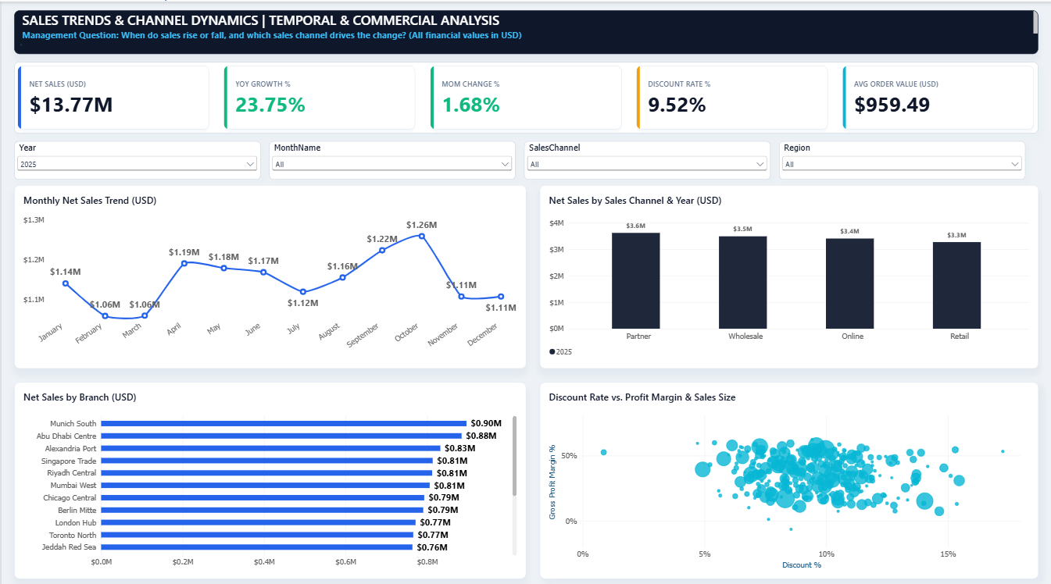
1. Management Question When do sales rise or fall during the year, and which sales channel drives the change? (All financial values in USD)
2. Key Performance Indicators (KPIs Summary — Year 2025)
- Net Sales (USD): $13.77M (for the selected period: Year 2025).
- YoY Growth %: +23.75% compared to the prior year.
- MoM Change %: +1.68%.
- Discount Rate %: 9.52%.
- Average Order Value (AOV - USD): $959.49 per order.
3. Visual & Dimensional Breakdown
- Monthly Net Sales Trend: Sales open in January at $1.14M before dipping to the annual low in February and March ($1.06M each). Revenue rebounds in Q2, reaching $1.19M in April and holding steady through May ($1.18M) and June ($1.17M), followed by a mild mid-summer dip in July ($1.12M). The strongest growth wave builds from August ($1.16M) through September ($1.22M), peaking in October at $1.26M, before moderating to $1.11M in November and December.
- Sales Channel Performance: Revenue in 2025 is well-diversified across all four commercial channels, led by the Partner channel at $3.6M (~26.1% of total sales), followed closely by Wholesale ($3.5M), Online ($3.4M), and Retail ($3.3M).
- Top Performing Branches: Munich South leads branch-level net sales in 2025 with $0.90M, followed closely by Abu Dhabi Centre ($0.88M) and Alexandria Port ($0.83M), while Singapore Trade, Riyadh Central, and Mumbai West are tied at $0.81M each.
- Discount Rate vs. Profit Margin & Sales Size (Scatter Analysis): The majority of transactions cluster within a 6% to 12% discount band (averaging 9.52%), sustaining healthy Gross Profit Margins between 20% and 55%. However, outlier transactions pushed past 14%–16% discount rates show compressed profit margins dropping toward 10%–15% without generating proportionally larger bubble sizes (sales volume).
- Executive Finding (Data-Driven Insight — Correlation vs. Causation) In 2025, the company achieved strong annual growth (+23.75% YoY, reaching $13.77M in Net Sales) with a high Average Order Value of $959.49. Seasonality peaks sharply in late Q3 and early Q4 (September at $1.22M and October at $1.26M), while B2B-oriented channels (Partner at $3.6M and Wholesale at $3.5M) collectively drive over 51.5% of total revenue. Crucially, the scatter analysis reveals that offering discounts above 12% correlates with severe margin erosion rather than larger transaction sizes; higher discounting does not causally drive larger order volumes compared to the optimal 8%–10% discount range.
5. Actionable Recommendation
- Enforce a Tiered Discount Cap: Establish a standard discount ceiling at 10%–11%, requiring executive approval and strict minimum order volume thresholds for any promotional discount exceeding 12% to prevent unnecessary margin leakage.
- Capitalize on Q3/Q4 Peaks & Stimulate Q1 Troughs: Lock in early volume commitments across Partner and Wholesale channels ahead of the September–October peak season, while deploying targeted bundle promotions in February and March to lift revenue above the $1.06M seasonal floor.
6. Units, Timeframe & Sources of Uncertainty (Data Governance)
- Units & Currency: All financial metrics are reported in US Dollars (USD) (Millions $M for aggregated trends, exact USD for AOV); growth and discount metrics are expressed in percentages (%).
- Time Horizon: Filtered specifically to Year = 2025 across all months, sales channels, and regions.
- Sources of Uncertainty & Data Caveats:
- MoM % Aggregation Context: Because MonthName is set to All, the 1.68% MoM Change reflects the terminal month comparison (December vs. November) or full-year period logic; users should filter a specific month to evaluate isolated monthly momentum.
- Slicer Scope Variance vs. Page 01: Page 02 displays $13.77M because the Year slicer is filtered to 2025, whereas Page 01 displayed $32.85M across all historical years combined (Year = All)

PAGE 03: CUSTOMER SEGMENTATION & MARKET CONCENTRATION | PARETO & TOP CLIENT ANALYSIS
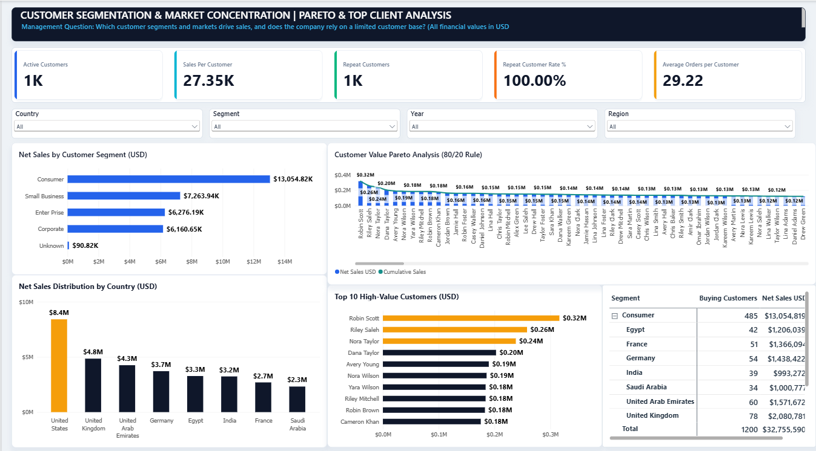
1. Management Question Which customer segments and geographic markets drive sales, and does the company rely on a limited customer base? (All financial values in USD)
2. Key Performance Indicators (KPIs Summary)
- Active Customers: 1K (~1,200 exact buying customers recorded in the detailed matrix).
- Sales Per Customer (USD): $27.35K average lifetime/period revenue per customer.
- Repeat Customers: 1K customers.
- Repeat Customer Rate %: 100.00% (Every active customer placed multiple orders across the analyzed period).
- Average Orders per Customer: 29.22 orders per customer.
3. Visual & Dimensional Breakdown
- Net Sales by Customer Segment: The Consumer segment is the primary revenue driver at $13,054.82K ($13.05M) across 485 customers (~39.8% of total segment sales). It is followed by Small Business ($7,263.94K), Enterprise ($6,276.19K), and Corporate ($6,160.65K), with $90.82K attributed to an unclassified Unknown segment.
- Geographic Concentration (Net Sales by Country): The United States leads all markets by a substantial margin at $8.4M (~25.6% of total revenue), nearly doubling the second-largest market, the United Kingdom ($4.8M). Other key markets include the United Arab Emirates ($4.3M), Germany ($3.7M), Egypt ($3.3M), India ($3.2M), France ($2.7M), and Saudi Arabia ($2.3M).
- Customer Value Pareto & Top 10 High-Value Clients: The top individual customer is Robin Scott ($0.32M), followed by Riley Saleh ($0.26M), Nora Taylor ($0.24M), and Dana Taylor ($0.20M), while the remaining Top 10 clients contribute between $0.18M and $0.19M each. Combined, the Top 10 customers generate $2.12M, representing only ~6.5% of total customer revenue ($32,755,590).
- Segment & Country Matrix (Consumer Breakdown): Within the leading Consumer segment (485 customers | $13.05M), the United Kingdom leads with 78 customers ($2.08M), followed by the UAE (60 customers | $1.57M), Germany (54 customers | $1.44M), France (51 customers | $1.37M), Egypt (42 customers | $1.21M), Saudi Arabia (34 customers | $1.00M), and India (39 customers | $0.99M).
4. Executive Finding (Data-Driven Insight — Correlation vs. Causation) The company does not suffer from single-client concentration risk:
- revenue is broadly distributed across 1,200 active customers, with the single largest account (Robin Scott at $0.32M) representing less than 1% of total sales, and the Top 10 accounts combined accounting for just ~6.5%. Furthermore, customer retention is exceptional, with a 100.00% Repeat Customer Rate and an average of 29.22 orders per client. Instead, commercial concentration occurs at the segment and country level, where the Consumer segment ($13.05M) and the United States market ($8.4M) dominate revenue. (Note: High total revenue in the Consumer segment correlates with a larger buyer headcount of 485 customers, rather than causally indicating higher per-customer spending than Corporate or Enterprise accounts).
5. Actionable Recommendation
- Upsell & Expand B2B Segments (Small Business, Enterprise & Corporate): Leverage the strong 100% repeat buying behavior to introduce volume-based annual contracts and account-management tiers for Small Business ($7.26M) and Enterprise ($6.28M) clients, aiming to lift average revenue per customer above the $27.35K baseline.
- Diversify Geographic Growth Beyond the US: Capitalize on strong regional traction in the UAE ($4.3M), Germany ($3.7M), and Egypt ($3.3M) through localized customer acquisition campaigns to balance the heavy reliance on the US market ($8.4M).
6. Units, Timeframe & Sources of Uncertainty (Data Governance)
- Units & Currency: Monetary values are reported in US Dollars (USD) (Millions $M in country/Pareto charts, Thousands $K in segment bars and KPIs, and exact USD in the matrix); customer counts are in whole numbers and thousands (K).
- Time Horizon: Full historical dataset (Year = All) across all countries, segments, and regions.
- Sources of Uncertainty & Data Caveats:
- Pareto Cumulative Line Context: In the Pareto visual, the Cumulative Sales green line tracks individual customer bars rather than rising monotonically to 100%, indicating that the DAX cumulative measure requires ALLSELECTED(Dim_Customers[CustomerName]) rank-order context to display a traditional 80/20 cumulative curve.
- Unmapped Segment Records & Rounding: $90.82K in Net Sales is tied to an Unknown segment (and the matrix total of $32.76M vs. Page 01's $32.85M reflects ~$90K in
- transactions without mapped customer attributes), while the KPI card rounds 1,200 customers to 1K

PAGE 04: PRODUCT PORTFOLIO & PROFITABILITY | MARGIN & ABC ANALYSIS
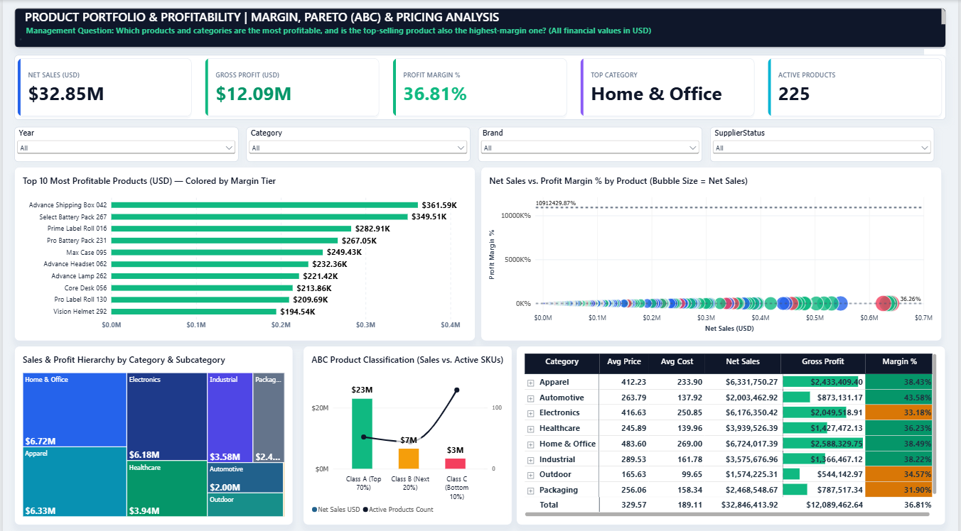
- Management Question: Which products and categories are most profitable, and is the top-selling product also the highest-margin one?
- Key Metrics: Net Sales: $32.85M | Gross Profit: $12.09M (36.81% margin) | Active Products: 225.
- Visual Breakdown: Home & Office leads sales ($6.72M | $2.59M profit), while Automotive achieves the highest profit margin at 43.58% ($2.00M sales). Packaging has the lowest margin (31.90%). Class A products generate $23M in sales.
- Executive Finding: Top-selling categories do not yield the highest profit margins (Automotive leads margins at 43.58%, while Home & Office leads volume). High-volume items cluster around average margins (~36%).
- Actionable Recommendation: Re-engineer pricing/costs in Packaging and Electronics (33.18% margin) and rationalize over 120 low-yielding Class C SKUs.
- Data Caveats: An outlier data point in the profit margin scatter plot requires cleaning (Profit Margin % <= 100%).
PAGE 05: BRANCH & EMPLOYEE PERFORMANCE | TARGET & PROFIT CONTRIBUTION
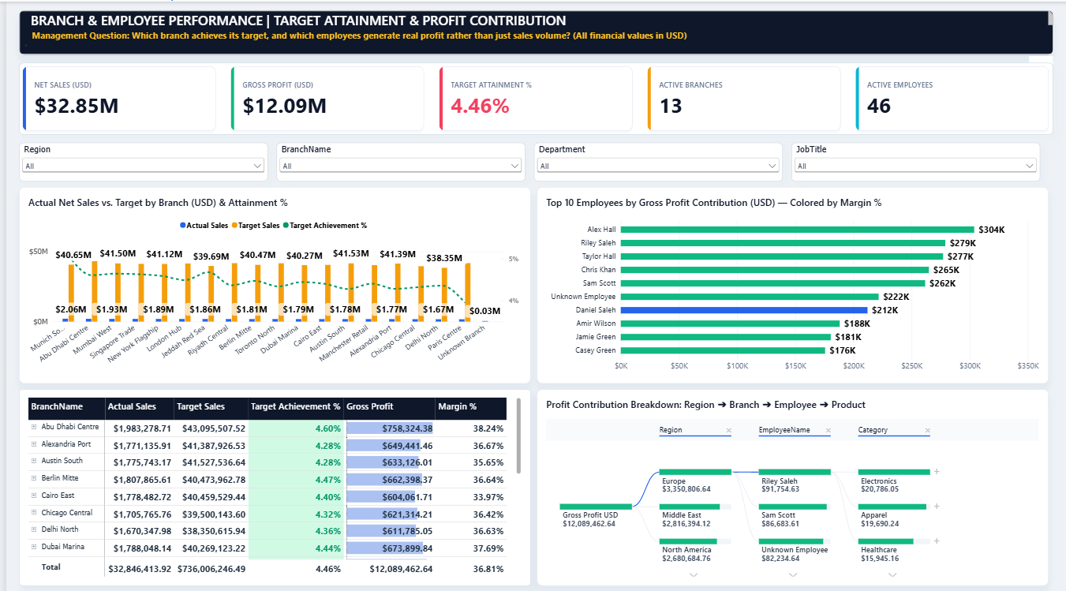
- Management Question: Which branch achieves its target, and which employees generate real profit rather than just sales volume?
- Key Metrics: Net Sales: $32.85M | Target Attainment: 4.46% | Active Branches: 13 | Active Employees: 46.
- Visual Breakdown: Munich South leads actual sales ($2.06M), while Abu Dhabi Centre leads branch profit ($758.3K | 38.24% margin). Alex Hall ($304K profit) and Riley Saleh ($279K profit) top employee contributions.
- Executive Finding: No branch meets its system target due to a ~20x target inflation (~$40M target vs. ~$2M actual run-rate). Operational profit varies: Abu Dhabi outperforms Cairo East (33.97% margin). Daniel Saleh generates high sales volume but lower profit margins compared to peers.
- Actionable Recommendation: Re-align branch targets with historical run-rates and tie employee commissions to Gross Profit rather than revenue volume alone.
- Data Caveats: $222K in profit is tied to an Unknown Employee, and achieved percentage formatting requires conditional logic adjustment.

