**CAHPTER#5**

In this chapter provides an in-depth understanding of the widget tree, a critical concept in Flutter development that emerges from nesting widgets to create layouts ranging from simple to highly complex. The chapter explains how deeply nested widget trees, while functional, can lead to code that is harder to read, debug, and maintain. To address these challenges, it introduces best practices for keeping the widget tree as shallow as possible, improving code clarity and reducing technical debt.

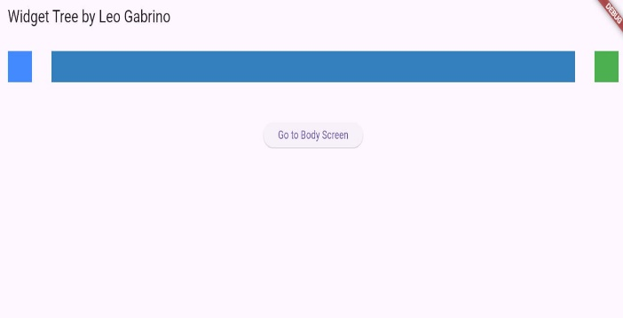I’ll gain insight into the widgets commonly used in layouts and learn how their structure impacts the overall widget tree. The chapter highlights the pitfalls of deep widget trees, such as increased complexity and difficulty in tracking relationships between components. To resolve these issues, you’ll explore three powerful refactoring techniques: extracting a constant, defining a method, and creating a widget class. Each technique is discussed with practical examples, showing how to simplify the tree structure while maintaining functionality. The chapter also weighs the benefits and drawbacks of each approach, helping you choose the most suitable method for different scenarios. By the end of this chapter, you’ll be equipped to create clean, modular, and maintainable widget trees, a cornerstone of effective Flutter development.

