**CHAPTER#8**

Chapter 8 focuses on creating seamless and intuitive navigation within a Flutter app, which is essential for a great user experience (UX). Good navigation ensures users can easily access information and interact with the app. The chapter highlights how adding animations during navigation transitions can enhance UX, provided they convey an action rather than distract the user. You’ll learn how to use the Navigator widget to manage a stack of routes, allowing users to move between pages effectively. The chapter introduces the Hero widget, which enables navigation animations by smoothly transitioning and resizing a widget from one page to another, creating a visually cohesive experience.

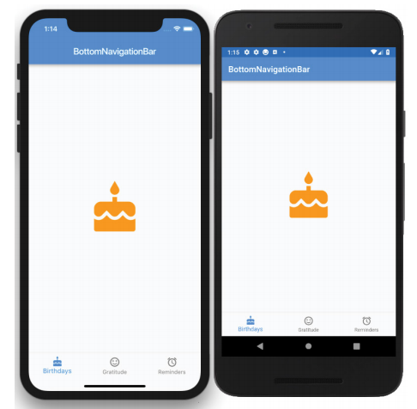Additionally, you'll explore different navigation methods, including the BottomNavigationBar, BottomAppBar, TabBar, TabBarView, and Drawer widgets, which offer a variety of ways to switch between app sections. The chapter also demonstrates how to use the ListView widget in combination with the Drawer widget to create a navigational menu, providing users with an easy-to-use interface for moving through the app. By the end of the chapter, you'll have the skills to implement versatile and user-friendly navigation systems with engaging animations to improve the overall user experience.

