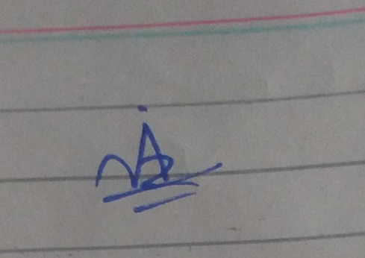**Signature:**

**Name:**

**Jabir Ali Khan**

**Country:**

**Pakistan**

**Address:**

**Chak #: 6/3.L, Jhang, Pakistan**

**Email:**

[**alijabir253@gmail.com**](mailto:alijabir253@gmail.com)

**Phone:**

**+923000425436**

**Languages:**

**English, Arabic, Urdu**