# POC Implementation document

## About Porttal:

A catalogue of information portal from various suppliers of enterprise users.

## Technical details:

This POC is a 3-tier web application which can be deployed in any application server. It has been tested on tomcat 7. Following other technologies have been used to develop it.

* Java
* Spring
* RESTful web services
* Hibernate
* JSP
* HTML/HTML5
* JQuery
* MySQL

# Screen shots:

There are four different pages.

## Login: (index.jsp)

Default user is admin (DB script is attached in zip file provided). However, any user which is created with admin profile can be used to login.

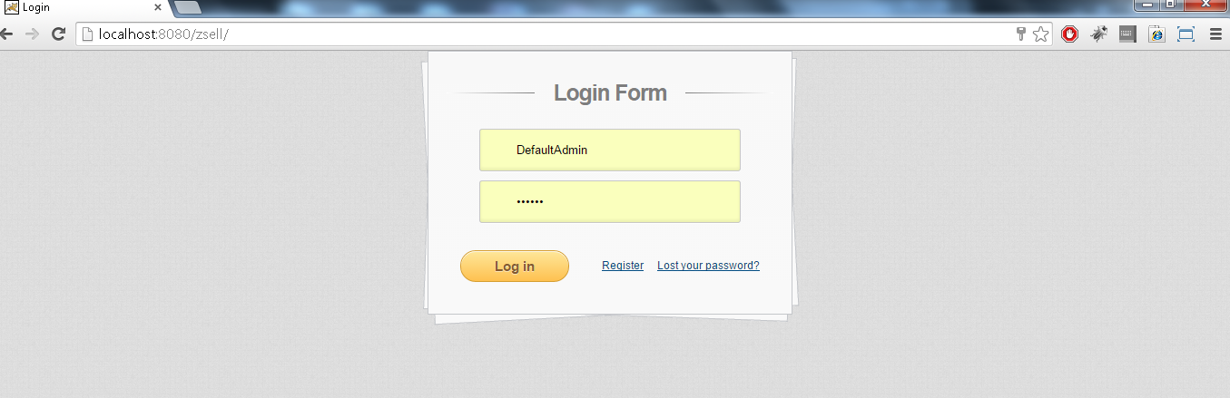

## Administrator page: (admin.jsp)

Administrator can create and modify any other user profile. He/she can also modify his/her own profile. However, current logged in administrator cannot change its own account type from admin to anything else. This is to show we can restrict any field from modification depending on some criteria.

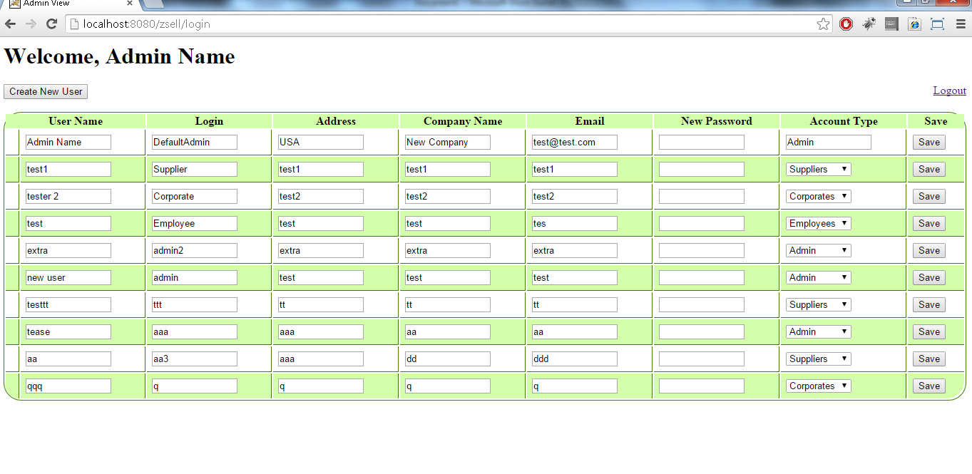

## New user button: (admin.jsp)

New users can be created by clicking on ‘Create New User’ button.

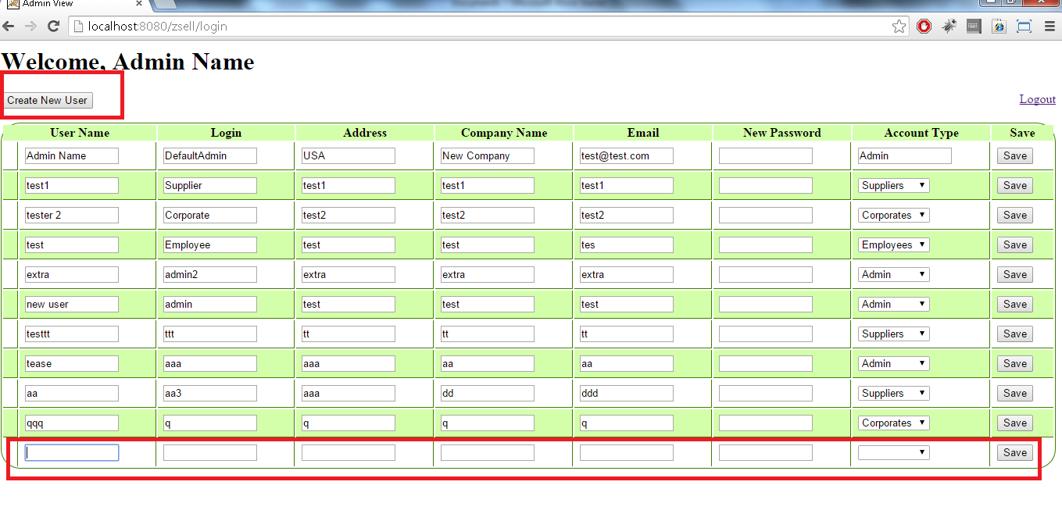

**NOTE**: Once admin page loads it will not reload again to decrease user wait time. It will behave as single page application as a highly responsive application for admin. Same can be done for other profiles such as supplier/corporate/employee.

## Supplier Page: (supplier.jsp)

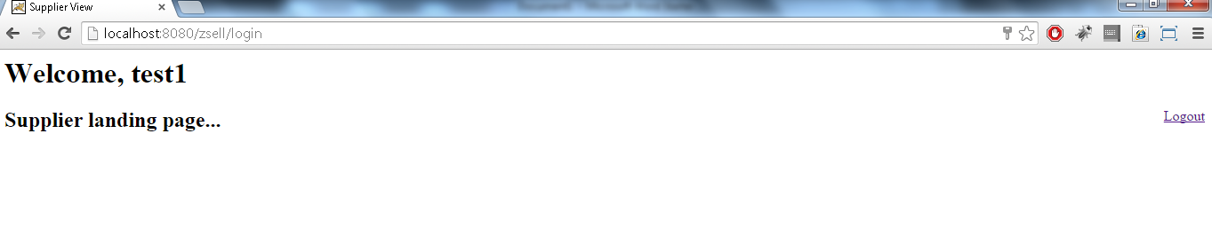

## Corporate page: (corporate.jsp)

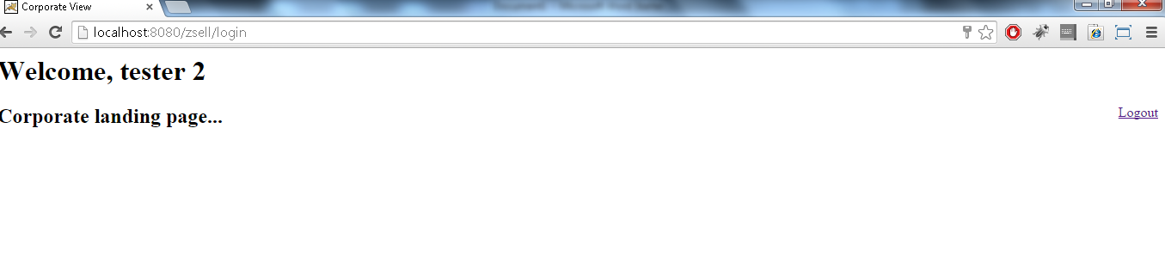

## Employee Page: (employee.jsp)

