IN00265726 | CR00007968

Part 1: Considering earliest StartTime and latest EndTime from RESOURCE_LABOR and LABOR for ExecutionLabor instead of the current system where it’s opposite.

ProductionOrder.Operation.SAP.SendConfirmation_Action > Prepare XML

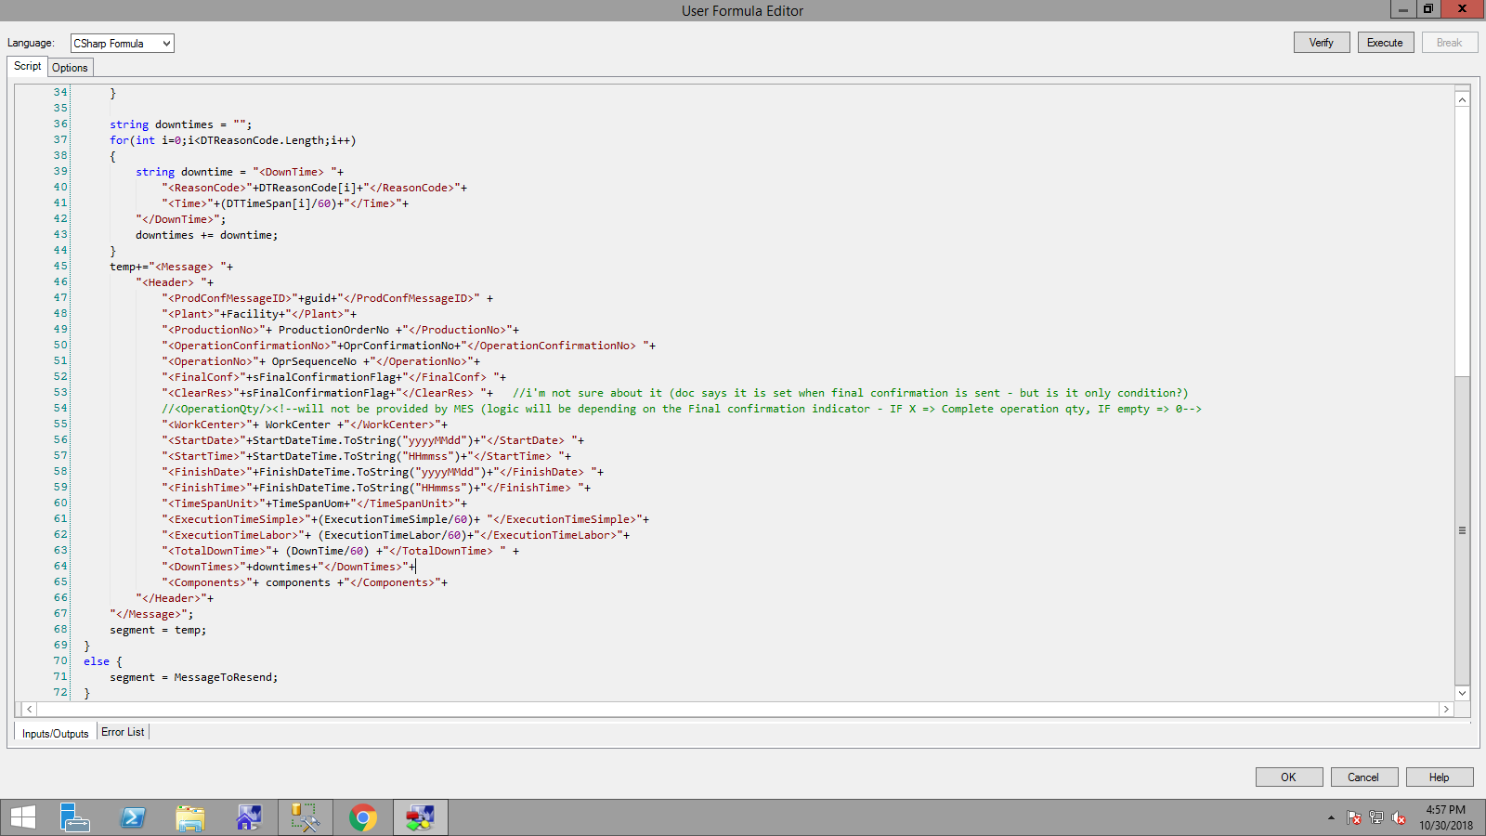

Call_k6_xmlwritetest < ExecutionTimeSimple < GetOperationTimes

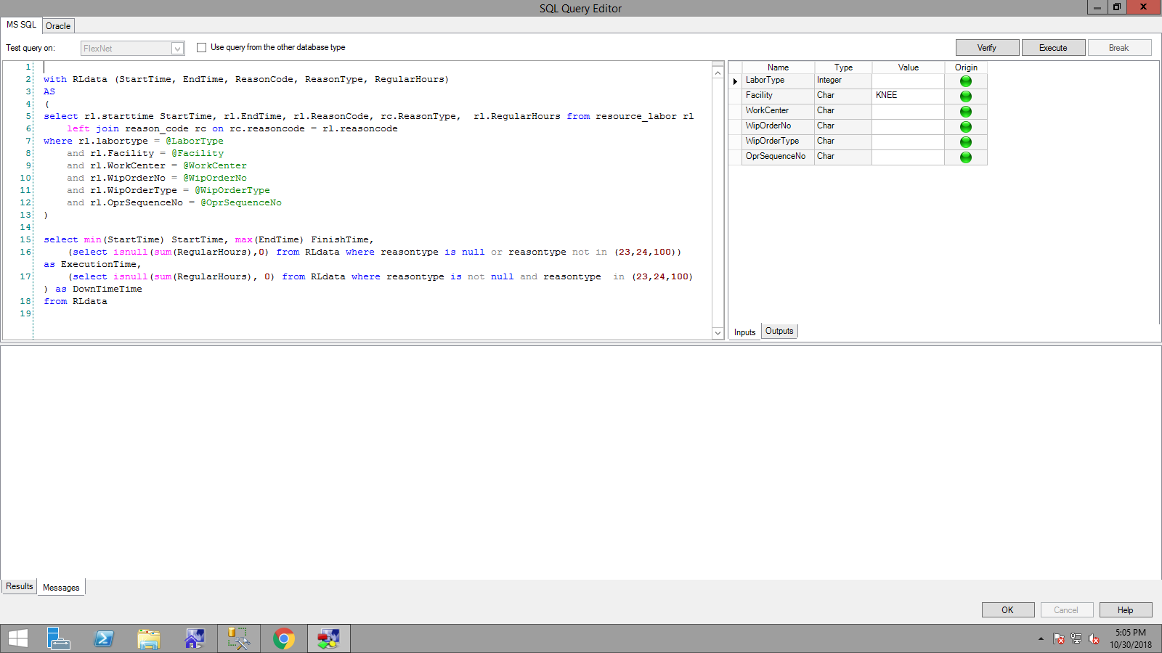

Call_k6_xmlwritetest < ExecutionTimeLabor < GetOperationExecutionTimeWithLabor

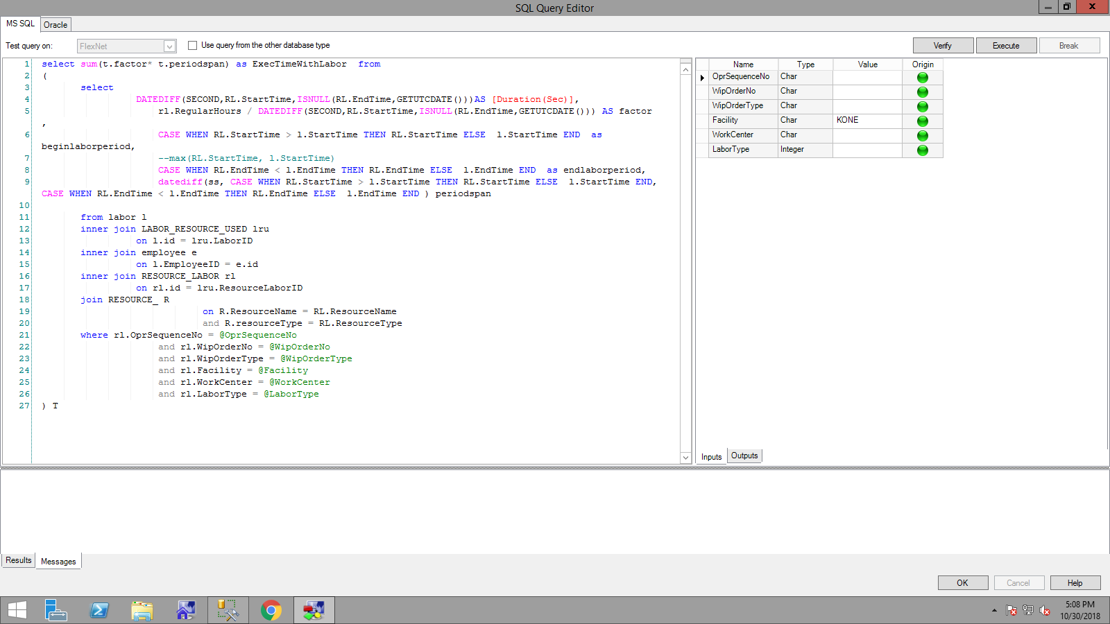

Part 2: Wrong entry of EndTime in RESOURCE_LABOR.