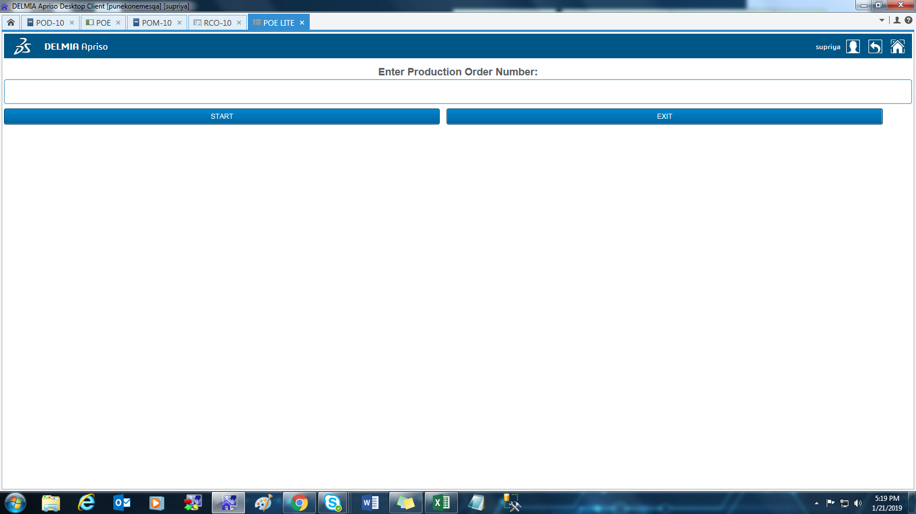

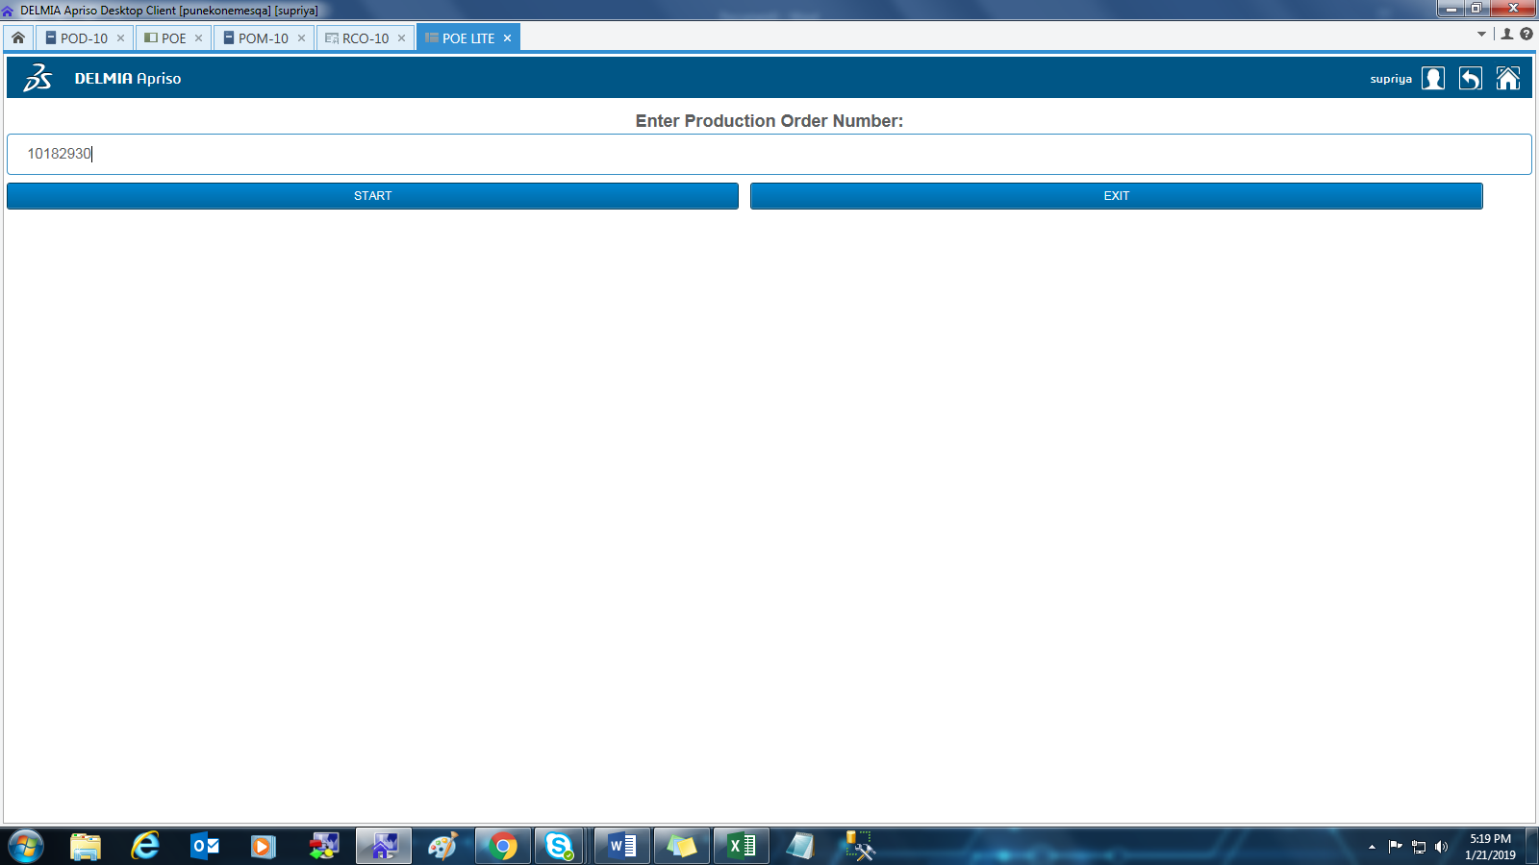

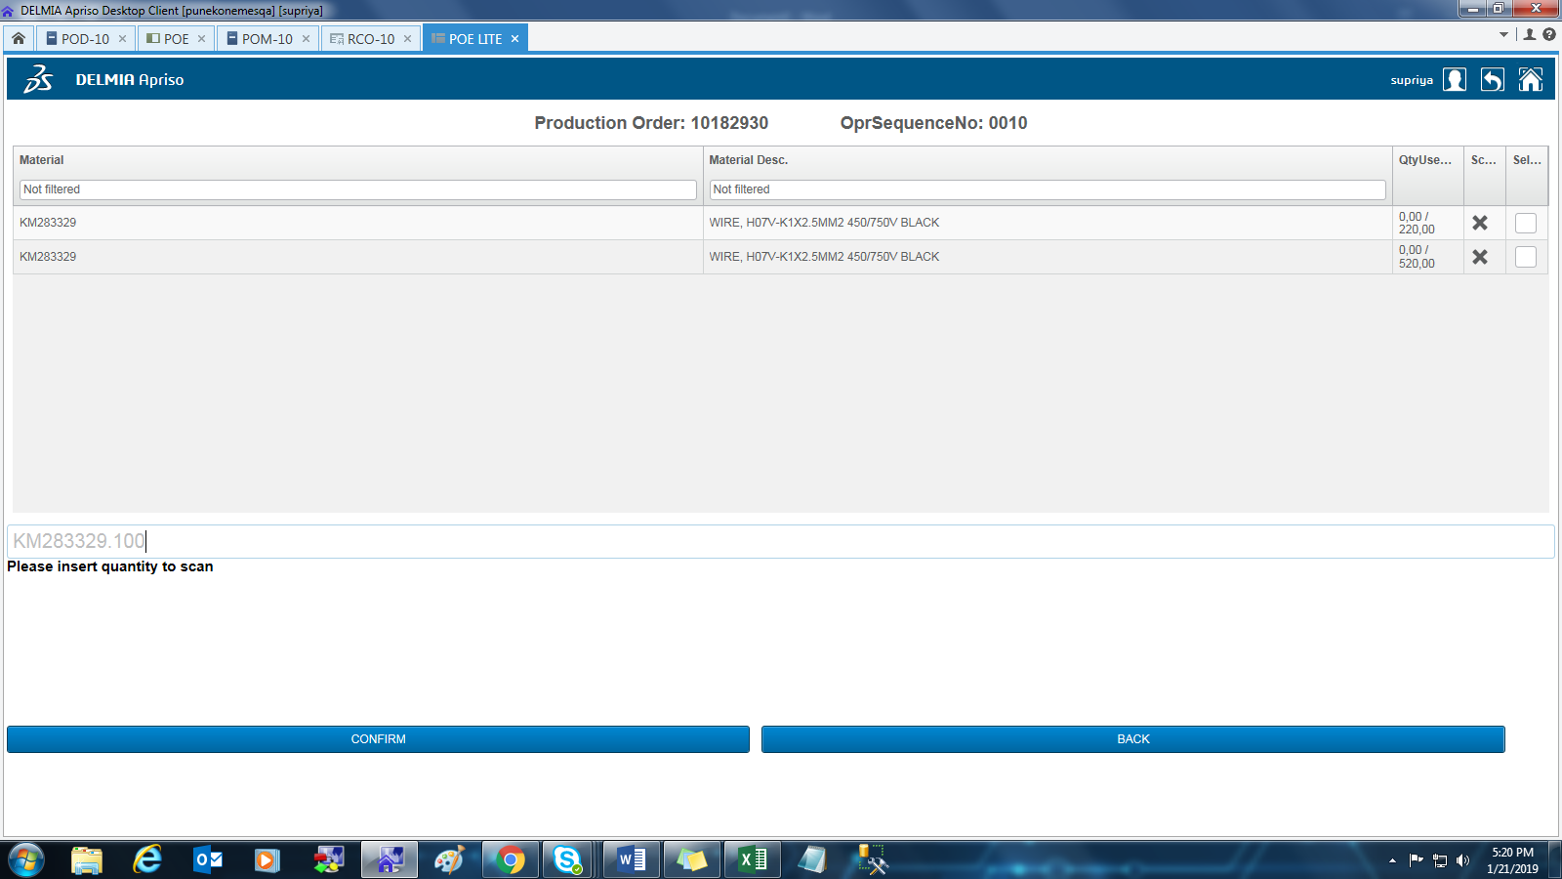

Click on confirm

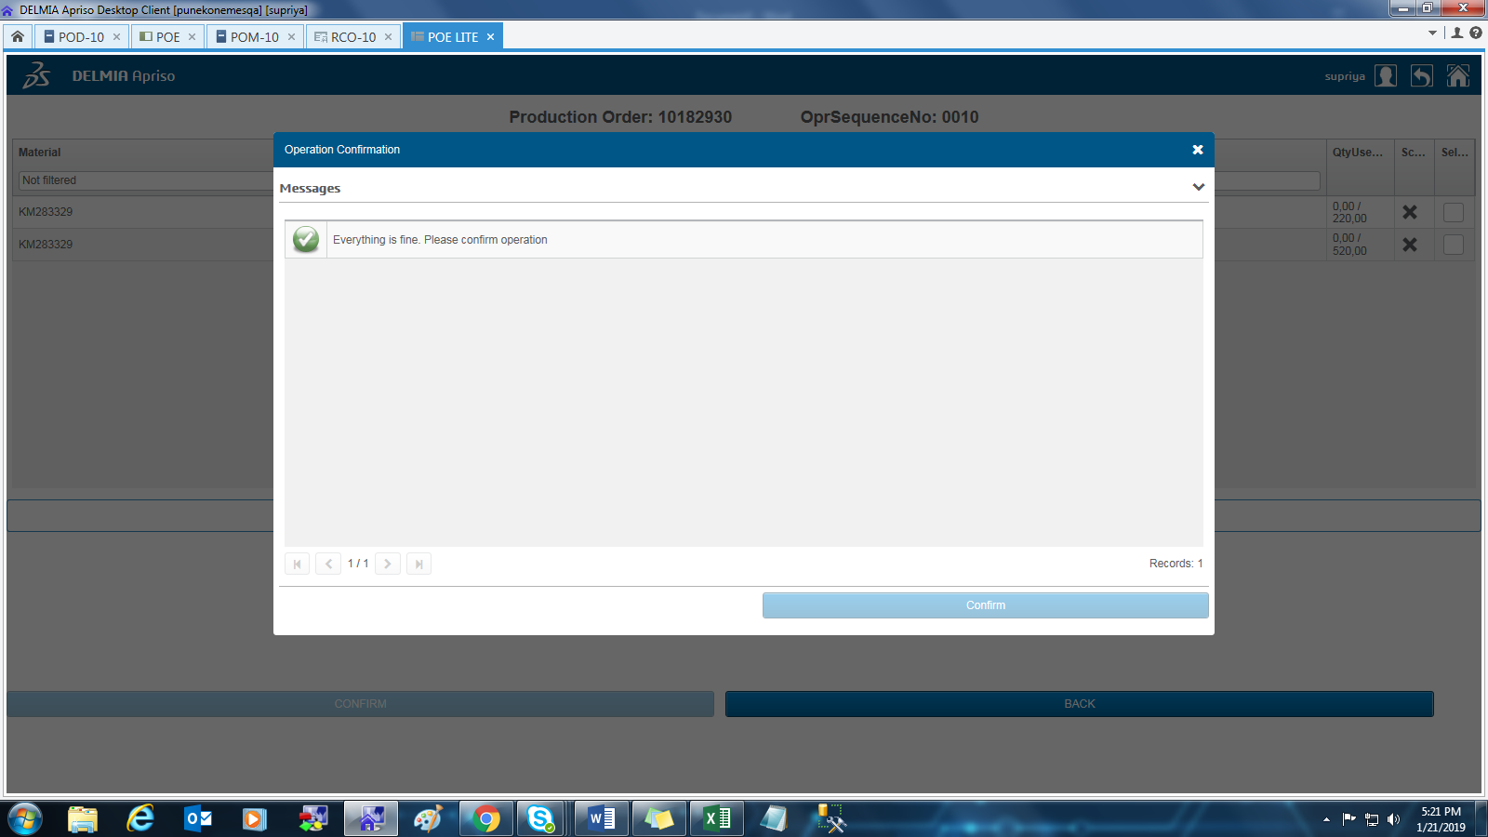



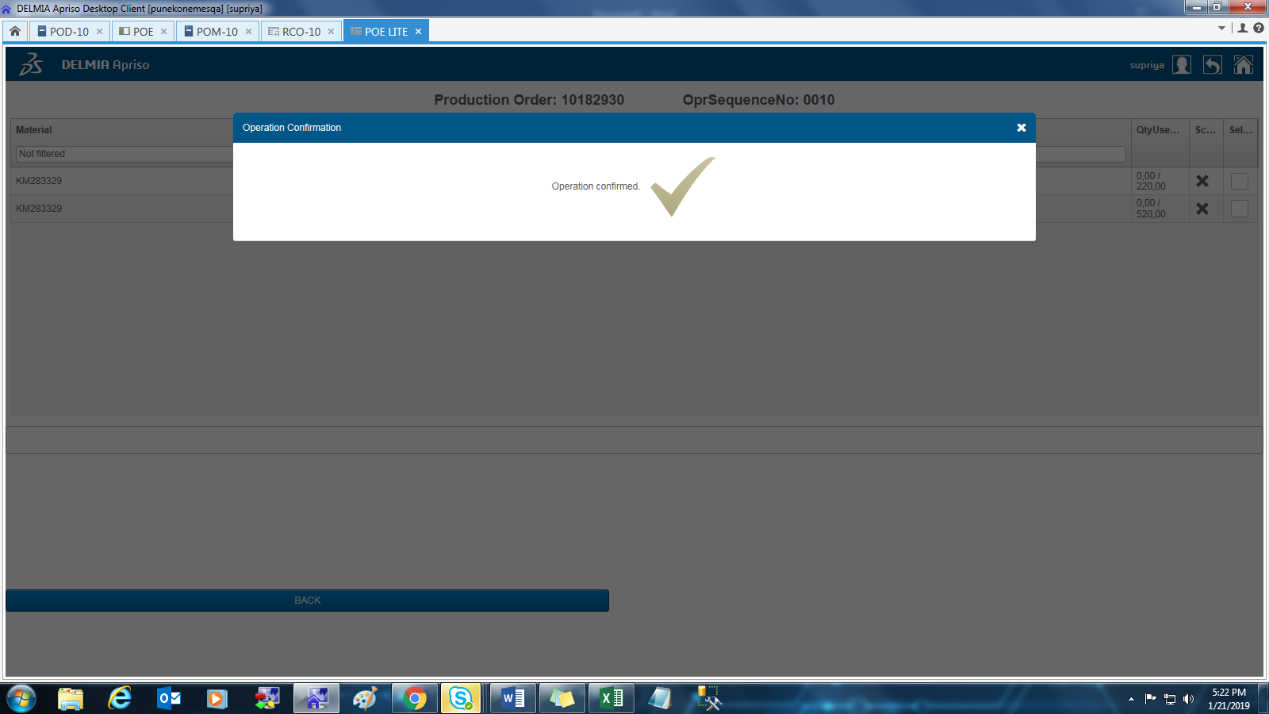

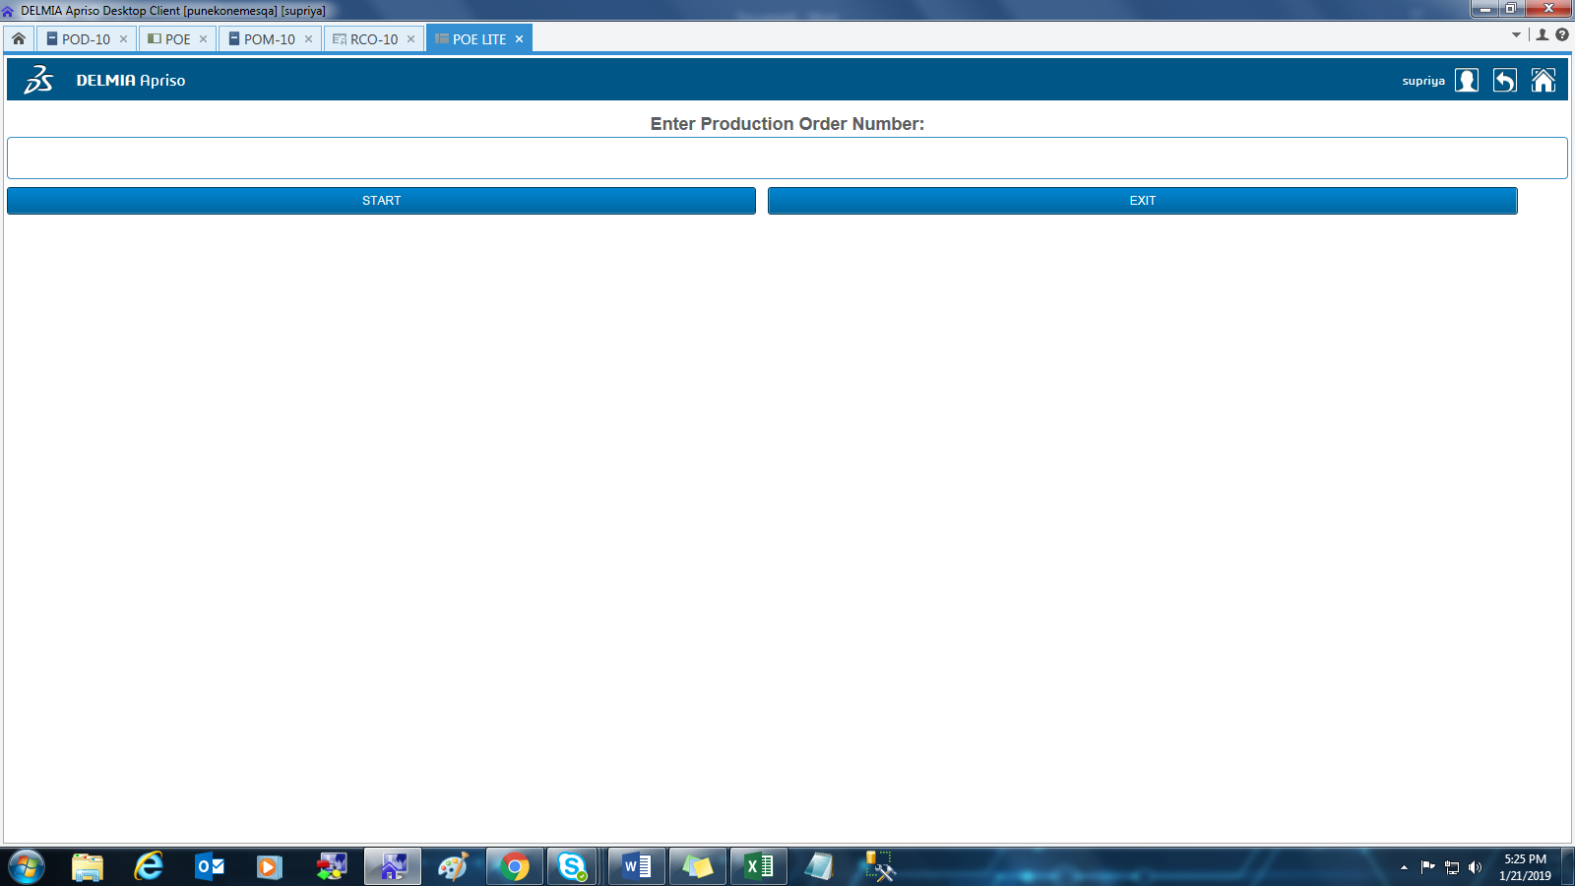

POE

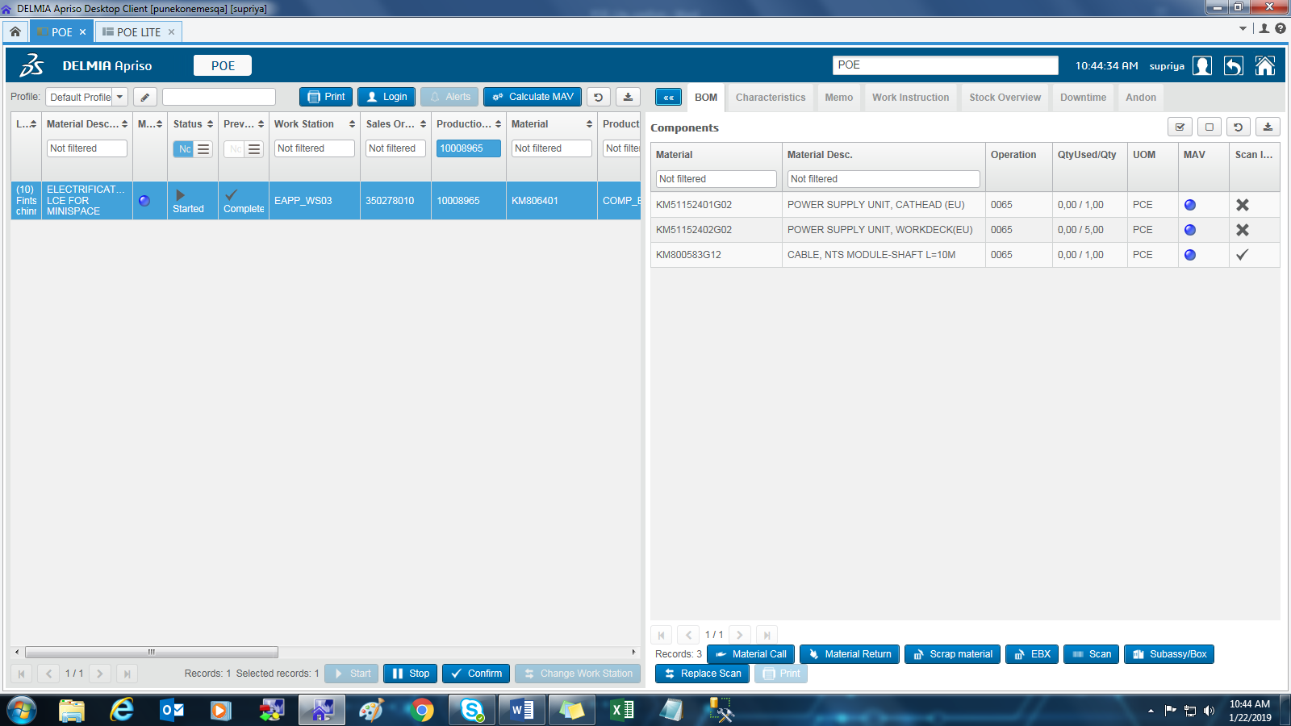

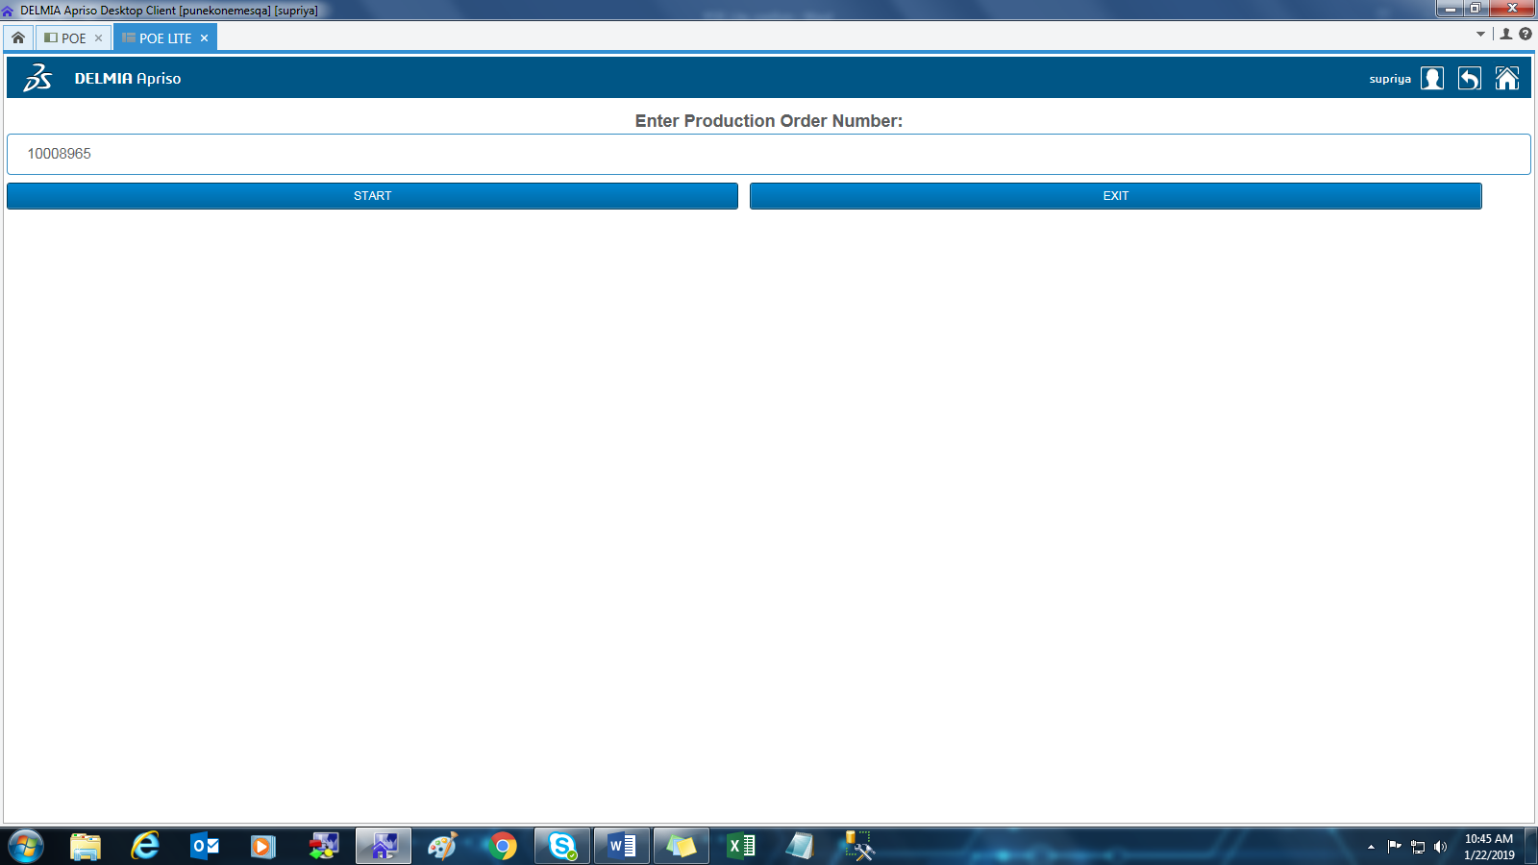

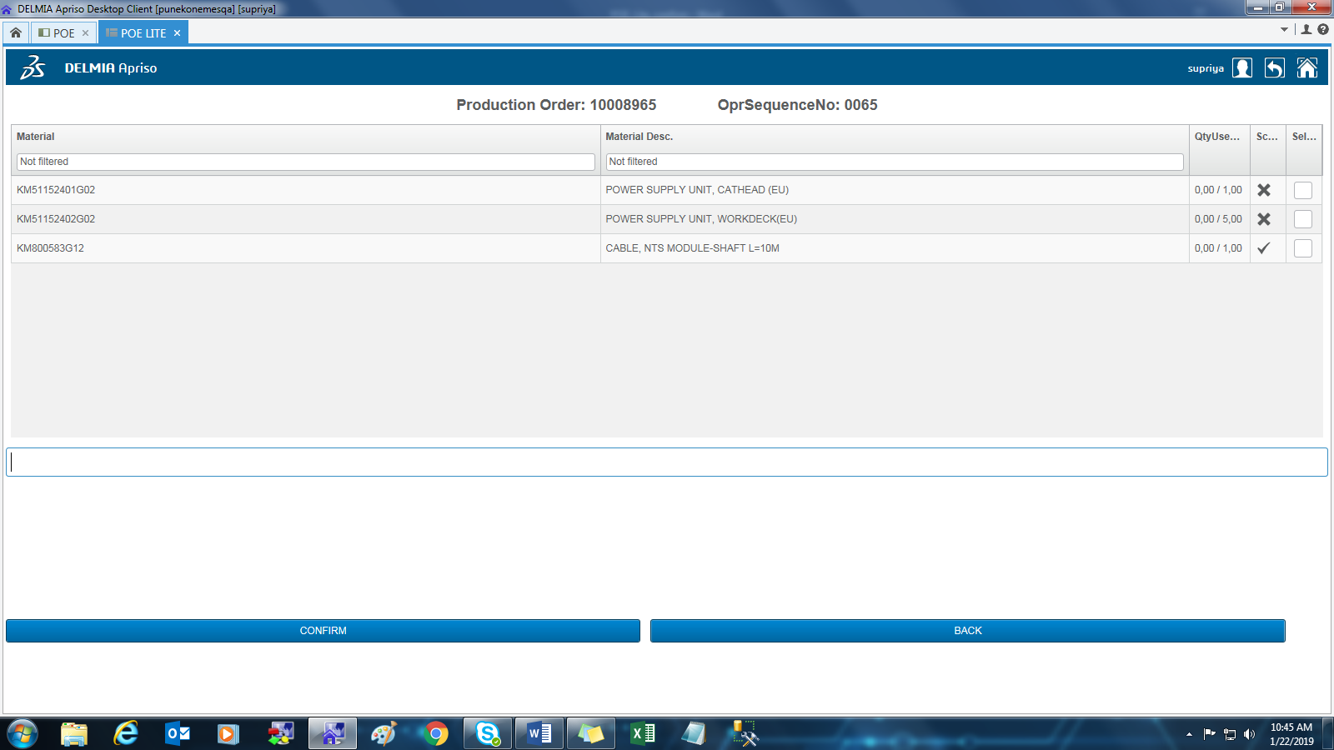

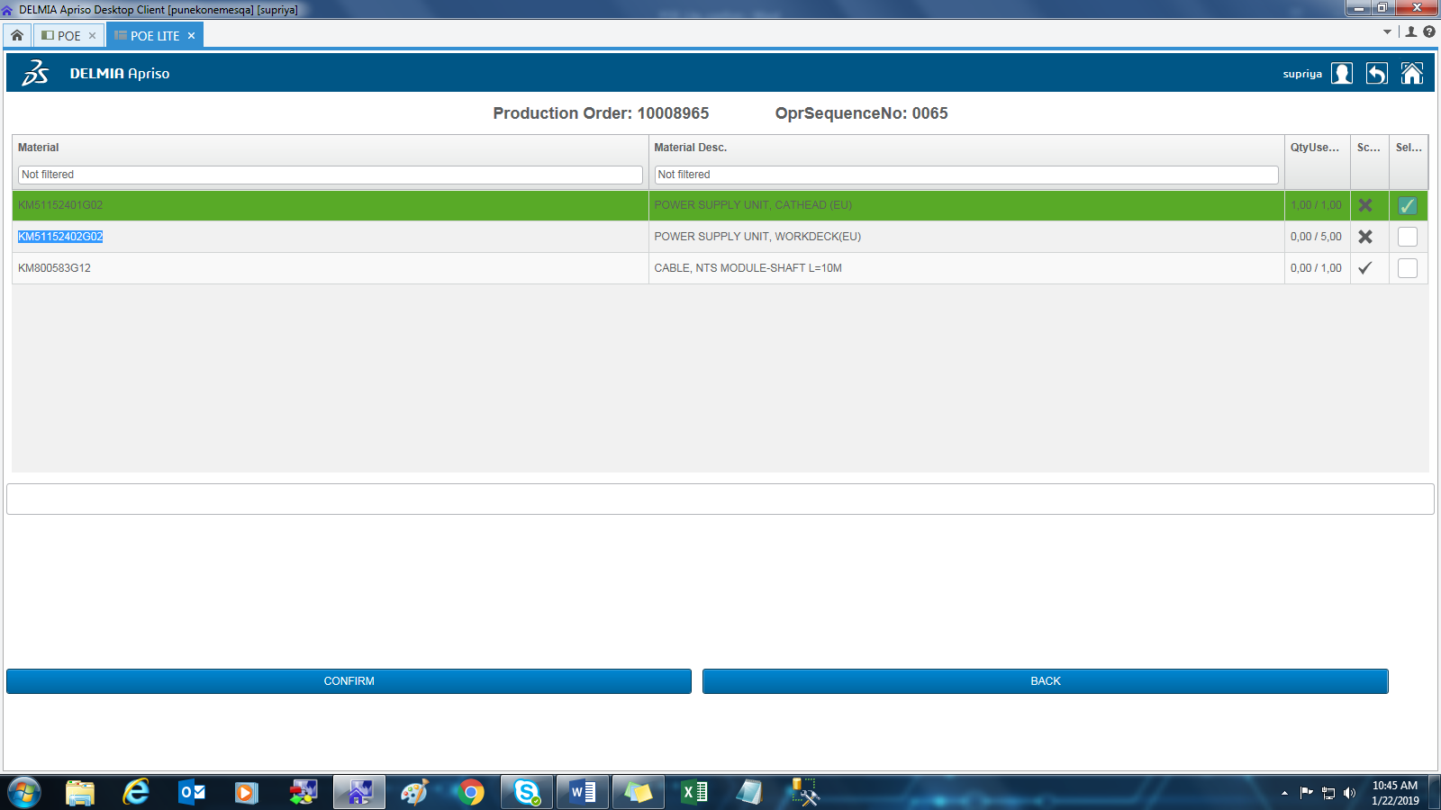

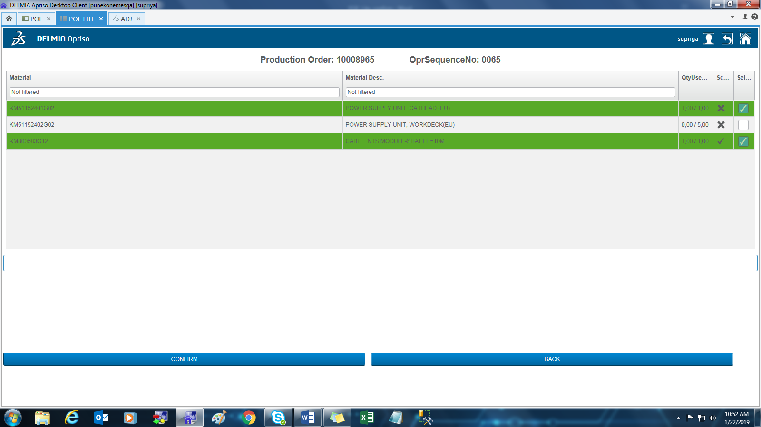

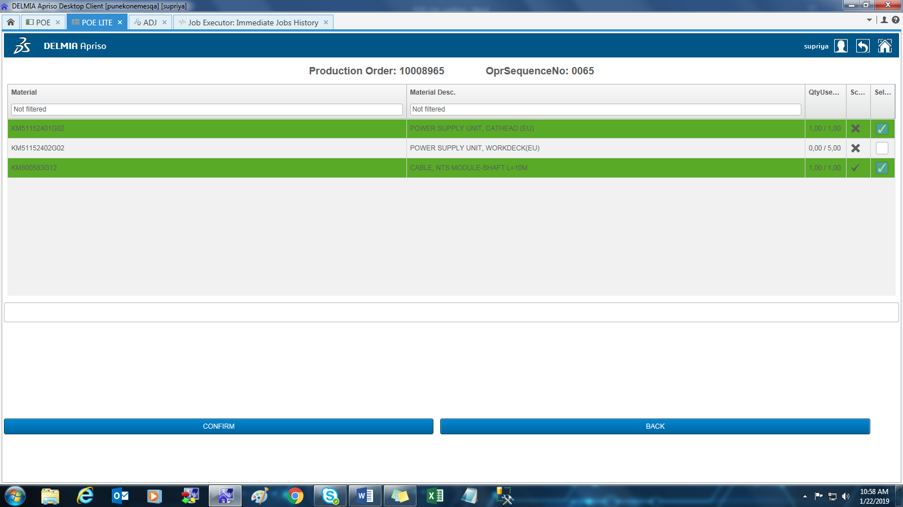

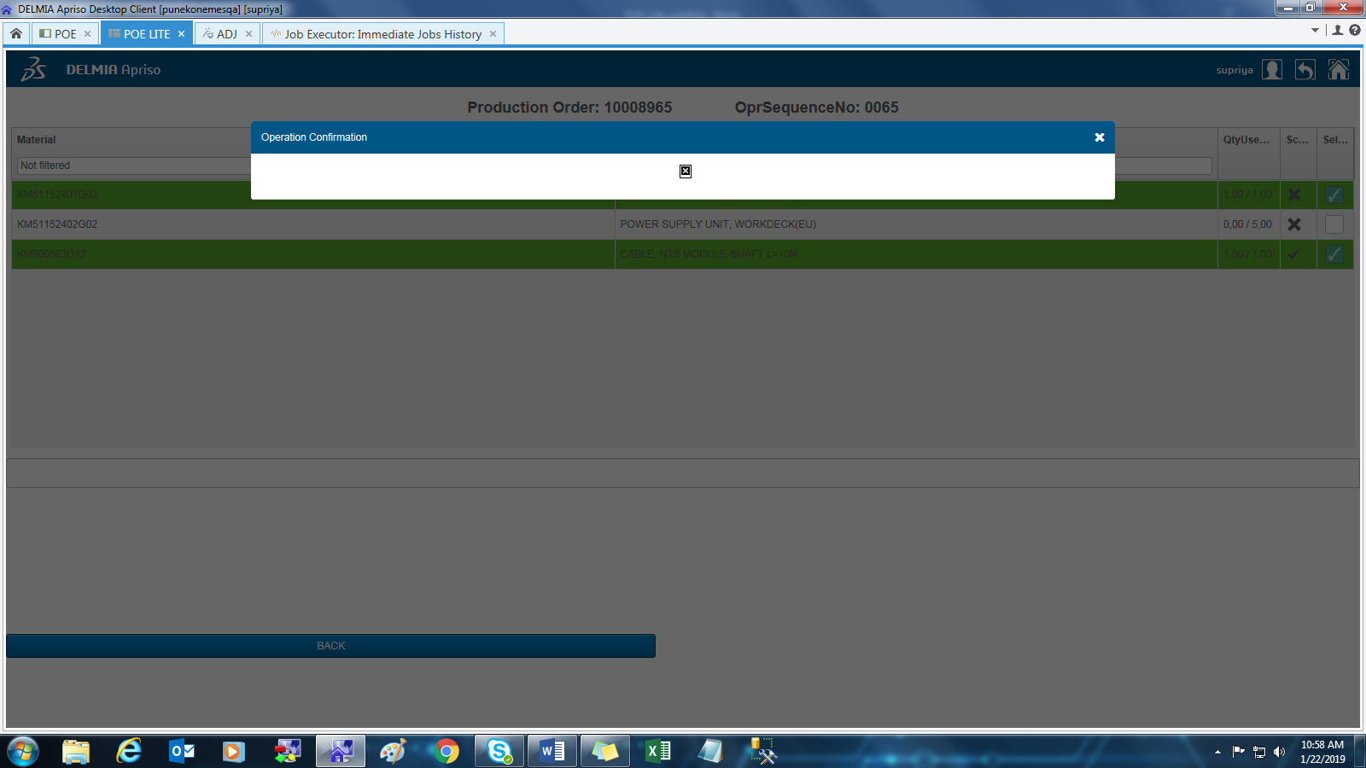

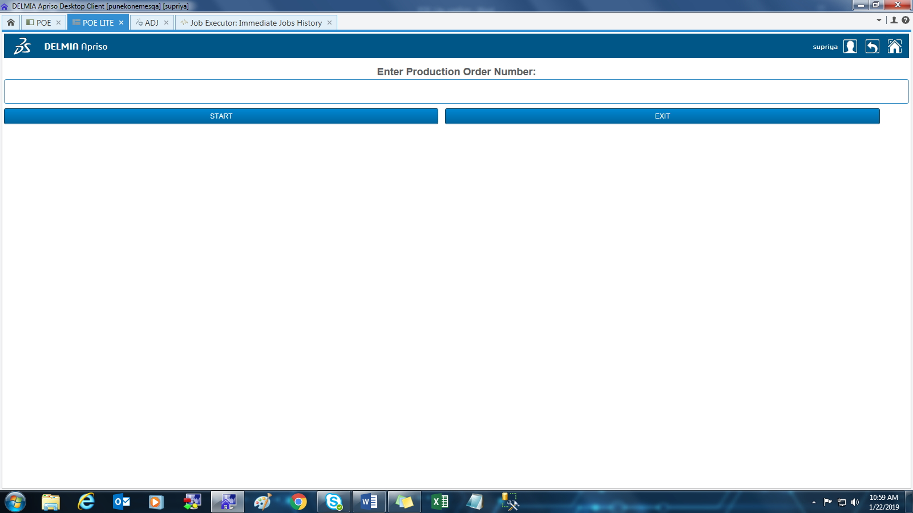

<?xml version="1.0" encoding="utf-8"?>

<ProdConf xmlns="http://www.Apriso.com/ProdConf.xsd" xmlns:xsd="http://www.w3.org/2001/XMLSchema">

<SessionContext>

<EmployeeID>100001260</EmployeeID>

<EmployeeNo>24329</EmployeeNo>

<TransactionTime>2019-01-22T05:29:12.5362983</TransactionTime>

<Facility>KNEE</Facility>

<Department />

<OperationID>100002496</OperationID>

<OperationRevision>K1X.PH1.1.002</OperationRevision>

<StepSequenceNo>1</StepSequenceNo>

<FunctionName>WriteXML</FunctionName>

<TransactionGUID>T301957</TransactionGUID>

<EquipmentID>0</EquipmentID>

<FunctionID>100092814</FunctionID>

<OperationCode>ProdConfirmation.SAP.WriteXml_Process</OperationCode>

<OprSequenceNo />

<LocalTransactionTime>2019-01-22T07:29:12.6654007</LocalTransactionTime>

<PartnerInfo>

<RCVPOR>SAPC64</RCVPOR>

<SNDPRN>FLEXNET</SNDPRN>

<RCVPRN>SAPLOG</RCVPRN>

<RCVPRT>LS</RCVPRT>

<SNDPOR>A000000022</SNDPOR>

<SNDPRT>LS</SNDPRT>

<CLNT>100</CLNT>

</PartnerInfo>

<PropertyBagV2>

<Item Name="PostingDate">

<ValueList>

<Value>20190122</Value>

</ValueList>

</Item>

<Item Name="PostingTime">

<ValueList>

<Value>072912</Value>

</ValueList>

</Item>

</PropertyBagV2>

</SessionContext>

<Message>

<Header>

<ProdConfMessageID>4f226b24-03a6-42cb-9918-d53eb165c4f5</ProdConfMessageID>

<Plant>KNEE</Plant>

<ProductionNo>10008965</ProductionNo>

<OperationConfirmationNo>0794958522</OperationConfirmationNo>

<OperationNo>0065</OperationNo>

<FinalConf>X</FinalConf>

<ClearRes>X</ClearRes>

<WorkCenter>KNE1EAPP</WorkCenter>

<StartDate>20181105</StartDate>

<StartTime>152955</StartTime>

<FinishDate>20190122</FinishDate>

<FinishTime>072904</FinishTime>

<TimeSpanUnit>MIN</TimeSpanUnit>

<ExecutionTimeSimple>111839</ExecutionTimeSimple>

<ExecutionTimeLabor>536539</ExecutionTimeLabor>

<TotalDownTime>0</TotalDownTime>

<DownTimes />

<Components>

<Component>

<ProductNo>KM51152401G02</ProductNo>

<UOM>PCE</UOM>

<Quantity>1</Quantity>

<StorageLocation>1100</StorageLocation>

<MoveType>261</MoveType>

<SpecialStock>E</SpecialStock>

<SalesOrder>350278010</SalesOrder>

<SalesOrderItem>61</SalesOrderItem>

<ReservationNo>0331767360</ReservationNo>

<ReservationItem>56</ReservationItem>

</Component>

<Component>

<ProductNo>KM800583G12</ProductNo>

<UOM>PCE</UOM>

<Quantity>1</Quantity>

<StorageLocation>1100</StorageLocation>

<MoveType>261</MoveType>

<SpecialStock>E</SpecialStock>

<SalesOrder>350278010</SalesOrder>

<SalesOrderItem>61</SalesOrderItem>

<ReservationNo>0331767360</ReservationNo>

<ReservationItem>64</ReservationItem>

</Component>

</Components>

</Header>

</Message>

</ProdConf>

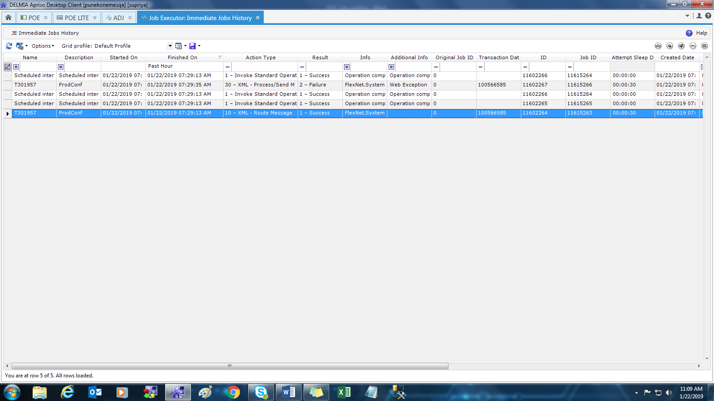

Try to confirm same from POE

