Glossary

|  |  |
| --- | --- |
| Server – Hyvinkaa UAT (003) | Sales Order No – 350195116 |
| Screens – POE, IVL, REX, BOM | Production Order No – 6467988 |
|  | Operation Sequence No – 0030 |
|  | TO No – TONHE00728 |
|  | Material Code – KM829311G12 |
|  | LU No – LUNE10001015 |

Plan

1. Find an order number with a bounded material.
2. Create a TO for replenishment of that material.
3. Find the material in inventory.
4. Pick a LU with that material having order bound.
5. Start replenishment with that LU.
6. Consume more than the order bound quantity of that material.
7. Check TO status.

Execution

1. Order selected. 350195116
   1. Operation selected.
   2. Work station changed.
   3. Operation started.

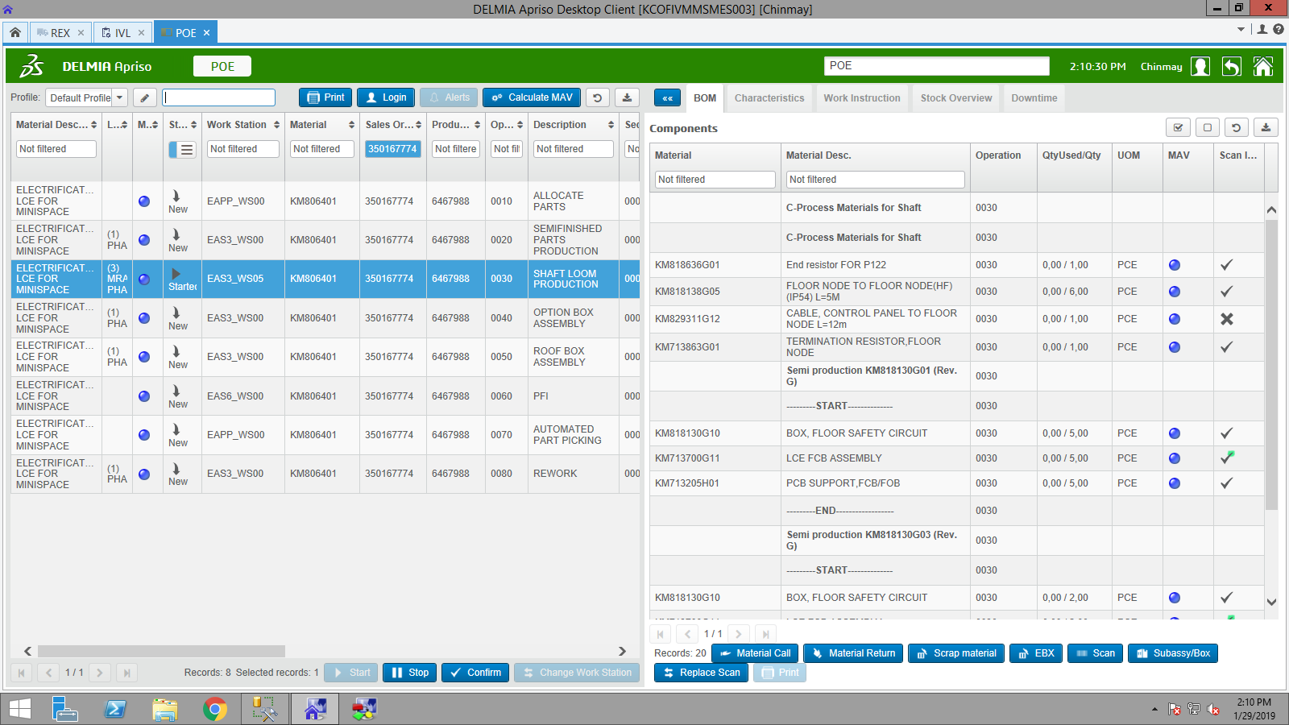

1. Material selected. KM829311G12
2. Searched in IVL for existing LU.

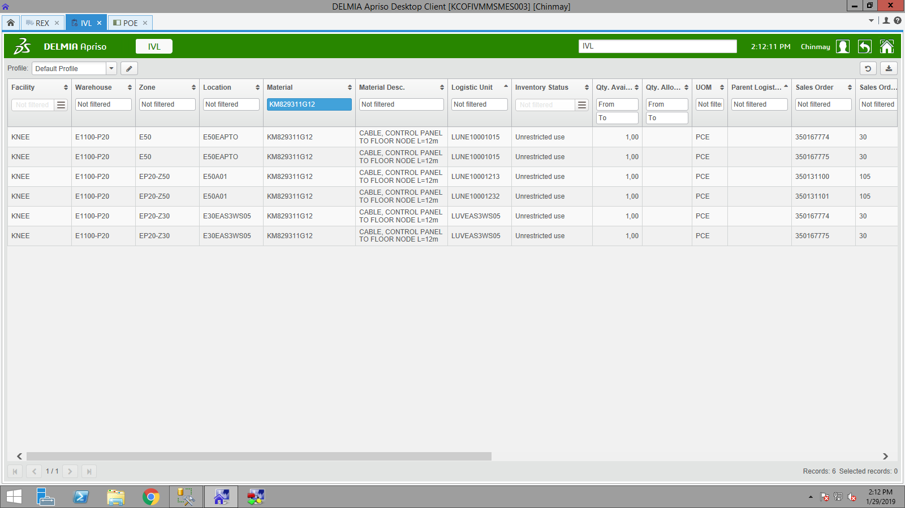

1. LU selected. LUNE10001015

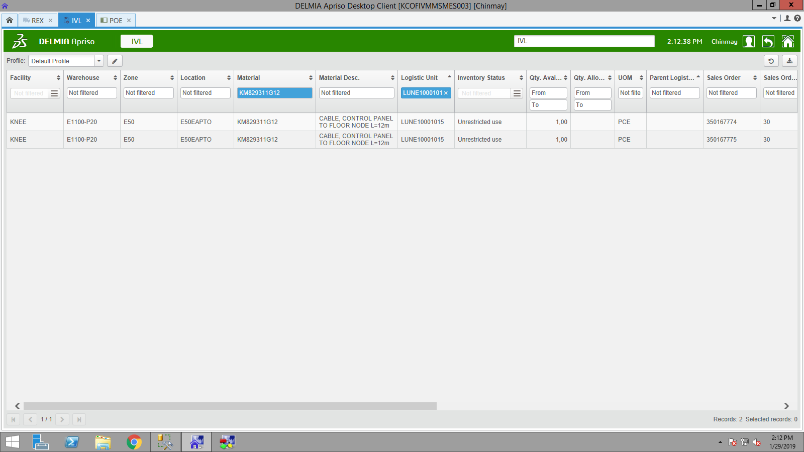

1. TO was created in POE. TONHE00728

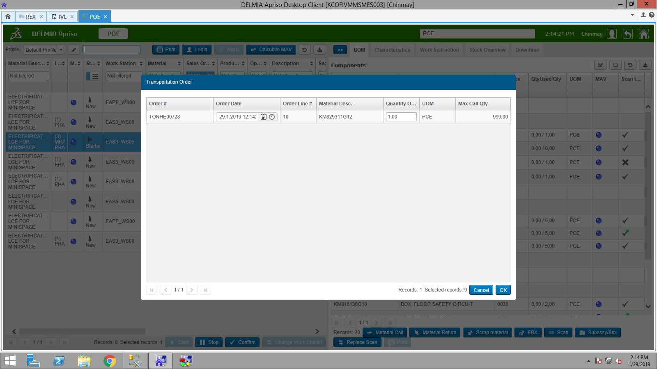

1. Replenishment started.

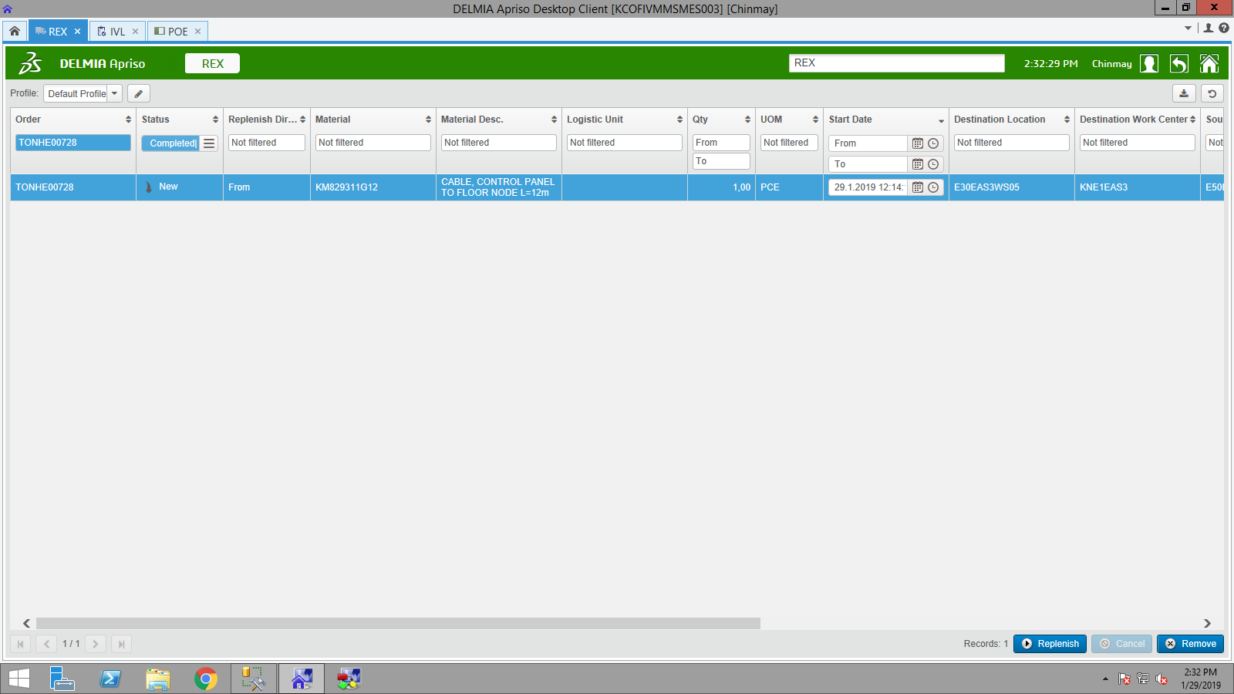

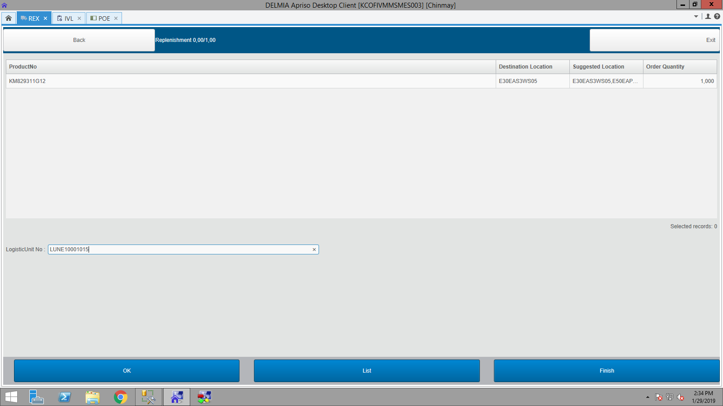

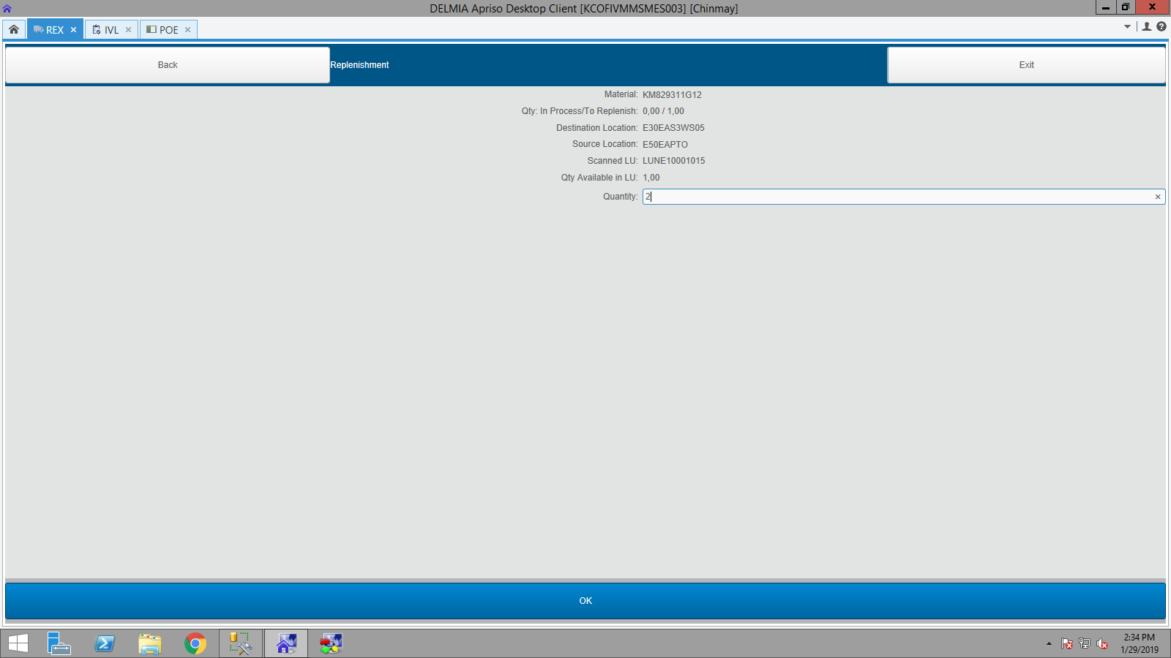

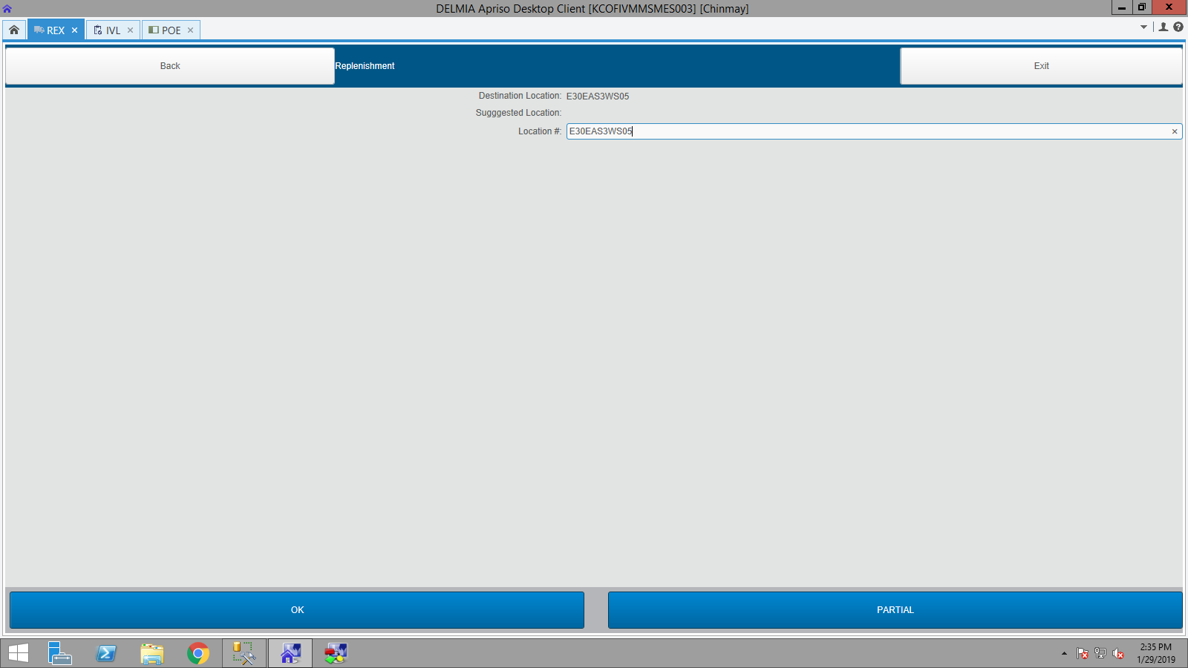

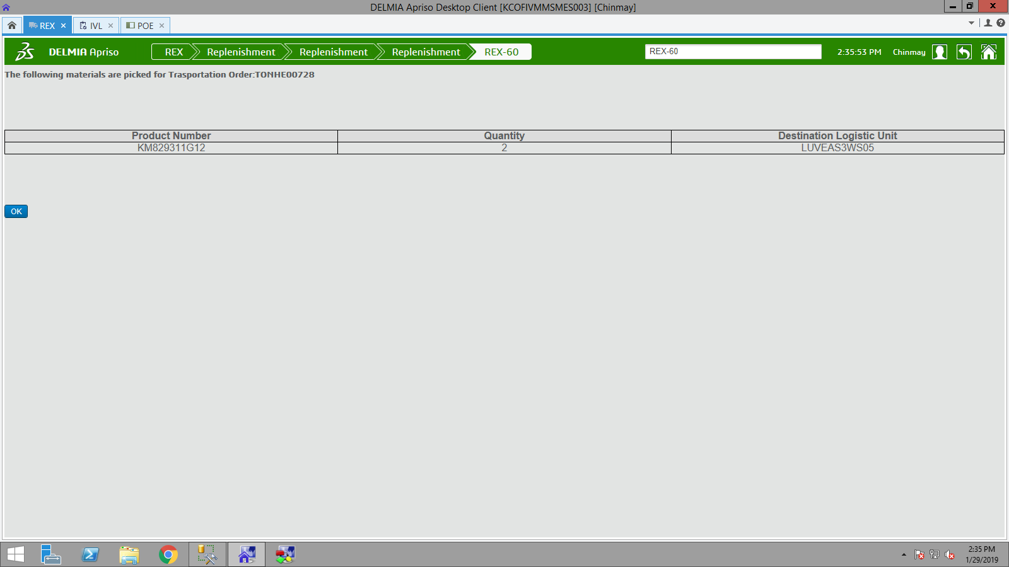

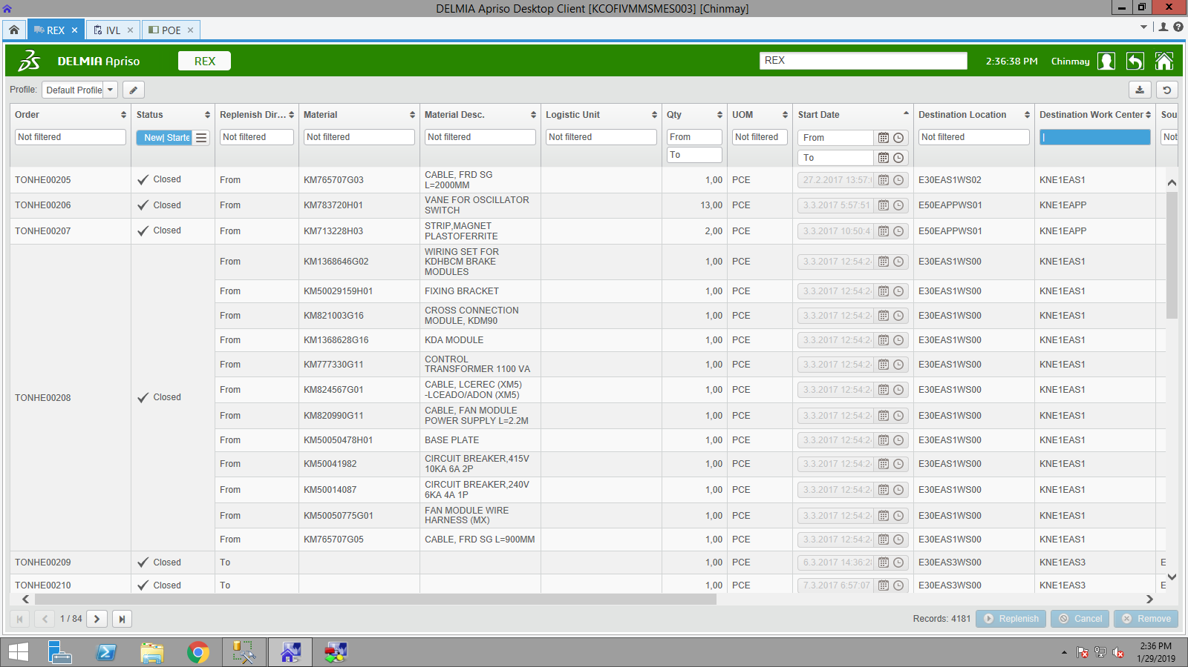

Result

* Case successfully reproduced.
* Bug found: no validation for order bound materials.