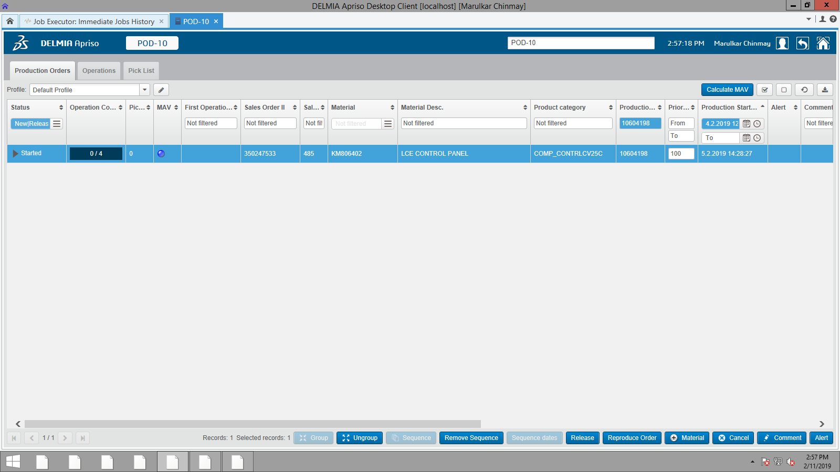

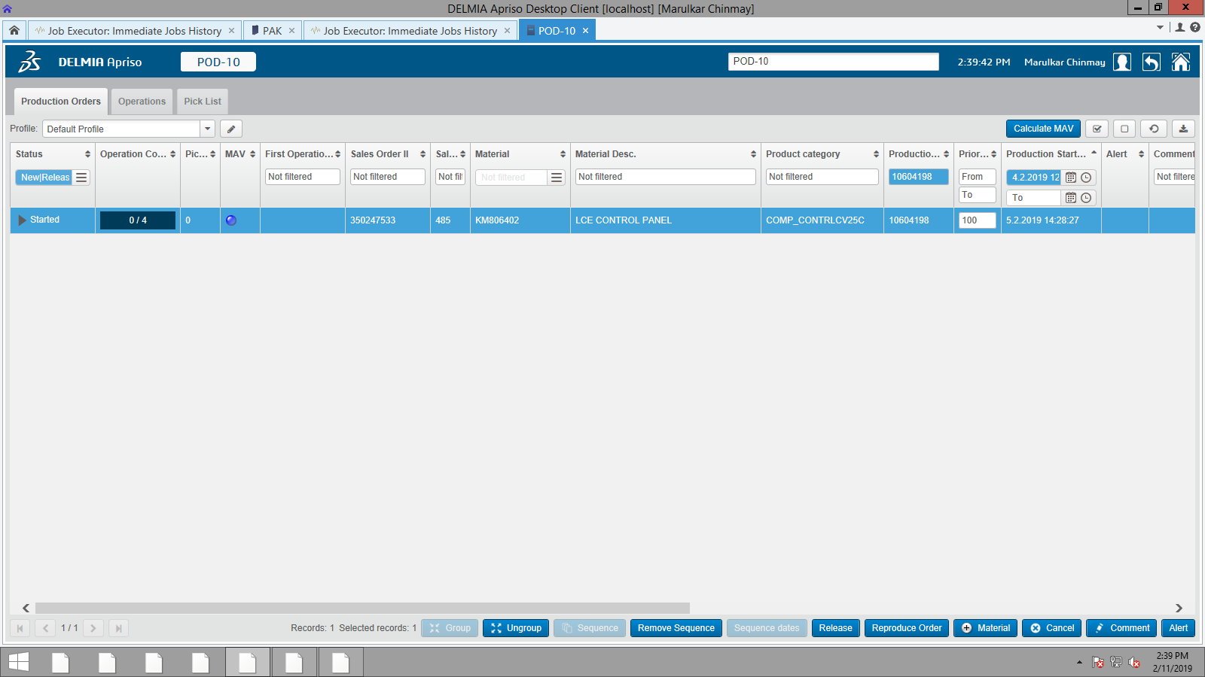

Production Order No – 10604198

<AUFNR>10604198</AUFNR>

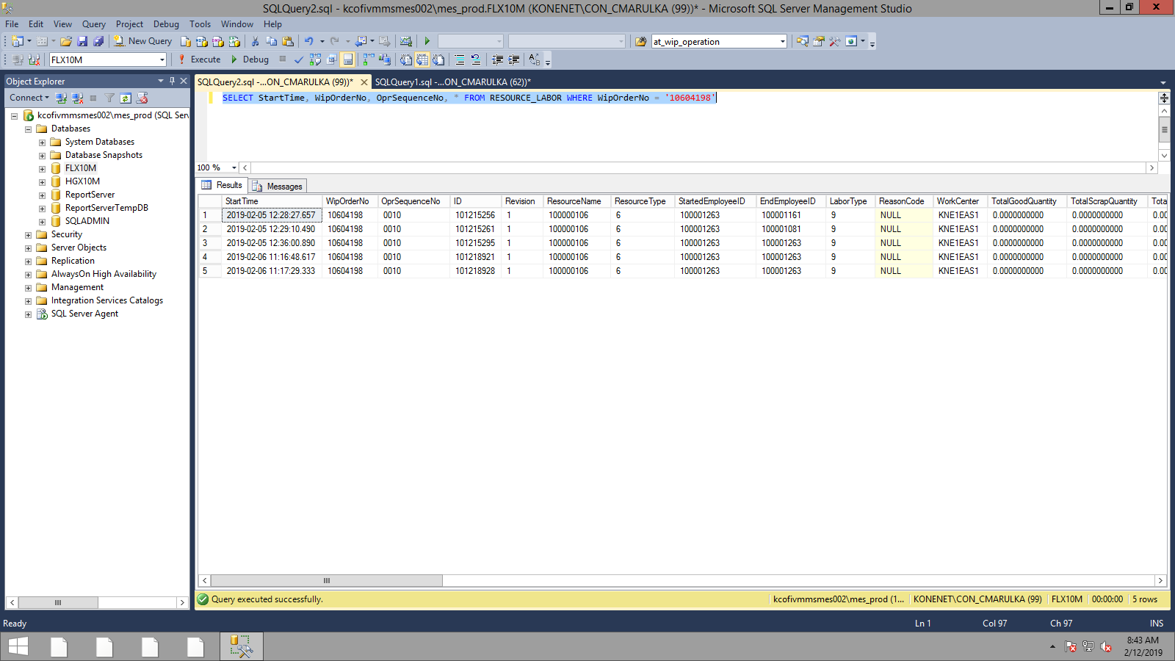

QA Reproduction

ID in IJH – 11602880

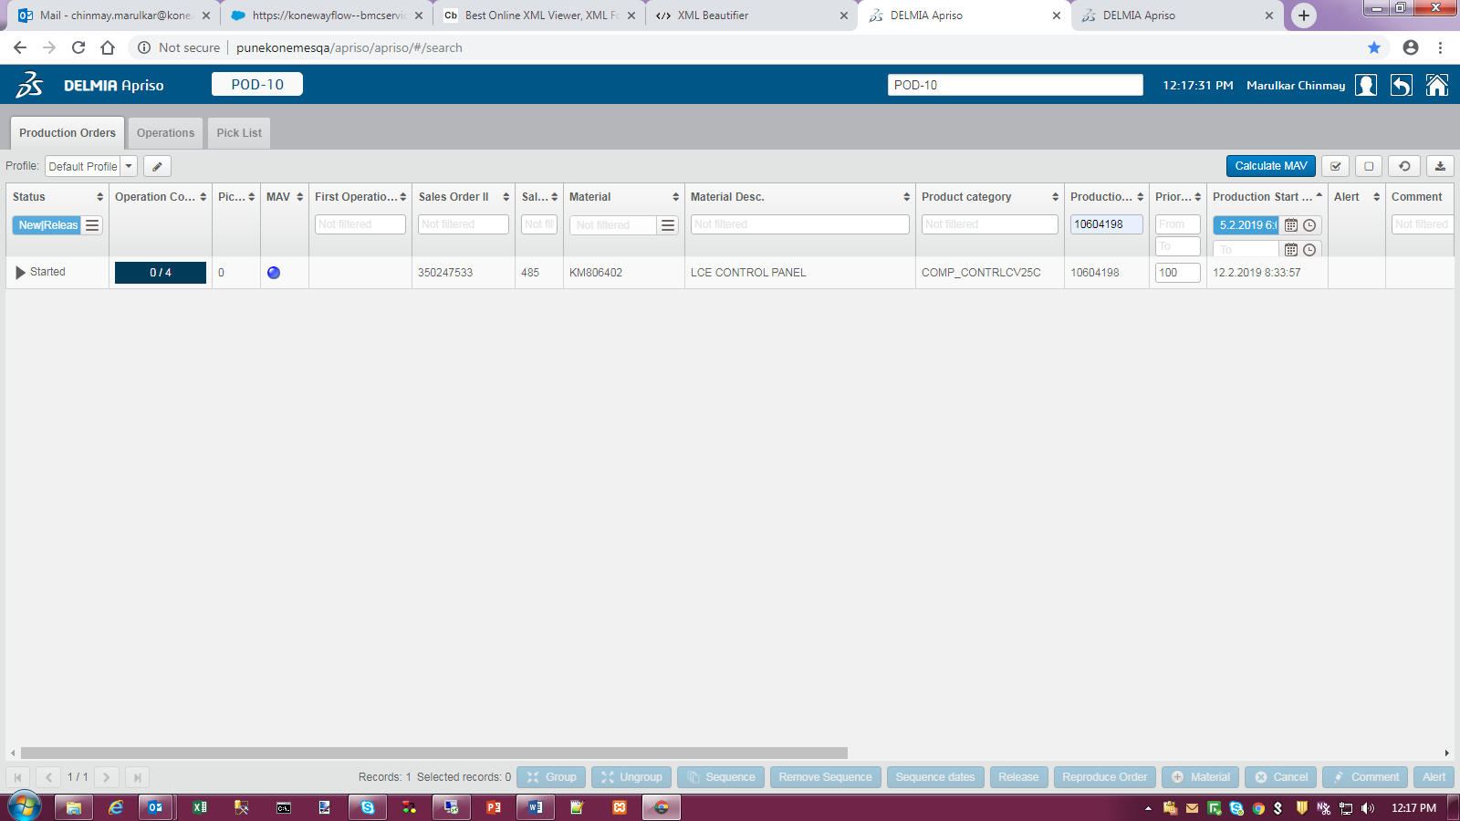

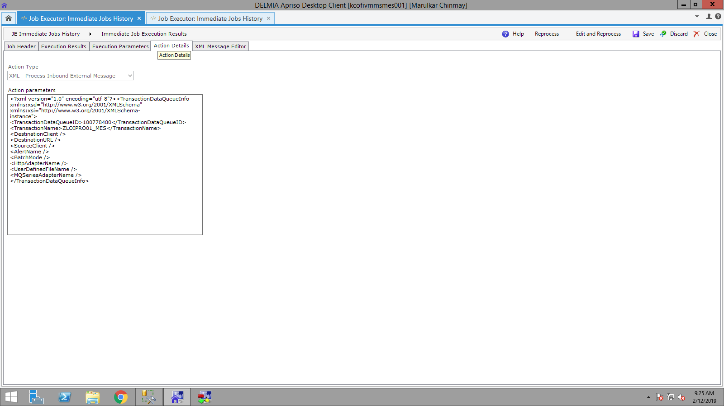

<?xml version="1.0" encoding="utf-8"?><TransactionDataQueueInfo xmlns:xsd="http://www.w3.org/2001/XMLSchema" xmlns:xsi="http://www.w3.org/2001/XMLSchema-instance">

<TransactionDataQueueID>100778480</TransactionDataQueueID>

<TransactionName>ZLOIPRO01_MES</TransactionName>

<DestinationClient />

<DestinationURL />

<SourceClient />

<AlertName />

<BatchMode />

<HttpAdapterName />

<UserDefinedFileName />

<MQSeriesAdapterName />

</TransactionDataQueueInfo>

