

Submitted to



April 19, 2019





**Digitaligence@work**

Submitted by:

**ITC Infotech**

6th Floor, B2 Wing, Cerebrum IT Park, Marigold Complex, Kalyani Nagar, Pune - 411014

**ITC INFOTECH (www.itcinfotech.com)**

**Trademark Acknowledgement**

©2017 ITC INFOTECH

All products or brand names used in this document are trademarks or registered trademarks of their respective companies. The information in this document is subject to change without notice.

ITC Infotech shall not be liable for errors contained herein, or for consequential damages in connection with the furnishing, performance or use of the material. No part of this document may be reproduced or transmitted in any form or by any means, for any purpose, or translated to another language without the prior written consent of ITC Infotech.

**Confidentiality Statement**

By accepting this document the recipient agrees:

* To keep permanently confidential all information which it contains
* To treat and retain as secret and confidential all information contained in this document or otherwise acquired by the receiving party from ITC including, without prejudice to the generality of the foregoing, all handbooks, manuals, drawings, designs, specifications, charts, diagrams, tapes, disks, diskettes and any other documents or materials containing such information

This may not be construed as legally valid and binding agreement between ITC and the recipient of this document. If accepted, agreement will be formalized incorporating mutually agreed terms and conditions

**Document Control**

**Document History**

|  |  |  |  |
| --- | --- | --- | --- |
| **Issue** | **Date** | **Maintainer/Owner** | **Description** |
| 1.0 | 19-Apr-19 | Abinash Mishra | Original Document |

**People Involved in Preparation and Review of the Document**

|  |  |
| --- | --- |
| **Name** | **Role** |
|  |  |
|  |  |
|  |  |
|  |  |

**Contact Information**

|  |
| --- |
| **Contact Person** |
| **Name: Abinash Mishra**  Associate IT Consultant  Email: abinash.mishra@itcinfotech.com  Phone: +91 88 952 94063 |

Business Requirement:

To have a new functionality of **starting** and **confirming** multiple Production Order Items in POE screen.

Feasibility Study:

Not feasible to update existing POE screen for adding these new functionalities.

Proposed Option – Building a screen from scratch with these features named **POE_M**.

Basic Screen Layout:

1. Header
2. Grid Definition Buttons –
   1. Profile
   2. Login – LOG screen
   3. Alert
   4. Calculate MAV
3. POE Grid
   1. Columns – [see Annexure 1]
   2. Buttons –
      1. Refresh
      2. Export
      3. Select All
      4. Deselect All
   3. Paging – Enabled
4. Operational Buttons –
   1. Start
   2. Stop (tentative)
   3. Confirm

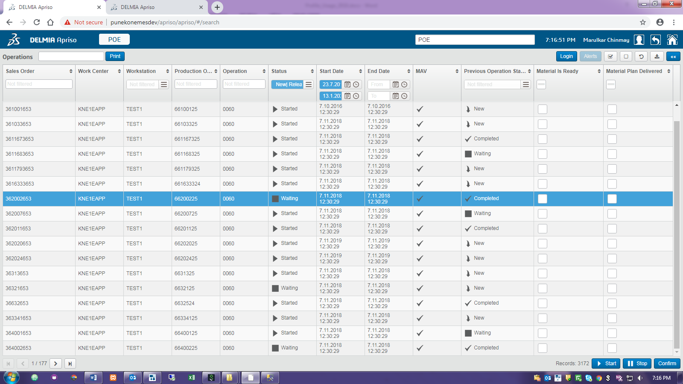

Configurable Parameters:

These variables can be configured to optimise usability and performance.

1. Max Load – maximum selection of operation sequence possible to start or stop at once.
2. POE Grid columns – available columns in POE Grid for visibility. [Table joins impact performance]

Functional Working Principle:

1. Start:

Same as POE. Iteration principle for each order items rather updating DB at once.

1. Confirm:

Same as POE. Validation iteration and confirmation at once in DB.

