

Submitted to



April 9, 2019





**Digitaligence@work**

Submitted by:

**ITC Infotech**

6th Floor, B2 Wing, Cerebrum IT Park, Marigold Complex, Kalyani Nagar, Pune - 411014

**ITC INFOTECH (www.itcinfotech.com)**

**Trademark Acknowledgement**

©2017 ITC INFOTECH

All products or brand names used in this document are trademarks or registered trademarks of their respective companies. The information in this document is subject to change without notice.

ITC Infotech shall not be liable for errors contained herein, or for consequential damages in connection with the furnishing, performance or use of the material. No part of this document may be reproduced or transmitted in any form or by any means, for any purpose, or translated to another language without the prior written consent of ITC Infotech.

**Confidentiality Statement**

By accepting this document the recipient agrees:

* To keep permanently confidential all information which it contains
* To treat and retain as secret and confidential all information contained in this document or otherwise acquired by the receiving party from ITC including, without prejudice to the generality of the foregoing, all handbooks, manuals, drawings, designs, specifications, charts, diagrams, tapes, disks, diskettes and any other documents or materials containing such information

This may not be construed as legally valid and binding agreement between ITC and the recipient of this document. If accepted, agreement will be formalized incorporating mutually agreed terms and conditions.

**Document Control**

**Document History**

|  |  |  |  |
| --- | --- | --- | --- |
| **Issue** | **Date** | **Maintainer/Owner** | **Description** |
| 1.0 | 9-Apr-19 | Abinash Mishra | Original Document |

**People Involved in Preparation and Review of the Document**

|  |  |
| --- | --- |
| **Name** | **Role** |
|  |  |
|  |  |
|  |  |
|  |  |
|  |  |
|  |  |
|  |  |

**Contact Information**

|  |
| --- |
| **Contact Person** |
| **Name: Abinash Mishra**  Associate IT Consultant  Email: Abinash.mishra@itcinfotech.com  Phone: +91 88 952 94063 |

Business Requirement Summarization:

To have a report from MES database, containing information about the inventory that summarizes quantities per plant and per inventory status OR per storage locations(warehouse) and inventory status in one line in order to make more effective the inventory control work in materials management.

Requirement Document:



Proposed Solution:

A screen named IVL Report with 4 tabs for different types of reports:

1. Default Screen
2. Materials at Facility level (no warehouse selection)
3. Materials at single Warehouse
4. Materials at multiple Warehouses (not Combined)
5. Materials at multiple Warehouses (Combined)
6. Default Screen:

This will show all required columns gathered from Inventory Table without any particular cumulating of data. All other reports will be developed over this.

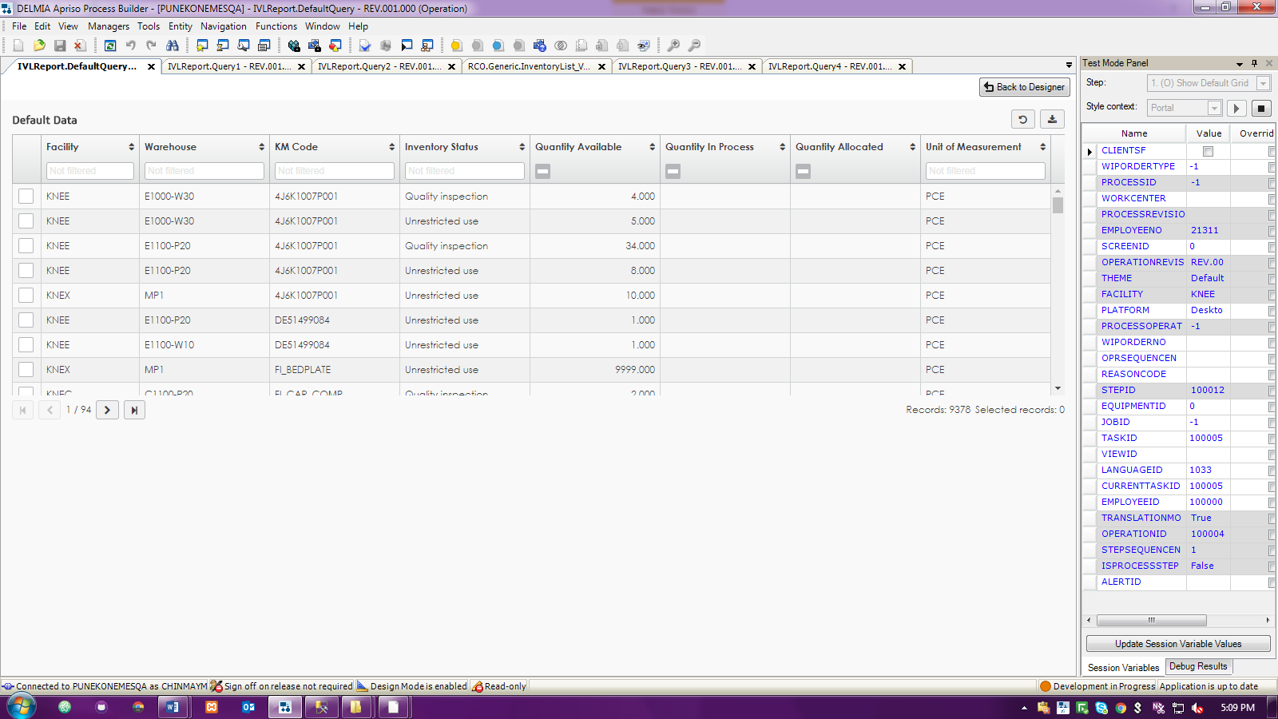

1. Materials at Facility level (no warehouse selection):

This will cumulate the materials throughout all warehouses in any particular plant. Also there will be a column call Total Quantity which will sum up Quantity Available, Quantity in Process and Quantity Allocated.

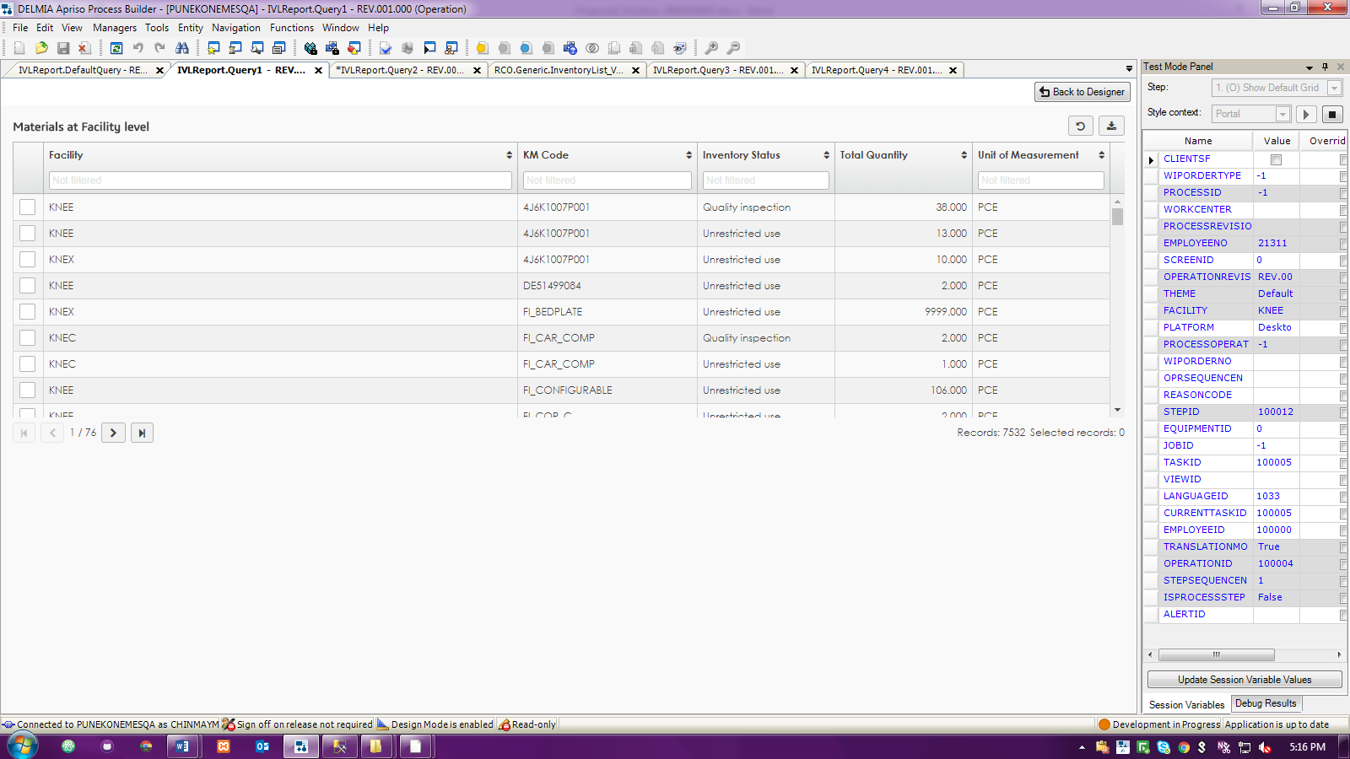

1. Materials at single Warehouse

This will cumulate the materials in a user selected single warehouse.

1. Step 1: User selects the warehouse

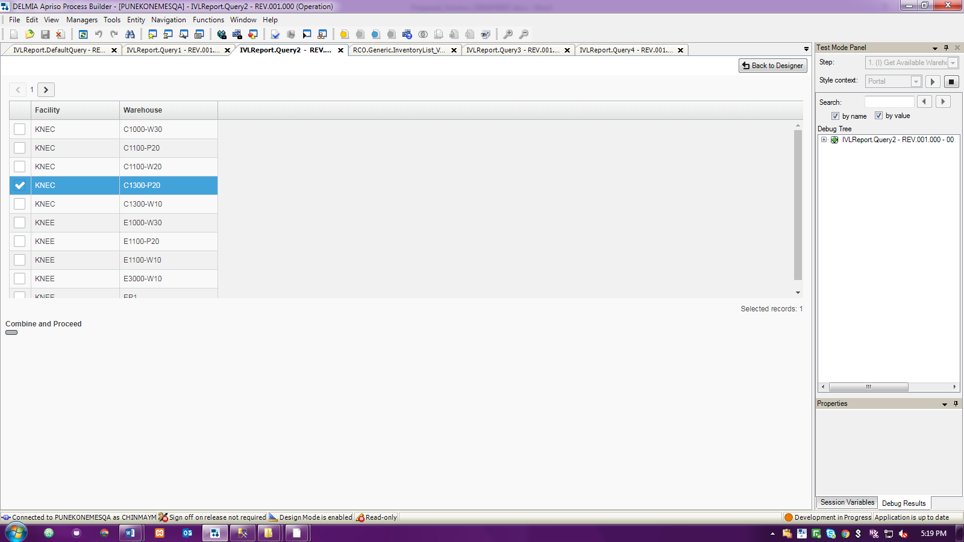

1. Step 2: Cumulative report for that warehouse is visible

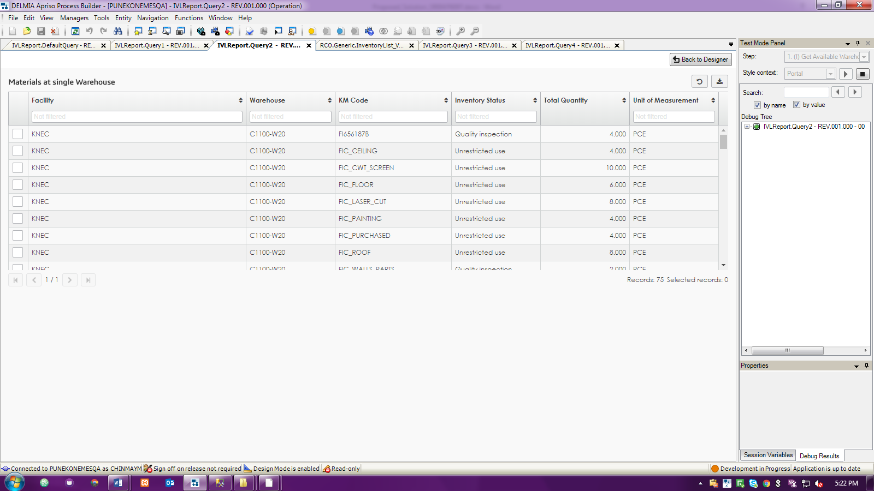

1. Materials at multiple Warehouses (not Combined):

This will show materials at multiple Warehouses without cumulating the data at warehouse level.

1. Step 1: User selects the warehouses

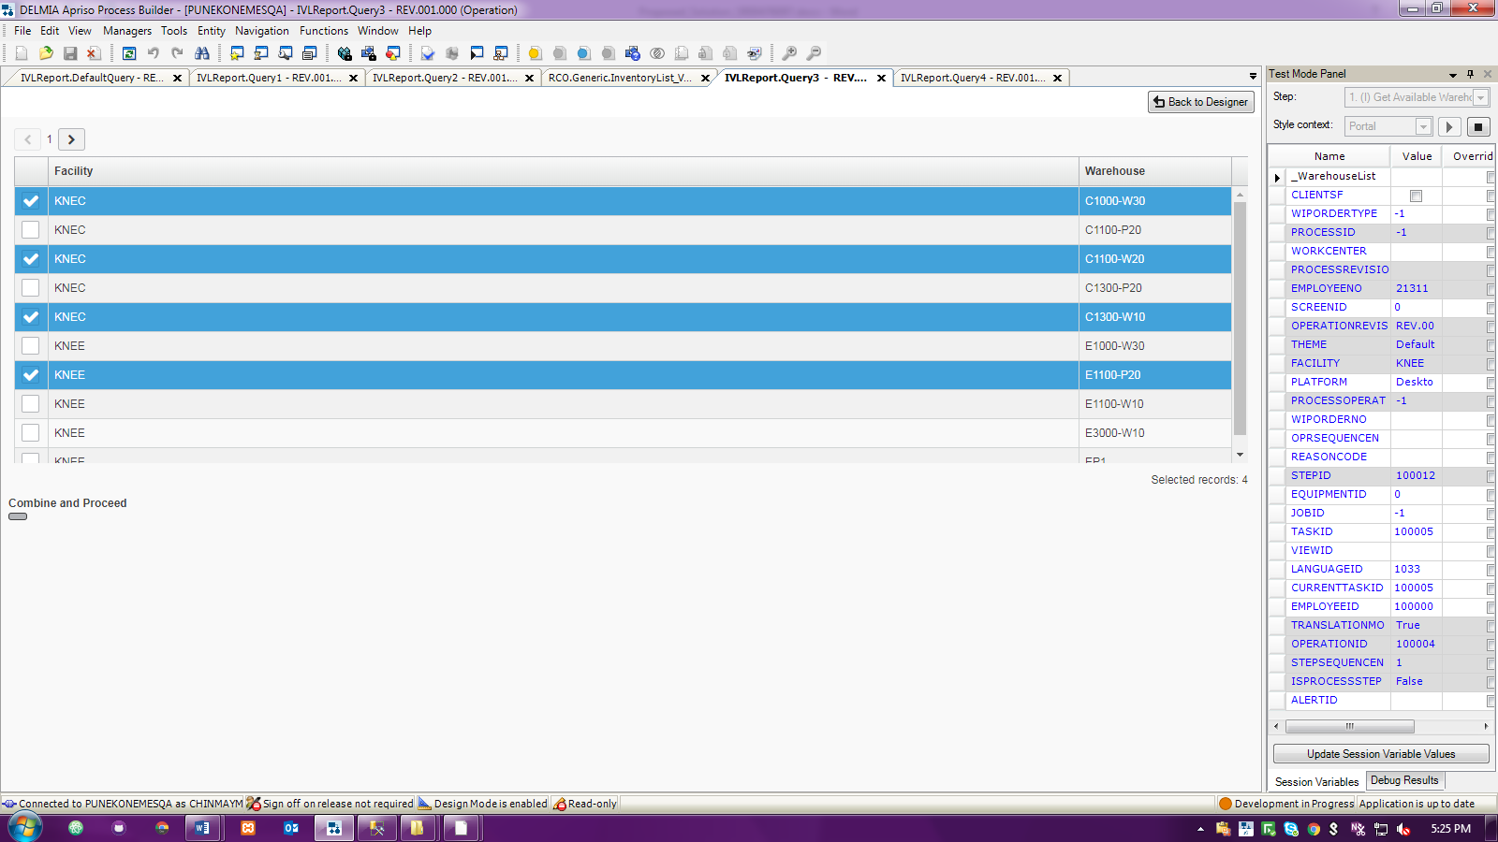

1. Step 2: Materials in those selected warehouse is visible now:

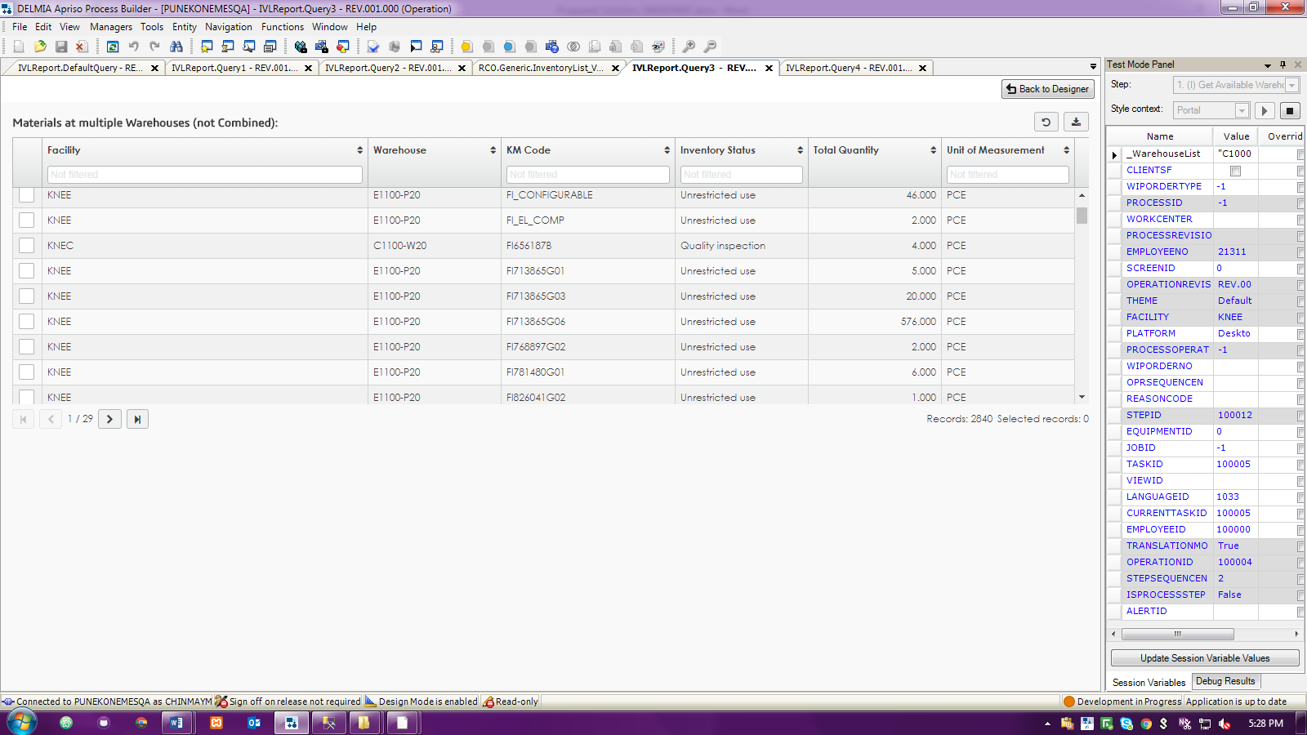

1. Materials at multiple Warehouses (Combined):

This will show materials at multiple Warehouses with cumulating the data at warehouse level.

1. Step 1: User selects the warehouses



1. Step 2: Materials in those selected warehouse combined is visible now:

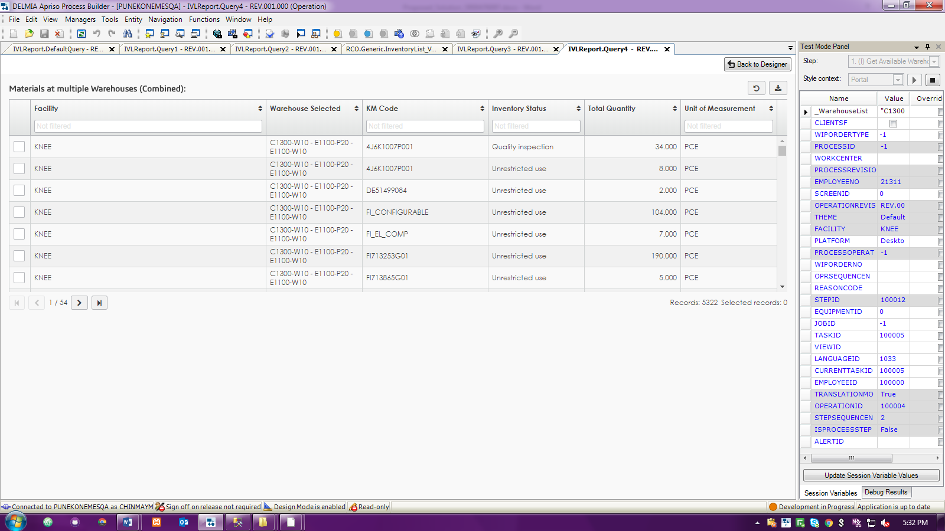

Please Note – All these data grids will have **Export button** from where user can export reports easily.

