10/12/16 GUI C++

Class notes

Layouts

Absolute positioning

* Def.) Allows you to directly set the item coordinates and size for each individual item.
* Ex)

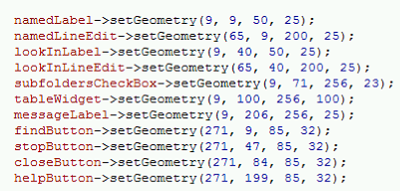

Resizing with absolute

* Def) Allows absolute positioning to resize items when window size changes
* Uses the *resizeEvent(QResizeEvent\* event)* function
* Ex)

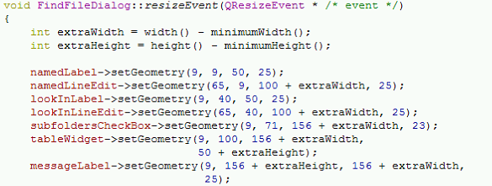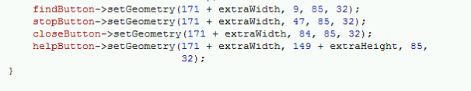

* + Note: Resizing label is unnecessary in this example
  + First coordinates are repositioned, last are resized

Layouts

* Def.) Predefined formatters for widget placement
* Layouts change size automatically
* Types:
  + QVBoxLayout
  + QHBoxLayout
  + QGridLayout
  + QStackLayout

QVBoxLayout

* Def.) Lays widgets in a vertical layout that places items from top to bottom
* Ex)

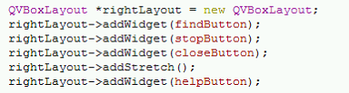

* + Note:
    - addStretch()
      * Def.) Creates a blank space between items

QHboxLayout

* Def.) Lays widgets in a horizontal layout that places items from left to right
* Ex)

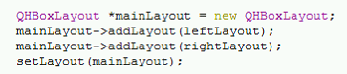

QGridLayout

* Def.) Sets a table like layout for widgets
* Ex)

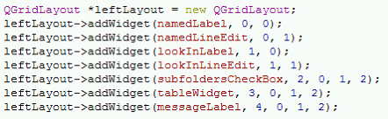

QStackLayout

* Def.) Stacks items in a layer within the same area
* Allows multiple windows to appear in the same area
* Ex)

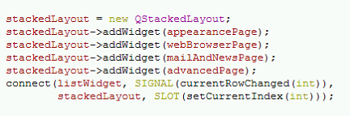

Widgets

* Ex)

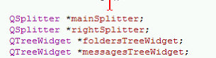

TreeWidget

* Def.) A list of items

Splitter

* Def.) adds a split between items
* Constructor defines split direction
* Widgets must be added to the splitter
* Ex) Vertical split

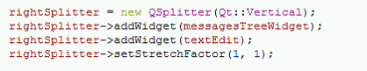

* Ex2) Horizontal split

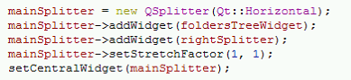

textEdit

* Text boxes can also be modified using html
* Ex)

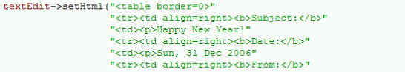

MDI

* Def.) Multiple document interface; Contains multiple windows that function separately
* Examples:
  + Art programs that can open multiple canvases
  + QT with its multifunctional panels
* Ex)

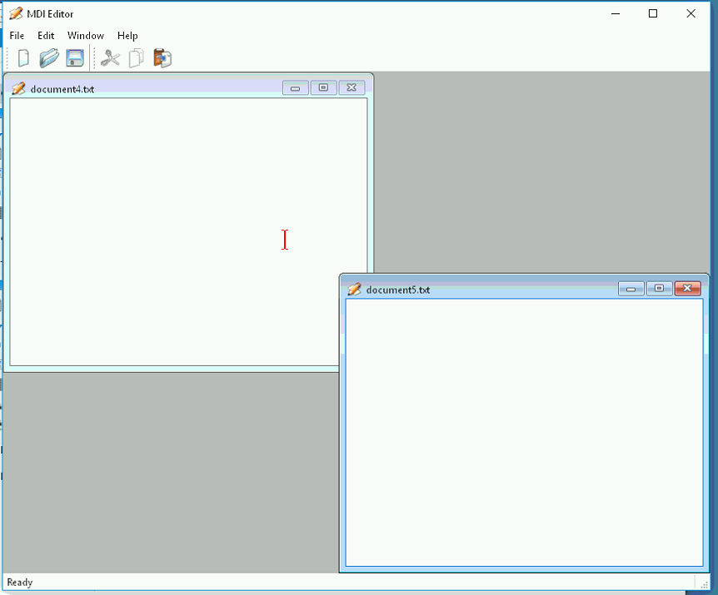

QMdiArea

* Def.) A declared area that allows multiple documents to be interfaced.

QMdiSubWindow

* Def.) Declares a sub window for mdi
* Qt handles some functions for the window
* Ex)

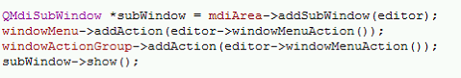

QListWidget

* Def.) Creates a text box that creates a list of items
* Ex)

