Csc17b Notes

11/9/2016

More Databases

Table

* Rules
  + Every table needs a key
    - Keys must be the same data type
  + Bringing it to first normal form
    - Columns must be atomic,
      * meaning that they must be separated in the terms that will be used.
    - Map out keys so it’s easy to read
  + Relationships between tables and items
    - Several types:
      * One to zero/one
      * One to many
      * Many to many
  + Second normal form
    - Any non-key columns must depend on the entire primary key.
  + Third normal form.
    - Requires that all columns depend directly on the primary key.
* Rules help:
  + Avoids duplication

SQL

* Structure Query Language
* Allows access to a database
* Two parts:
  + DML
    - Data manipulation language
  + DDL
    - Data definition language
* Like condition
  + Def.) used to specify a search in column

Data bases

* Review:
  + 3 Types of tables
    - Entity – objects with properties
    - Enum -
    - xRef - Primary key
  + The xRef acts as the map for the tables
  + Ex) 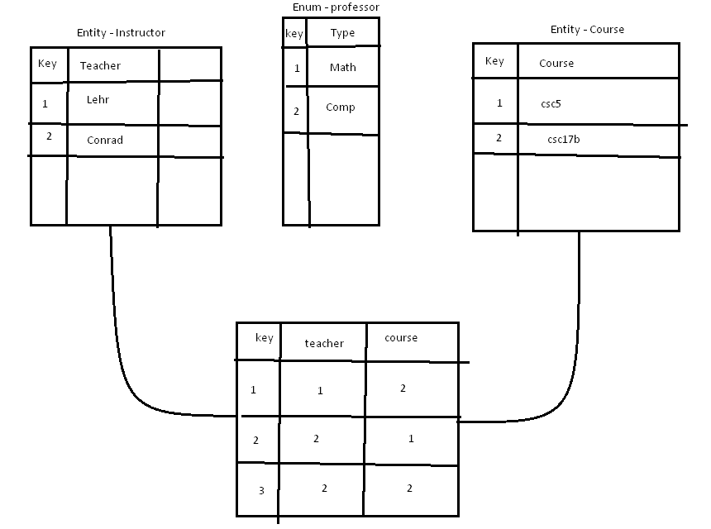

Creating data base

* Step 1)
  + Start sql in xxamp
    - 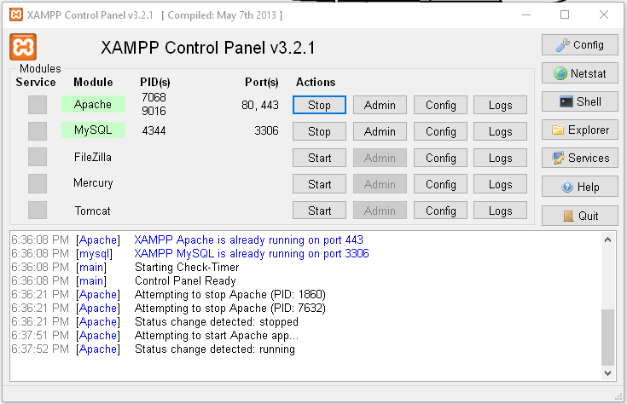
* Step 2)
  + Run Openoffice and create new database
  + Connect to sql
    - 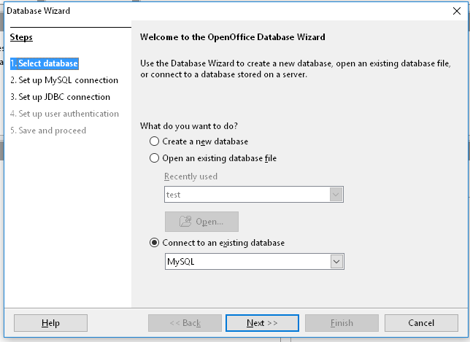
* Step 3)
  + Connect using JDBC
    - 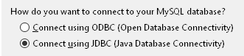
* Step 4) complete connection steps
* Step 5) Create table

OpenOffice

* Create table with wizard
* You can right click on left border to set primary key
  + **Always set primary key before saving**
  + 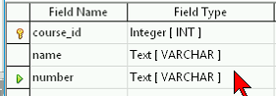
* Set auto value on for easy enumeration
  + 
    - Autofield sets number once place is assigned
* Once table is complete, save and it will be displayed at office home
  + 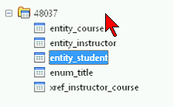

Creating a Query

* Allows you to access and sort tables
* Step 1)
  + Select and create queries
  + Then right click>edit to modify
    - 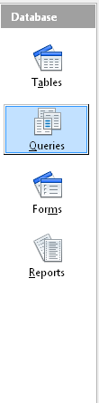
* Step 3) Add and connect entities by clicking and dragging the names
  + 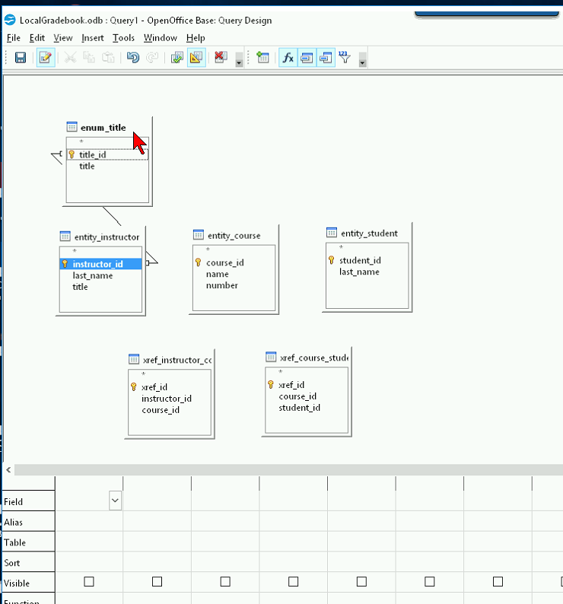
  + 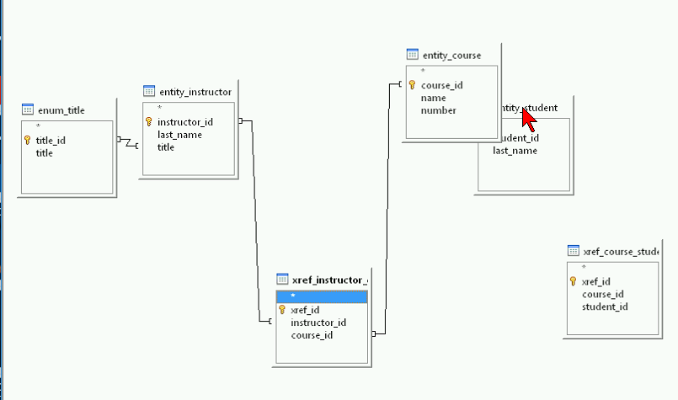
    - Ensure that all titles are connected
* Step 4)
  + Set items into table
    - 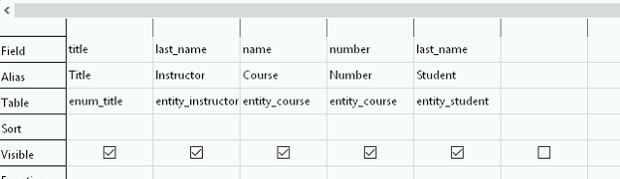
  + You can also sort
* Step 5)
  + Right click>edit in sql to find source code

Placing SQL in qt

* Install sql drivers into qt
* Open Lehr’s .pro
* Paste code into query.exec
  + 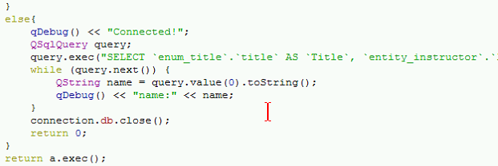
    - QString then receives data with query.value(n).toString();
* Database must then be exported and stored elsewhere in MySqlWorkbench
  + 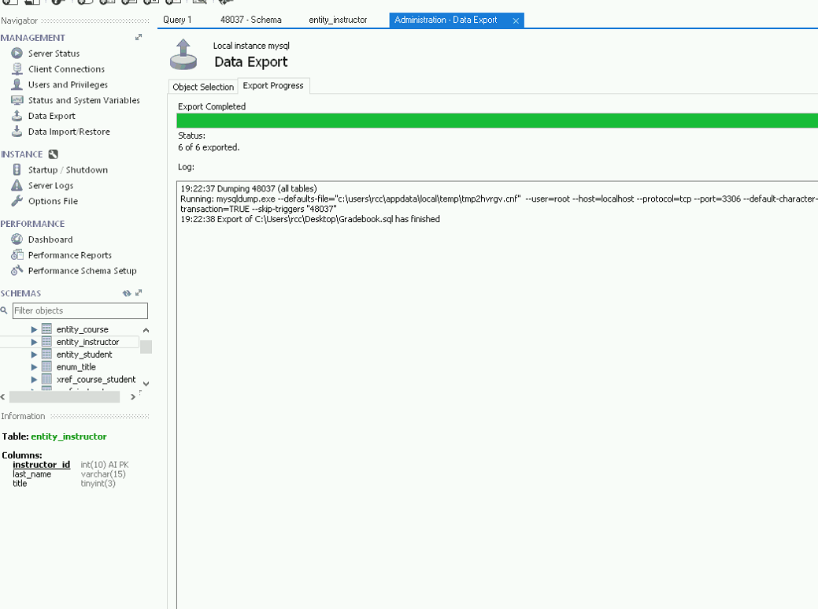
* Once completed, re-create connection in mySqlWorkbench
* Remove locks & unlocks
* If connection consistently fails, erase small code cluster at start and end
  + Error identifies code

Once done

* Java connection in openoffice
  + 