Csc17b Notes

11/23/2016

Regular Expressions

Helpful documents

* Dave child’s cheatsheet
  + <https://www.cheatography.com/davechild/cheat-sheets/css2/>
* Regular expression tester
  + <https://regex101.com/>
    - Creates code

Regular expression

* Def.) Pattern matching construct for decoding
  + Takes a string and checks to see if it matches with the regular expression.
  + 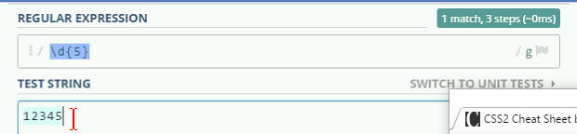
    - \d{5}
      * searches for 5 digits
* Can also use ranges for expression
  + [0-9]{5}
    - Searches for numbers 0-9 with 5 digits
* Utilize ^ and $ to begin and end expressions
  + 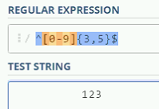
    - Forces it to read spaces
* Letter ranges work as well
  + Ex) Demonstrates multiple condition ranges and char ranges
  + 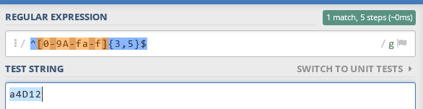
* Can add multiple subscript ranges to modify one digit at a time
  + 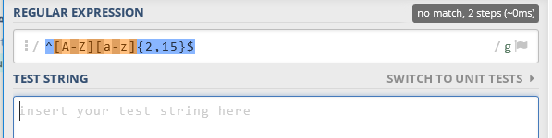
    - Checks first character with the first condition the checks the rest with the second.
* \s\*
  + Checks for all spaces
* Ex) Reads in spaces a first name, spaces, then a last name
  + 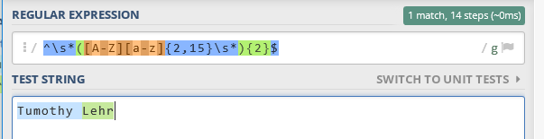
    - (expression){2}
      * Calls for the function to be called twice
* Ex) Searches for first name, and initial with a period, then last name
  + 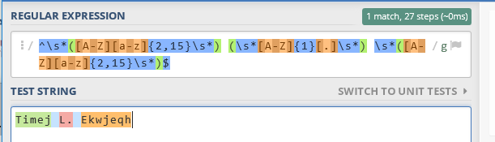
* Ex) Checks for a zip code with an optional dash plus extension
  + 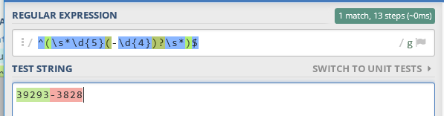

Passwords

* Regular expression pattern for password checking
  + Requires 1 capital, 1 symbol, 1 number, and at least 6 characters
* 