Csc17b Notes

11/23/2016

Threads

Threads

* Works in conjunction with functions
  + 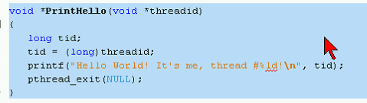
    - Void \*
      * Def.) An ambiguous pointer
      * Must be type casted
        + Ex) Type casted into a long
  + Ex) Creates threads
    - 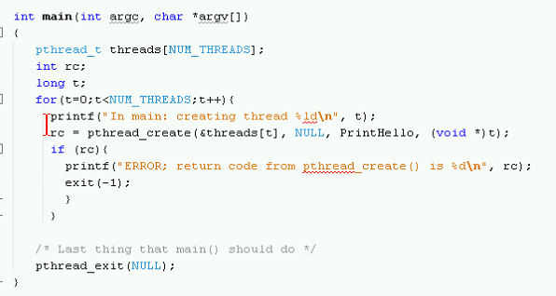
      * Utilizes printf since it works well with threads
        + printf(“Encapsulates the string!”);

Example: Sends a structure of data through threads

* 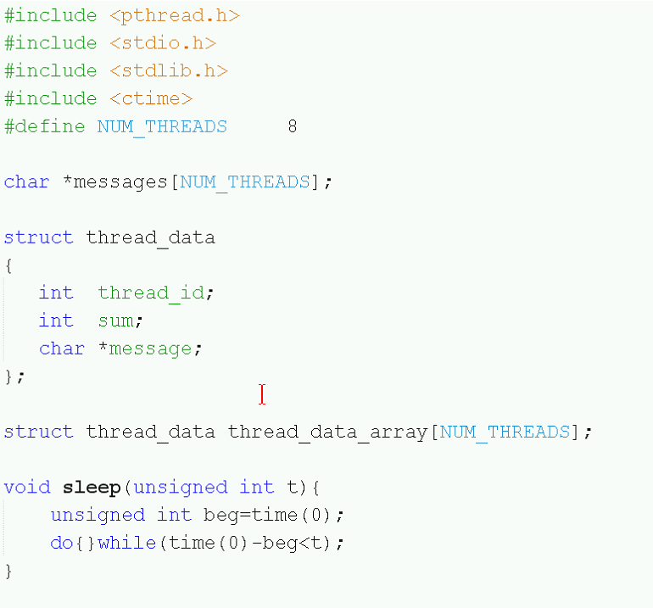
* 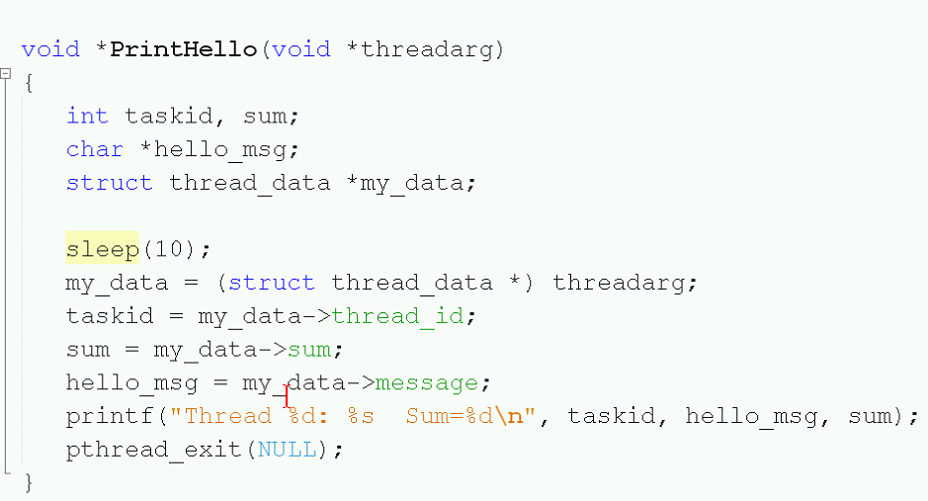
  + Program generates 8 threads
    - Resource manage shows 10, since there are two hidden threads: Main and some other thread.
  + With threads, it’s unpredictable to determine the order in which threads finish
    - Ex) 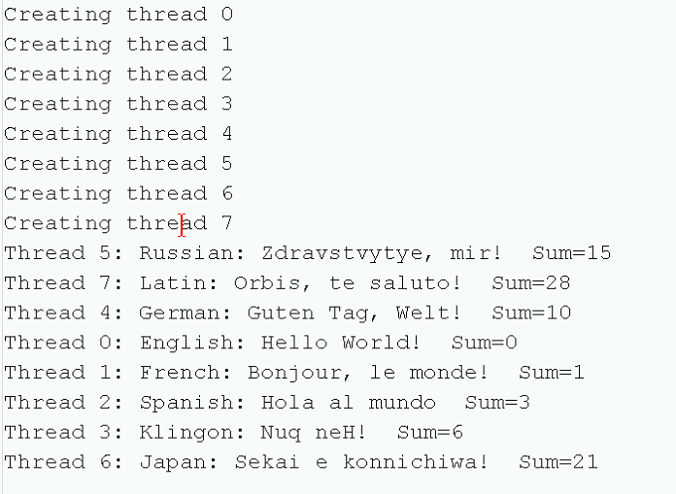

Rejoining threads

* 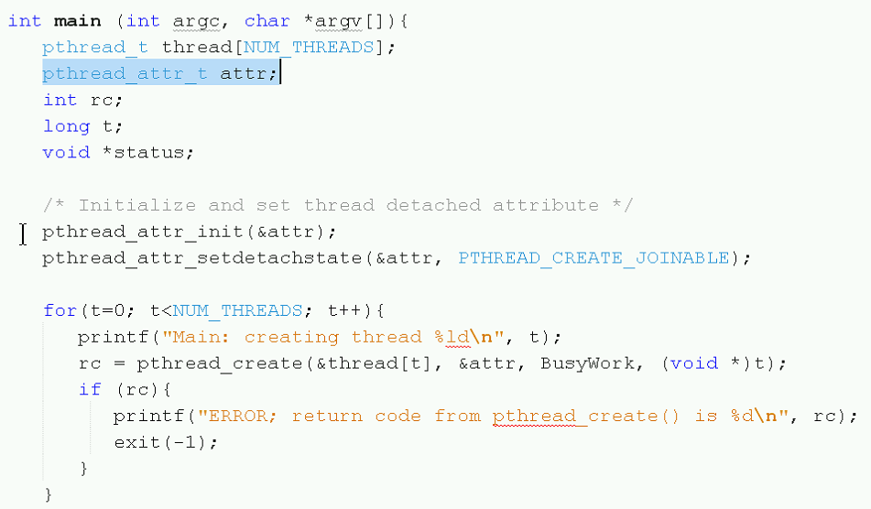
  + Detaches the threads
* 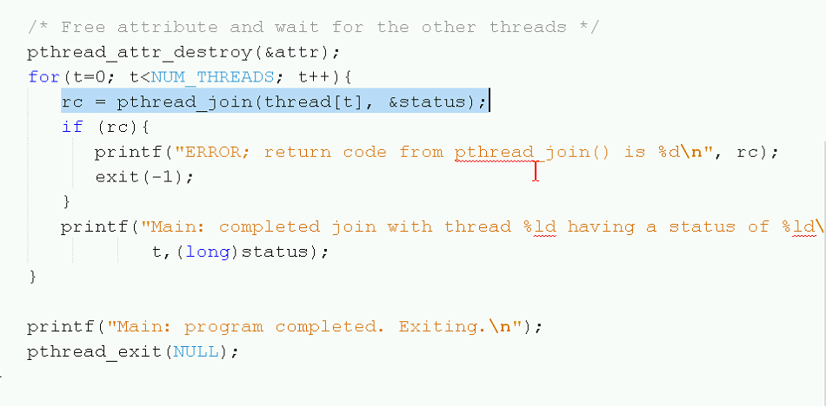
  + Spawns the threads and reattaches them

Threads can exist in Global.