Csc 7 Notes 2/27/17

Valid/Invalid forms of proofs

* 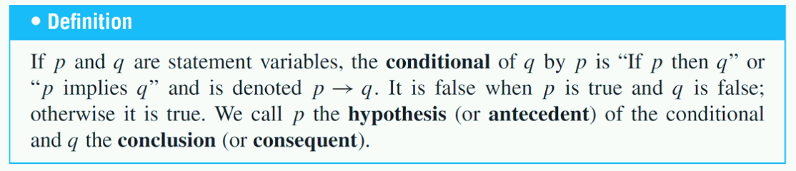
  + Ex) 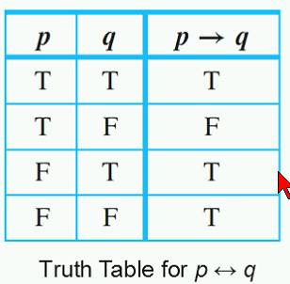
* Consider statement:
  + If 0 =1 then 1=2
    - Note: If premise is false, anything can be claimed afterwards.
* Order of operations for validations:
  + 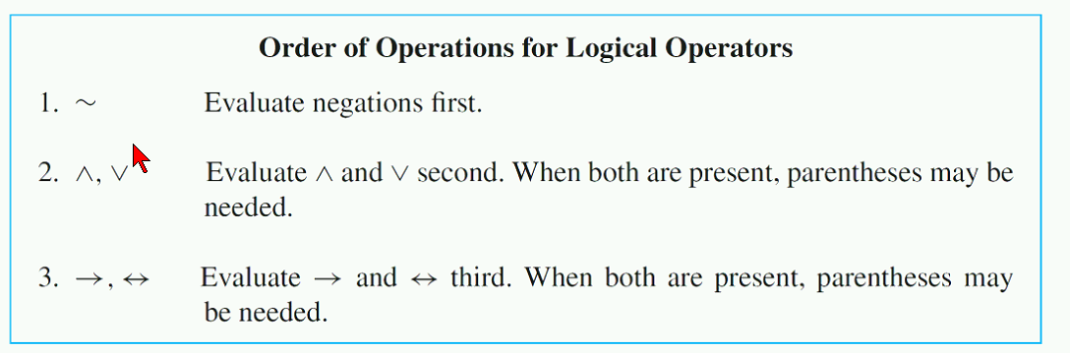
  + Ex)
    - 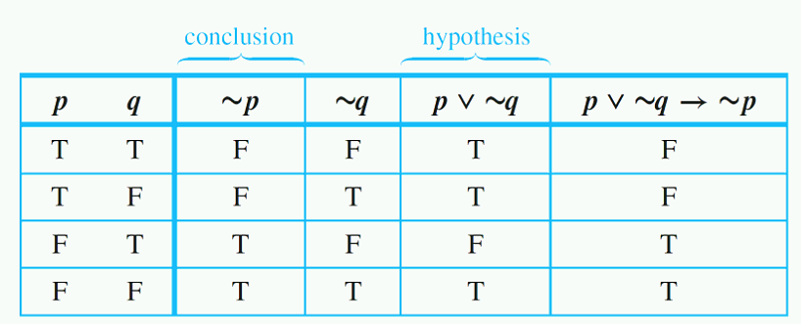

Logical Equivalence

If- then form

Negation of conditional statements

* 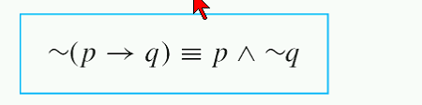

Biconditional Statements

* 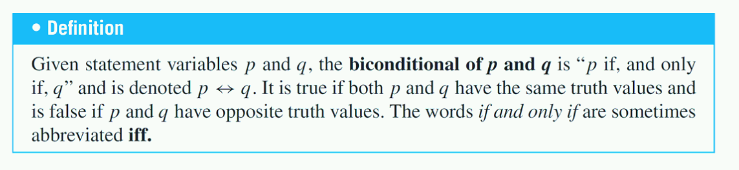
* Ex)
  + 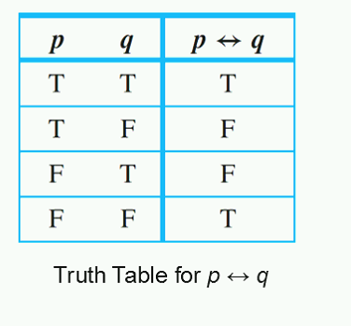

Necessary and Sufficient Conditions

* 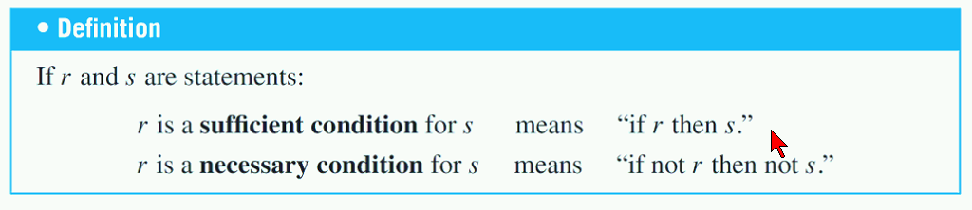

Valid/Invalid Arguments

* Arguments
  + Def) A sequence of statements ending in a conclusion
  + Argument is true of premise is true.
* An argument is invalid if one premise proves false

Modus Ponens and Modus Tollens

* Syllogism
  + Def) An argument form consisting of two premises and a conclusion
    - Ex)
      * 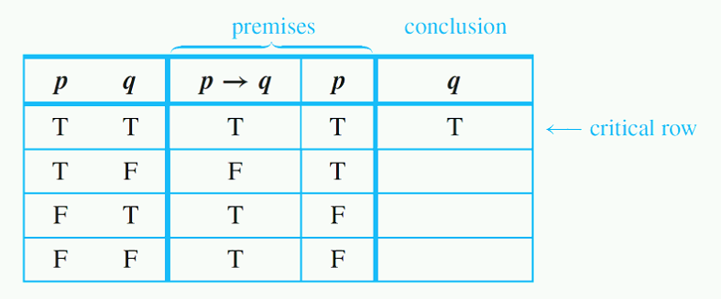

Additional Valid argument forms

* Rules of Inference
  + Def)