Chapter 4: Elementary number theory and methods of proof

Direct Proof

* Both discovery and proof are integral parts of problem solving.
  + When you think you have discovered that a certain statement is true, try to figure out why it is true.
  + If you succeed, you will know that your discovery is genuine.
  + If you fail, the process of trying will give you insight into the nature of the problem and may lead to the discovery that the statement is false.

Definitions

* In order to evaluate the truth or falsity of a statement, you must understand what the statement is about.
* Even/Odd
  + Def)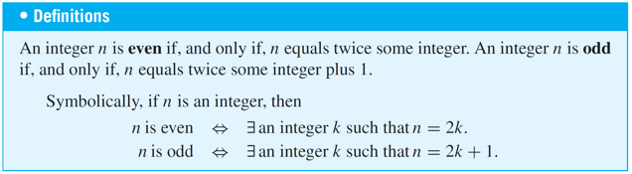
  + Examples:
    - A) is 0 even?
      * Solution: Yes, 0 = 2*0
* Prime/Composite
  + Def)

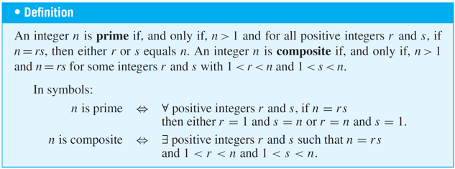

Proving Existential Statements

* Given:
  + 
  + 
* Constructive Proofs of existence:
  + One way to prove this is to find an x in D that makes Q(x) true
  + Another way is to give a set of directions for finding x
* Ex)
  + 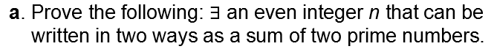
  + 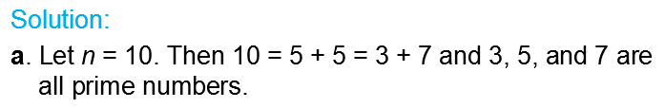

Nonconstructive proof of existence

* Last method to try
* Involves showing either
  + A) The exitence of a value of xthat makes Q(x) true is guaranteed by an axiom or a prv theorem
  + B) The assumption that there is no such x
    - This leads to a contradiction
* Disadvantage:
  + Gives no clue about where or how to find x

Disproving universal statements by counterexample

* Disproving shows that the statement is false, and thusly showing that it’s negation is true
  + Ex)
    - If false: 
    - This true: 
* Thus to that that an existential statement is true, we get a counterexample.
  + 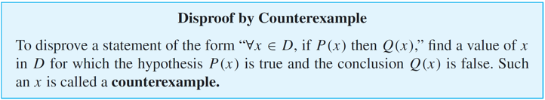

Proving Universal Statements

* By Method of Exaustion:
  + Given: 
    - When *D* is finite or when only a finite number of elements satisfy *P*(*x*), such a statement can be proved by the method of exhaustion.
* Method of Generalizing from the Generic Particluar
  + 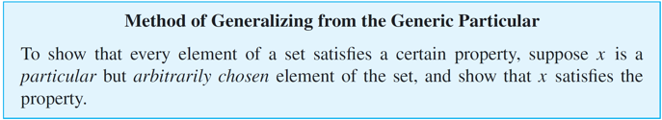
  + Ex)
    - You ask a person to pick any number, add 5, multiply by 4, subtract 6, divide by 2, and subtract twice the original number.
    - 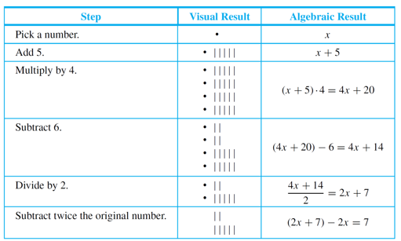
* Method of Direct Proof
  + 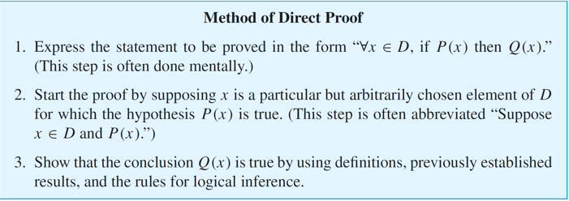
  + Ex) Prove that the sum of any two even integers is even.
    - Steps to solution:
      * First: Ask yourself if you think it’s true
        + In this case you might imagine some pairs of even integers, say 2 + 4, 6 + 10, 12 + 12, 28 + 54, and mentally check that their sums are even.
        + Unfortunately it’s impossible to check all even ints
      * Second: Prove the statement in general
        + You need to show that no matter what even integers are given, their sum is even. But given any two even integers, it is possible to represent them as 2*r* and 2*s* for some integers *r* and *s*.
        + 2*r* + 2*s* = 2(*r* + *s*)

Since the result is even, it is true in general

* + - * Third: Formally Restate it
        + Restatement:**∀** integers *m* and *n*, if *m* and *n* are even then *m* + *n* is even.
      * Fourth: State your starting point
        + Ask yourself “Where am I starting from?” or “What am I supposing?”
        + Starting Point: Suppose *m* and *n* are particular but arbitrarily chosen integers that are even

(Or abbreviated: Suppose *m* and *n* are any even integers)

* + - * Fifth: State conclusion
        + To show: m+n is even
    - Existential Instantiation
      * 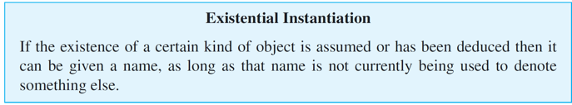
* Directions for writing proofs of universal statements
  + 1. **Copy the statement of the theorem to be proved on your paper.**
  + 2. **Clearly mark the beginning of your proof with the word Proof.**
  + 3. **Make your proof self-contained.**
    - This means that you should explain the meaning of each variable used in your proof in the body of the proof.
  + 4. **Write your proof in complete, gramatically correct sentences.**
    - Does not mean you should avoid symbols & shorthand abbreviations
  + 5. **Keep your reader informed about the status of each statement in your proof.**
    - Your reader should never be in doubt about whether something in your proof has been assumed or established or is still to be deduced. If something is assumed, preface it with a word like *Suppose* or *Assume*.
    - If it is still to be shown, preface it with words like, *We   
      must show that* or *In other words*, *we must show that*.   
      This is especially important if you introduce a variable in rephrasing what you need to show.
  + 6. **Give a reason for each assertion in your proof.**
    - Each assertion in a proof should come:
      * Directly from the hypothesis of the theorem
      * Follow from the definition of one of the terms in the theorm
      * Be a result obtained earlier in the proof
      * Be a mathematical result that has been previously established/agreed to be assumed.
    - Use phrases such as: “by hypothesis”, “by definition”, “by theorm”
  + 7. **Include the “little words and phrases” that make the logic of your arguments clear.**
  + 8. **Display equations and inequalities.**

Variations among proofs

* It’s rare for two proofs to be identical

Common mistakes

* 1. **Arguing from examples.**
  + Good for teaching problem solving
  + Cannot be used for general stateents
* 2. **Using the same letter to mean two different things.**
* 3. **Jumping to a conclusion.**
* 4. **Circular reasoning.**
  + A variation of jumping to a conclusion.
* 5. **Confusion between what is known and what is still to   
   be shown.**
* 6. **Use of *any* rather than *some*.**
* 7. **Misuse of the word *if*.**

Starting a proof

* Once you understand generalizing from the generic particular and the method of direct proof
  + It is possible to write the beginning of proofs even if you don’t understand it.
    - The reason is that the starting point and what is to be shown in a proof depend only on the linguistic form of the statement to be proved, not on the content of the statement.
* Ex) “Every complete, bipartite graph is connected.”
  + Solution:
  + (It is helpful to rewrite the statement formally using a quantifier and a variable)
    - 